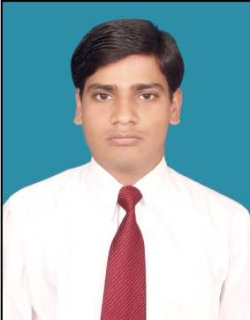**DHEERAJ KUMAR**

Address: A-77-78 Top Flore/Front Shide, Mohan Garden

Uttam Nagar, Metro Piller no.764,

New Delhi 110059

Contact: +91 9990811194

Email ID: kumardheeraj15@gmail.com

Career Objective

To work in an organisation that appreciates the efforts of its employees so that I can utilize and enhance my skills and knowledge for the development of the organization as well as myself.

Academic Qualification

|  |  |  |  |
| --- | --- | --- | --- |
| **Qualification** | **Board/**  **University** | **Year** | **Percentage** |
| **Industrial Traing** | Ducat | 2016-2017 | .net (6 month) |
| **Internship** | CEBC | 2016 | Java |
| **MCA** | Galgotias University | 2013-16 | 65% |
| **DISM** | APTECH | 2013 | 70% |
| **BCA** | SMU | 2009-12 | 56.08% |
| **XIIth Science** | BSEB | 2009 | 47.6% |
| **Xth** | BSEB | 2005 | 49.14% |

Professional Skills

* Language : C, Java, C#, VB
* Web Development : HTML, Java EE, Asp.net, Web Service, Jquery, Angular, Report Viewer, Entities, MVC(Basic)
* Database : MYSQL, Oracle 10g,Sql Server
* IDE : Netbeans (Basics), Visual Studio.

**Project Experience**

* ***Food Ordering System (Sem IV):*** A asp.net to help a customer view and order different kinds of food online.
* ***Online Exam (Sem VI):*** Online Exam on a project.
* ***Working on:*** (it is Online Project But Dummy project.)

**Summary**

This project used in Three Module (Admin, Company, Candidate).Company & Candidate registration. Company is add the Question then Candidate Chose the Company then Start the Exam. Database Connectivity is used in DAO Class.

**Work Experience**

* ***2.10 Year Experience :-*** Last Working with N.D. Microsystems Pvt. Ltd. (NDM), Unit #410, Unitech Arcadia, South City – II, Sector 49, Gurugram (Gurgaon), Haryana -122018. (05-Nov-2018 to 09-Sep-2021) as Software Developer.

**Title :**IERP

**Role :**Software Developer (Team Size-> 3-4 members)

**Environment :** C#,(Web Application), Visual Studio 2012 , SQL SERVER .

**Description :**This application provides complete Enterprise resource planning . It is a solution to manage the manufacturing production and sales in mannered way through different -different module configuration. Like Purchase, Sales and Finance module.

* **1 Year experience**:- *info solution software pvt.ltd*

CB-174, Ring Rd, Block CB, Naraina Village, Naraina, New Delhi, Delhi 110028 (07-08/2017 to 03-11/2021) as Software Developer.

**Title :** School-ERP

**Role :** Software Developer (Team Size-> 4-5 members)

**Environment :** C#,(Web Application), Visual Studio 2012 SQL Server ,

**Description :**This application provides complete automation to school process including HRMS. Having modules like Admission, Bus, Fee, Class Teacher, Library,Front Office, Message.

Personal Details

Date of Birth : September 5nd, 1990

Nationality : Indian

Languages : English, Hindi

Hobbies & Passions : Problem solving, drawing, Travelling, Plantation.

Date Dheeraj Kumar