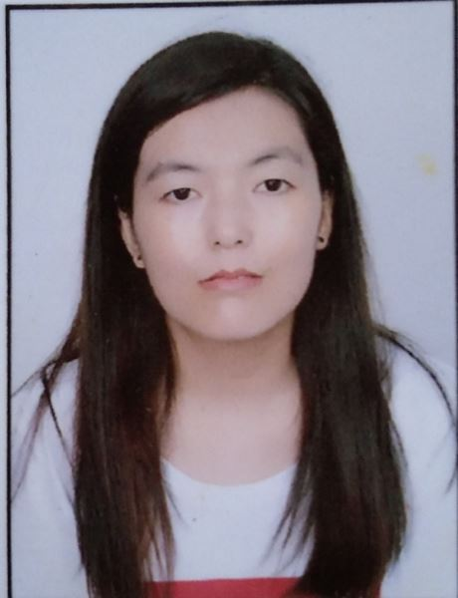**RESUME**

1. **Name :** Disket Dolker
2. **Father’s name :** Rigzen Dorjey
3. **DOB :** 19/01/1995
4. **Category :** Schedule Tribe-Leh
5. **PermanentAddress :** Village-Igoo, Leh

Ladakh

1. **Mobile No :**  9469084903
2. **Email-id :** disketdol15@gmail.com@gmail.com

**Objective:**

* To expend my knowledge and skills.
* A highly organized and hard-working individual looking for a responsible position to gain practical experience.

**Educational Qualification:**

|  |  |  |  |  |
| --- | --- | --- | --- | --- |
| **S.NO** | **Examination passed** | **University/Board/**  **Institution** | **Year of passing** | **Percentage of marks/ OGPA** |
| 1. | Class 10th | J&K BOARD | 2011 | 40.8 |
| 2. | Class 12th | J&K BOARD | 2013 | 42.6 |
| 3. | Graduate | Govt.College for Women, ParadeJAMMU | 2019 | 51.58 |
|  |  |  |  |  |

**COMPUTER PROFICIENCY**

* BASIC KNOWLEDGE OF COMPUTER
* TYPING

**OTHERS**

NCC: B Certificate

NCC: C Certificate

**LANGUAGE KNOWN:**

**Read, write and speak:**  English, Urdu and Ladakhi.

**Speak:** Hindi

**Declaration:** I do here by declare that the information given above is true to the best of my knowledge.

**Place: LEH**

**Date: 22/01/2021**