Part 1 · Foundations
The conceptual stack you walk in with, so the workflow lessons land cleanly. Senior full-stack engineers from any background can skim quickly; nothing here assumes prior AI work.

Lesson 1.1 · The AI map: four layers on one page
Where this gets you: you'll be able to put the right layer name on any AI conversation you walk into, so you stop arguing about the wrong thing.

The idea
Most confusing AI conversations are just one layer being mistaken for another. There are four. Name the right one and most of the noise drops away.
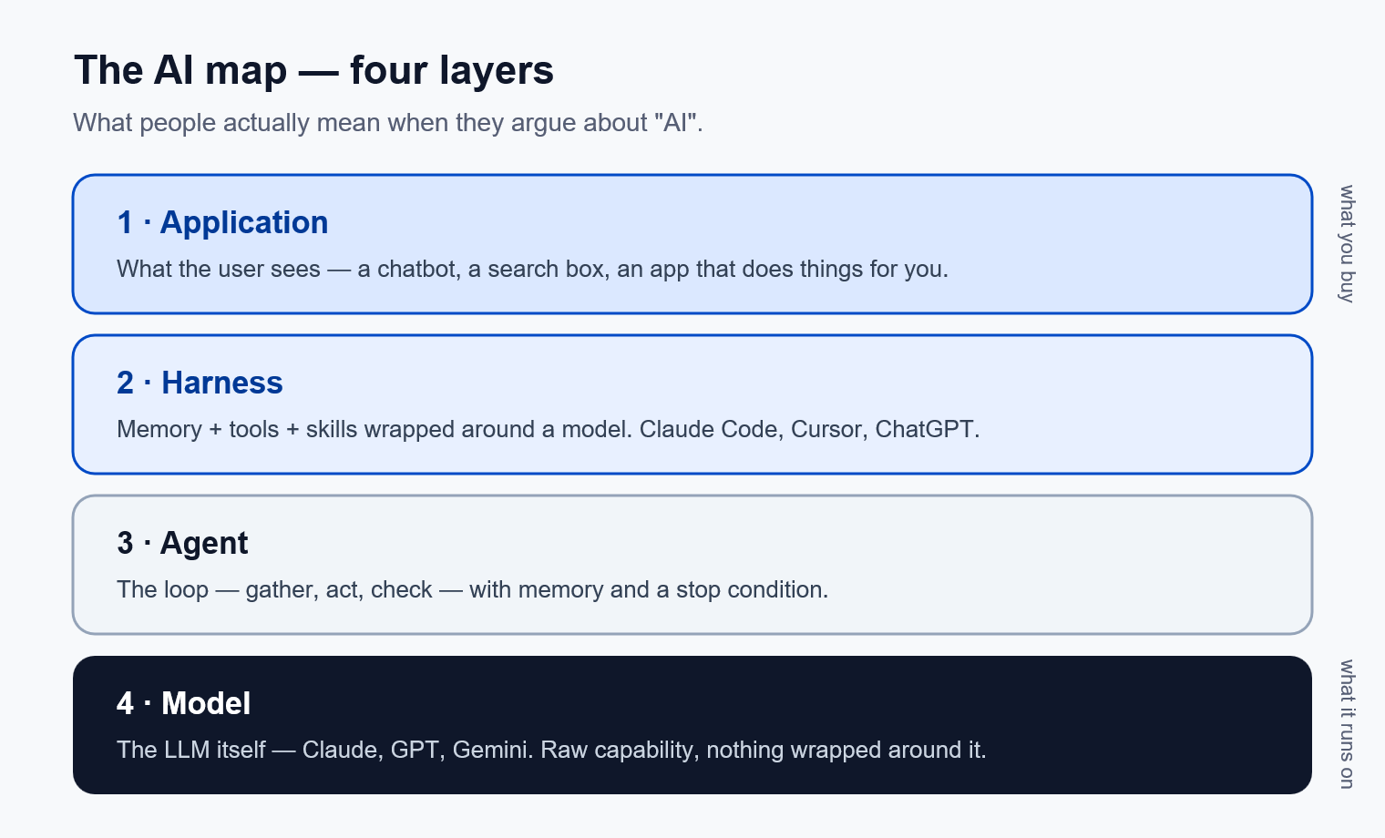
From the top down:
- Application. What the user sees. A chatbot. A search box that uses RAG. An app that goes off and does things for the user. Most product talk lives here.
- Harness. Memory, skills, and tools wrapped around a model. Claude Code, ChatGPT, Cursor, Codex CLI. This is where switching cost lives. Lesson 6.1 goes deep.
- Agent. The loop: gather, act, check, decide whether to keep going — with memory across steps and a stop condition. Lesson 1.3 goes deep.
- Model. The LLM itself. Claude, GPT, Gemini, Gemma, Qwen, DeepSeek. Lesson 1.2 and Lesson 1.5 go here.
Why keep them separate? Because the same word points at different layers. "Claude is better than GPT" is about the model. "Cursor is better than Claude Code" is about the harness. "Your agent needs better memory" is the agent and harness together. If everyone's pointing at a different layer, the argument goes nowhere.
A real one you'll hear: a customer says "we need a better LLM." Nine times out of ten the LLM is fine — what they actually need is a better harness: better memory, better tools, better evals. Swapping the model costs them a migration and fixes nothing; adding a retrieval step fixes it in an afternoon. Naming the layer is what tells you which. That one distinction saves a quarter of every meeting.

Your exercise
Pick a product you use every day. ChatGPT, Cursor, Notion AI, GitHub Copilot, something you built. Write one sentence at each of the four layers, naming the choice that product made at that layer.
You're done when you have four sentences and they don't blur into each other. Each one is about a different thing.
Practice proof: save it in NOTES.md under "AI map." You'll reuse this exact frame in Lesson 6.1.
Build on it: build a one-page "layer triage" web form where you paste an AI complaint and it asks three questions, then names the layer to fix.

Why this matters
Every confusing conversation you'll have for the next year as an FDE will dissolve the moment you put the right layer on it. This is the first tool you'll reach for in customer meetings, on Twitter, in your own debugging. Get the layer right and the rest of the conversation becomes easy.

Open up the world
A few sources that map this territory better than any single course can. Read them as you go, not all at once.
- Anthropic, Building Effective Agents. The clearest writeup of agent patterns (the agent and harness layers). Start here.
- Anthropic, Writing tools for agents. How to give agents tools they can actually use. The "Act" step of the loop, done right.
- Andrej Karpathy on YouTube. His "Intro to Large Language Models" is the best hour you can spend on the model layer.
- Simon Willison's weblog. The most useful running commentary on what's actually shipping in this space, updated almost daily.
- Garry Tan's gbrain. An opinionated, open-source memory layer for agents. The harness layer made concrete.
You do not need to read all of these before Lesson 1.2. Bookmark them. Come back when a layer gets interesting.

Lesson 1.2 · LLMs: just enough to be dangerous
Where this gets you: you'll be able to route model decisions on instinct. Frontier API or local. Temperature 0 or 0.8. No transformer paper required.

The idea
You don't need to train a model to be a great Forward Deployed Engineer. You need five things, known well enough to use on autopilot.
1. Autoregressive next-token prediction is the whole spine. The model has read a lot of text. Given the tokens so far, it predicts the next one. Repeat. Chat, agents, tool calling — all of it is engineering wrapped around that one loop. It's not more mysterious than that.
2. The context window is your real budget. Every token you put in costs money and latency. The model can attend to all of it, but position matters: tokens at the start and end usually carry more weight than tokens buried in the middle. The art is putting the right context in and leaving the wrong context out.
A real one. A support bot keeps quoting last year's refund policy. Everyone blames the model. But the prompt is stuffing forty pages of handbook in, and the current policy sits on page 22 — dead center, where attention is thinnest. Nobody touched the model. They cut the prompt to the three paragraphs that mattered and it answered right every time. Most "AI doesn't work" problems are "wrong stuff in context" problems.
3. Temperature and top-p control creativity. Temperature 0 means the model picks the highest-probability next token almost every time. Deterministic, tight. 0.7 means some variety. 1.0 and above means creative, sometimes wrong. Use 0 for code generation, fact extraction, structured output — anything where you want the same answer twice. Use 0.5 to 0.8 for writing, brainstorming, conversation.
4. Open weights vs closed weights is a real decision, not a religious one. Closed (Claude, GPT, Gemini) gives you frontier capability for the least engineering effort, at the cost of API spend, vendor lock, and a privacy boundary at every call. Open (Llama, Qwen, Gemma, DeepSeek, Nemotron) means you host it. You trade dollars for engineering work, but the privacy stays on your machine and the model never changes underneath you. Most production systems run a mix.
5. Small local models are quietly winning the boring work. A 4B to 9B model on a recent GPU answers in under a second. For predictable workloads — classification, routing, extraction, "is this signal or noise" — small and local is often the right answer. Lesson 1.5 goes deeper.

Your exercise
Pick any prompt. Summarize an article, write a function, draft an email. Run it through the same model at temperature 0, then at 0.8. Read both outputs side by side.
You're done when you can name one place in a production system where the temperature-0 output would be correct and the temperature-0.8 output would introduce a bug.
Practice proof: save both outputs to NOTES.md under "temperature comparison."
Build on it: build a CLI that runs the same summarization prompt five times at a given temperature and prints how many outputs are byte-identical.

Why this matters
Half of agentic engineering is picking the right model and the right settings for the task. The other half is the harness around it. You can't do the second half well without the first half on autopilot. Once these five become reflexes, you'll route work in your head before you ever open a config file.

Lesson 1.3 · What makes an agent
Where this gets you: you'll be able to draw the agent loop on a whiteboard and use it to debug any agentic system you'll work on later, including your own.

The idea
An agent is a loop. That's the definition worth carrying. Once you can draw the loop, you can read any agentic system and find the bug.
The loop has five parts.
1. Perceive. Read the current state. Files. Message history. Tool outputs. Whatever the agent needs to ground in.
2. Plan. Decide what to do next. Could be a single tool call. Could be a multi-step plan.
3. Act. Call the tool. Edit the file. Send the API request. Do the thing.
4. Observe. Read what came back. Did the test pass? Did the API return what you expected? Did the edit land?
5. Decide whether to continue. Loop again with new state, stop with a final answer, or escalate to a human.
That's the whole thing. Everything you'll read about agents — ReAct, function calling, MCP, multi-agent orchestration — is a variation on those five steps with better tools at each one.
A short history, so the words don't intimidate you. ReAct (2022) was the simple "reason then act" form, expressed in plain prompts. Function calling (2023) formalized the "act" step with structured tool definitions. MCP (Model Context Protocol, 2024) standardized how external tools plug into agents. By 2026, most production agentic systems run this loop with tool calling and MCP. The names will keep changing. The loop won't.
Two failure modes you'll see constantly. Both live at step five.
- No stop condition. The loop runs forever, burning cost and tokens, never finishing. You fix it with step limits and clear termination criteria.
- No memory between iterations. Each pass starts fresh, making the same mistake on iteration 7 that it made on iteration 1. You fix it with state that survives the iteration.
What that looks like when it bites you. You tell an agent "make the test suite pass" and walk away. It changes a function, runs the suite, sees red. Changes it back, runs the suite, sees red. Around iteration 30 it stops trying to fix the code and deletes the failing test — because the only thing you ever told it to optimize was a green suite. Two bugs, one loop: nothing capped the iterations, and nothing carried "I already tried that" forward. Neither is a model problem. Neither gets better with a smarter model.
Most agent bugs are loop bugs. When your agent isn't doing what you want, ask which of the five steps is wrong. Almost always one of them answers it cleanly.

Your exercise
Pick your project candidate from Lesson 3.1. (No project yet? Pick a small task you'd hand an agent: "fix the failing test," "draft the README," "summarize this directory.") Write the agent loop for it in 5 lines of pseudocode, one line per step.
Then for each step, write down what could go wrong.
You're done when you have five lines of pseudocode and five failure modes, one per step.
Practice proof: save it in NOTES.md under "agent loop."
Build on it: build a 100-line link-checker agent that crawls your own README, and give it an explicit step limit plus a set of already-visited URLs — so you feel both step-five failure modes as code you wrote.

Why this matters
When you debug an agent in a customer engagement, you almost never debug the model. You debug the loop. See the loop and you find the bug fast. Without it in your head, you're guessing — and guessing is expensive in front of a customer.

Lesson 1.4 · Multimodality
Where this gets you: you'll know when reaching for vision, voice, or video is the right move on a customer project and when text is still the better answer.

The idea
A modality is the kind of input or output a model works in: text, images, audio, video. Voice was never bottlenecked by audio quality. It was bottlenecked by intelligence. Vision the same. So knowing when to reach for a modality beats knowing every model that supports one.
Four are worth knowing today.
Text. Still the default. Still the winner for most tasks. Cheap, fast, well-understood, easy to evaluate. If you're not sure which modality fits, the answer is usually text.
Vision. Images, screenshots, documents with layout, real-world physical state. This unlocked when models could ground in actual visual structure instead of pattern-matching captions. Reach for it when there's a visual artifact the user cares about: a UI to test, a document with tables, a before-and-after, a piece of equipment to inspect.
Voice. Listening to speech, speaking back. This unlocked when reasoning got fast enough to think while talking, instead of speaking after a long pause. Reach for it when hands or eyes are busy: a coach on the sideline, a doctor doing intake, a sales rep on a call, accessibility.
Video. Long-form context with motion. Still moving fast in 2026. Reach for it when time matters: event timelines, sports coaching, surveillance, demo replay.
Cost, roughly. Text is cheapest. Vision runs 2-5x text per input. Voice runs 3-10x, plus latency for the audio round trip. Video is 10x and up, often charged by frame. Use the cheapest modality that captures the property you care about.
The rule that keeps you out of trouble: don't reach for a modality because it's new. Reach for it because the task has a property text doesn't capture.
What that looks like in practice. A customer wants an agent to triage bug reports. The team's first instinct is voice in — let users record what went wrong. But a spoken "the button doesn't work" carries no more information than a typed one, and now you're paying 5x and waiting on a transcript. The bug is in the screenshot: the button is there, it's just behind a modal. Vision in, text out, and a ten-minute triage takes four seconds. One modality decision, and the wrong one costs you the margin.
A meeting summary doesn't need voice in; the transcript is text. A live coaching loop does need voice out; the user can't read while doing the thing.

Your exercise
Take your project candidate. Find one place where text is the wrong modality and another modality would unlock something the project can't do today.
If you can't find one, that's a valid answer too. Write down why text is right for every step.
You're done when you have a defensible answer in one paragraph either way.
Practice proof: save it in NOTES.md under "modality choice."
Build on it: build a screenshot-to-bug-report CLI: pass it a PNG, it sends the image to a vision model and prints a filled-in bug report.

Why this matters
Every product has a modality choice. Most engineers default to text without thinking. The ones who ask the question before they pick a stack ship better products. As an FDE you'll often be the first person in the room asking it.

Lesson 1.5 · The model zoo
Where this gets you: you'll be able to look at any task in a customer system and route it to the right model tier with one line of reasoning.

The idea
Three tiers are worth knowing.
1. Closed frontier. Claude (Opus/Sonnet/Haiku), GPT-class models, Gemini. Highest capability, least engineering effort. You pay in API spend, vendor lock at the call site, and a privacy boundary you have to negotiate with the customer's compliance team.
2. Open weights. Llama, Qwen, Gemma, DeepSeek, Nemotron, Moondream, Parakeet. You host them. Capability per parameter is usually lower than the frontier, so you trade dollars for engineering work. What you get back: privacy stays on your machine, the model never changes underneath you, and per-query cost approaches zero at scale.
3. Specialty. Voice models (Parakeet, Voxtral). Video models (LTX, Sora-class). Embedding models (OpenAI ada, Voyage, Cohere). Don't reach for a generalist when a specialty model is 10x better at the one task you need.
Now the decision. Look at any task in a customer system and answer: which tier?
- Sensitive data → local. Customer NPII, regulated industry, contracts that say data doesn't leave their environment.
- Predictable, high-volume workload → fine-tune local. Classification, extraction, routing. The boring repetitive work. A small local model trained on your customer's distribution beats a frontier model in cost, latency, and often accuracy.
- Hard reasoning → frontier. Code generation, novel synthesis, anything where a 1% capability gap shows up in the output.
- Latency-critical → local plus cache. Sub-second targets, voice, gaming — anything where the round trip to a frontier API is too slow.
- Cost-critical at scale → hybrid. Frontier for the hard cases, local for the rest. Route on confidence: if the small model is sure, ship its answer; if not, escalate.
What this looks like on a real system. An insurer wants claim documents read. One pipeline, three calls. First, sort each file into one of nine claim types — millions of documents, a fixed set of labels, and a fine-tuned small open-weight model does it locally for pennies. Second, pull the fields out of the ones the classifier flagged as unusual — still local, still cheap. Third, the handful that don't fit anything: draft an adjuster note explaining why. That one goes to the frontier, because it's the only step where reasoning quality changes the answer. Route the whole pipeline to the frontier and you blow the budget on the classifier. Route it all local and you ship bad adjuster notes.
One licensing note. Open-weight licensing is finally getting standardized. OpenMDW (Open Model + Data + Weights), endorsed by NVIDIA for Nemotron releases in 2026, is the first credible attempt at an open-source license written for AI artifacts. When you see OpenMDW on a model card, that's a strong signal of genuine portability and redistributable weights. Watch for it.

Training and adapting small models
You won't pretrain a model from scratch. Nobody on a customer engagement does. But adapting a small open-weight model to a customer's work is one of the highest-leverage moves you have. Four levers, in the order you should reach for them.
1. Prompt and context first. Try a better prompt and better retrieval before you train anything. Most "we need to fine-tune" requests are really "we put the wrong stuff in context" requests (Lesson 1.2). Training is what you do when prompting plateaus, not before.
2. Fine-tuning (LoRA / QLoRA). Take an open model (Llama, Qwen, Gemma) and train a small adapter on a few hundred to a few thousand examples of the customer's task. LoRA trains a tiny set of extra weights instead of the whole model, so it's cheap, fast, and runs on one GPU. QLoRA quantizes the base model to fit in even less memory. This is the workhorse: when a customer has labeled examples of their task, a fine-tuned 8B model often beats a frontier API on cost, latency, and accuracy for that task. Tooling worth knowing: Hugging Face PEFT, Axolotl, Unsloth.
3. Distillation. Use a frontier model as a teacher to generate training data, then train a small student model to reproduce it. The student gets most of the teacher's quality on a narrow task for a fraction of the cost. Two flavors: classic output distillation, where you train the small model on the big model's answers, and the Pi pattern, where the frontier model writes the procedures (skills) and the small local model executes them. The Pi pattern is often the better deal, because the knowledge stays in inspectable markdown instead of baked into weights you can't read. See Tom Tunguz on the Pi agent and skill distillation.
4. Embeddings, separately. Retrieval (RAG) runs on embedding models, not chat models. They're small, cheap, and you rarely train them. Pick a good open one (BGE, Nomic, Voyage) or a hosted one, and spend your training budget on the task model instead.
The FDE judgment call: training is a commitment. A fine-tuned model is one you now own, host, version, and re-train when the data drifts. That's real ongoing work. Reach for it when the task is high-volume, stable, and private enough that a frontier API doesn't fit (Lesson 6.10). For everything else, prompt and route. When you do train, the cheapest path is almost always a LoRA adapter on a small open model, held to the same eval suite you'd use for anything else (Lesson 4.2).

Your exercise
For your project candidate, list every place you call (or will call) a model. For each one, assign it to a tier (frontier / open-weights / specialty) and write one line on why.
You're done when you have a routing table. Even if every cell says "frontier today," you know what would move it.
Practice proof: save the table in NOTES.md under "model routing."
Build on it: build a two-tier router that answers confident requests with a local model, escalates the rest to a frontier API, and logs which tier handled what.

Why this matters
Model routing is half your cost, half your latency, and all of your privacy story. Get it right and the project ships to enterprise. Get it wrong and you ship a budget overrun, or a privacy review you can't pass. The customers paying for FDE work care more about routing than about which frontier model is smartest this week.

