Part 2 · Get set up
From nothing installed to your first agent session.

Lesson 2.1 · What is agentic engineering?
Where this gets you: you'll be able to say plainly what a coding agent is, how it's different from the AI you've already used, and why "agentic engineering" is a real skill and not a buzzword.

The idea
If you've used AI to write code, it was probably autocomplete — it finishes your line and you keep typing — or a chat window you paste errors into. Useful, but you're still doing the work, keystroke by keystroke.
An agent is different. You hand it a goal — "add a logout button," "figure out why this test keeps failing" — and it goes and works. It reads your files, makes a plan, edits code, runs it, sees what broke, tries again. One sentence from you can turn into fifteen minutes of finished work. Your job moves: you're judging the result now, not typing every line.
That's the shift: stop operating a tool, start directing one.

Your job starts looking less like typing and more like this: pointing, deciding, judging what came back.
There are two ways people direct an agent.
The first is the one most people drift into. Type a prompt, glance at what comes back, looks fine, move on. No plan, no definition of "done" except that it ran once. Call it vibe coding. It's quick, it's genuinely fine for experiments and learning, and it falls apart the moment real users touch the thing.
The second is agentic engineering. You write the agent a real brief. You decide up front how you'll know it worked. You hold the output to a standard and ship it with proof. Same agent, same model as the person vibe coding next to you — but the work that comes out is not close.
What that gap looks like in practice. Two engineers get the same ticket: "add password reset." The vibe coder types "add password reset to my app," gets code that looks right, and ships it — no test for the expired-token case, no rate limit, tokens logged in plaintext. It works in the demo and breaks in week two. The agentic engineer writes three lines first — reset link expires in 30 min, one active token per user, never log the token — has the agent build to that, and checks each against a test before shipping. Same tool, same afternoon. One of them gets paged at 2am.
This course teaches the second way: not prompt tricks, habits.
You do not need years of experience to learn this. Fresh graduates can follow the course by keeping the project small and reading every diff carefully. Experienced engineers can move faster, but the standard is the same: you are responsible for the brief, the review, and the proof.

Your exercise
You will build something real through this course, so start looking now.
Write down three small things you could build or fix. Next to each, add one line for what it does and one line for how you'd know it works.
Good candidates: a one-command CLI, a small page, an internal tool, a bug fix, or the script you keep meaning to write.
You're done when you have three candidates written down. You'll pick one in Lesson 3.1.
Practice proof: save the three candidates somewhere durable, like NOTES.md. For each one, include the check that would prove it works.
Build on it: build a donecheck script that reads three acceptance criteria from a file and makes you tick each one before it will let you git commit.

Why this matters
Every lesson after this hands you a new skill and asks you to use it on a real project. Do that on a throwaway toy and it stays trivia you'll forget by Friday. Do it on something you actually care about and it turns into how you work. So pick real candidates. The whole course compounds on that one choice.

Lesson 2.2 · Install your tool
Where this gets you: the tool installed, you logged in, and a first real exchange with it. About ten minutes of work.

The idea
Everything in this course happens inside a terminal agent that can touch your actual files. We use Claude Code as the main path. Codex CLI, Gemini CLI, and Coco share the same habits with different commands and permission models.
Install once, log in once. After that you start it by typing one word inside any project.
Where the first session goes wrong is what you point it at. Open an empty folder, ask "what does this project do?", and the agent says something plausible about the two config files it found. You have no idea if that's good. Open a repo you wrote last year and ask the same thing, and within a paragraph you know: it named the actual entry point, or it confidently described a module you deleted. That's the whole test. You can only judge an agent on code you already understand — so make your first exchange one you can grade.

Do it
Choose your track. Stay on one for the course unless you have a reason to switch.
Track | Use when | Start command
Claude Code | You want the main course path | claude
Codex CLI | You want the OpenAI CLI path | codex
Gemini CLI | You want the Google CLI path | gemini
Snowflake Coco | Your team works inside Snowflake or a governed enterprise workspace | your approved Coco entry point
The rest of this lesson uses Claude Code as the example.
Install it.
macOS, Linux, or WSL:
curl -fsSL https://claude.ai/install.sh | bash
Windows (PowerShell):
irm https://claude.ai/install.ps1 | iex
On a Mac, brew install --cask claude-code works too.
Check it landed. Before you open a project, confirm the tool is on your machine and on your PATH:
claude --version
which claude
claude --help
You should see something like this:
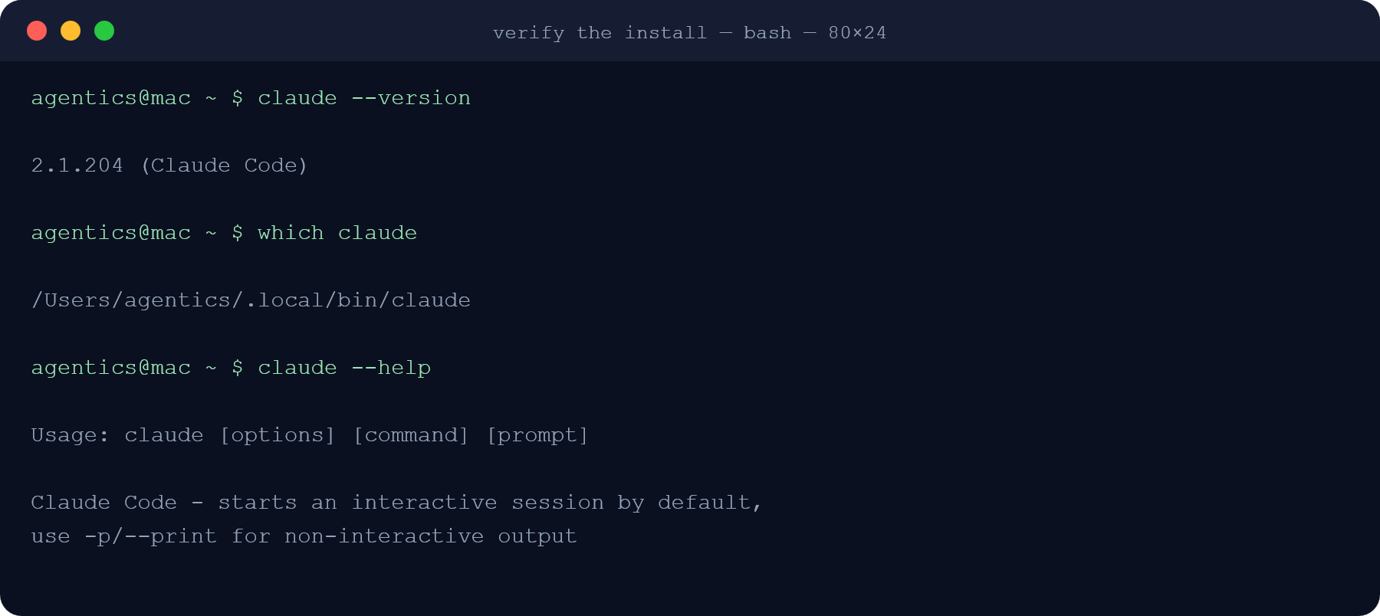
If which claude prints nothing, the install worked but your shell can't find it — reopen the terminal, or add the install directory to your PATH.
Start it. Open a terminal, cd into a project you already have on your machine, and run:
claude
Keep this quick-start block handy during the workshop:
# move into a project you already understand
cd path/to/your-project
# start the primary course tool
claude
# first orientation prompt to paste into the agent
what does this project do?
Log in. The first run walks you through signing in.
Say something. When it's ready, ask it a plain question:
what does this project do?
It reads the project and answers from the code. That's a real agent session.
Using something else? Codex CLI: install from OpenAI's developer site, run codex. Gemini CLI: install it, run gemini. Coco: use your organization's approved setup path. The habit is the same: start in the repo, sign in, ask it to orient on code you know.
For the full translation table, keep CLI variants open while you work.

Your exercise
Point the tool at a repo you know, not an empty folder. No repo yet? A class app, a portfolio project, or a sample CLI with fewer than ten files will do.
Ask it two things:
- What does this project do?
- Where would I add a new [something small. A route, a command, a config option]?
Use this starter if you want the low-friction path:
What does this project do?
Then answer this: where would I add a small route, command, or config option?
Read the repo first. If you are unsure, say what you checked and what you still need.
Read the answers like a reviewer. You know this code. Did it get it right?
You're done when the tool is installed, you're logged in, and you've had that two-question back-and-forth on a real repo.
Practice proof: paste the tool name, repo name, and the two answers into a NOTES.md file. Mark anything the agent got wrong.
Build on it: build a repo-orient shell script that drops you into the agent inside any repo you cd to and pastes the "what does this project do?" prompt for you, so orienting on unfamiliar code is one command.

Why this matters
You'll live in this tool for the rest of the course. Get it working today, and watch it understand code you know, and every lesson after this starts from "this works" instead of "wait, is it broken?"

Lesson 2.3 · Your first session
Where this gets you: you'll take one small task end-to-end with an agent and understand the loop it runs (the thing every later lesson builds on).

The idea
An agent session is a loop, not one prompt and one answer.
You give it a goal. Then it circles: gather the files it needs, act by making an edit or running a command, check what happened by running the test or reading the error. Then it loops — gather, act, check — until the goal is met or it gets stuck and asks you.
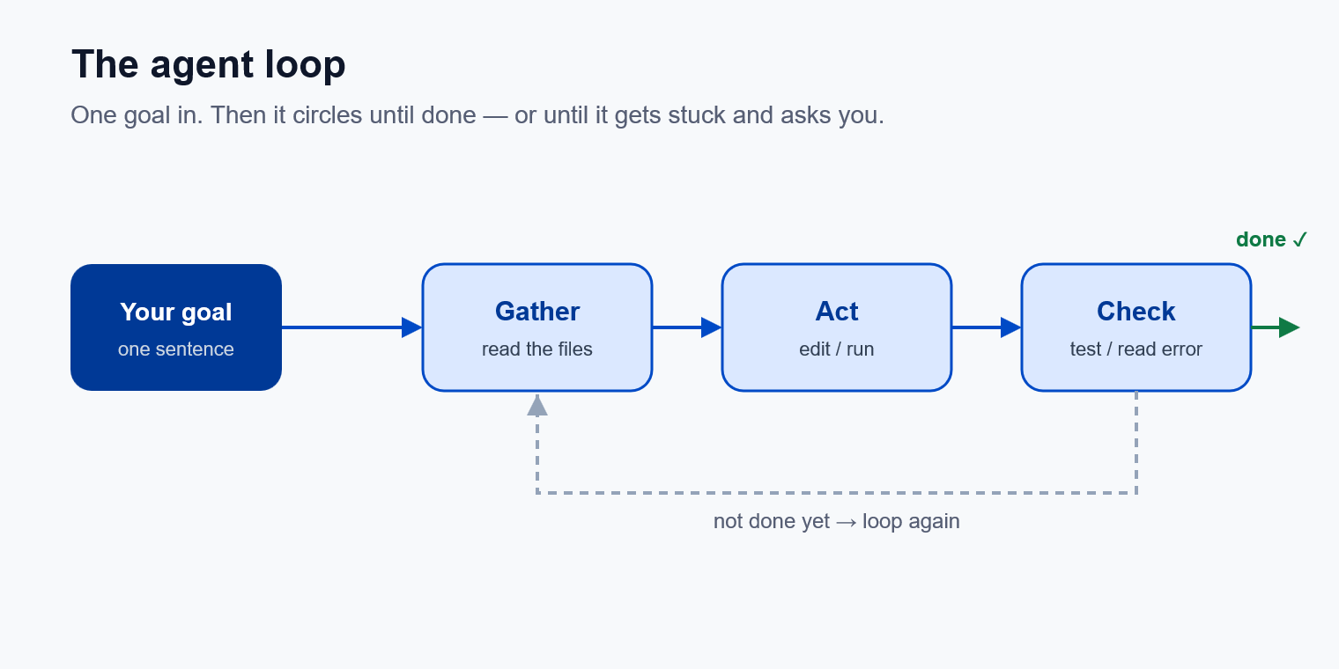
You watch this happen in your terminal. It tells you what it read, what it will change, and what each command printed. Read that stream — it's where you catch wrong turns early.
Here's a real one, captured from an actual session. A four-line app.py ends with a bare greet("world"), so the greeting fires on import, not just when you run the file. Nobody asked for that bug to be found — the prompt was only "find one tiny improvement." The agent read the file (gather), ran it to see the current behaviour (check), guarded the call behind __main__ (act), then ran it again both ways to prove nothing broke (check):
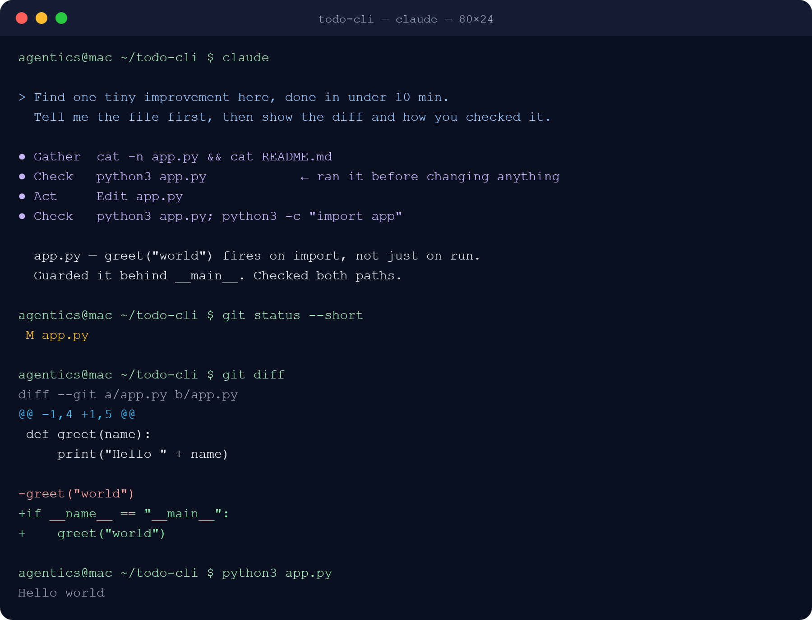
Two things worth noticing. The agent ran the program before editing it — that's how it knew what "unchanged behaviour" meant. And the last three commands are yours: git status --short, git diff, then run it. That's you doing the check by hand, on top of the agent's.
When it heads the wrong way, hit Esc and correct it in plain words: "the config lives in settings/, not the root" or "skip tests for now, just make the change." It picks up from there with the new information.
Small asks beat one giant prompt. "Rename this function and update its callers" gives the agent a clear target. "Refactor the whole module" gives it room to wander. Scope down; ask for the next piece after you've reviewed the last one.

Do it
Open a repo you know and start your tool:
claude
Codex CLI users run codex. Gemini CLI users run gemini. Coco users open the approved workspace for the repo or data product.
Pick something genuinely small. A typo in a string, a renamed variable, one new log line.
Give it the goal in one sentence. Then watch. Don't touch anything. Read each step as it scrolls by. What file it opened, what it changed, what it ran.
Here is a safe first-session prompt:
Find one tiny improvement in this repo that can be completed in under ten minutes.
Before editing, tell me the exact file you plan to touch and why.
After editing, show me the diff and the command or manual check you used.
If it heads somewhere wrong, hit Esc and type what you meant. Let it finish.

Your exercise
In a repo you know well, give the agent one small, real task. Something you could have done yourself in a few minutes.
Watch the whole loop run without jumping in unless it goes wrong. When it's done, read every change it made. Open the diff, read each line, make sure you'd have signed off on it yourself.
Use these commands after the agent finishes:
# see every changed file
git status --short
# read the actual patch before accepting it
git diff
# run the smallest relevant check for your project
npm test
# or
pytest
# or
make test
You're done when you've taken one small task end-to-end and can describe the gather → act → check loop in your own words.
Practice proof: save the prompt you gave, the diff it produced, and the command or manual check you used to verify it. Fresh graduates should ask a human or teammate to review this first diff if possible.
Build on it: build a small script that reads a saved session transcript and prints each step tagged gather, act, or check, so wrong turns stand out.

Why this matters
Everything later in this course is this loop, scaled up. Bigger tasks, more of them, several at once. If the loop is clear to you on something small, the hard stuff later is just more of a thing you already understand. If it's a blur now, it stays a blur.

Lesson 2.4 · Staying in control
Where this gets you: you'll know the permission modes, how to read a diff before you accept it, and how to redirect the agent when it's wrong.

The idea
By default, the agent asks before it edits a file or runs a command. That pause is where you stay the reviewer.
There are four permission modes, and you cycle through them with Shift+Tab:
- Default. Asks every time, before every edit and every command. Slower, and exactly right while you're learning. Start here.
- Accept-edits. Auto-accepts file edits, so the agent keeps moving. Faster, but now you're reviewing after the fact instead of before.
- Plan mode. Read-only. The agent looks but changes nothing; it proposes a plan and waits for your go-ahead. Lesson 3.2 covers it properly. For now, just know it exists.
- Bypass. Skips every prompt. The agent edits and runs whatever it wants. Only for a throwaway or isolated environment: a scratch container, a repo you'd be fine deleting. Anywhere real, bypass means a command you'd never have approved runs before you see it. Don't.
No mode removes your job. In Default you review before. In Accept-edits you review after. In bypass, bring your own guardrails.
Reading a diff is the skill underneath all of this. Don't skim the green. Read the removed lines and the added lines together. What's actually different? Does it touch only what you asked? Any file you didn't expect?
Why the removed lines matter. Someone asks the agent to strip unused imports, and it's a boring task, so they're in Accept-edits. It deletes twenty imports across the repo. Nineteen were dead. The twentieth was import logging_config at the top of main.py — nothing referenced it by name, but importing it was what installed the log handlers. Nothing failed. Tests passed. It shipped. Two weeks later there's an outage and the logs for it are empty. The added lines said nothing; the removed line was the whole story.
If a line looks wrong, reject it and say why: "that breaks the null case. Handle empty input too." The agent takes the correction and tries again. Rejecting isn't failure; it's the loop working.

Do it
In a repo you know, start claude in Default mode. Give it a small task. At each prompt, actually read the diff before you approve. Out loud if it helps.
Then press Shift+Tab to reach Accept-edits and give it a similar task. Notice it doesn't stop. You're reading changes as they land instead of before.

Your exercise
Do two small tasks in a repo you know. The first in Default mode: approve each step and read every diff before you accept it. The second, something similar, in Accept-edits: let the edits land, then review them together at the end.
You're done when you've used at least two modes and can say plainly when you'd pick each one.
Build on it: write a review-diff shell script that runs git diff and prints only the removed lines, grouped by file, so you can check what an Accept-edits run quietly deleted before you commit.

Why this matters
As the tasks get bigger, the temptation is to stop reading and just accept. The modes exist so you can move faster on purpose. Not so you can stop reviewing. Learn the trade-off now and you'll speed up where it's safe and slow down where it counts — instead of finding out which was which after something breaks.

