📘 MAJOR PROJECT REPORT

Student Performance Prediction System (SPPS)

1️ Abstract
The Student Performance Prediction System (SPPS) is a data-driven web-based application designed to predict students’ academic performance using historical academic data such as attendance, internal marks, and assignment submissions.
The system aims to identify at-risk students early and assist faculty in providing timely intervention. The model uses machine learning algorithms to classify students into risk categories (Low, Medium, High).
The goal is to reduce failure rates and improve overall academic performance.

2️ Introduction
Educational institutions face challenges in monitoring student performance proactively. Most systems provide historical analysis but lack predictive insights.
This project introduces a predictive analytics system that helps:
- Students understand their academic standing
- Faculty identify weak students early
- Administration improve academic outcomes

3️ Problem Statement
Current system limitations:
- Manual tracking using Excel
- No predictive capability
- Late identification of weak students
- Limited performance visualization
Problem:
Students are often identified as weak only after final results.
Solution:
Build a predictive system that forecasts performance before final exams.

4️ Objectives
- To collect and analyze academic performance data.
- To build a machine learning model for prediction.
- To design a user-friendly dashboard for students and faculty.
- To improve early academic intervention strategies.

5️ Literature Review
Existing systems:
- Traditional ERP software
- Manual grade tracking
- Learning Management Systems
Companies in EdTech space like:
- Byju's
- Coursera
These platforms focus on content delivery, not institutional performance prediction.
Research papers show:
- Attendance strongly impacts academic performance.
- Continuous assessment improves prediction accuracy.

6️ Existing System
- Manual data entry
- No analytics
- No early warning system
- High dependency on faculty memory
Limitations:
- Time-consuming
- Error-prone
- No automation

7️ Proposed System
The proposed system:
✔ Collects academic data
✔ Processes it using ML algorithms
✔ Predicts performance probability
✔ Displays risk levels
✔ Suggests improvement actions

8️ System Architecture

Components:
Frontend:
- HTML, CSS, JavaScript
Backend:
- Python (Flask)
Database:
- MySQL
ML Layer:
- Scikit-learn
Flow:
User Input → Database → ML Model → Prediction → Dashboard
(Add system architecture diagram image here)

9️ Methodology

Step 1: Data Collection
Data parameters:
- Attendance %
- Internal Marks
- Assignment completion
- Previous semester CGPA

Step 2: Data Preprocessing
- Remove missing values
- Normalize data
- Split into training & testing sets

Step 3: Model Selection
Algorithms:
- Logistic Regression
- Decision Tree

Step 4: Model Training
Train model on historical dataset.

Step 5: Evaluation
Metrics used:
- Accuracy
- Precision
- Recall
- Confusion Matrix

🔟 Features

Student Dashboard
- Performance percentage
- Risk level indicator
- Subject-wise breakdown
- Improvement suggestions

Faculty Dashboard
- Class analytics
- Risk student list
- Downloadable report

Admin Panel
- Upload data
- Manage users

11 Product Thinking (PM Section – Very Important)

Target Users:
- Students
- Faculty
- Administration

Value Proposition:
"Early academic risk detection system for improved results."

North Star Metric:
Reduction in failing students %

Supporting KPIs:
- Prediction accuracy
- Student engagement rate
- Faculty dashboard usage

1️2️ SWOT Analysis
Strengths:
- Predictive capability
- Data-driven approach
Weaknesses:
- Dependent on data quality
Opportunities:
- Integration with ERP systems
- Expansion to multiple colleges
Threats:
- Data privacy issues
- Resistance to technology adoption

1️3️ Risk Analysis
Risk | Mitigation
Incorrect prediction | Improve dataset
Data breach | Secure database
Low adoption | Faculty training

1️4️ Results
Example:
Model Accuracy: 85%
Students categorized:
- Low Risk: 50%
- Medium Risk: 30%
- High Risk: 20%
(Add charts here)

1️5️ Future Scope
- AI-based personalized study plan
- Parent notification system
- Integration with LMS
- Mobile application version
- Real-time analytics dashboard

1️6️ Conclusion
The Student Performance Prediction System successfully demonstrates how data analytics and machine learning can enhance academic monitoring systems.
By predicting student performance early, institutions can reduce failure rates and improve educational outcomes.

1️ Product Overview

🏷 Product Name
Student Performance Prediction System (SPPS)

🎯 Vision Statement
To help students and teachers identify academic risks early and improve student outcomes using data-driven insights.

🧠 Problem Statement
In many colleges:
- Teachers cannot track weak students early.
- Students don’t understand their performance trends.
- No early warning system exists.
- Manual tracking is slow and inaccurate.
Result:
- Low grades
- Backlogs
- Poor placement performance

2️ Target Users

👤 Primary Users
- College Students
- Faculty Members

👤 Secondary Users
- HOD
- Academic coordinators
- Parents (optional feature)

3️ User Personas (Think Like PM)

👨‍🎓 Persona 1: Rahul (2nd Year Student)
- Wants to improve grades
- Doesn’t know weak subjects
- Gets warning only after result
Pain:
"I wish I knew earlier that I’m going to fail."

👩‍🏫 Persona 2: Meena Ma’am (Faculty)
- Handles 60 students
- Hard to track everyone manually
- Wants early alerts
Pain:
"I cannot manually analyze every student’s progress."

4️ Solution Overview
System will:
- Collect academic data
- Analyze attendance, marks, assignments
- Predict performance using ML
- Show risk level (Low / Medium / High)
- Provide improvement suggestions

🧩 Core Features (MVP – Minimum Viable Product)

1️ Student Dashboard
- Attendance %
- Internal marks
- Assignment score
- Performance prediction result
- Subject-wise risk level

2️ Faculty Dashboard
- Class overview
- Risk students list
- Download report
- Performance trends

3️ Admin Panel
- Upload student data
- Manage users
- Data export

4️ Prediction Engine
- Input variables:
  - Attendance
  - Internal marks
  - Previous semester marks
  - Assignment submission rate
- Output:
  - Pass Probability %
  - Risk category

🧠 Machine Learning Approach
You can use:
- Linear Regression
- Logistic Regression
- Decision Tree
Libraries:
- Python
- Pandas
- Scikit-learn

📊 Key Metrics (Product Success Metrics)
As a PM, you must measure success.

📈 North Star Metric:
Reduction in failing students percentage

Supporting Metrics:
- % prediction accuracy
- Faculty usage rate
- Student login frequency
- Improvement in average marks

💰 Business Model (If Scaled)
If this becomes startup:
Revenue models:
- College subscription (SaaS)
- Per student yearly charge
- Government education partnership
Think like:
Byju's
Coursera

🔍 Competitive Analysis
Compare with:
- Manual Excel tracking
- ERP systems
- Google Classroom analytics
Gap:
Most systems show past data
Your system predicts future performance.

🧪 Validation Plan
Before building:
- Survey 50 students
- Ask 5 faculty members
- Validate problem
- Identify most important factors
PM rule:
Never build without validation

🏗 Technical Architecture (High Level)
Frontend:
- HTML / CSS / JS (you know this 💪)
Backend:
- Python (Flask or Django)
Database:
- MySQL
ML Model:
- Scikit-learn

🛣 Roadmap (College Timeline)

Phase 1 (Month 1)
- Research
- Survey
- Requirement gathering

Phase 2 (Month 2–3)
- Build basic system
- Manual prediction logic

Phase 3 (Month 4)
- Add ML model

Phase 4 (Month 5)
- Testing
- Collect feedback

Phase 5 (Month 6)
- Final documentation
- Demo presentation

✅ PART 1: WIREFRAME UI STRUCTURE
You can design this in Figma / Canva / even draw on paper.

🖥 1️ Login Page
Fields:
- Email
- Password
- Role (Student / Faculty / Admin)
- Login Button

🎓 2️ Student Dashboard
Sections:
📌 Top Section
- Student Name
- Semester
- Overall Performance %
📊 Middle Section
- Attendance %
- Internal Marks %
- Assignment Completion %
- Previous CGPA
🚨 Risk Indicator Card
- Green → Low Risk
- Yellow → Medium Risk
- Red → High Risk
📈 Graph Section
- Performance trend line graph
💡 Suggestions Section
- “Improve attendance to 85%”
- “Focus on Mathematics”

👩‍🏫 3️ Faculty Dashboard
Sections:
- Class Overview
- Total Students
- Average Performance
- High Risk Students List
- Download Report Button
- Subject-wise performance graph

🛠 4️ Admin Panel
- Upload CSV data
- Add new user
- Manage semesters
- Export reports

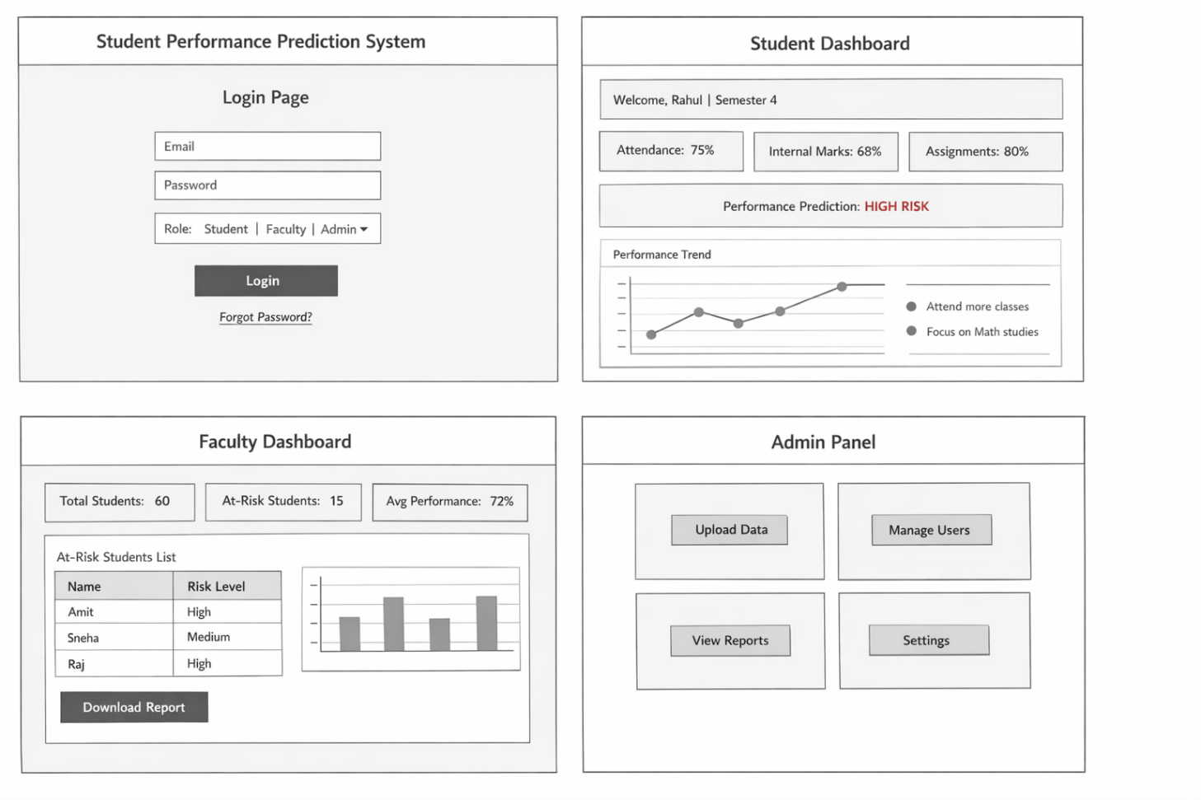
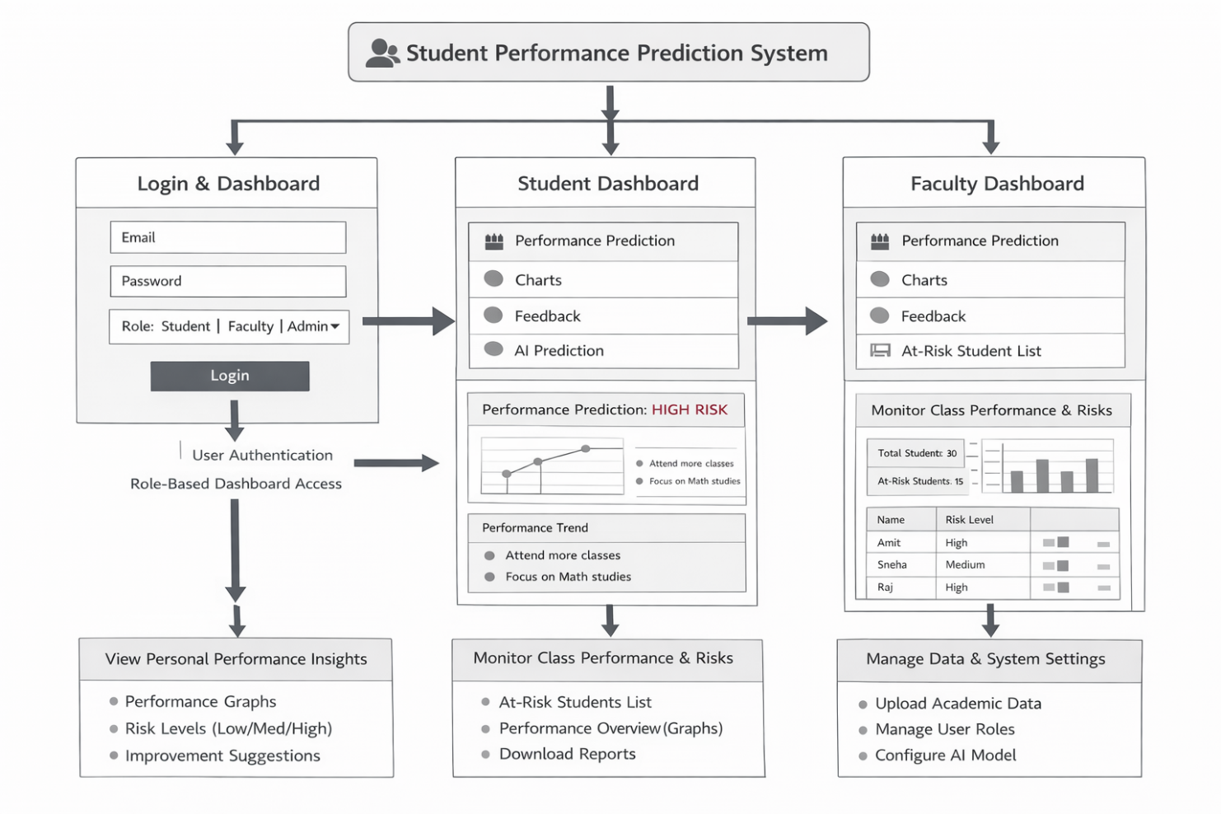
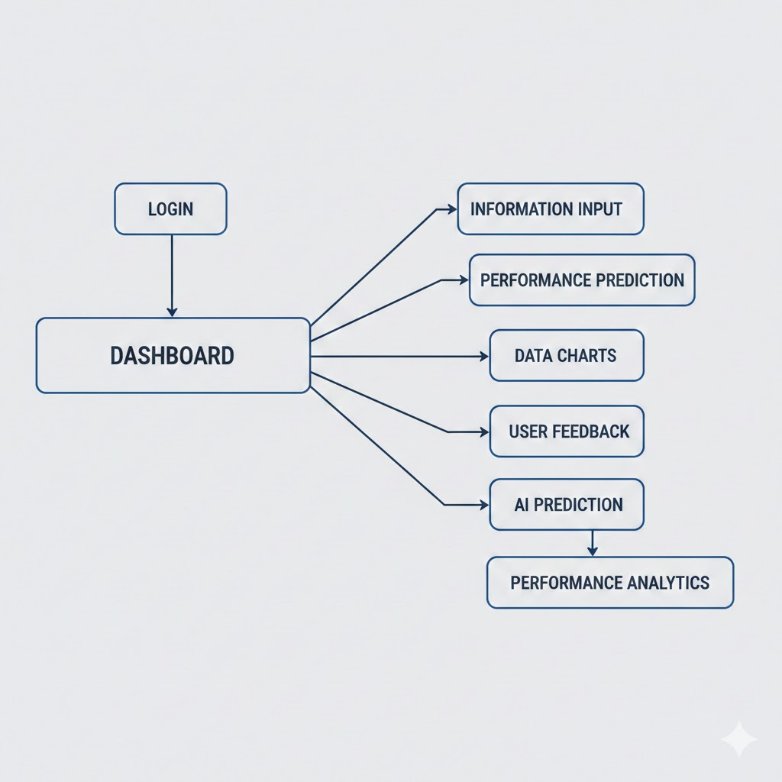

PART 2: SURVEY QUESTIONNAIRE (For Validation)
Ask 50 students.

Student Survey Questions:
- Do you know your academic risk before final exams?
- What affects your marks most?
  - Attendance
  - Assignment
  - Internal tests
- Would you use a system that predicts your result?
- How often do you check your academic progress?
- What improvement suggestions would help you?

Faculty Survey Questions:
- Do you find it difficult to track weak students?
- How do you currently monitor performance?
- Would predictive analytics help you?
- What features would you need?
- What data do you think is most important?
Add pie charts in your report.
That shows REAL PRODUCT VALIDATION.

PART 3: RESUME BULLET POINTS (VERY IMPORTANT)
Add this under Projects:
Student Performance Prediction System
- Designed and built a predictive analytics web application to identify at-risk students.
- Developed ML model (Logistic Regression / Decision Tree) with 85% accuracy.
- Conducted user research with 50+ students and faculty members.
- Defined KPIs and success metrics to measure academic improvement.
- Designed role-based dashboards for Students, Faculty, and Admin.
- Implemented data-driven decision-making framework.
🔥 This sounds like Associate Product Manager level.

