PES UNIVERSITY, BANGALORE
Department of Computer Science and Engineering | UE24CS341A Software Engineering | Jackfruit Mini-Project
Software Architecture and Design Document
Web-Based ML Model Evaluator (WBMME)
Part B: Front matter, Introduction, Goals and Stakeholders, and Design (Sections 1, 2, 3.1, 3.2, 4 and 5)
Project | Web-Based ML Model Evaluator
Course | UE24CS341A Software Engineering, B.Tech CSE, V Semester
Repository | SE_498_515_534_911
Document | Software Architecture Document (SAD), Part B (Design)
Version / Status | 0.1 / Draft for team review
Author (Part B) | Member 4
Part A (Sections 3.3 to 3.9) | Member 3 (merged without change)
Date | 12-10-2026
Related documents | SRS (Members 1 and 2), Test Plan (Members 1 to 4), RTM

Revision History
Version | Date | Author | Change summary | Approval
0.1 | 12-10-2026 | Member 4 | Initial draft of Part B: cover, Sections 1, 2, 3.1, 3.2, 4.1 to 4.6 and Appendices | Pending team review
0.2 | Planned | Members 3 and 4 | Merge Part A (3.3 to 3.9); replace provisional MLE-* IDs with final SRS IDs | Planned

Approvals
Role | Name | Signature / Date
Course Coordinator
Faculty guide
Team representative

Contents
1. Introduction
2. Document Overview
3. Architecture (3.1 Goals and Constraints, 3.2 Stakeholders; 3.3 to 3.9 in Part A)
4. Design (4.1 Design Overview, 4.2 Sequence Diagrams, 4.3 API Design, 4.4 Error Handling, Logging and Monitoring, 4.5 UX Design, 4.6 Open Issues)
5. Appendices (5.1 Glossary, 5.2 References, 5.3 Tools, A: Design reference index, B: Repository layout)

1. Introduction

1.1 Purpose
This Software Architecture and Design Document (SAD) describes how the Web-Based ML Model Evaluator (WBMME) is structured and how its parts are designed. It turns the requirements in the SRS into modules, data structures, interactions and interfaces that the team can implement, the testers can verify and the evaluators can review.
It covers the two design deliverables required by the Jackfruit guidelines: the high-level architecture document and the software design document (UML, API definition, modular design and division of work within the team).

1.2 Scope
This document covers WBMME v1.0: user registration, login and role-based access; CSV dataset upload, profiling and preparation; model selection, configuration and training; evaluation metrics and charts; experiment history, comparison and report export; administration; and logging.
It does not cover deep-learning models, uploading of pre-trained model files, real-time prediction serving, mobile layouts or production-scale deployment. As in the SRS, the application is intended for educational and experimental evaluation of models, not for certifying production suitability.

1.3 Definitions and acronyms
Terms defined in SRS Section 1.4 are used with the same meaning. Additional terms used in this document:
Term | Meaning
Run | One recorded execution of a chosen model, parameters, preprocessing and split on a dataset, with its status and metrics.
Artifact | A trained model file written by the system (joblib) and stored in the owner's private directory.
Pipeline | The ordered stages Upload, Validate, Profile, Prepare, Split, Train, Evaluate and Record.
Service | A Python class holding business logic with no dependency on HTTP; called by controllers.
Controller | A Django view that validates a request, checks authorisation, calls services and returns JSON.
Model registry | The catalogue that maps a model name to its scikit-learn class and allowed hyperparameters.
MVT | Model-View-Template, the Django variant of the MVC pattern.
RBAC | Role-based access control.
CSRF | Cross-Site Request Forgery.
DS-ID | Design reference ID (for example DS-Data-01) used in SAD Section 3.8 and Appendix A to trace a requirement to its design.
MLE-F / MLE-NF / MLE-SR | Provisional functional, non-functional and security requirement IDs (see Section 2.4).

1.4 References
- WBMME Software Requirements Specification (SRS), v0.1, Members 1 and 2.
- WBMME SAD Part A, Sections 3.3 to 3.9 (component diagram, architecture pattern, technology stack, risks, traceability, security architecture), Member 3.
- WBMME Software Test Plan, v0.1, Members 1 to 4.
- Jackfruit SE Mini-Project Guidelines 2026, PES University (UE24CS341A).
- IEEE Std 1016-2009, Systems Design: Software Design Descriptions.
- OWASP Top 10 and OWASP Application Security Verification Standard.
- Django 5 and scikit-learn documentation (framework and library behaviour).

2. Document Overview

2.1 Organisation
Section | Content | Owner | Status
Cover, 1, 2 | Front matter, purpose, scope, definitions, how to read the document | Member 4 | This draft
3.1, 3.2 | Architecture goals and constraints; stakeholders | Member 4 | This draft
3.3 to 3.9 | Component diagram, component descriptions, pattern, technology stack, risks, traceability, security architecture | Member 3 | Part A, separate file
4.1 | Design overview: modules, pipeline, data model, key decisions | Member 4 | This draft
4.2 | Sequence diagrams: login, upload, train and view metrics | Member 4 | This draft
4.3 | API design: conventions, endpoint list, detailed contracts | Member 4 | This draft
4.4 | Error handling, logging and monitoring | Member 4 | This draft
4.5 | UX design: screen map, inventory, wireframes | Member 4 | This draft
4.6, 5 | Open issues and next steps; appendices (glossary, references, tools) | Member 4 | This draft

2.2 Related Documents
Software Requirements Specification (SRS), Software Test Plan (STP) and the Requirements Traceability Matrix (RTM). See Section 2.5 for how they relate to this document.

2.3 How to read this document
Reader | Start with
Developer | Section 3.4 (components), then 4.1 (modules and pipeline), 4.3 (API contracts) and 4.4 (errors and logging).
Tester | Appendix A (requirement to design to test traceability), 4.3 (expected responses) and 4.4 (error catalogue).
Reviewer / faculty | Section 3.1 (goals and constraints), 3.5 (pattern rationale), 4.2 (sequences) and 4.6 (open issues).
Designer / UX | Section 4.5 and the screens listed there.

2.4 Conventions
- Requirement IDs. MLE-F-nnn (functional), MLE-NF-nnn (non-functional) and MLE-SR-nnn (security) are provisional, taken from SAD Section 3.8 and the Test Plan. They will be replaced with the final SRS IDs from Members 1 and 2 in one pass, using Appendix A.
- Design reference IDs. DS-Area-nn, as defined in SAD Section 3.8. Appendix A lists where each is designed in this document.
- Figures. Part B figures are numbered B1 to B6 so they do not clash with Part A figures when the documents are merged.
- Proposed values. Limits, quotas and defaults marked as proposed are design choices awaiting team confirmation (see Section 4.6).
- Notation. Interfaces are JSON over HTTP. Times are ISO 8601 in UTC. Diagrams follow UML sequence and entity-relationship notation.

2.5 Relationship to other documents
The SRS states what the system must do, this SAD states how it is built, and the Test Plan states how each requirement is verified. The Requirements Traceability Matrix (RTM) links the three through requirement IDs, design references and test case IDs. Appendix A extends the RTM with the design column.

3. Architecture
Sections 3.3 to 3.9 (component diagram, component descriptions, architecture pattern and rationale, technology stack, risks, traceability to requirements, security architecture) are written by Member 3 in Part A and are inserted between 3.2 and Section 4 when the documents are merged.

3.1 Goals and Constraints

3.1.1 Architecture goals
ID | Goal | How the architecture meets it | Requirements
G1 | Correct, reproducible evaluation | Preprocessing is fitted on the training split only; every run stores its dataset, model, parameters, preprocessing, split and random seed; train and test metrics are both reported. | MLE-F-006 to F-013
G2 | Confidentiality and integrity of user data | Ownership check on every query and file path; validated uploads; only system-created artifacts are loaded; audit log of sensitive actions. | MLE-SR-001 to SR-005
G3 | Responsive under load | Training runs as a background job with status polling; upload and row limits; stateless API; paginated lists. | MLE-NF-001 to NF-003
G4 | Modular and extensible | Layered design with service classes behind controllers; a model registry so a new algorithm is added by one registry entry; pipeline stages with a common interface. | Guidelines
G5 | Testable | Services have no HTTP dependency, so unit tests need no browser; layers can be stubbed; coverage target 70% or higher for service modules. | Test Plan 5, 14
G6 | Easy for a first-time user | Guided linear workflow, safe defaults, plain-language errors, visible progress. | MLE-NF-005
G7 | Portable | Docker image with pinned dependencies; no OS-specific code. | MLE-NF-004
G8 | Deliverable in two sprints | Single deployable unit; minimal end-to-end flow first; explainability and PDF export deferrable. | Test Plan 7

3.1.2 Constraints
ID | Constraint | Source | Design impact
C1 | Agile process only; backlog and user stories in Jira or GitHub | Guidelines | Modules map to Jira epics (WBMME-4 to WBMME-11); work is delivered in two sprints.
C2 | CI/CD, code review and security validation are mandatory | Guidelines | GitHub Actions runs tests and linting on every pull request; pull-request reviews before merge.
C3 | Every member implements a full functionality; commits are checked | Guidelines | Modules in 4.1.2 are separable so each member can own one end to end.
C4 | Python 3.11, Django 5, pandas, scikit-learn, joblib, SQLite or PostgreSQL | SRS 2.4, SAD 3.6 | Technology choices are fixed; no other backend language.
C5 | The browser never touches the database or file store directly | SRS 2.5 | All access goes through the API layer and services.
C6 | Only CSV input and implemented algorithms are supported; proposed limits 10 MB and 50,000 rows | SRS 2.5, Test Plan | Validation rules in 4.3.3; model registry in 4.3.4.
C7 | Datasets and artifacts are stored outside the web root, per user | SRS 2.4, 2.5 | File store layout in 4.1.4 and Appendix B.
C8 | Two sprints, finishing by 30-Oct-2026 | Test Plan 7 | Optional features (SHAP, Celery, PDF export) are deferrable.
C9 | Desktop browsers only | SRS 2.4 | No responsive mobile layouts are designed.
C10 | Single deployable unit, no microservices | SAD 3.5 | Services are Python modules in one Django project.

3.1.3 Main trade-offs
- Threads versus Celery for training. Threads need no extra infrastructure and suit the team size, but jobs are lost on restart. The design persists run status in the database and marks interrupted runs FAILED at start-up. Celery remains an upgrade path behind the same JobRunner interface.
- Polling versus WebSockets. Polling /api/evaluate/{run_id} every 2 seconds is simpler to build and test; the delay is acceptable for jobs of up to a minute.
- Preprocessing inside the training request. Missing-value, encoding and split options travel with /api/train rather than being saved as a separate prepared dataset. This avoids data leakage and keeps one run reproducible from one record.

3.2 Stakeholders
Stakeholder | Description | Main concerns | Addressed by
Data Scientist | Experienced ML user who uploads datasets, trains and compares models. | Choice of algorithms and parameters, trustworthy metrics, run comparison, export. | 4.1.3 pipeline, 4.3.4 model catalogue, 4.3.6 runs and compare.
Student | Learner using the tool for coursework and experiments. | Clear guidance, understandable errors, safe defaults. | 4.5 UX design, 4.4 error messages.
Administrator | Operates the platform, manages users and datasets, reviews logs. | Access control, audit trail, system health, no exposure of user data. | 3.9 (Part A), 4.3.7 admin API, 4.4 logging and monitoring.
Development team (Members 1 to 4) | Builds, tests and documents the system. | Clear module boundaries, stable APIs, parallel work without merge conflicts. | 4.1.2 modules, 4.3 API contracts, Appendix B.
Repository owner / reviewer | Reviews pull requests and protects the main branch. | Quality gates, traceability from requirement to code to test. | Constraint C2, Appendix A.
Course faculty and evaluators | Assess documents, code understanding and the demo. | Complete SDLC artefacts, justified decisions, working demo. | Sections 2, 3.1, 4.2 and 4.6.

4. Design

4.1 Design Overview

4.1.1 Design approach
WBMME follows the layered architecture chosen in SAD Section 3.5: a Presentation layer (Django templates and JavaScript), an Application/API layer (controllers), an ML pipeline and domain layer (services) and a Data layer (database and file store). The design rules below keep the layers apart.
- Thin controllers. A controller validates input, checks the session and role, calls one service method and shapes the JSON response. It contains no ML or file logic.
- Services own the logic. Services are plain Python classes with explicit inputs and outputs, so they can be unit-tested without HTTP.
- Owner-scoped data access. Every query goes through a manager that filters by the requesting user's ID. Admins use a separate, narrower interface.
- Model registry (strategy pattern). The registry maps a model name to a scikit-learn class, its default parameters and the allowed range of each hyperparameter. Training code never hard-codes an algorithm.
- Pipeline stages. Each stage takes a context object and returns an updated one, so stages can be tested alone or replaced.

4.1.2 Module structure
Module | Responsibility | Key classes and functions | Component (3.4)
accounts | Users, roles, registration, login, logout, login throttling | User (role field), AuthService, role_required decorator, PasswordPolicy | Auth and Access Control
datasets | Upload validation, storage, profiling, missing values, encoding, split | Dataset, UploadValidator, DatasetProfiler, Preprocessor, Splitter, DatasetService | Data Workspace
mlcore | Model registry, training, background jobs, artifact storage | ModelRegistry, ModelSpec, TrainingService, JobRunner, ArtifactStore | Model Selection and Training
evaluation | Metrics, confusion matrix, feature importance | MetricsCalculator, ConfusionMatrixBuilder, FeatureImportanceService | Evaluation and Explainability
experiments | Run history, comparison, report export | Run, Metric, ExperimentService, ReportExporter | Experiment Management and Reporting
audit | Audit trail, structured logging, request IDs, health check | AuditLog, audit.record(), JsonFormatter, RequestIdMiddleware, health_view | Logging, Monitoring and Audit
api | URL routing, controllers, request validators, error mapping | UploadView, TrainView, EvaluateView, RunsView, AdminView, ApiError, error_handler | API Gateway and Controllers; Input Validation
web | Templates, static JavaScript, Chart.js charts | Page templates, api.js (fetch wrapper with CSRF), charts.js, poll.js | Web UI

4.1.3 Pipeline design
The ML workflow is a pipe-and-filter pipeline. Upload and profiling run when a file arrives; the remaining stages run together inside one training job.
Stage | Input | Output | Failure handling
Validate | Uploaded file, user | Accepted file or ValidationError | Reject with 400, 413 or 415; nothing is stored.
Profile | Stored CSV | Rows, columns, types, missing counts, unique counts | Unparseable file: delete it and return 400.
Prepare | Dataset, target column, options | Cleaned feature matrix: missing values imputed (mean, median, most frequent or drop rows), categories encoded (one-hot or ordinal), optional scaling | Unknown column or unsupported option returns 400; target with missing values is rejected.
Split | Prepared data, test size, seed, stratify flag | Train and test sets | Too few rows per class for a stratified split returns 422 with the reason.
Train | Train set, model name, parameters | Fitted model and artifact path | Exception or timeout marks the run FAILED; partial artifact is deleted.
Evaluate | Fitted model, train and test sets | Metrics, confusion matrix, feature importance where supported | Metric not defined for the data (for example ROC-AUC on a single class) is omitted and noted.
Record | Configuration and results | Run and Metric rows, status COMPLETED | Database error marks the run FAILED and is logged.

Preprocessing parameters (imputation values, encoders, scaler) are fitted on the training split only and then applied to the test split, which prevents data leakage (risk R4 in SAD Section 3.7).

4.1.4 Data model
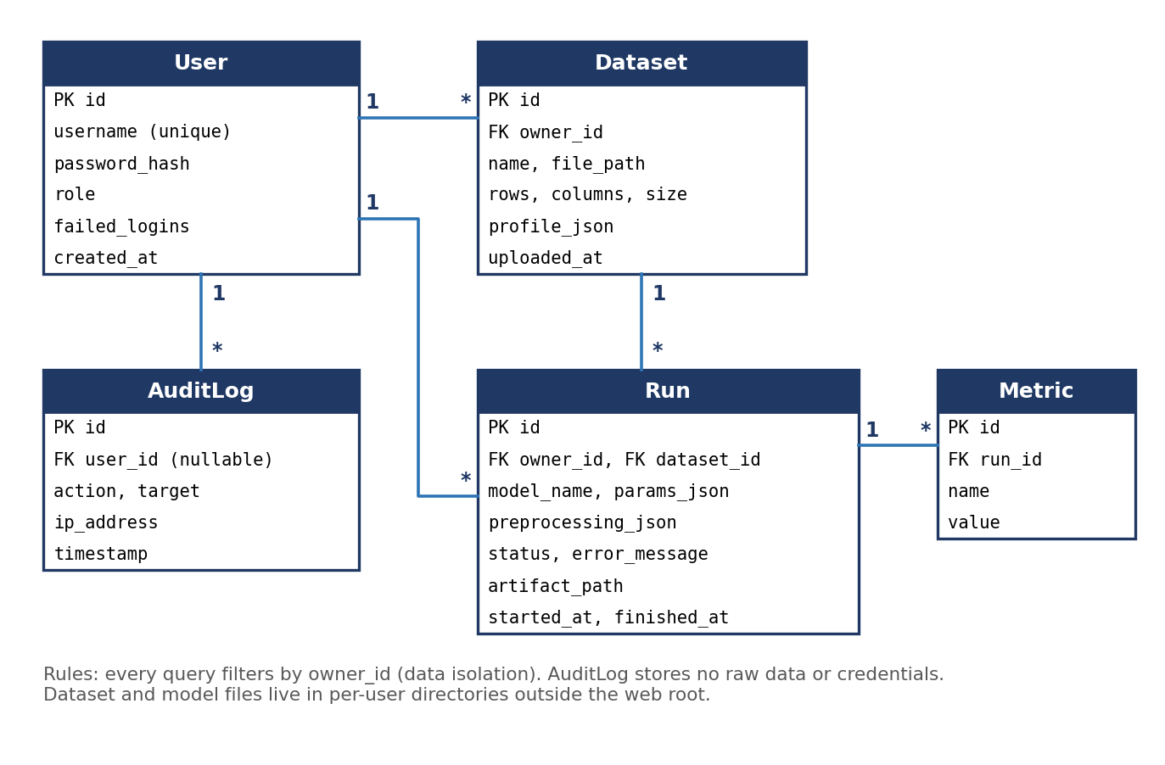
Figure B1: Entity-relationship diagram of the relational database
Run status follows a fixed life cycle: QUEUED, then RUNNING, then TRAINED, then COMPLETED. A run moves to FAILED from any state on error or timeout. Metric names carry the split they were computed on (for example test_accuracy and train_accuracy) so both are stored in one table.
Files are stored under a per-user directory outside the web root: data/{user_id}/datasets/{uuid}.csv and data/{user_id}/models/{run_id}.joblib. File names are generated by the server; the user's file name is kept only as display text.

4.1.5 Key design decisions
ID | Decision | Reason
DD1 | Training runs in a background thread; status is stored in the database | Keeps the UI responsive for long jobs and survives page reloads; no extra infrastructure.
DD2 | Single /api/train request carries model, parameters, preprocessing and split | One record reproduces one run; avoids leakage; fewer endpoints to test.
DD3 | Artifacts are loaded only from paths registered by the system for the owner | Prevents unsafe deserialisation of user-supplied files (risk R3, MLE-SR-004).
DD4 | Another user's resource returns 404, not 403 | Does not reveal that the resource exists (MLE-SR-005).
DD5 | Admins manage users and dataset records but cannot read dataset contents or train on other users' data (proposed) | Keeps confidentiality of user data (G2); to be confirmed in 4.6.
DD6 | Classification metrics only in v1.0 (accuracy, precision, recall, F1, ROC-AUC) | Matches the metrics named in the SRS; regression is deferred (see 4.6).

4.2 Sequence Diagrams
Three sequence diagrams cover the flows that carry most of the requirements: login (security), dataset upload (data handling and validation) and training with metric viewing (the core ML flow). Solid arrows are calls, dashed arrows are returns, and red arrows are error paths.

4.2.1 Login and authentication (DS-Auth-01)
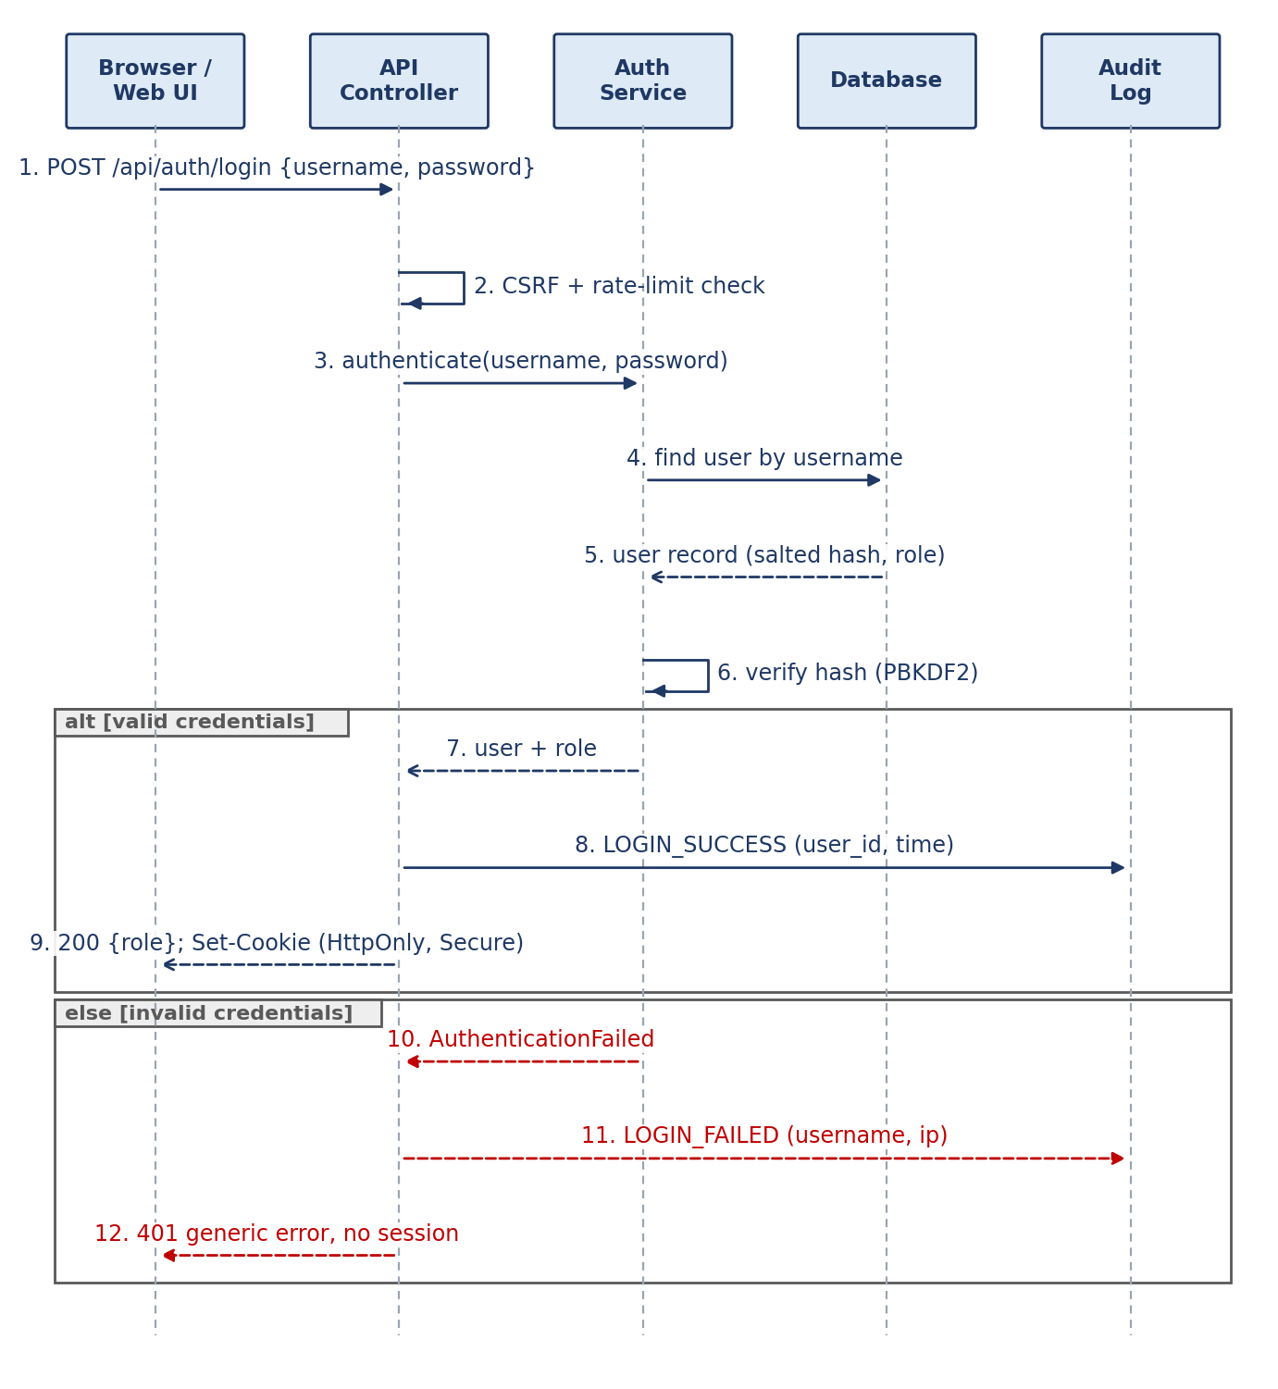
Figure B2: Sequence diagram, login and authentication
- The controller checks the CSRF token and the login rate limit before any credential check.
- AuthService loads the user and verifies the password against the stored PBKDF2 hash. Plain passwords are never stored or logged (MLE-SR-001).
- On success, the session cookie is set with HttpOnly and Secure flags and the response carries the role so the UI shows the right menu.
- On failure, the response is the same generic message whether the username or the password was wrong; repeated failures return 429. The attempt is written to the audit log.

4.2.2 Upload a dataset (DS-Data-01)
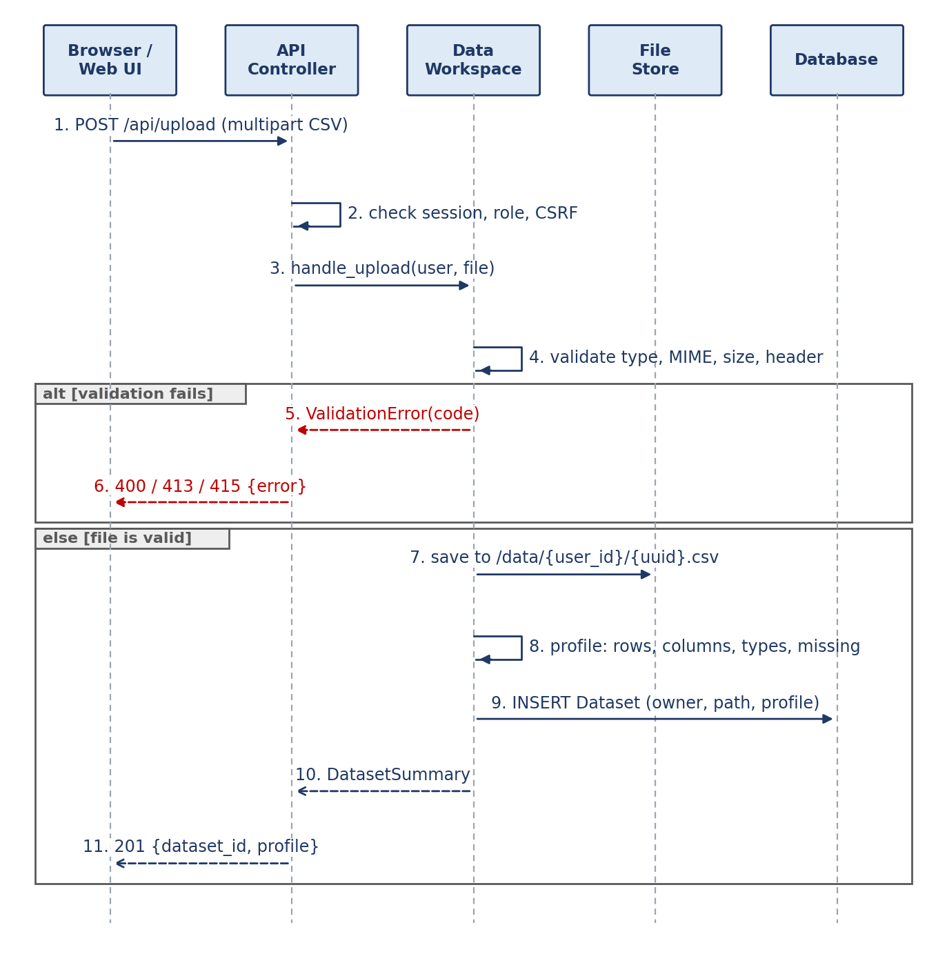
Figure B3: Sequence diagram, dataset upload and profiling
- Authentication, role and CSRF are checked before the file is read.
- UploadValidator checks extension, MIME type, size, encoding and header row before anything is saved (MLE-SR-003).
- The file is saved under a server-generated name in the owner's directory, profiled, and a Dataset row is created with the profile as JSON.
- Failure returns a specific code (400, 413 or 415) and stores nothing.

4.2.3 Train a model and view metrics (DS-Model-03, DS-Eval-01)
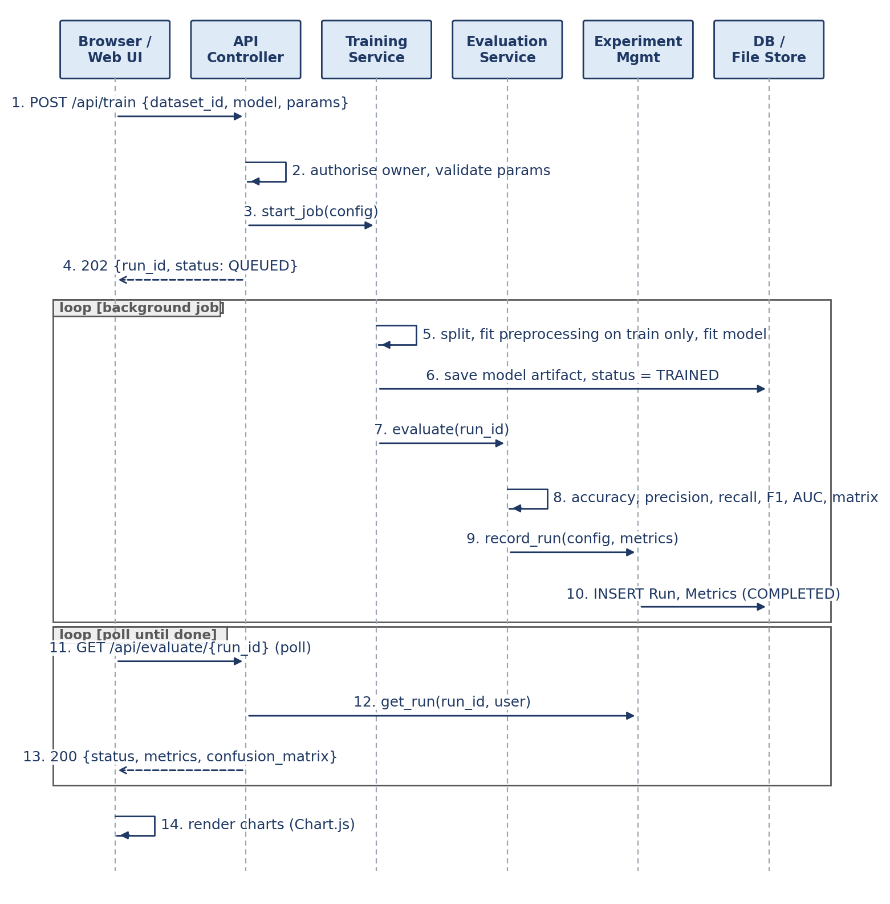
Figure B4: Sequence diagram, training, evaluation and viewing metrics
- /api/train returns 202 immediately with a run ID; the job runs in the background so the UI stays responsive (MLE-NF-002).
- The job splits the data, fits preprocessing on the training split only, trains the model and saves the artifact.
- Evaluation computes metrics on the test set (and train set for comparison) and ExperimentService records the run.
- The browser polls /api/evaluate/{run_id} until the status is COMPLETED or FAILED, then draws the charts.

4.3 API Design

4.3.1 Conventions
Topic | Convention
Base path and format | /api/, JSON in UTF-8. The upload endpoint uses multipart/form-data. Unversioned in v1.0.
Authentication | Django session cookie (HttpOnly, Secure, SameSite=Lax). Unauthenticated calls return 401.
CSRF | State-changing requests (POST, PATCH, DELETE) must send the token in the X-CSRFToken header.
Transport | HTTPS with TLS 1.2 or higher in deployment (MLE-SR-002), terminated at a reverse proxy in front of Django.
Identifiers and time | Integer IDs. Timestamps in ISO 8601 UTC, for example 2026-10-20T09:30:00Z.
Pagination | List endpoints accept page (default 1) and page_size (default 20, maximum 100).
Authorisation | Deny by default. A resource that belongs to another user returns 404.
Errors | One envelope for every error (see below) and the HTTP status codes listed in Section 4.4.2.

Error envelope used by every endpoint:
{ "error": {
"code": "VALIDATION_ERROR",
"message": "Test size must be between 0.1 and 0.5.",
"details": { "field": "split.test_size" },
"request_id": "9f3c2a1e" } }

4.3.2 Endpoint summary
Method | Path | Purpose | Roles | Requirement / DS-ID
POST | /api/auth/register | Create an account | Public | MLE-F-001 / DS-Auth-01
POST | /api/auth/login | Log in and start a session | Public | MLE-F-001, SR-001 / DS-Auth-01
POST | /api/auth/logout | End the session | Any logged-in user | MLE-F-001
POST | /api/upload | Upload a CSV dataset | DS, Student | MLE-F-003, SR-003 / DS-Data-01
GET | /api/datasets | List own datasets | DS, Student | MLE-F-004
GET | /api/datasets/{id} | Preview rows and profile | DS, Student | MLE-F-004 / DS-Data-02
DELETE | /api/datasets/{id} | Delete own dataset | DS, Student | MLE-SR-005
GET | /api/models | Model catalogue and parameter schema | DS, Student | MLE-F-007, F-008 / DS-Model-01, 02
POST | /api/train | Start a training run | DS, Student | MLE-F-005 to F-009 / DS-Data-03, 04, DS-Model-03
GET | /api/evaluate/{run_id} | Run status, metrics, confusion matrix | DS, Student | MLE-F-010 to F-012 / DS-Eval-01 to 03
GET | /api/runs | List own runs (filters) | DS, Student | MLE-F-013 / DS-Exp-01
GET | /api/runs/{id} | One run with configuration | DS, Student | MLE-F-013
GET | /api/runs/compare?ids=1,2 | Side-by-side comparison | DS, Student | MLE-F-014 / DS-Exp-02
GET | /api/runs/{id}/report?format=csv | Export a results report | DS, Student | MLE-F-015 / DS-Exp-03
DELETE | /api/runs/{id} | Delete own run and artifact | DS, Student | MLE-SR-005
GET | /api/admin/users | List users and roles | Admin | MLE-F-016 / DS-Admin-01
PATCH | /api/admin/users/{id} | Change role or disable an account | Admin | MLE-F-002, F-016
GET | /api/admin/datasets | List dataset records (metadata only) | Admin | MLE-F-016
DELETE | /api/admin/datasets/{id} | Remove a dataset record | Admin | MLE-F-016
GET | /api/health | Health check (no data) | Public | Section 4.4.5

DS = Data Scientist. In v1.0 the Data Scientist and Student roles have the same API access to their own data; they differ in the UI guidance shown (see open issue OI-6). Preview data in GET /api/datasets/{id} is limited to the first 20 rows.

4.3.3 POST /api/upload
Uploads one CSV file and returns its profile. Request is multipart/form-data with the fields file (required) and name (optional display name).
Validation rule (proposed) | Detail
Extension and type | .csv only; MIME type text/csv, application/vnd.ms-excel or text/plain; file content must parse as CSV.
Size | At most 10 MB (MLE-NF-001); empty files rejected.
Shape | Header row required; at least 2 columns and 10 data rows; at most 50,000 rows and 100 columns.
Encoding | UTF-8 (with or without BOM).
Content safety | Cells beginning with =, +, - or @ are flagged and neutralised in any export; the file is parsed as data and never executed.

Success response (201):
{ "dataset_id": 7, "name": "titanic.csv", "size_bytes": 61194,
"rows": 891, "columns": 12,
"profile": [
{ "column": "age", "type": "numeric", "missing": 177, "unique": 88 },
{ "column": "sex", "type": "categorical", "missing": 0, "unique": 2 } ],
"uploaded_at": "2026-10-20T09:30:00Z" }

Status | Code | When
201 | - | File accepted and profiled.
400 | VALIDATION_ERROR | Missing file, empty file, no header, too few rows or columns, too many rows or columns, not parseable as CSV.
401 | AUTH_REQUIRED | No valid session.
413 | PAYLOAD_TOO_LARGE | File larger than 10 MB.
415 | UNSUPPORTED_MEDIA_TYPE | Wrong extension or MIME type.
429 | RATE_LIMITED | Too many uploads in a short time.

4.3.4 GET /api/models and POST /api/train
GET /api/models returns the catalogue so the UI builds the parameter form from data rather than hard-coded fields. The proposed v1.0 catalogue:
Model (model value) | Class | Hyperparameters (default, range)
logistic_regression | LogisticRegression | C (1.0, 0.001 to 100); max_iter (200, 50 to 1000)
decision_tree | DecisionTreeClassifier | max_depth (5, 1 to 30); min_samples_split (2, 2 to 20)
random_forest | RandomForestClassifier | n_estimators (100, 10 to 300); max_depth (8, 1 to 30)
knn | KNeighborsClassifier | n_neighbors (5, 1 to 25); weights (uniform or distance)
svm | SVC | C (1.0, 0.01 to 100); kernel (linear or rbf)
naive_bayes | GaussianNB | var_smoothing (1e-9)

Request to POST /api/train (JSON):
{ "dataset_id": 7,
"target_column": "survived",
"model": "random_forest",
"params": { "n_estimators": 100, "max_depth": 8 },
"preprocessing": { "missing": "median", "categorical": "one_hot", "scale": true },
"split": { "test_size": 0.2, "random_state": 42, "stratify": true } }

Response (202 Accepted):
{ "run_id": 12, "status": "QUEUED",
"links": { "run": "/api/runs/12", "evaluate": "/api/evaluate/12" } }

Status | Code | When
202 | - | Run created and queued.
400 | VALIDATION_ERROR | Unknown model, parameter outside its allowed range, unknown column, invalid option, test size outside 0.1 to 0.5.
401 | AUTH_REQUIRED | No valid session.
404 | NOT_FOUND | Dataset does not exist or belongs to another user.
422 | UNPROCESSABLE | Request is valid but cannot be run, for example a stratified split with too few rows per class.
429 | RATE_LIMITED | Per-user job quota reached (proposed: 1 running and 2 queued).

4.3.5 GET /api/evaluate/{run_id}
Returns the status of a run and, once finished, its results. While the run is QUEUED or RUNNING the metrics field is null and the call still returns 200, so the browser can poll without treating progress as an error.
{ "run_id": 12, "status": "COMPLETED", "dataset_id": 7, "model": "random_forest",
"metrics": {
"test": { "accuracy": 0.91, "precision": 0.89, "recall": 0.90, "f1": 0.89, "roc_auc": 0.95 },
"train": { "accuracy": 0.97, "precision": 0.96, "recall": 0.97, "f1": 0.96, "roc_auc": 0.99 } },
"averaging": "weighted",
"confusion_matrix": { "labels": ["0", "1"], "matrix": [[85, 5], [8, 102]] },
"feature_importance": [ { "feature": "age", "importance": 0.31 } ],
"started_at": "2026-10-20T09:31:00Z", "finished_at": "2026-10-20T09:31:07Z",
"error": null }

If the run FAILED, status is FAILED, metrics is null and error holds a safe code and message. A run that does not exist, or belongs to another user, returns 404.

4.3.6 Runs, comparison and export
- GET /api/runs?dataset_id=7&model=random_forest&page=1 returns the user's runs newest first with model, key metrics and status.
- GET /api/runs/compare?ids=12,13 accepts 2 to 4 run IDs of the same user and returns their configurations and metrics aligned for a side-by-side table.
- GET /api/runs/{id}/report?format=csv returns a downloadable CSV with configuration and metrics. format=pdf is optional and deferred if the schedule is tight (risk R8). Cell values that start with a formula character are escaped.

4.3.7 Authentication and admin endpoints
POST /api/auth/login takes { "username": "...", "password": "..." } and returns 200 with { "user": { "id": 3, "username": "ds_test1", "role": "DATA_SCIENTIST" } } and the session cookie. A wrong username or password returns 401 INVALID_CREDENTIALS with the same message in both cases; too many failures return 429.
POST /api/auth/register creates a Data Scientist or Student account (an Admin account is created only by a server administrator). Passwords must be at least 8 characters and are stored as salted PBKDF2 hashes. Admin endpoints return 403 FORBIDDEN to non-admin users.

4.4 Error Handling, Logging and Monitoring

4.4.1 Principles
- Validate at the boundary. Controllers and UploadValidator reject bad input before it reaches services or storage.
- Fail safe. On error, no partial dataset, artifact or run record is left behind.
- Tell the user what to do, tell the log what happened. The user sees a short, plain message and a request ID; the log holds the technical detail. Stack traces and internal paths are never returned.
- One handler. A single error_handler maps ApiError subclasses and unexpected exceptions to the error envelope, so no controller formats errors itself.

4.4.2 Error catalogue
Code | HTTP | When | Message shown to the user
VALIDATION_ERROR | 400 | Input fails a validation rule | Names the field and the rule, for example: Test size must be between 0.1 and 0.5.
AUTH_REQUIRED | 401 | No valid session | Please log in to continue.
INVALID_CREDENTIALS | 401 | Wrong username or password | Invalid username or password.
FORBIDDEN | 403 | Role not allowed | You do not have permission to do this.
NOT_FOUND | 404 | Missing resource or one owned by another user | We could not find that item.
PAYLOAD_TOO_LARGE | 413 | File over the size limit | The file is larger than 10 MB.
UNSUPPORTED_MEDIA_TYPE | 415 | Wrong file type | Only CSV files are supported.
UNPROCESSABLE | 422 | Valid request that cannot be run | States the reason, for example: too few rows in a class to split.
RATE_LIMITED | 429 | Too many requests or jobs | Too many requests. Please wait and try again.
TRAINING_FAILED | Run status | Training or evaluation raised an error | Training did not complete. Check your data and options, then try again.
TRAINING_TIMEOUT | Run status | Job exceeded the time limit | Training took too long. Try a smaller dataset or a simpler model.
INTERNAL_ERROR | 500 | Unexpected server error | Something went wrong. Quote request ID {id} if you contact support.

4.4.3 Failure handling for training jobs
- Timeout. Each job has a time limit (proposed: 120 s, configurable; the performance target in MLE-NF-002 is 60 s for 50,000 rows). On timeout the run is marked FAILED with TRAINING_TIMEOUT.
- Exceptions. Any exception sets the run to FAILED with a sanitised message; the full exception goes to the log with the request ID.
- Cleanup. A partial artifact is deleted when a run fails.
- Restart recovery. At start-up, runs still marked QUEUED or RUNNING are set to FAILED with the message "interrupted by server restart".
- Quota. Each user may have 1 running and 2 queued jobs (proposed), which limits denial-of-service from one account.

4.4.4 Logging and audit
The application writes one JSON object per line to standard output (collected by Docker) and to a rotating file. Security-relevant events are also stored in the AuditLog table so the Admin can review them.
Field | Content
Common fields | timestamp, level, request_id, user_id, method, path, status, duration_ms, event.
Levels | INFO for normal events, WARNING for rejected input and denied access, ERROR for failed jobs and unexpected exceptions.
Never logged | Passwords, session IDs, CSRF tokens, dataset cell values, file contents or model parameters that identify private data.
Retention (proposed) | Daily rotation, 14 days kept for files; audit rows kept for the project period.

Audit events (MLE-SR-005): REGISTER, LOGIN_SUCCESS, LOGIN_FAILED, LOGOUT, UPLOAD, DATASET_DELETE, TRAIN_START, TRAIN_DONE, TRAIN_FAIL, REPORT_EXPORT, ACCESS_DENIED, ADMIN_USER_UPDATE, ADMIN_DATASET_DELETE. Each stores the user ID, target, IP address and timestamp.

4.4.5 Monitoring
- Health check. GET /api/health returns 200 when the database answers and the file store is writable, and 503 otherwise. It returns no user data. Docker uses it as the container health check.
- Operational indicators. Request count and error rate, training duration, number of queued jobs and number of failed runs, taken from the structured logs and shown on the Admin panel as a recent-activity summary.
- Pipeline checks. GitHub Actions runs tests, linting and coverage on every pull request; static analysis (SonarQube or flake8) reports code quality, matching the security validation required by the guidelines.
- Alert rules for the demo. A failed health check, more than 5 failed logins from one address in 10 minutes, or a failed-run rate above 20% are shown as warnings on the Admin panel.

4.5 UX Design

4.5.1 Principles
- Guided workflow. The main task is a clear sequence: upload, prepare, choose a model, train, read results. Each screen shows the next step.
- Visible status. Uploads and training show progress; a run's state is always readable (queued, running, completed or failed).
- Safe defaults. The model form is pre-filled with the default parameters, and the preparation step defaults to median imputation, one-hot encoding and an 80/20 split.
- Plain-language errors. Messages follow Section 4.4.2 and say what to do next.
- Consistency and accessibility. One layout, one navigation bar, labelled fields, keyboard operation, sufficient colour contrast, and text or table alternatives for charts.

4.5.2 Screen map
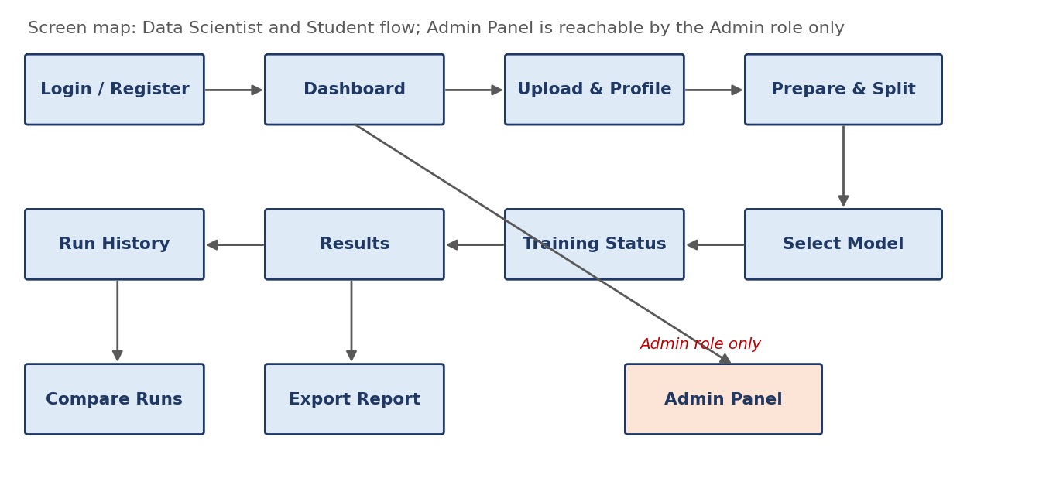
Figure B5: Screen map and navigation flow

4.5.3 Screen inventory
Screen | Purpose | Main elements | Requirement
Login / Register | Sign in or create an account | Username, password, role choice on registration, error banner | MLE-F-001
Dashboard | Starting point | Recent datasets and runs, shortcut to upload, Admin link for Admin only | MLE-F-002
Upload and Profile | Add and inspect a dataset | File drop area, size hint, upload progress, preview of first rows, profile table | MLE-F-003, F-004
Prepare and Split | Set preprocessing and split | Target column, missing-value method, encoding, scaling, test-size slider with default 20% | MLE-F-005, F-006
Select Model | Choose and configure a model | Catalogue cards, parameter form built from the schema, Train button | MLE-F-007, F-008
Training Status | Show progress | Status badge, progress indicator, polling every 2 s, error message if failed | MLE-F-009
Results | Read evaluation | Metric tiles, confusion matrix, metric bars, feature importance, Compare and Export buttons | MLE-F-010 to F-012
Run History | Browse past runs | Filterable table, select two or more runs, delete | MLE-F-013
Compare Runs | Side-by-side view | Table of configurations and metrics with best value highlighted | MLE-F-014
Admin Panel | Manage the platform | User list with role change and disable, dataset records, audit log, health | MLE-F-016

4.5.4 Wireframes
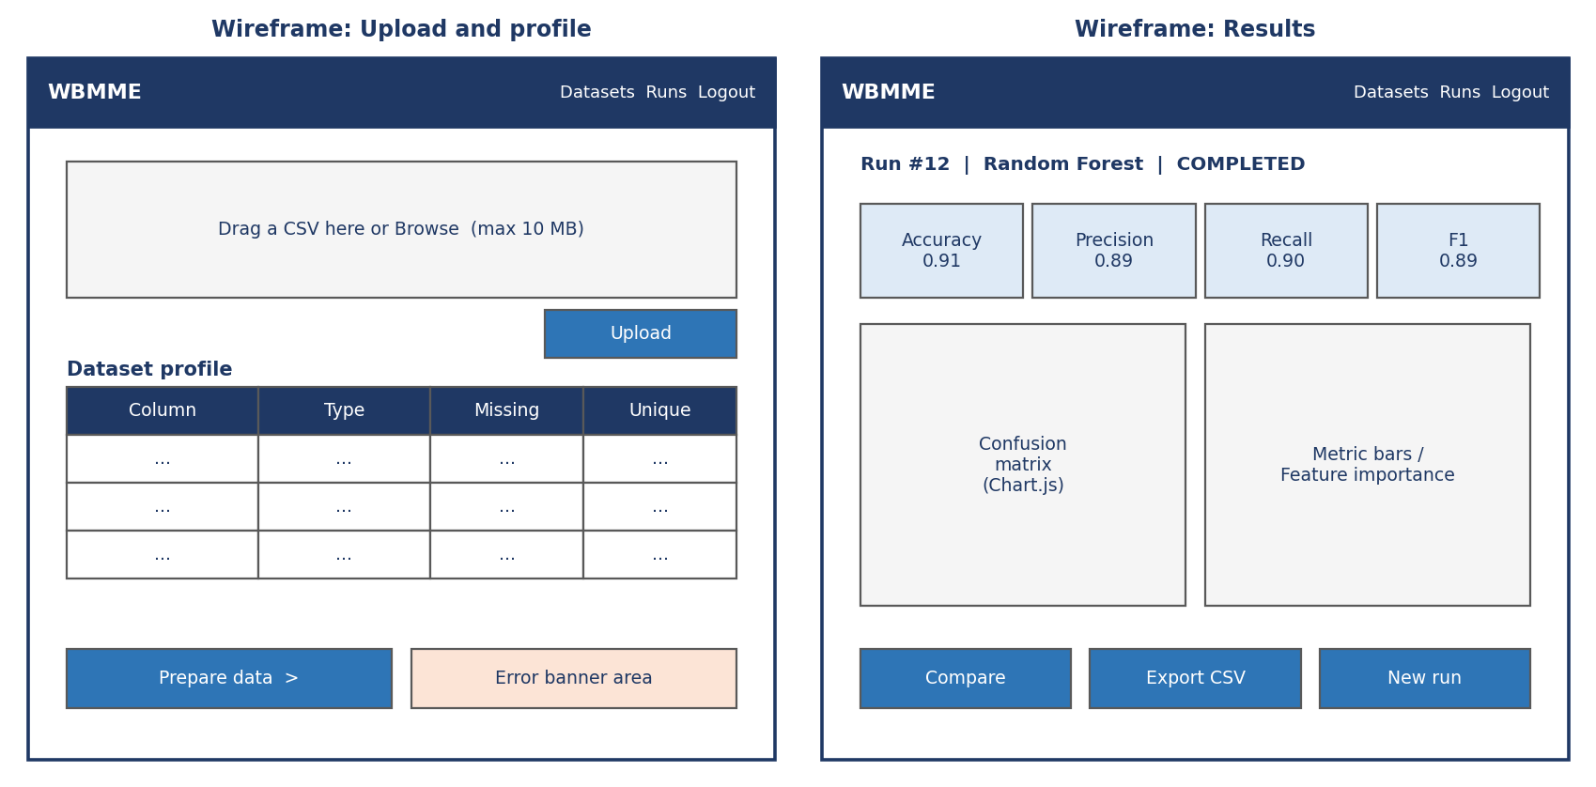
Figure B6: Wireframes for the Upload and Profile screen and the Results screen (sample values)

4.5.5 Feedback and usability
- Field errors appear next to the field; request-level errors appear in a banner at the top of the screen; success appears as a short confirmation.
- Delete actions for datasets, runs and users ask for confirmation.
- Empty states explain what to do (for example, an empty Run History links to Upload).
- Usability target for MLE-NF-005 (proposed measure for the Test Plan): a first-time user completes login, upload, training and viewing metrics within 10 minutes without help.
- Layouts are designed for desktop browsers only (SRS 2.4); mobile is out of scope.

4.6 Open Issues & Next Steps
ID | Issue | Impact | Proposed resolution | Decide by
OI-1 | Requirement IDs (MLE-*) are provisional | SAD 3.8, Test Plan 3 and 13, Appendix A | Members 1 and 2 publish final SRS IDs; replace in one pass | Before merge
OI-2 | Final list of supported algorithms and their parameters | 4.3.4, Test Plan scope | Adopt the catalogue in 4.3.4, or edit it | Sprint 1 planning
OI-3 | Background jobs: threads or Celery | 4.4.3, deployment | Threads for v1.0; Celery behind JobRunner if time allows | Sprint 1 planning
OI-4 | Upload limits (10 MB, 50,000 rows, 100 columns, 10 rows minimum) | 4.3.3, MLE-NF-001 and NF-002 | Confirm against SRS and test data | Sprint 1 planning
OI-5 | Problem types: classification only, or also regression | Metrics, 4.1.3, 4.3.5 | Classification only in v1.0; regression deferred | Sprint 1 planning
OI-6 | Do Student and Data Scientist differ in permissions or only in UI guidance | 4.3.2, role tests | Same API access in v1.0; Student sees extra guidance | Before merge
OI-7 | Admin access to dataset contents | DD5, 3.9 (Part A) | Admin sees metadata only | Before merge
OI-8 | HTTPS in the demo environment | MLE-SR-002, security tests | TLS at a reverse proxy in Docker; local demo may use HTTP | Sprint 2
OI-9 | PDF export and SHAP explanations | MLE-F-012, F-015 | CSV export and feature importance first; PDF and SHAP only if time allows | Sprint 2
OI-10 | Module ownership per team member (guidelines require one full functionality each) | 4.1.2, Jira epics | Assign modules to members at Sprint 1 planning | Sprint 1 planning

5. Appendices

5.1 Glossary
WBMME, SRS, SAD, STP, RTM, API, CSV, ML, MVT, RBAC, CSRF, STRIDE, TLS, PBKDF2, DS-ID, Run, Artifact and Pipeline are defined in Sections 1.3 and 3 of this document and in SRS Section 1.4.

5.2 References
IEEE 1016-2009, IEEE 42010, OWASP Top 10 and ASVS, NIST SP 800-160, Django 5 and scikit-learn documentation.

5.3 Tools
Matplotlib (diagrams), draw.io and PlantUML (alternatives), Postman and Swagger (API), GitHub Actions, pytest, Docker.

Appendix A: Design reference index and traceability
This table extends the RTM with the design location and is the single place to edit when requirement IDs change. Test case IDs are from the Test Plan (Section 13). "Planned" means the case is scheduled for Sprint 1 or 2.
Req ID | DS-ID | Design location | Test case(s)
MLE-F-001 | DS-Auth-01 | 4.2.1 login sequence; 4.3.7 auth endpoints; module accounts | TC-AUTH-01
MLE-F-002 | DS-Auth-02 | 4.3.2 roles; role_required; 4.3.7 | TC-SEC-01
MLE-F-003 | DS-Data-01 | 4.2.2 upload sequence; 4.3.3 /api/upload | TC-DATA-01, TC-DATA-02
MLE-F-004 | DS-Data-02 | 4.1.3 Profile stage; GET /api/datasets/{id} | TC-DATA-01
MLE-F-005 | DS-Data-03 | 4.1.3 Prepare stage; preprocessing in 4.3.4 | Planned (Sprint 1)
MLE-F-006 | DS-Data-04 | 4.1.3 Split stage; split in 4.3.4 | TC-MODEL-01
MLE-F-007 | DS-Model-01 | 4.3.4 GET /api/models; ModelRegistry | TC-MODEL-01
MLE-F-008 | DS-Model-02 | 4.3.4 params; registry parameter ranges | TC-MODEL-01
MLE-F-009 | DS-Model-03 | 4.2.3 train sequence; 4.3.4 /api/train; 4.4.3 | TC-MODEL-01
MLE-F-010 | DS-Eval-01 | 4.3.5 /api/evaluate; MetricsCalculator | TC-EVAL-01
MLE-F-011 | DS-Eval-02 | 4.3.5 confusion matrix; 4.5.3 Results screen | TC-EVAL-01
MLE-F-012 | DS-Eval-03 | 4.3.5 feature_importance | Planned (Sprint 2)
MLE-F-013 | DS-Exp-01 | 4.1.4 Run, Metric; 4.3.6 /api/runs | TC-EXP-01
MLE-F-014 | DS-Exp-02 | 4.3.6 /api/runs/compare; 4.5.3 Compare screen | TC-EXP-01
MLE-F-015 | DS-Exp-03 | 4.3.6 report export | Planned (Sprint 2)
MLE-F-016 | DS-Admin-01 | 4.3.2 and 4.3.7 admin endpoints; Admin Panel screen | TC-SEC-01
MLE-NF-001 | - | 4.3.3 size and row limits; streamed validation | TC-PERF-01
MLE-NF-002 | - | 4.2.3 background job; 4.4.3 timeout and limits | TC-PERF-02
MLE-NF-003 | - | 4.3.1 pagination and stateless API; 4.5 light pages | TC-PERF-03
MLE-NF-004 | - | Appendix B Dockerfile and compose file | Planned (Sprint 2)
MLE-NF-005 | - | 4.5 UX design; 4.5.5 usability target | Planned (Sprint 2)
MLE-SR-001 | - | 4.2.1 PBKDF2 hashes; 4.3.7 | TC-AUTH-01
MLE-SR-002 | - | 4.3.1 transport; OI-8 | Test Plan 5.1
MLE-SR-003 | - | 4.2.2 and 4.3.3 validation rules | TC-DATA-02
MLE-SR-004 | - | 4.1.5 DD3; ArtifactStore | Test Plan 5.1
MLE-SR-005 | - | 4.1.4 owner rule; DD4; 4.4.4 audit events | TC-SEC-01

Appendix B: Proposed repository layout
Layout of repository SE_498_515_534_911 that supports the module structure in 4.1.2 and lets members work on separate folders:
SE_498_515_534_911/
manage.py, requirements.txt, Dockerfile, docker-compose.yml
.github/workflows/ci.yml # tests, lint, coverage on every pull request
wbmme/ # settings, urls, wsgi
apps/
accounts/ datasets/ mlcore/ evaluation/
experiments/ audit/ api/
templates/ static/ (js/, css/, vendor/chart.js)
tests/ (unit/, integration/, system/)
docs/ (SRS, SAD, Test Plan, RTM)
data/ # outside web root; created at runtime, not committed

