1. Create a simple PairRDD of (1, 2), (3, 4), (3, 6).

val inputrdd = sc.parallelize (Seq ((1, 2), (3, 4), (3, 6)))

inputrdd.collect ()

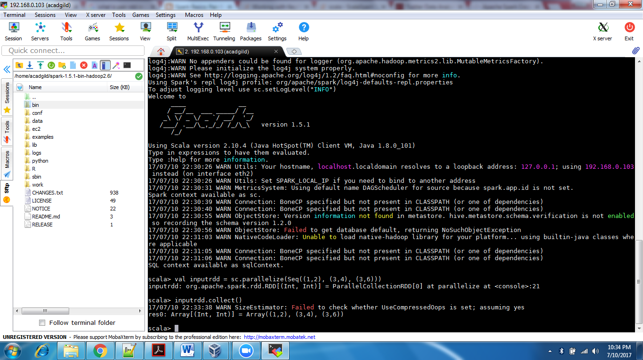

2. Transform an RDD of ("a","b","c","d","e") to PairRDD (a, 0), (b, 1), (c, 2), (d, 3), (e, 4)

val x=sc.parallelize (Seq ("a", "b", "c", "d", "e"))

val y=x.zipWithIndex

y.collect ()

