1) pwd: this is Print working directory, used to print the current working directory.

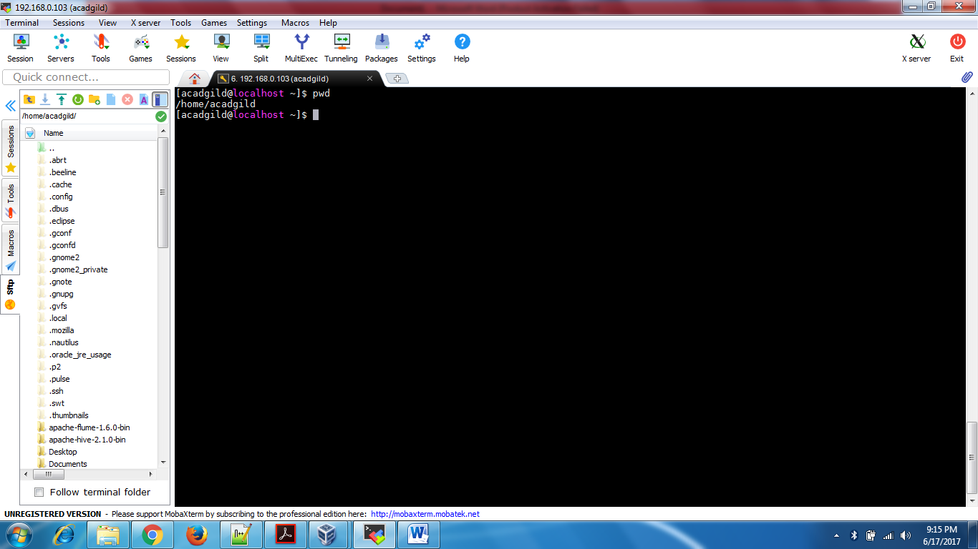

2) vi: this command is used to edit the file, there are 2 modes :command mode-to operate the commands, insert mode- to insert text in the file .

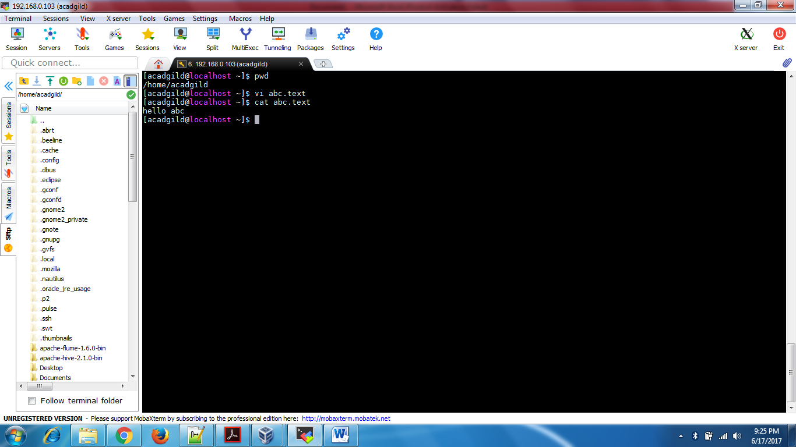

3) touch: The touch command updates the access and [modification](https://www.computerhope.com/jargon/m/modify.htm) times of each FILE to the current system time. e.g. - touch file.txt -> If file.txt exists, touch updates its access and modification times to the current time. If file.txt doesn't exist, it is created as a new, empty file.

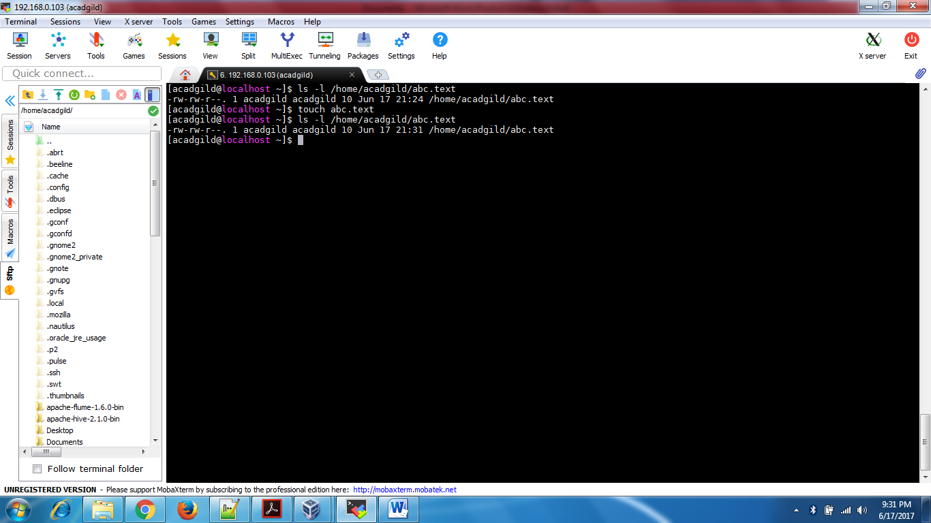

4) mkdir: this is used to create the directory

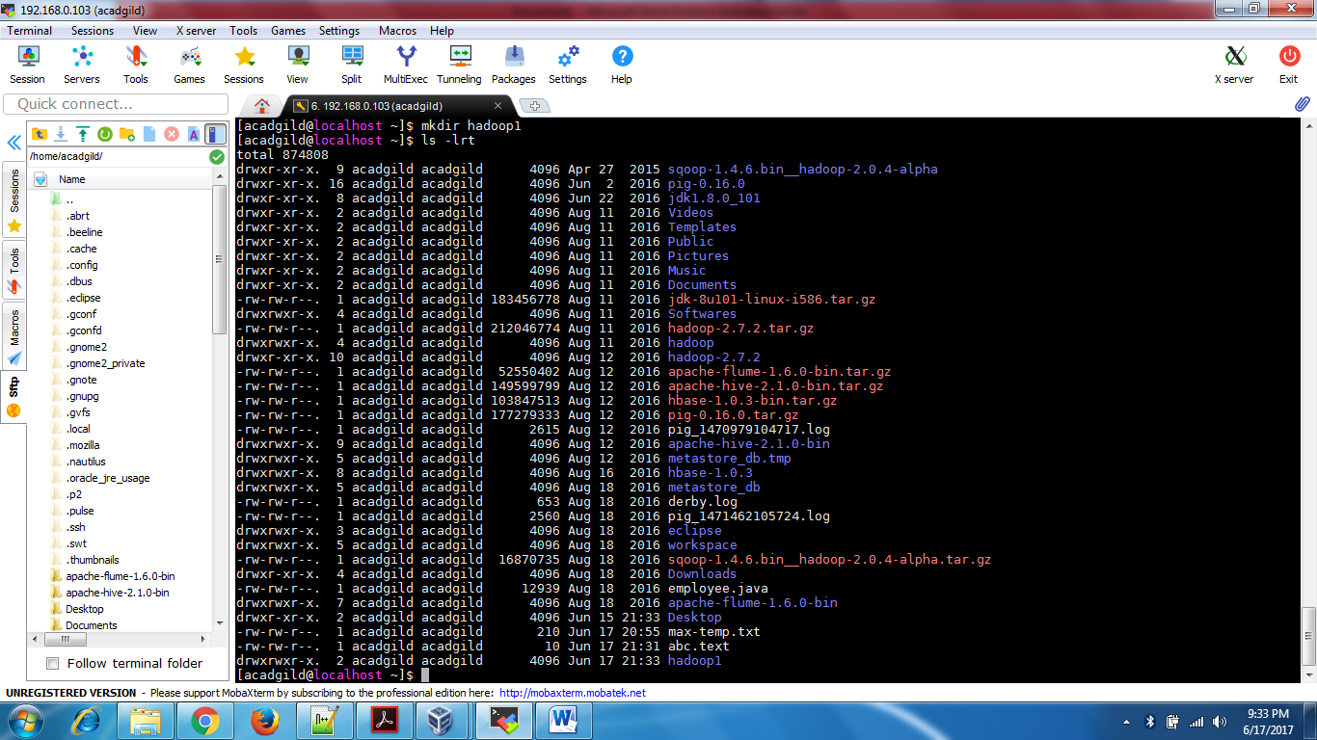

5) rm: this is used to remove a file or directory

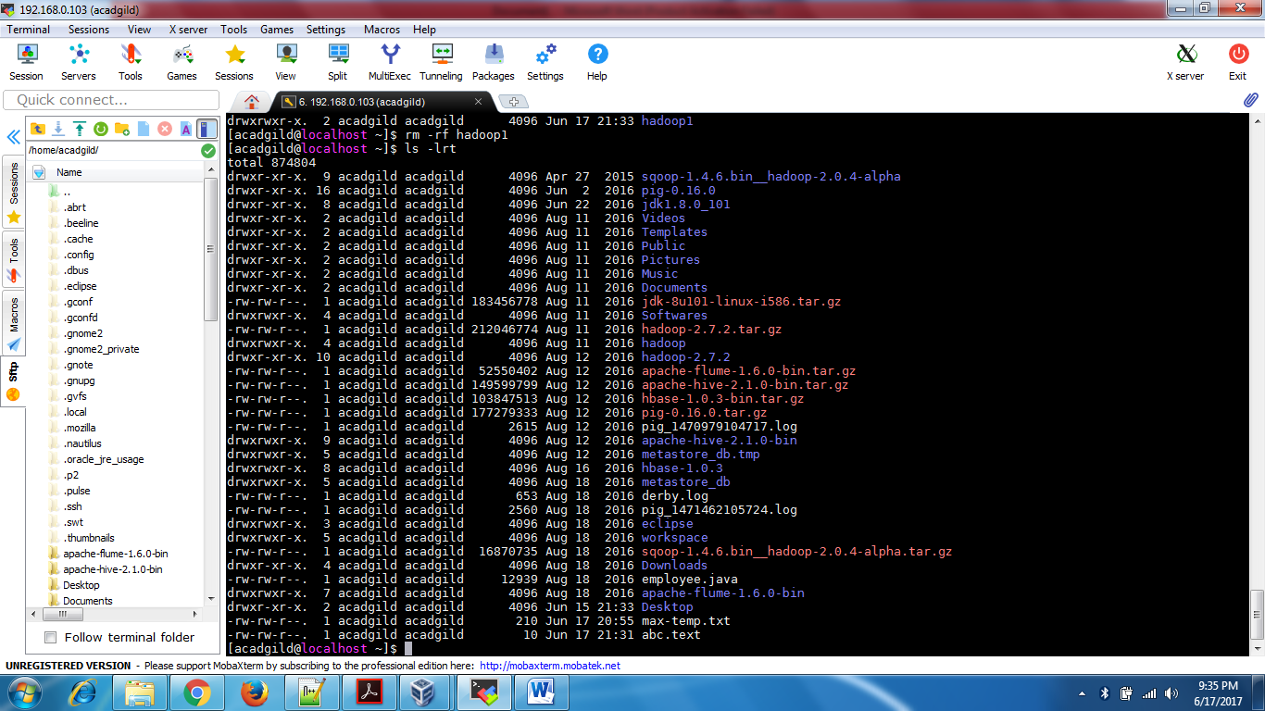

6) ls : this is used to list the content of a directory

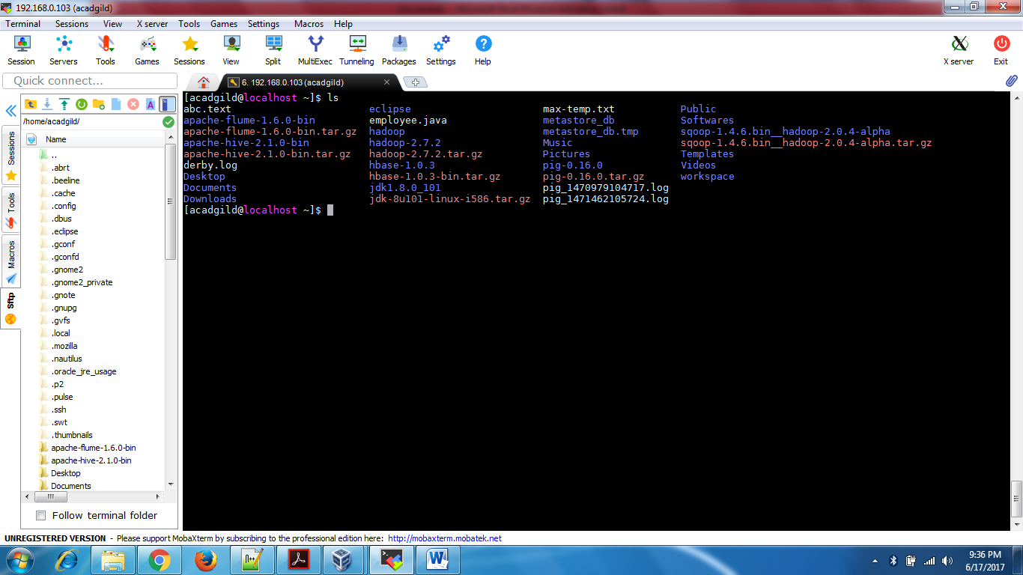

7) echo: echo command is built in shell command , which used to display the value of a variable or print line of text.

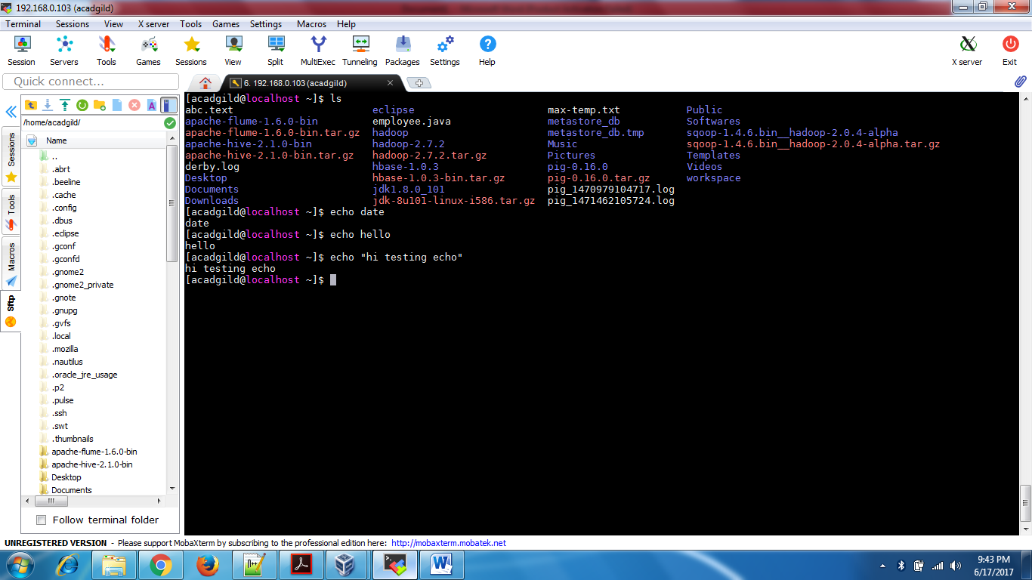

8) cat: this command allows us to create single or multiple files, view contain of file, concatenate files and redirect output in terminal or files.

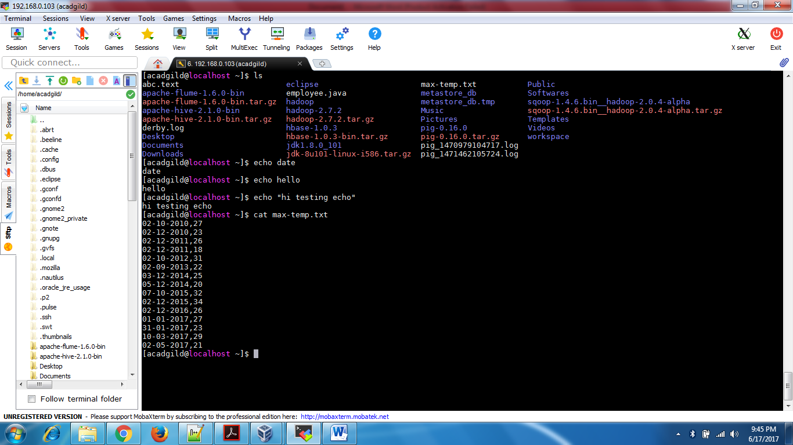

9) who: who displays a list of users who are currently logged into the computer.

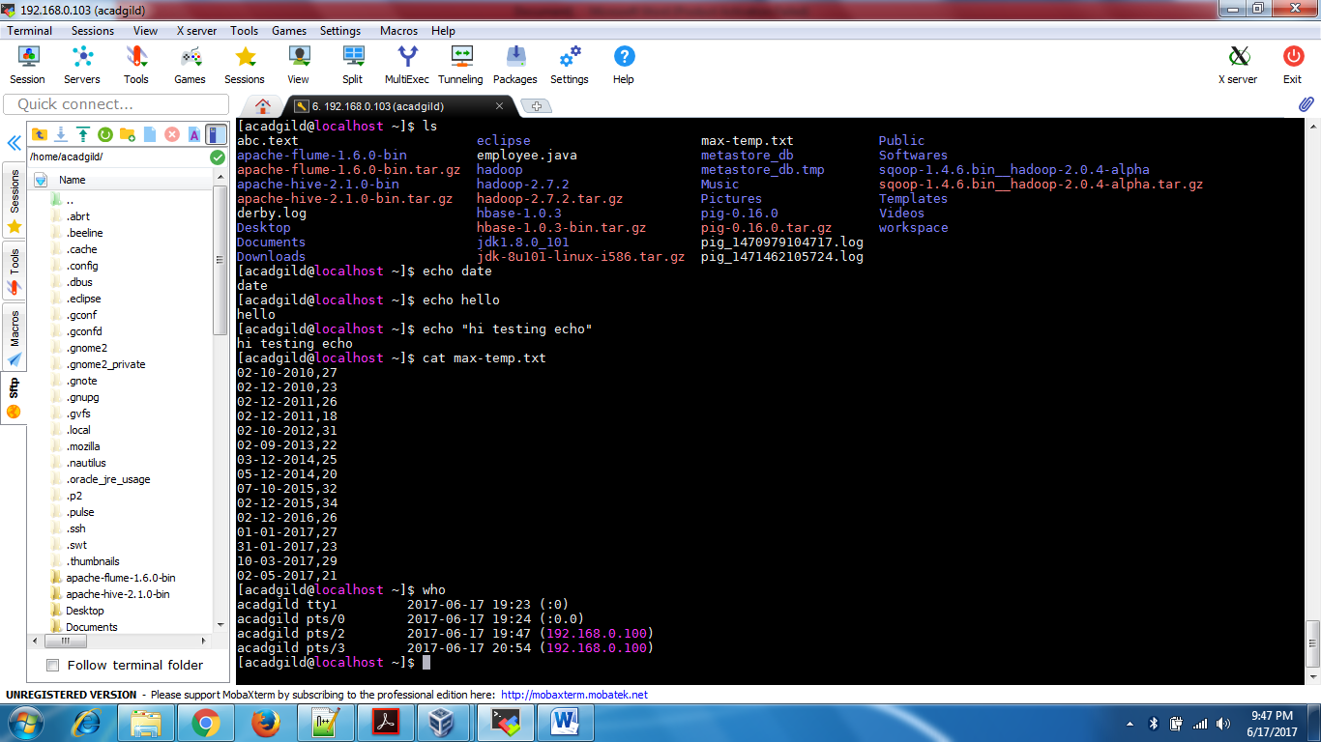

10) cd: this command is used to go to particular path in unix

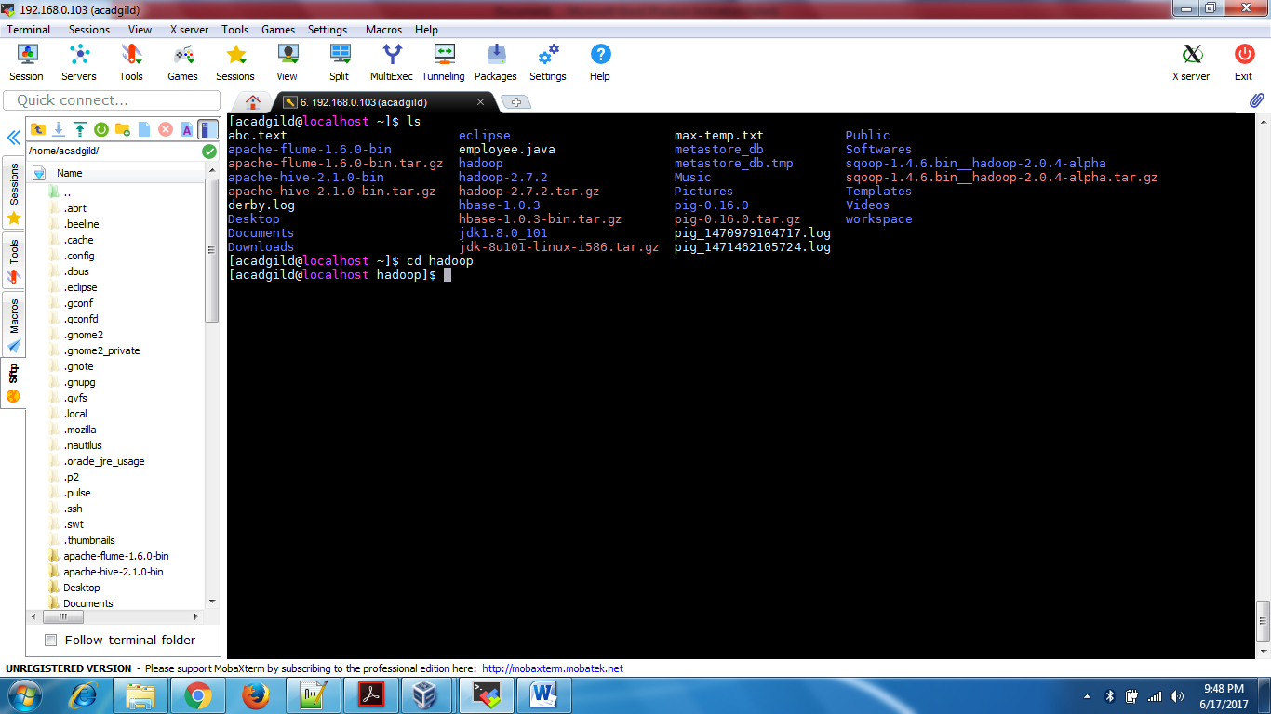

11) date: this command is used to show the current timestamp

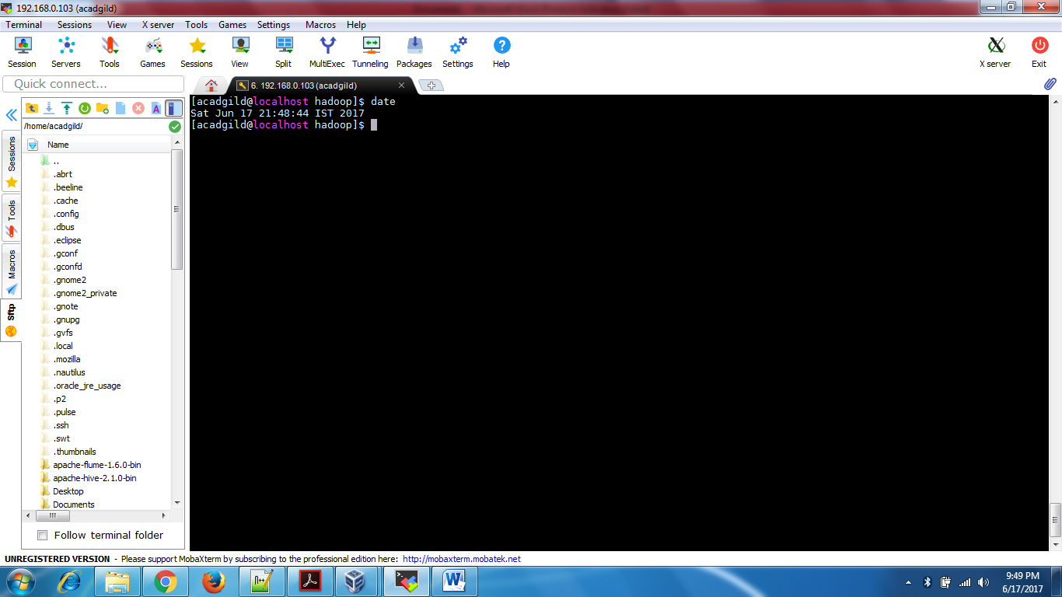

12) cal: this command is used to show the calendar

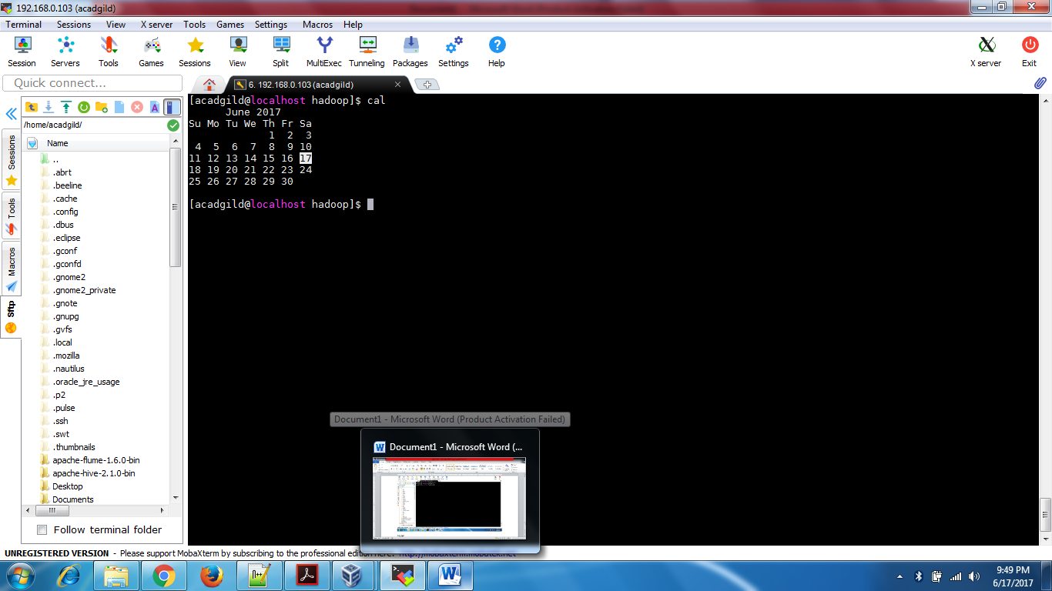

13) mv: this command is used to move a file to a different path.

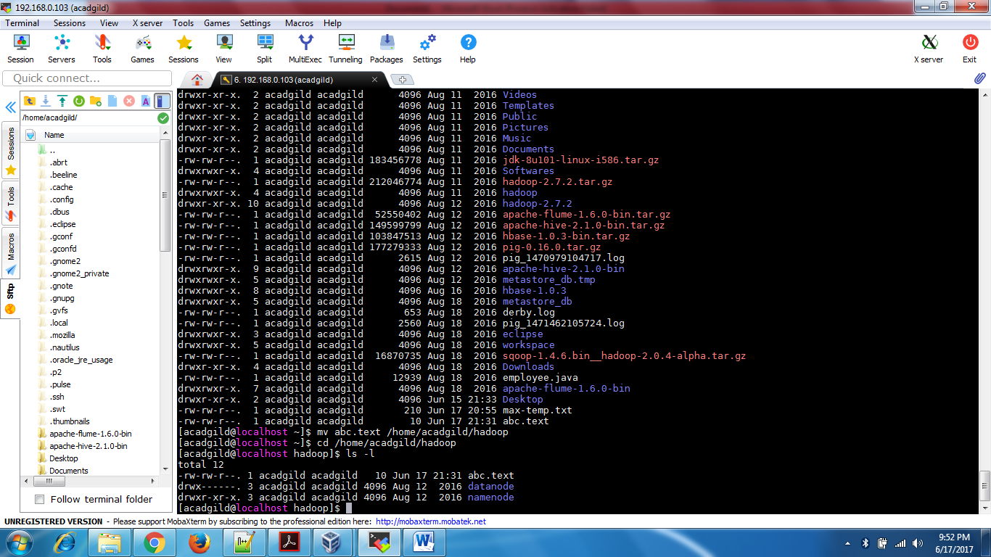

14) cp: used to copy a particular file to different location

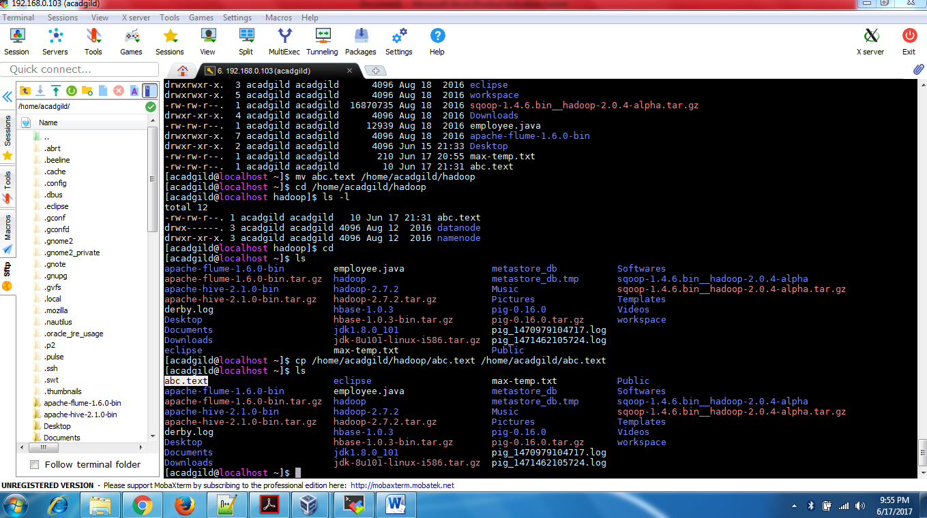

15) which: Locate the [executable file](https://www.computerhope.com/jargon/e/execfile.htm) associated with a given [command](https://www.computerhope.com/jargon/c/command.htm). e.g. (which sh)->Locates the pathname of the file which would be run if the [sh](https://www.computerhope.com/unix/ush.htm) command were executed.

