Loading crime data:

At first we are loading the csv file into crime_data relation

crime_data = LOAD 'Crimes.csv' USING PigStorage(',') AS (case_id:int,case_num:chararray,date:chararray,block:chararray,iucr:int,primary_type:chararray,description:chararray,location_desc:chararray,arrest:boolean,domestic:boolean,beat:chararray,district:chararray,ward:chararray,community:chararray,fbi_code:chararray,x_coordinate:chararray,y_coordinate:chararray,year:chararray,updated_on:chararray,latitude:chararray,longitude:chararray,location:chararray);

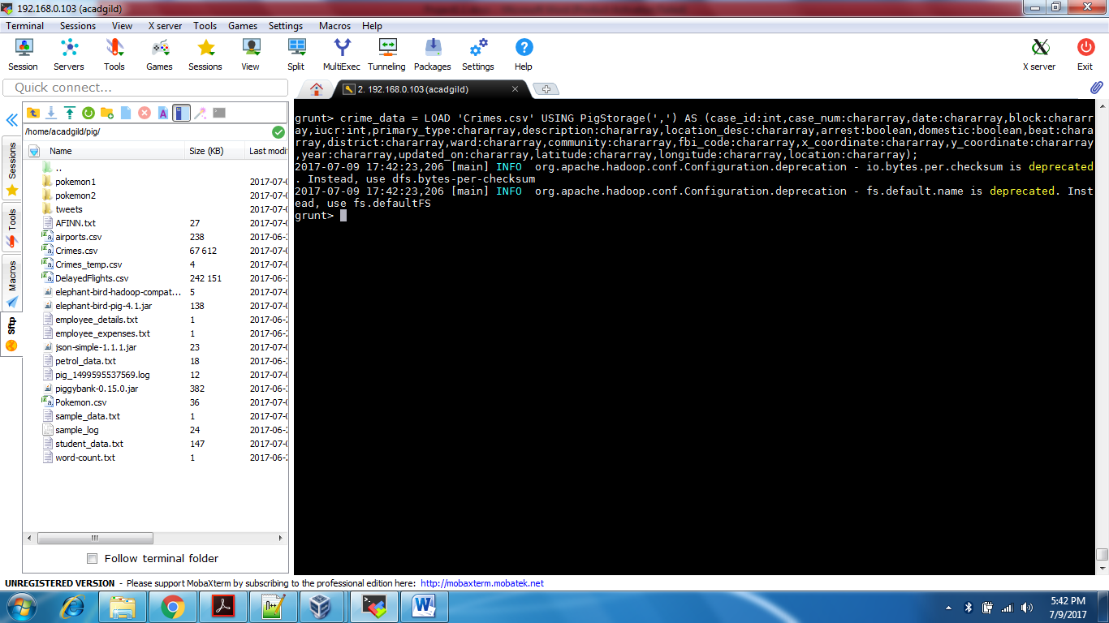

Number of cases investigated under each FBI code:

* Grouping data based on FBICode.
* Counting number of records for each FBICode.
* Getting the result by DUMP command.

grp_crime_data = GROUP crime_data BY fbi_code;

count_cases = FOREACH grp_crime_data GENERATE group, COUNT(crime_data);

DUMP count_cases;

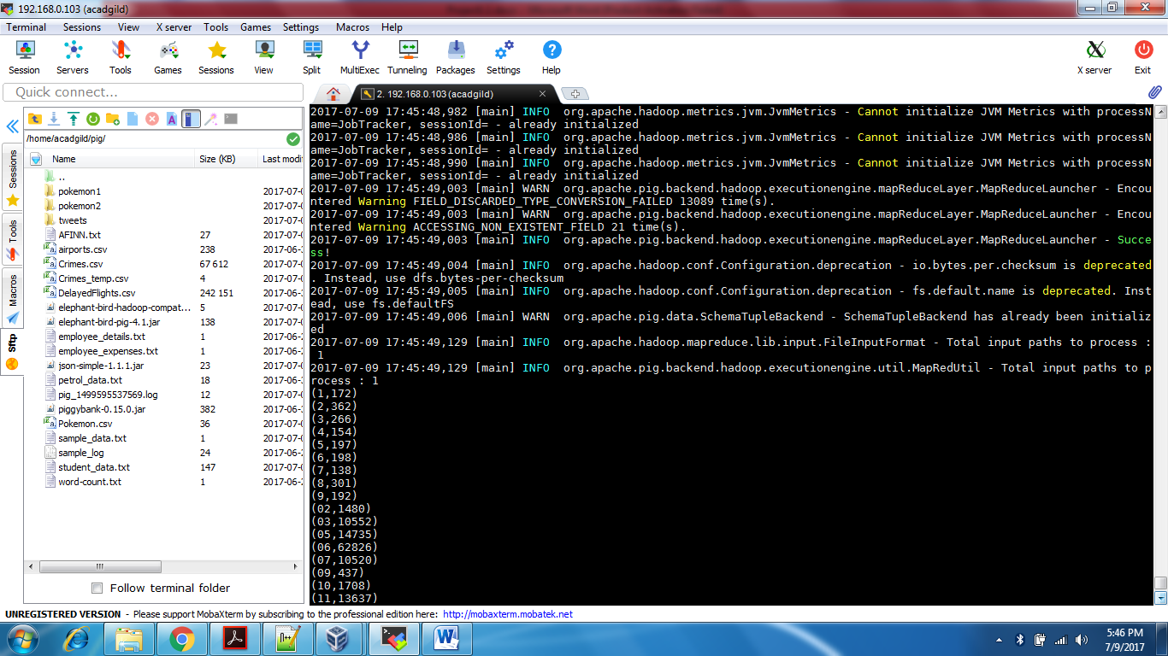

Number of cases investigated under FBI code 32:

* Filtering data based on FBICode.
* Grouping filtered data by null to get all the records.
* Counting number of records for FBICode 32.
* Getting the result by DUMP command.

filtered_crime_data = FILTER crime_data BY (fbi_code matches '32');

grp_crime_data_32 = GROUP filtered_crime_data BY NULL;

count_case_32 = FOREACH grp_crime_data_32 GENERATE COUNT (filtered_crime_data);

DUMP count_case_32;

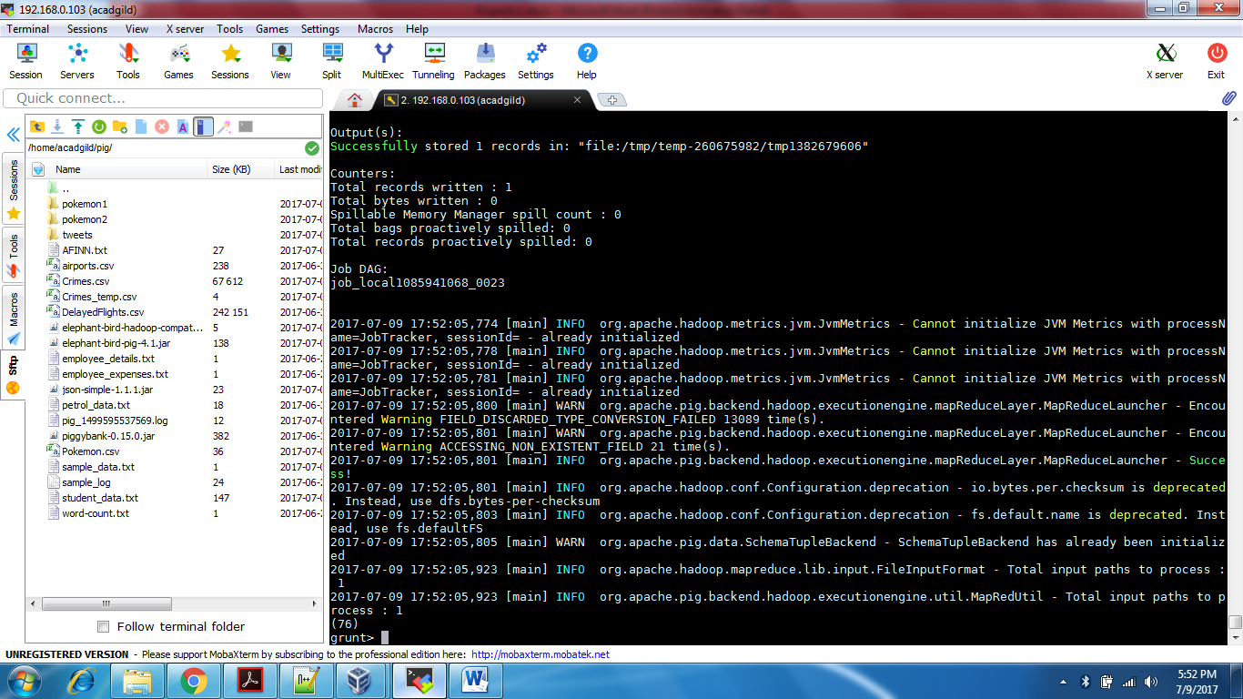

Number of arrests in theft district wise:

* Generating Primary Type, Arrest, and District for each record.
* Filtering data based on Primary type as ‘THEFT’ and arrest as true.
* Grouping data based on District.
* Counting number of records for arrests in ‘THEFT’.
* Getting the result by DUMP command.

crime_data_arrest = FOREACH crime_data GENERATE primary_type, arrest, district;

filtered_crime_data_arrest = FILTER crime_data_arrest BY ((primary_type matches 'THEFT') AND (arrest == true));

grp_crime_data_arrest = GROUP filtered_crime_data_arrest BY district;

count_theft_arrest = FOREACH grp_crime_data_arrest GENERATE group, COUNT (filtered_crime_data_arrest);

DUMP count_theft_arrest;

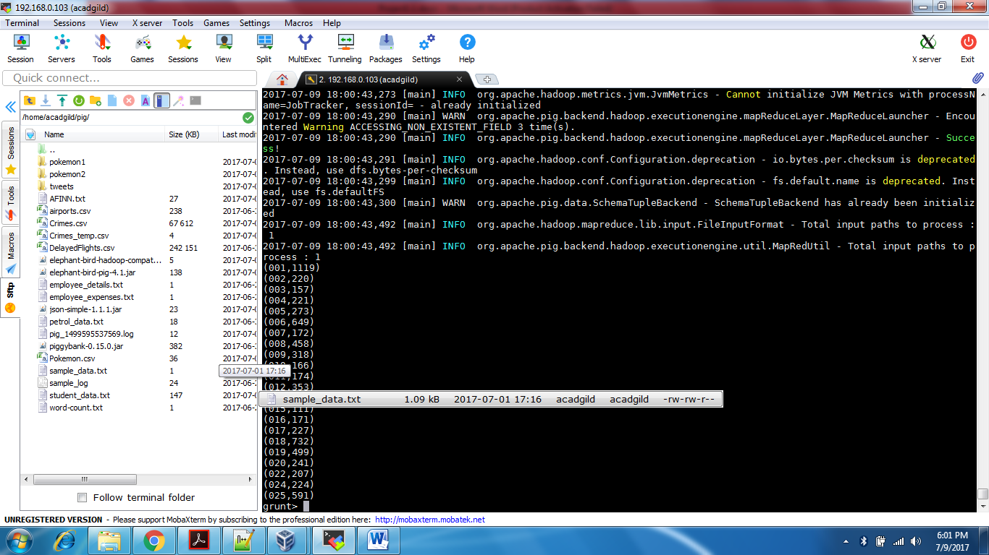

Number of arrests done between October 2014 and October 2015:

* Generating Date, Arrest for each record.

1. Here first SUBSTRING function has been used to neglect (AM/PM).
2. Then we gave converted the date from chararray to datetime format.

* Filtering data based on the desired duration and arrest as true.
* Grouping filtered data by null to get all the records.
* Counting number of records for arrests between OCT 2014 and OCT 2015.
* Getting the result by DUMP command.

crime_data_date = FOREACH crime_data GENERATE ToDate (SUBSTRING (date, 0, 19),'mm/dd/yyyy HH:mm:ss') AS fdate, arrest;

filtered_crime_data_date = FILTER crime_data_date BY ((ToDate ('2014-09-30') < fdate) AND (fdate < ToDate ('2015-11-01') AND (arrest == true)));

grp_crime_data_date = GROUP filtered_crime_data_date BY NULL;

count_arrest = FOREACH grp_crime_data_date GENERATE COUNT (filtered_crime_data_date);

Dump count_arrest;

