|  |  |  |
| --- | --- | --- |
| jb SUMMARY IT Professional with over 20 years of experience specializing in IT department management for several companies. I can implement good IT products at local and global levels. My greatest strength for project development is a mix of speed, quality and cost. Skills Project Scheduling – over 90% of projects led were finished in due time.  Strategic Planning  Communication Skills  Team Management Contact [jamesbrown.1986.222@gmail.com](mailto:jamesbrown.1986.222@gmail.com)  skype address: live:.cid.2ade2e02bf3b24a7 | |  | | --- | | james brownSenior firmware developer & hardware developer& team leader |  ExperienceProgram Developer • star group • 2008.5 – 2011.4 Responsible for developing Customer Relationship Management  Implemented Sales Force Automation for publishing company  Developed several business management program  Implemented secure file container based on driver development  Implemented anti-virus vaccine program firmware developer & hardware developer • star group • 2011.5 – 2015.7 Developed wireless communication system using Bluetooth module, nRF24 module and so on  Implemented karaoke PCB design and developed firmware  Developed ARM-based solution and microcontroller-based solution  Developed digital signal processing product  Implemented communication system using Xilinx and Cypress FPGA. project manager • nic • 2015.8 – 2020.9 Responsible for developing software & hardware project  As a project manager, implemented advanced secure USB  As a project manager, implemented network insulator device and print monitoring system  As a project manager, implemented 2 web-based projects Team leader • rasen • 2020.10 – current Responsible for 10 team members (6 program developers, 2 PCB designers and 2 firmware developers)  Responsible for teaching new team member  Implemented 2 solutions using hardware and software tech both Educationbachelor of computer science • 2004.11 – 2008.4 • national institute of information technologymaster of computer science • 2010.4 – 2012.12 • karnata universityCertification MCSD from Microsoft, 2007.9  Java SE Programmer from Sun, 2008.1 |

### SNAPSHOT

### 1. karaoke pcb design

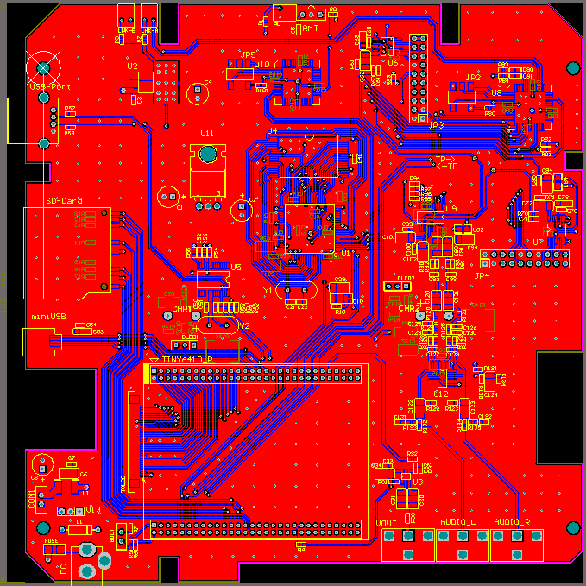

### 2. communication system using xilinx Fpga

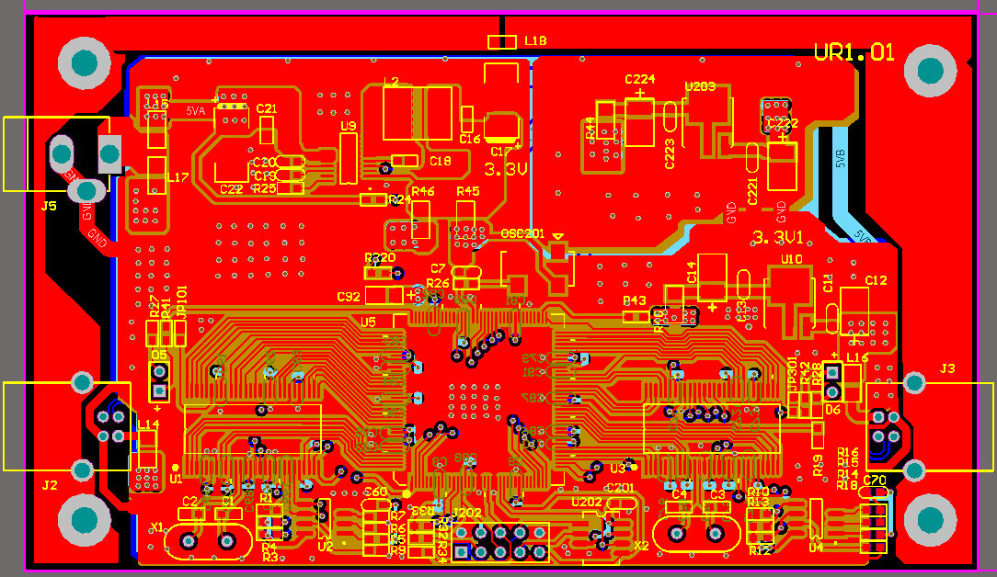

### 3. ARM based firmware

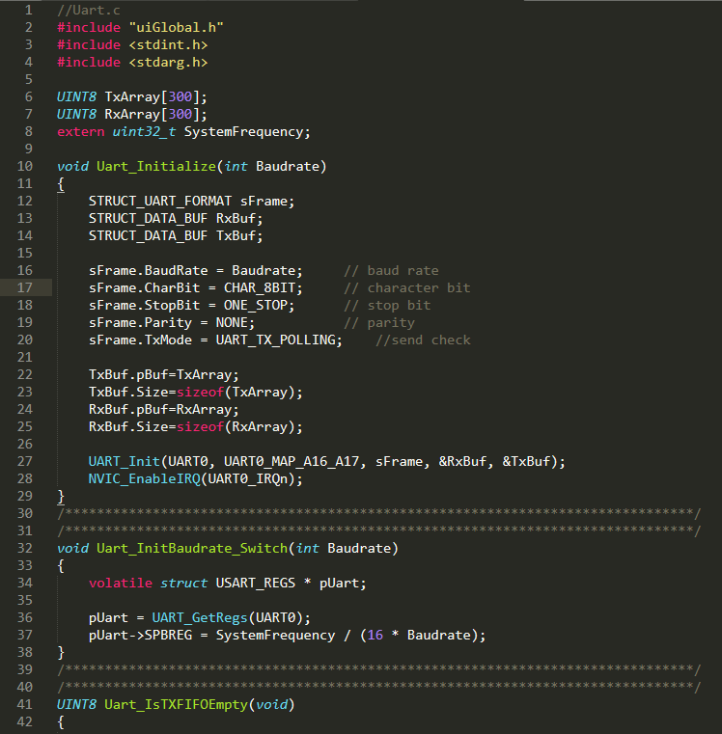

### 4. Wireless communication module

