Technical Architecture Document
ML Invoice Classification System (Intermedia V3)

1. Executive Summary
The ML Invoice Classification System (Intermedia) is an intelligent automation platform designed to modernize and streamline the Accounts Payable (AP) process. The system automatically classifies invoices into one of three outcomes:
- ✅ Approve
- ⚠️ Review Further
- ❌ Reject
By combining Machine Learning (LightGBM) with Generative AI (Google Gemini), the solution not only makes accurate decisions but also clearly explains why each decision was made. This significantly reduces manual review effort, improves compliance, and increases trust in automation.

2. Solution Overview
The system operates across three core stages:
1. Synthetic Data Generation
Creates realistic enterprise-grade datasets (Suppliers, Purchase Orders, Invoices) that include both normal and high-risk scenarios.
2. Model Training & Tracking
Trains a robust ML classification model using MLOps best practices, with full experiment tracking, performance monitoring, and probability calibration.
3. Interactive AI Dashboard
A Streamlit-based application that serves predictions, visualizes risk signals, and uses GenAI to generate human-readable explanations for every decision.

3. Component Breakdown
3.1 Data Generation (dataset/generate_data.py)
Purpose
Simulates a real-world ERP environment for training and demonstration.
Key Elements
- Suppliers
  - 50 suppliers
  - Risk scores: 1–100
  - Tenure: 30–3650 days
- Purchase Orders
  - 300 POs
  - Categories: IT, Marketing, Finance, Operations
- Invoices
  - 1,500 historical invoices for training
  - 60 new invoices designed to represent edge cases:
    - Clean invoices
    - Amount variance
    - Currency mismatch
    - Smart-matched invoices
    - High-risk Non-PO invoices

3.2 Model Training Pipeline (train_model.py)
Training Strategy
- Rolling Window Training:
Uses the most recent 90 days of invoice data to reflect current business behavior.
Model
- LightGBM Classifier
- Hyperparameters optimized using trial-based experimentation
Probability Calibration
- Isotonic Regression via CalibratedClassifierCV
- Ensures confidence scores accurately reflect real-world risk
Tracking & Monitoring (MLflow)
- Metrics:
  - Accuracy
  - Precision
  - Recall
  - F1-Score
- Artifacts:
  - Confusion matrices
  - SHAP feature importance plots
  - Model parameters and versions

3.3 User Interface (app.py)
Framework
Streamlit
Key Capabilities
- Batch Inference
All new invoices are scored automatically on page load.
- Risk Visualization
  - 🟢 Approve
  - 🟠 Review Further
  - 🔴 Reject
- Explainable AI (Decision Cards)
Uses Google Gemini 2.5 Flash to convert model outputs and features into clear, business-friendly explanations.
- Inference Monitoring
  - Every prediction and audit action is logged back to MLflow for governance and compliance.

4. Feature Engineering & Risk Calculations
This section outlines how raw data is transformed into meaningful risk signals.

4.1 Core Risk Indicators
Metric | Formula | Purpose
Amount Variance | (Invoice Amount − PO Amount) / PO Amount | Detects over- or under-billing
Absolute Difference | Invoice Amount − PO Amount | Raw financial deviation
Days Since PO | Invoice Date − PO Date | Measures delay since authorization
Currency Mismatch | 1 if Invoice Currency ≠ PO Currency | Flags FX risk

4.2 Supplier Behavior Metrics
Calculated from historical invoice data.
- Supplier Approval Rate
Percentage of past invoices that were approved
- New Supplier Flag
Supplier tenure < 90 days
- Average Invoice Amount
Typical billing behavior for the supplier
These features help the model understand supplier reliability and historical behavior.

4.3 Text-Based Risk Signals
Extracted from the invoice Description field.
- Word Count
Measures description completeness
- Urgency Indicators
Flags keywords like urgent, wire, transfer, asap
- Semantic Features (LSA)
Top 5 latent topics derived using TF-IDF + Truncated SVD

5. Invoice Matching & Decision Logic
5.1 Matching Engine Flow
Invoices are matched to Purchase Orders using a cascading approach:
- Strict Match
  - Exact match on normalized PO Number
- Smart Match
  - Used when PO Number is missing
  - Matches based on:
    - Same Supplier
    - Date difference ≤ 14 days
    - Amount variance ≤ 2%
- Non-PO Invoice
  - No match found
  - Treated as higher-risk by default

5.2 Confidence Score
The confidence shown in the UI is derived from calibrated probabilities:
$$\text{Confidence}=max⁡(P(\text{Approve}),P(\text{Review}),P(\text{Reject}))$$
This ensures that confidence is trustworthy and well-calibrated, not just a raw model output.

6. Technology Stack
- Programming Language: Python 3.10+
- Machine Learning: LightGBM, Scikit-Learn
- MLOps & Tracking: MLflow
- Generative AI: Google Gemini 2.5 Flash
- Web Framework: Streamlit
- Data Processing: Pandas, NumPy
- Explainability:
  - SHAP (static feature importance)
  - Gemini (dynamic, natural-language explanations)

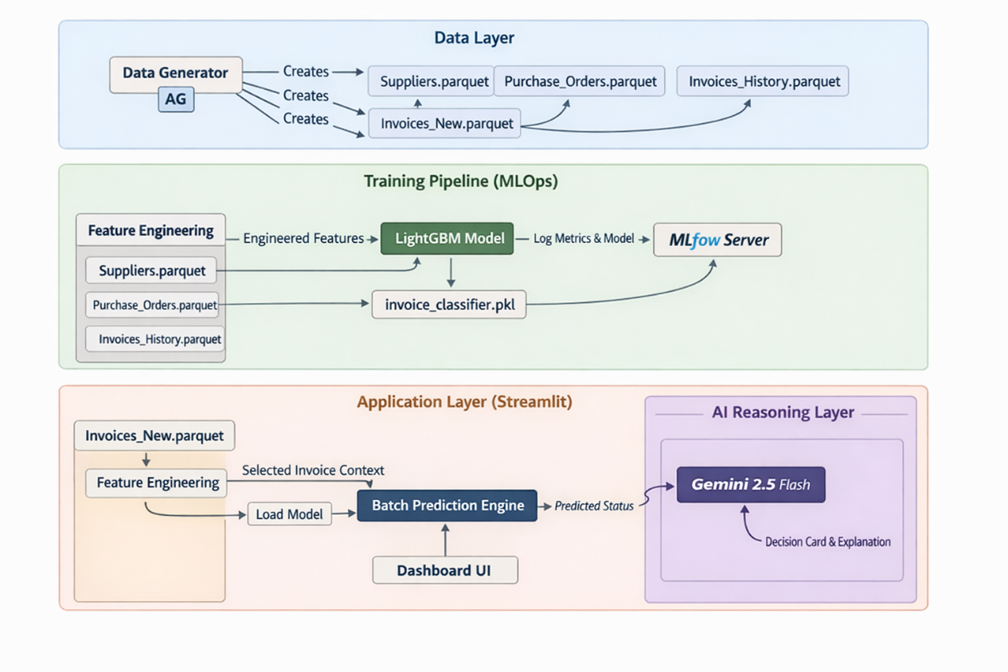

🧭 RISK INDICATORS (Top Section)
1️⃣ Variance – 150.0%
What it means (Business):
How much the invoice amount deviates from the matched PO amount.
Formula (Code):
Amt_Variance = (Invoice_Amount - PO_Amount) / PO_Amount
Example (from screenshot):
- PO Amount ≈ 5,987
- Invoice Amount ≈ 14,968
(14,968 - 5,987) / 5,987 ≈ 1.50 → 150%
Why it matters:
- Normal tolerance: ≤ 2%
- 150% = very high risk
- Primary reason for Reject

2️⃣ Supplier Risk – 21
What it means:
An externally assigned supplier risk score (0–100).
Source (Code):
d['Sup_Risk'] = sup.iloc[0]['Risk_Score']
Interpretation:
Score Range | Meaning
0–30 | Low risk
30–70 | Medium risk
70–100 | High risk
📌 In screenshot: 21 = Low-risk supplier, but overridden by amount variance.

3️⃣ Match Type – Strict Match
What it means:
Invoice PO number exactly matches a PO in the system.
Logic (Code):
if normalized_invoice_po == normalized_po:
return match, "Strict"
Match Hierarchy:
Strict > Smart > None
Why it matters:
- Strict match normally reduces fraud risk
- But amount mismatch can still override

4️⃣ Branch – PO-Linked
What it means:
Which decision logic path was used.
Logic:
branch = "PO-Linked" if Match_Type in ["Strict", "Smart"] else "Non-PO Branch"
Branches:
Branch | Meaning
PO-Linked | Valid PO exists
Non-PO | No PO → higher scrutiny

📋 DETAILED MATCH DATA (Table)

🔹 Invoice_ID
Source:
Invoice_ID
Unique invoice identifier.

🔹 Department
Source:
Department
Used for:
- Historical risk patterns
- Feature encoding (Dept_Code)

🔹 Predicted_Status – Reject
What it means:
Final ML model decision.
How it's computed:
preds = model.predict(X)
Predicted_Status = labels_map[pred]
Possible values:
- Approve
- Review Further
- Reject

🔹 Match_Type – Strict
Same as Risk Indicator Match Type.

🔹 Amt_Variance – 1.5
Same as top metric (decimal form).
Stored as:
1.5 → 150%

🔹 Amt_Diff_Abs – 8981.21
What it means:
Absolute difference between invoice and PO amount.
Formula:
Amt_Diff_Abs = abs(Invoice_Amount - PO_Amount)
Why it matters:
- Large absolute gaps flag overbilling
- Used by ML even if % variance is ignored

🔹 Sup_Is_New – 0
What it means:
Whether supplier is new (< 90 days).
Logic:
Sup_Is_New = 1 if Tenure_Days < 90 else 0
Interpretation:
Value | Meaning
0 | Established supplier
1 | New / untrusted supplier

🔹 Sup_Approval_Rate – 0.36
What it means:
Historical approval success of the supplier.
Formula:
Sup_Approval_Rate = Approved_Invoices / Total_Invoices
Example:
36 approvals out of 100 invoices → 0.36
Why it matters:
- < 50% = unreliable supplier
- Used heavily in Reject decisions

🔹 Desc_Word_Count – 5
What it means:
Number of words in invoice description.
Formula:
len(Description.split())
Why it matters:
- Very short descriptions → suspicious
- Too generic → higher fraud probability

🔹 Has_Urgent_Keyword – 0
What it means:
Checks for pressure/fraud language.
Keywords:
['urgent', 'wire', 'transfer', 'immediate', 'asap']
Logic:
1 if any(keyword in description) else 0
Interpretation:
Value | Meaning
0 | No urgency manipulation
1 | Potential fraud signal

