**Manual Testing for eCommerce Application**

**Software Testing Life Cycle:**

**-----------------------------------**

**Manual Testing Project:**

**-------------------------**

* **Project introduction**
* **Understanding & explore the functionality of the product (need to read FRS doc.)**
* **Test plan** (before test plan => we need to refer project plan (duration) & FRS Doc.)
* Writing test scenarios
* Writing test cases & reviews
* Environment setup & build deployment
* Test execution
* Bug reporting & tracking
* Sanity Testing, Re-Testing & Regression testing
* Test Sign off

**Project VS Product**

**--------------------**

Product => eCommerce Application

**eCommerce**

----------

* Login
* Serach for Products / iterms
* Add then to cart
* Do payment
* Product will be deliverd
* Returns the product

**Frontend => public**

**Backend => Admin**

**Frontend => Internet Application**

**Backend => Intranet Application**

**Demo Application for testing:**

**------------------------------**

<https://demo.opencart.com/>

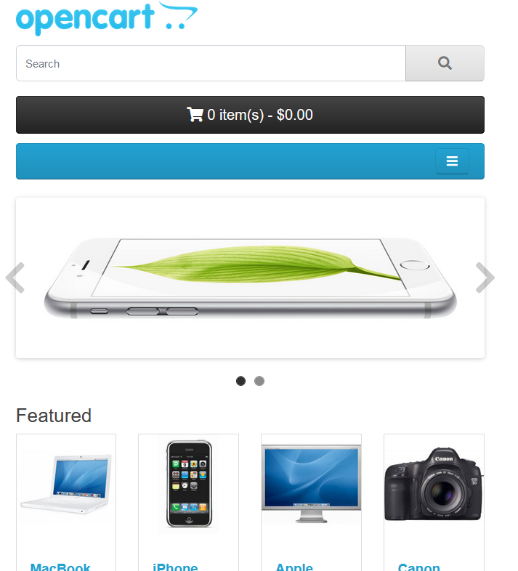

**------------------------------------------------------------------------------**

**FRS => Functional Requirements Specification**

**Mockup Screen** => it is dummy screen. which will design before actual software design.

**Test Plan Doc** => which is describe the socp of the testing.(feature has to be tested, feature has not to be tested, schedules, what are the tool we used, what type of testing we conduct etc.. )

**Test Plane DOC**

**--------------**

