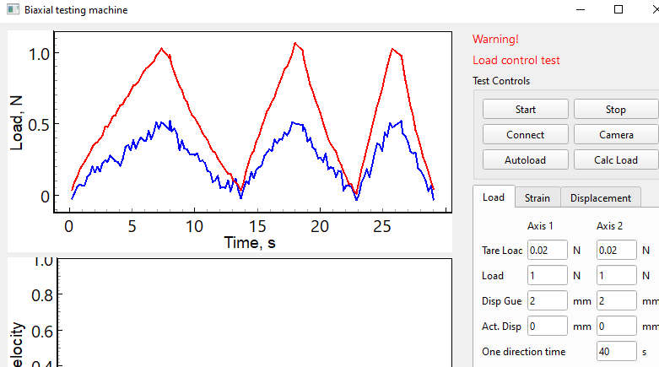

Timer started

time_to_load1: 11.504, time_to_load2: 7.148, current_cycle_time: 7.32477

Corr1: 1.456, Corr2: 0.981, Velocity1: 0.05, Velocity2: 0.05

time_to_load1: 21.258, time_to_load2: 17.747, current_cycle_time: 4.27741

Corr1: 4.176, Corr2: 3.519, Velocity1: 0.0728, Velocity2: 0.04905

time_to_load1: 27.042, time_to_load2: 25.653, current_cycle_time: 2.8358

Corr1: 7.829, Corr2: 7.437, Velocity1: 0.1092, Velocity2: 0.07358

LoadControlTest: Test finished

