**Assignment – 5**

**Which components have you used in J-meter.**

J-Meter offers a variety of components used to design and execute test plans. Common components include:

1. **Thread Group**: Controls the number of threads (virtual users) and their behaviour.
2. **Samplers**: Send requests to the server (e.g., HTTP Request, FTP Request).
3. **Listeners**: Display test results (e.g., Graph Results, Summary Report).
4. **Timers**: Introduce delays between requests.
5. **Assertions**: Validate the response from the server.
6. **Pre-processors and Postprocessors**: Modify requests or extract data from responses.
7. **Config Elements**: Define default settings for Samplers (e.g., HTTP Header Manager).

**How can you set the number of Virtual users in J-meter?**

The number of virtual users is controlled using the **Thread Group** component:

1. Navigate to the **Thread Group** in your test plan.
2. Set the following parameters:
   * **Number of Threads (users)**: The total number of virtual users.
   * **Ramp-up Period (seconds)**: The time to start all users gradually.
   * **Loop Count**: The number of iterations for each user.

**How J-Meter interacts with the application?**

J-Meter simulates real-world user behaviour by sending requests (HTTP, HTTPS, FTP, JDBC, etc.) to the application under test. It measures the application’s response times, throughput, and other metrics to evaluate performance.

**Number of VUsers Required for Load Testing**

The number of VUsers depends on:

* Application size and user base.
* Expected traffic levels.
* Test objectives (e.g., stress testing vs. load testing). A baseline often involves 1-2% of the actual user base for moderate load testing.

**Relationship between Response Time and Throughput**

* **Response Time**: The time taken for a request to complete.
* **Throughput**: The number of requests processed per unit time.
  + As throughput increases, response time increased.
  + Throughput indicates the scalability, and response time indicates speed.
  + Throughput focus on server capacity and response time focus user experience.
  + Ex. Throughput – server might handle 500 order per second.
  + Ex. Response time- click on new page and page open in 2 seconds.

**What is Automation Testing?**

Automation testing involves using tools or scripts to execute test cases automatically, reducing manual effort. It improves accuracy, speed, and test coverage.

* **Which Are The Browsers Supported By Selenium Ide?**
* Google Chrome
* Mozilla Firefox
* **What are the benefits of Automation Testing?**

1. Faster execution compared to manual testing.
2. Consistent and repeatable tests.
3. Supports regression testing.
4. Increases test coverage.
5. Reduces human error.
6. Enables continuous integration (CI/CD).

* **What are the advantages of Selenium?**

1. Open-source and free to use.
2. Supports multiple programming languages (e.g., Java, Python, C#).
3. Cross-platform compatibility.
4. Extensive browser support (Chrome, Firefox, Safari, Edge, etc.).
5. Integrates well with CI/CD tools.

* **Why testers should opt for Selenium and not QTP?**

1. **Cost**: Selenium is free, while QTP (now UFT) is commercial.
2. **Platform Support**: Selenium supports Windows, Mac, and Linux; QTP is Windows-only.
3. **Browser Support**: Selenium supports more browsers than QTP.
4. **Flexibility**: Selenium supports multiple programming languages, while QTP mainly uses VBScript.
5. **Community**: Selenium has a larger, active community for support.

* **To test the Performance testing on “Tops Technologies website”**

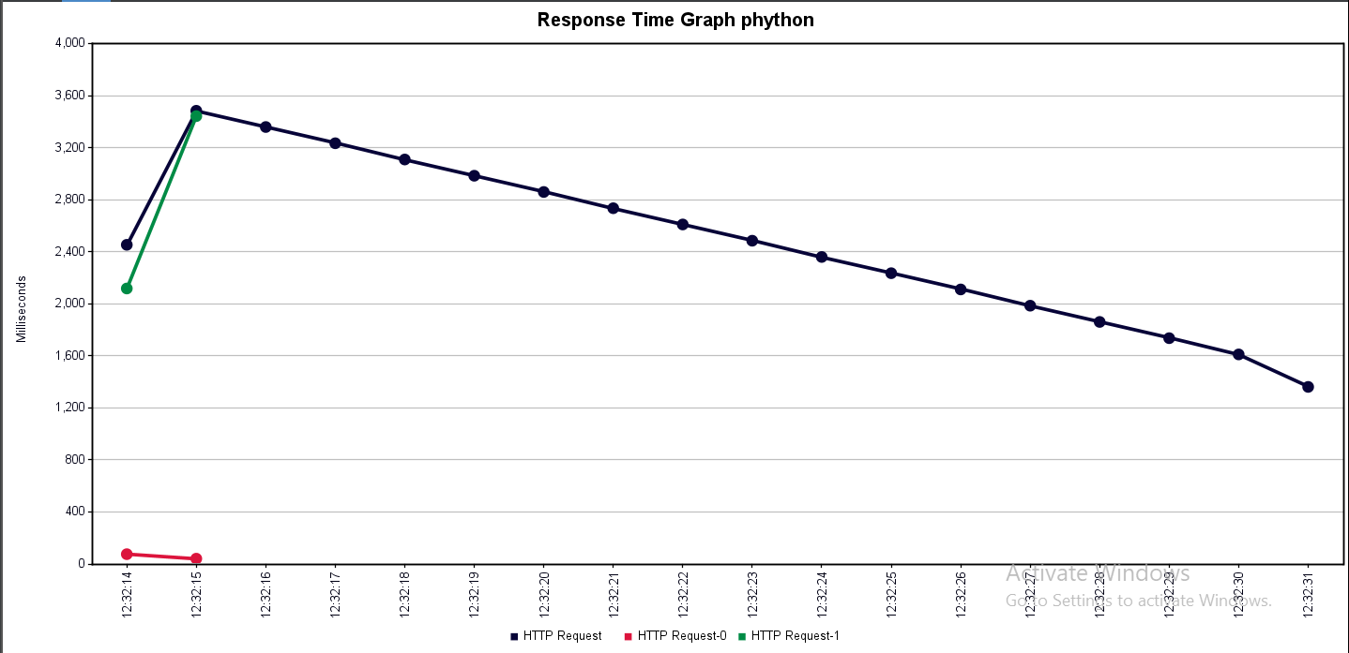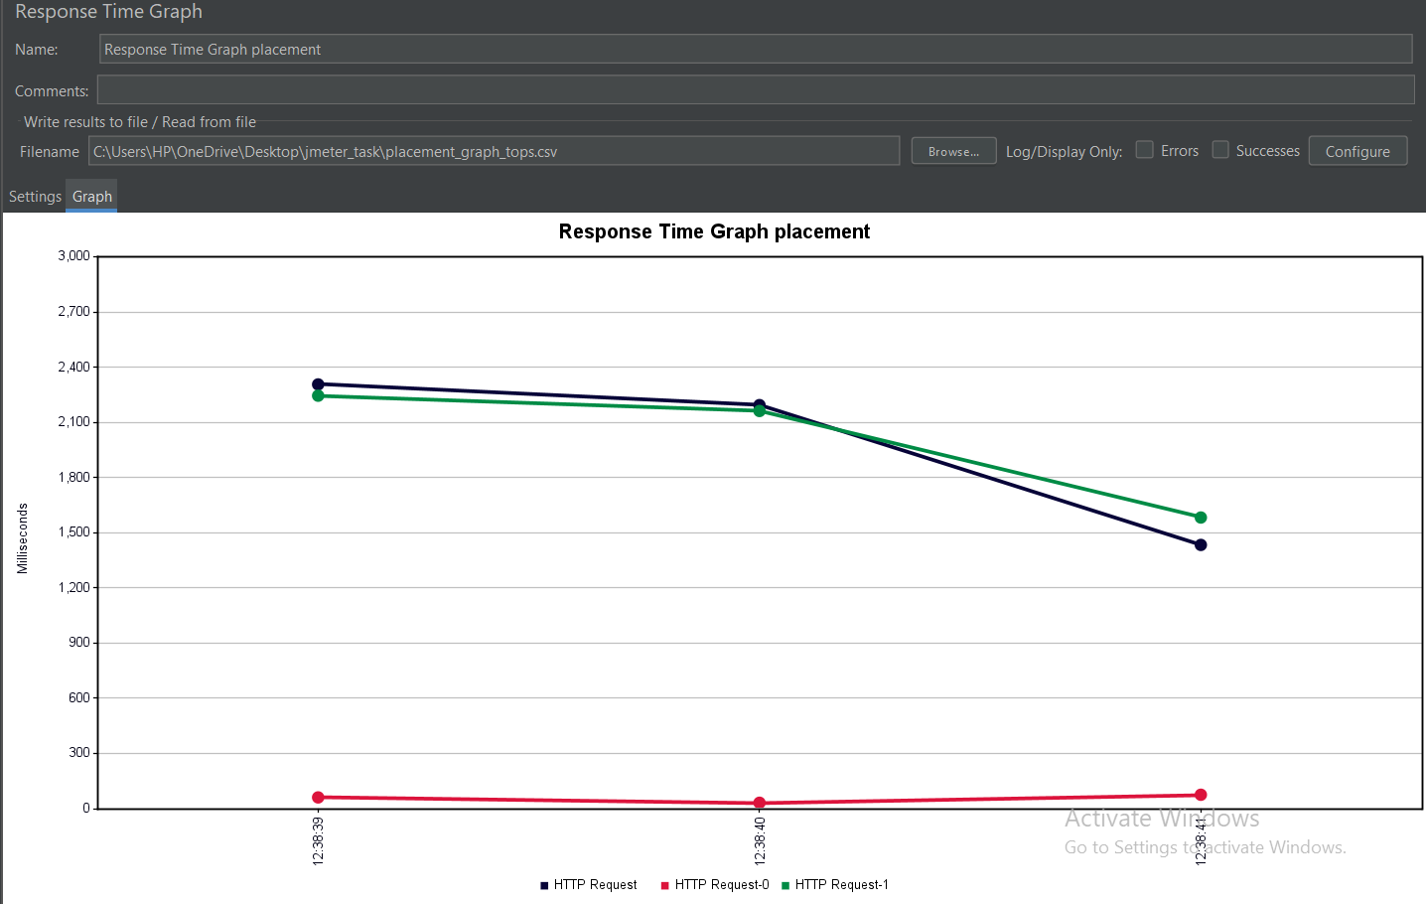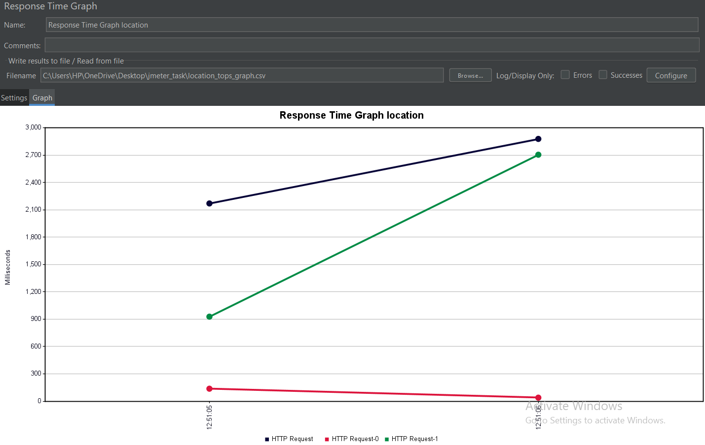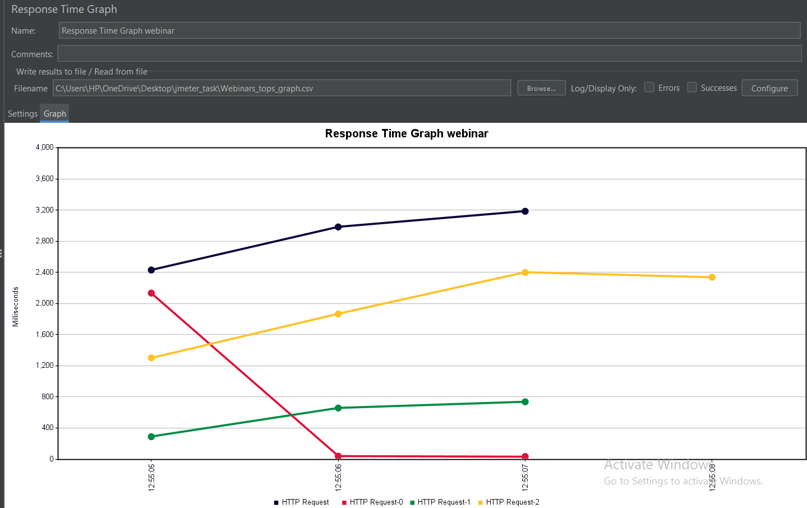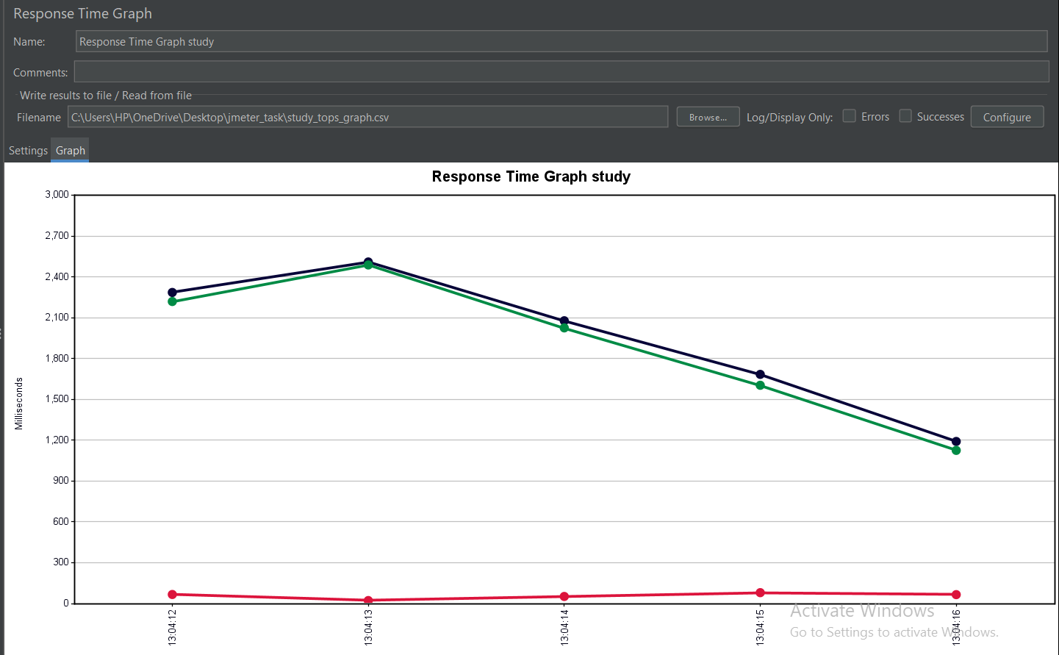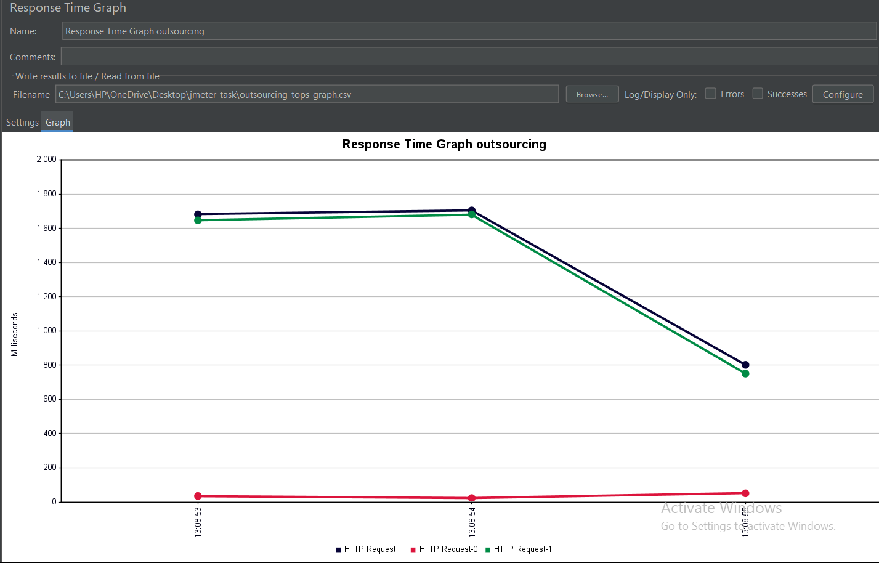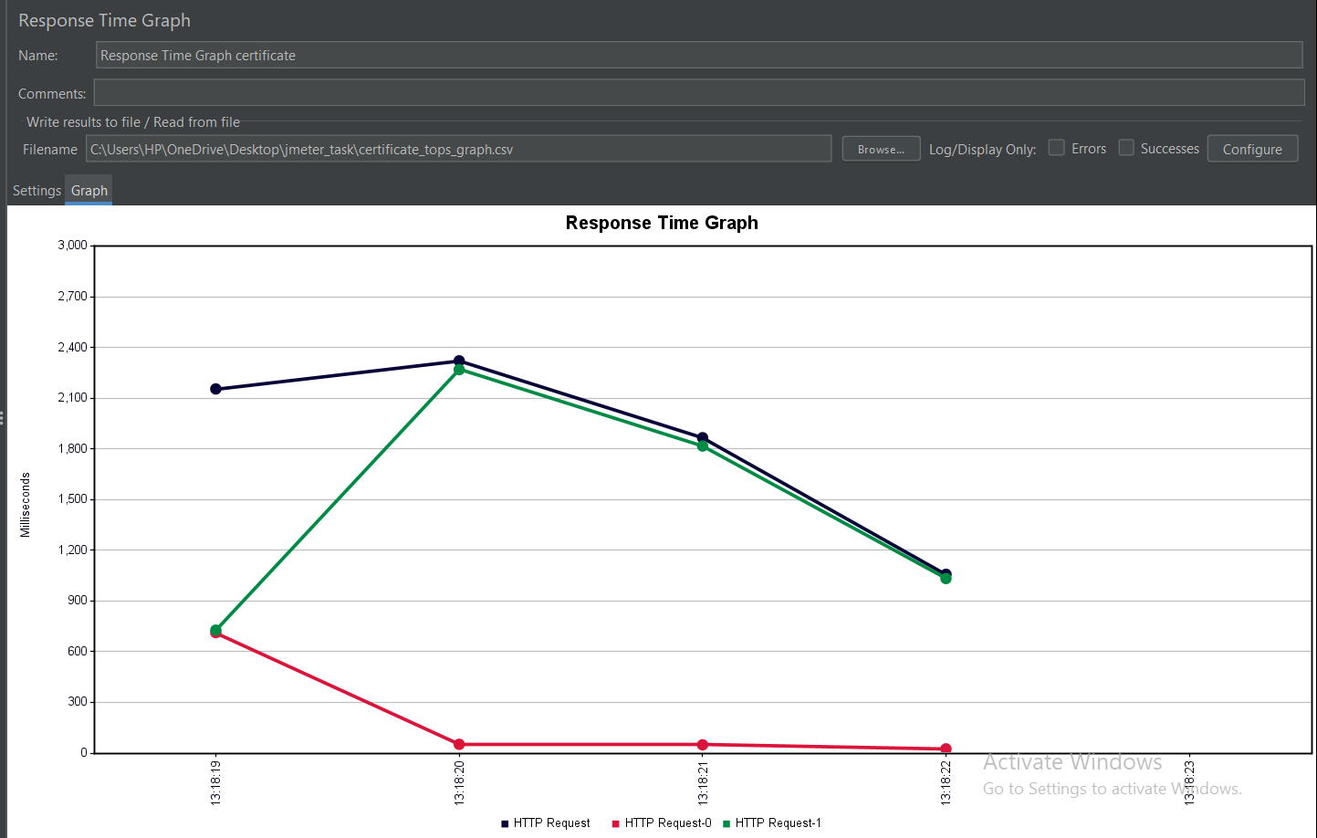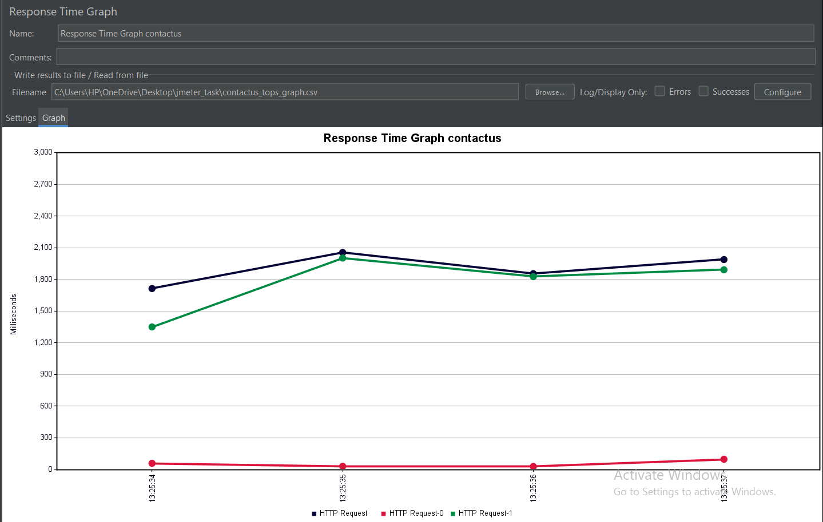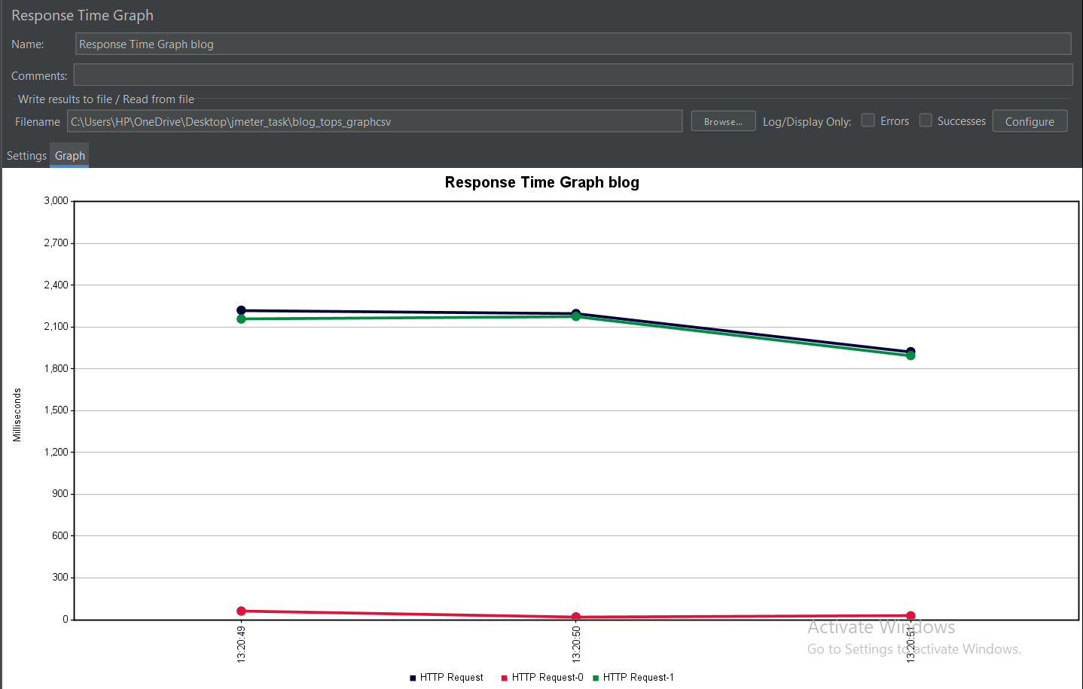

* **To test the Performance testing on “Saucedemo website”**