Batch: B2 Roll No.: 1411099

Experiment No. 9

Grade: AA / AB / BB / BC / CC / CD /DD

Signature of the Staff In-charge with date

Title: Implementation of Backtracking Algorithm

Objective: To learn the Backtracking strategy of problem solving for Graph Colouring problem
CO to be achieved:

Sr. No | Objective
CO 1 | Compare and demonstrate the efficiency of algorithms using asymptotic complexity notations.
CO 2 | Analyze and solve problems for divide and conquer strategy, greedy method, dynamic programming approach and backtracking and branch & bound policies.
CO 3 | Analyze and solve problems for different string matching algorithms.

Books/ Journals/ Websites referred:
- Ellis horowitz, Sarataj Sahni, S.Rajsekaran,” Fundamentals of computer algorithm”, University Press
- T.H.Cormen ,C.E.Leiserson,R.L.Rivest and C.Stein,” Introduction to algortihtms”,2nd Edition ,MIT press/McGraw Hill,2001
- http://www.math.utah.edu/~alfeld/queens/queens.html
- http://www-isl.ece.arizona.edu/ece175/assignments275/assignment4a/Solving%208%20queen%20problem.pdf
- http://www.slideshare.net/Tech_MX/8-queens-problem-using-back-tracking
- http://www.mathcs.emory.edu/~cheung/Courses/170.2010/Syllabus/Backtracking/8queens.html
- http://www.geeksforgeeks.org/backtracking-set-3-n-queen-problem/
- http://www.hbmeyer.de/backtrack/achtdamen/eight.htm

Pre Lab/ Prior Concepts:
Data structures, Concepts of algorithm analysis

Historical Profile:
Given an undirected graph and a number m, determine if the graph can be colored with at most m colors such that no two adjacent vertices of the graph are colored with same color. Here coloring of a graph means assignment of colors to all vertices.
Input:
1) A 2D array graph[V][V] where V is the number of vertices in graph and graph[V][V] is adjacency matrix representation of the graph.
Output:
An array color[V] that should have numbers from 1 to m. color[i] should represent the color assigned to the ith vertex. The code should also return false if the graph cannot be colored with m colors.
Following is an example graph can be colored with 3 colors.
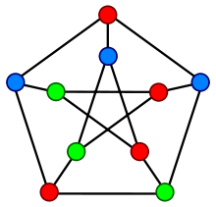

New Concepts to be learned:
Application of algorithmic design strategy to any problem, Backtracking method of problem solving Vs other methods of problem solving problem graph colouring and its applications.

Algorithm Graph colouring Problem:-

Example Graph Colouring Problem:
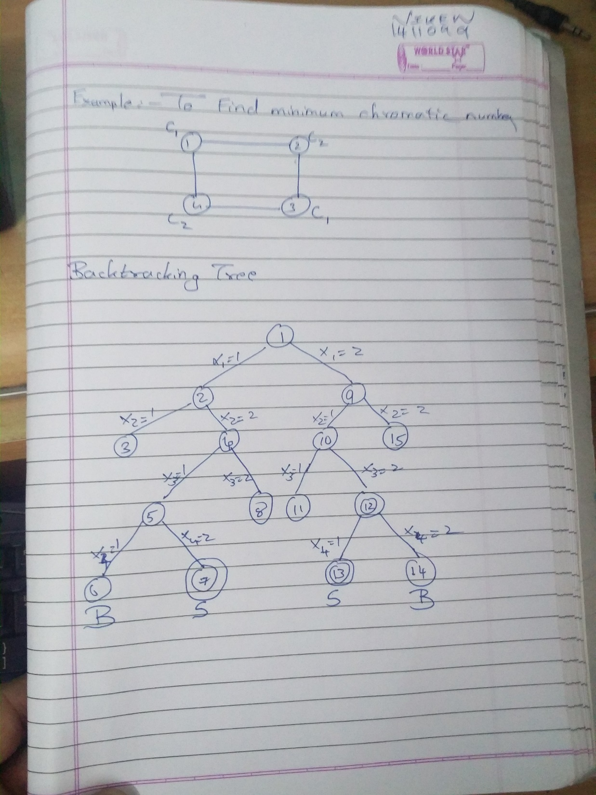

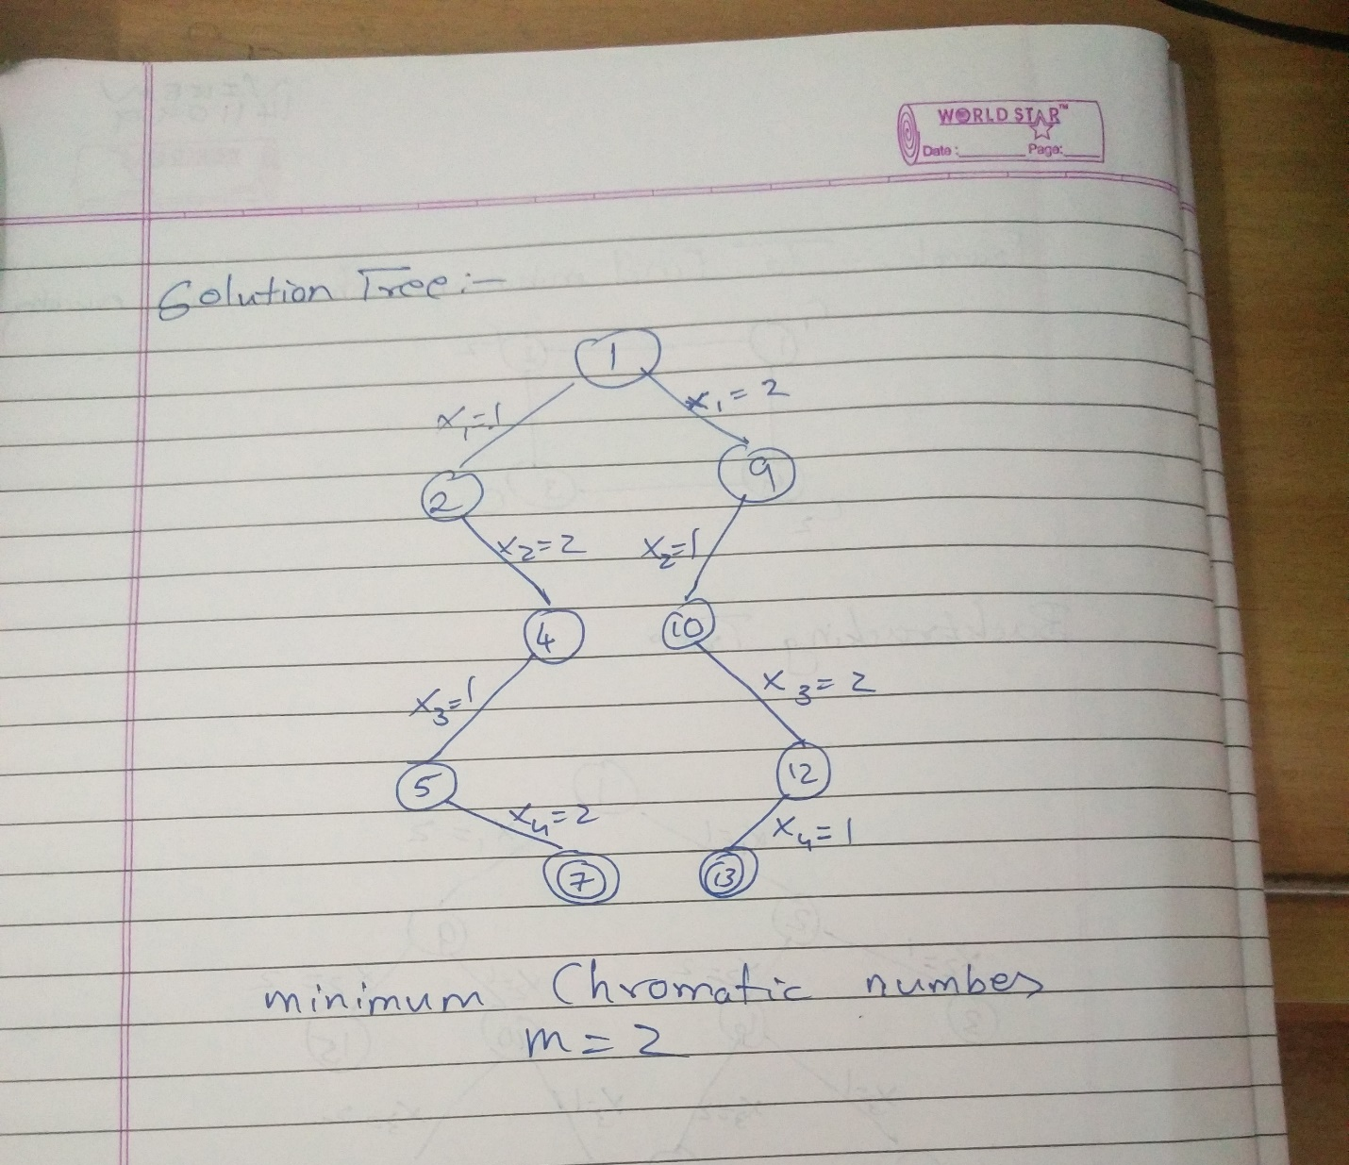

Analysis of Backtracking solution for Graph Colouring Problem:

There will be O(V^m) configurations of colors where V= number of vertices & m= Chromatic number.

