|  |  |
| --- | --- |
|  | **30 LESSONS** |
| 1 | Pronouns, to be, alphabet, reading rules |
| 3 | Present simple |
| 4 | Future simple |
| 5 | Past simple |
| 6 | Irregular verbs |
| 7 | Simple Tense |
| 8 | Negative and interrogative sentences - Simple |
| 9 | Present Continuous |
| 10 | Future Continuous |
| 11 | Past Continuous |
| 12 | Continuous Tense |
| 13 | Negative and interrogative sentences - Continuous |
| 14 | Present Perfect |
| 15 | All Tenses |
| 16 | Negative and interrogative sentences - All Tenses |
| 17 | Prepositions of place |
| 18 | What is the time |
| 19 | Dates in English |
| 20 | There is/there are |
| 21 | Articles |
| 22 | Singular and Plural nouns |
| 23 | Comparative and Superlative Adjectives |
| 24 | Active Voice and Passive Voice |
| 25 | Modal verbs |
| 26 | Would and Used to |
| 27 | Imperative sentences |
| 28 | 8 basic rules of Grammar (part 1) |
| 29 | 8 basic rules of Grammar (part 2) |
| 30 | Repeat: Active and passive voice |
| 31 | Repeat: Prepositions of Place |
| 32 | Repeat: Singular & Plural, Comperative & Superlative |
| 33 | Repeat: modal verbs |
| 34 | Repeat: date and time |
| 35 | Repeat: Irregular verbs |
| 36 | Repeat: Simple Tense |
| 37 | Repeat: Continues Tense |
| 38 | Repeat: Present Perfect |
| 39 | Repeat: Negative and interrogative sentences - All Tenses |
| 40 | Future Perfect and Past Perfect |

**LESSON 1**

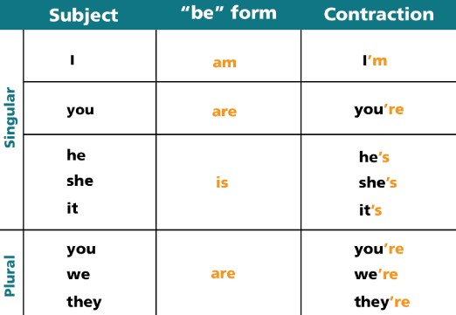

**LESSON 2**

**LESSON 3**

**LESSON 4**

**LESSON 5**

**LESSON 6**

**LESSON 7**

**LESSON 8**

**LESSON 9**

**LESSON 10**

**LESSON 11**

**LESSON 12**

**LESSON 13**

**LESSON 14**

**LESSON 15**

**LESSON 16**

**LESSON 17**

**LESSON 18**

**LESSON 19**

**LESSON 20**

**LESSON 21**

**LESSON 22**

**LESSON 23**

**LESSON 24**

**LESSON 25**

**LESSON 26**

**LESSON 27**

**LESSON 28**

**LESSON 29**

**LESSON 30**