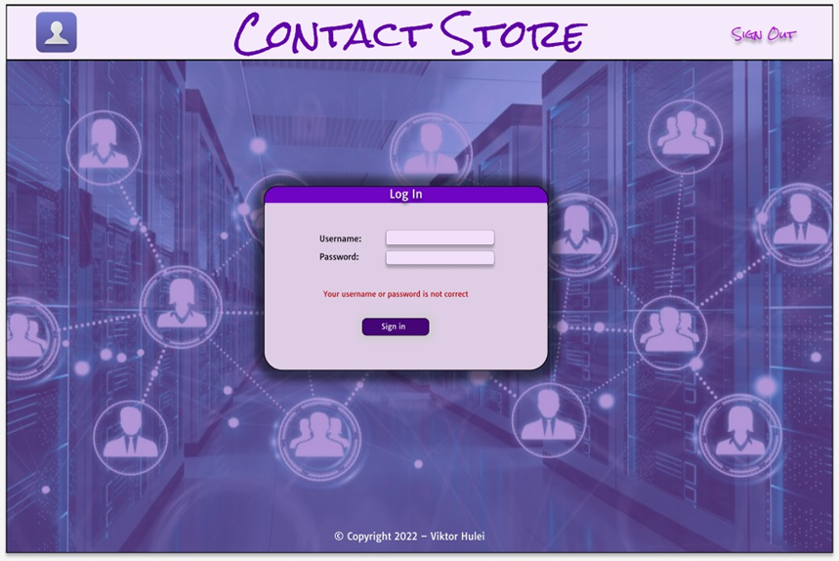1. Login screen

2. After a successful login – 1) can change picture and update password, 2) list of contacts is showing, which you can filter by name, number, company or country, 3) no contact is selected:

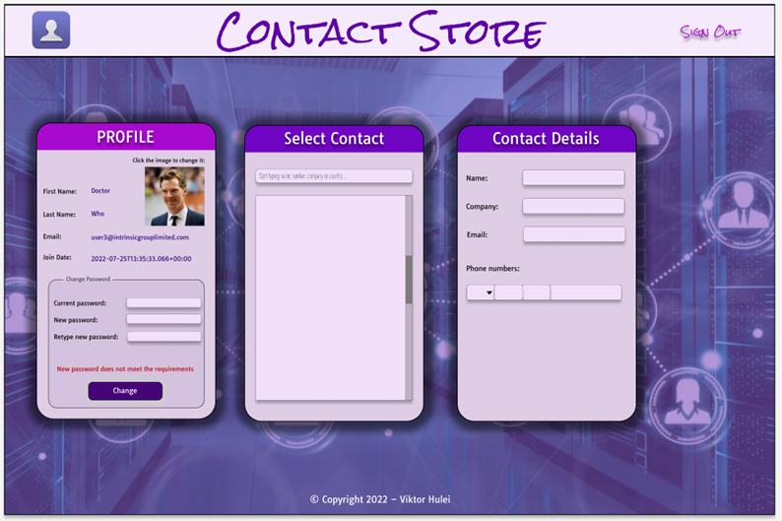

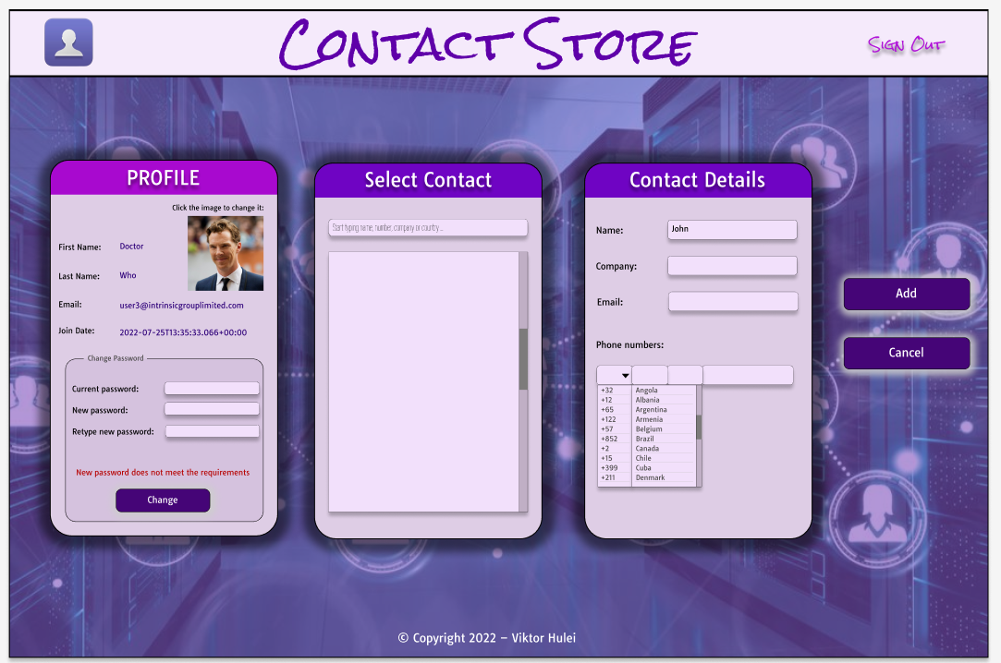3. As soon as you start typing in the fields for the new contact, ADD and CANCEL buttons appear:

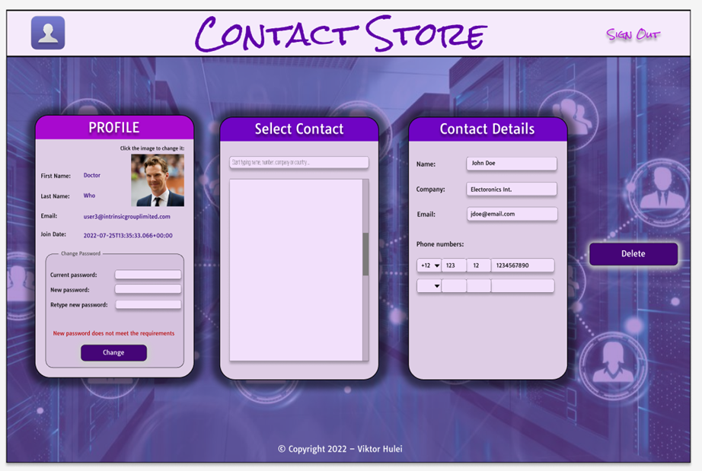4. If you select the contact from the list, it fills in the details and DELETE button appears:

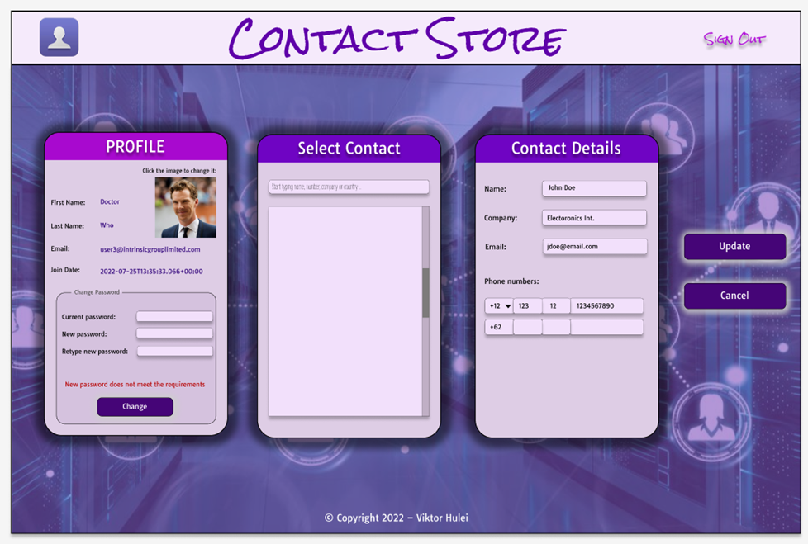5. As soon as you start changing anything in the fields or try to add a new number, UPDATE and CANCEL buttons appear: