

BARCODE GENERATOR – MAGENTO 2

INSTALLATION GUIDE

Table Of Contents

Installation..….……………………………………………………………………….3
option1..................................................................….........3
option2……………................................................................4

Installation:

There are two ways of installing extension in magento2.

1) Using COMMAND LINE.
2) Manually install extension.

Option 1: Magento 2 install extension using COMMAND LINE (Recommended).

Follow below steps to install extension from the command line.

Step 1: Install laminas-barcode library using below command.
( require this in magento 2.3.x or 2.4.x only )

:- composer require laminas/laminas-barcode:*

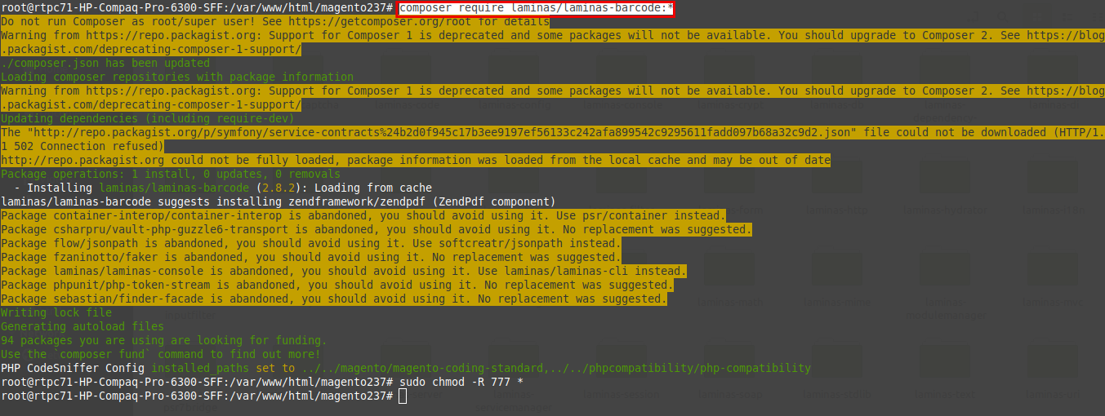

Step 2: Download the extension and unzip it.

Step 3: Upload it to code directory in your magento installation’s app directory.
If code directory does not exists then create.

Step 4: Disable the cache under System → Cache Management.

Step 5: Enter the following at the command line:
php bin/magento setup:upgrade
php bin/magento setup:static-content:deploy

Step 6: Once you complete above steps log out and log in back to the admin
panel and switch to Stores → Configuration → Mageants → Barcode - Generator.

The module will be displayed in the admin panel.

Option 2: Magento 2 install extension manually.

Step 1: Install laminas-barcode library using below command.
( require this in magento 2.3.x or 2.4.x only )

:- composer require laminas/laminas-barcode:*

Step 2: Download the extension and unzip it.

Step 3: Upload it to code directory in your magento installation’s app directory.
If code directory does not exists then create.

Step 4: Disable the cache under System → Cache Management Edit
app/etc/config.php file and add one line code:
‘Mageants_BarcodeGenerator label’ → 1

Step 5: Disable the cache under System → Cache Management

Step 6: Once you complete above steps log out and log in back to the
admin panel and switch to Stores → Configuration → Mageants →
Mageants_BarcodeGenerator, the module will be displayed in the admin panel.

Thank you!
if you have any questions or feature suggestions, please contact us at: https://www.mageants.com/contact-us

Your feedback is absolutely welcome!

