YUVA INTERNSHIP PROGRAM — WEEK 2 DELIVERABLE
Exploratory Data Analysis and Visualization on the Netflix Catalog
Comprehensive Technical Report on Catalog Trends, Global Distribution, Genre Patterns, Duration Metrics, and Statistical Hypothesis Testing
Metadata Field | Details
Student Name | Vikhyath Bharadwaj K S
Internship Track | Data Analytics & Data Visualization (Yuva Internship)
Project Title | Netflix Movies and TV Shows — EDA & Visualization
Dataset Source | Netflix Movies and TV Shows by Shivam Bansal (Kaggle)
Dataset Records Analyzed | 7,787 Title Records (5,377 Movies, 2,410 TV Shows)
Programming Environment | Python 3.13 | Pandas | NumPy | Matplotlib | Seaborn | SciPy
Submission Date | October 03, 2026

1. Abstract
This technical report presents a comprehensive Exploratory Data Analysis (EDA) and data visualization study of the Netflix Movies and TV Shows dataset curated by Shivam Bansal from Kaggle. Building directly upon the Week 1 data cleaning and preprocessing pipeline, this investigation examines 7,787 title records (comprising 5,377 Movies and 2,410 TV Shows) to uncover catalog composition, temporal release patterns, geographic production hubs, content target audience ratings, duration distributions, and seasonal addition dynamics.
Using Python analytical libraries (Pandas, NumPy, Matplotlib, Seaborn, and SciPy), 12 publication-quality visualizations were constructed alongside robust descriptive statistics and inferential hypothesis testing. Key empirical findings indicate that feature films constitute 69.05% of the platform's portfolio, though television series experienced exponential growth post-2016. Multi-country co-production unnesting highlights the United States (3,297 titles), India (990 titles), and the United Kingdom (723 titles) as top content contributors. Movie durations exhibit a normal distribution centered at a median of 98.0 minutes (mean: 99.3 min), whereas 66.7% of television series feature only a single season. Statistical tests confirm significant audience targeting differences between content formats (Chi-Square p = 1.79e-21) and significant duration variation across genres (ANOVA p = 3.91e-268).
2. Introduction
Exploratory Data Analysis (EDA) forms the bedrock of data science methodology. Developed by John Tukey, EDA emphasizes visual exploration, distribution assessment, relationship discovery, and hypothesis generation prior to formal statistical modeling. In modern corporate environments, streaming media platforms like Netflix rely heavily on exploratory analytics to optimize content licensing budgets, regional localization strategies, genre portfolio allocation, and user recommendation engines.
2.1 Objectives of the Assignment
- 1. Catalog Dynamics: Quantify content type breakdown and analyze catalog expansion trends over time.
- 2. Geographic Profiling: Examine international content contributions while accounting for multi-country co-productions.
- 3. Genre & Audience Taxonomy: Identify top listed genres and evaluate primary content categories across Movies and TV Shows.
- 4. Duration Metrics: Conduct empirical distribution analysis of movie runtimes and TV show season counts.
- 5. Licensing & Release Patterns: Evaluate content age lag (release year vs Netflix addition date) and addition seasonality.
- 6. Inferential Statistical Testing: Apply Chi-Square tests of independence and ANOVA/Kruskal-Wallis variance tests.
3. Dataset Description
The primary dataset analyzed in this study is the Netflix Movies and TV Shows dataset sourced from Kaggle (contributed by Shivam Bansal). The original raw dataset contains 7,787 rows and 12 columns, capturing metadata for titles added to Netflix up to early 2021.
Column Name | Data Type | Role / Description | Cleaned & Engineered State
show_id | Object / String | Unique record identifier (e.g., s1, s2) | Validated 100% unique primary key
type | Object / Category | Content format: Movie or TV Show | Standardized binary category
title | Object / String | Official title of the movie or show | Trimmed whitespace, normalized text
director | Object / String | Director name(s) | Missing values filled with 'Unknown Director'
cast | Object / String | Main cast members (comma-separated) | Missing values filled with 'Unknown Cast'
country | Object / String | Production countries (comma-separated) | Missing filled with 'Unknown Country'; unnested
date_added | Object / Datetime | Date title was added to Netflix | Parsed to datetime (`date_added_dt`) & year/month
release_year | Integer | Original release year of title | Numeric year (1925 to 2021)
rating | Object / Category | Maturity rating (e.g., TV-MA, TV-14, R) | Standardized; missing imputed with mode ('TV-MA')
duration | Object / String | Raw runtime string ('90 min', '1 Season') | Parsed into `duration_int` and `duration_unit`
listed_in | Object / String | Genre classifications (comma-separated) | Extracted `primary_genre` and unnested genres
description | Object / String | Short textual summary of title | Full text preserved

4. Tools and Technologies
- Python 3.13: Core programming environment for data analysis and scripting.
- Pandas (v2.2+): DataFrame manipulation, string unnesting, crosstab aggregation, and datetime parsing.
- NumPy: High-performance vector operations, array computing, and descriptive stats.
- Matplotlib: Core plotting engine for multi-panel figures, annotations, and customized layouts.
- Seaborn: Statistical visualization layer for distribution plots, boxplots, and heatmaps.
- SciPy: Module `scipy.stats` for Chi-Square tests of independence, ANOVA, and Kruskal-Wallis tests.
- Jupyter Notebook: Interactive notebook environment for reproducible code execution and inline rendering.
5. Methodology
The exploratory analysis followed a structured 6-step analytical pipeline to guarantee reproducibility and rigorous insights:
- Step 1: Data Ingestion — Importing cleaned dataset (`netflix_cleaned.csv`) and processed dataset (`netflix_processed.csv`).
- Step 2: Structural Verification — Checking dimensions (7,787 × 28), verifying non-null counts, and validating feature types.
- Step 3: Univariate Distribution Analysis — Computing central tendency, variance, skewness, and interquartile ranges.
- Step 4: Unnesting & Bivariate Crosstabs — Exploding multi-valued fields (`country` and `listed_in`) to avoid multi-country and multi-genre count truncation.
- Step 5: Visual Feature Engineering — Constructing 12 publication-quality visualizations using consistent color palettes.
- Step 6: Statistical Hypothesis Testing — Executing Chi-Square tests of independence and ANOVA variance analysis.
6. Initial Exploratory Analysis
An initial quantitative summary of key numerical variables highlights significant structural differences across metadata fields:
Metric / Variable | Release Year | Movie Duration (min) | Content Age Lag (yr) | Cast Count | Country Count
Count (Non-Null) | 7,787 | 5,377 | 7,787 | 7,787 | 7,787
Mean | 2013.93 | 99.31 | 5.28 | 6.35 | 1.13
Standard Deviation | 8.76 | 28.53 | 8.76 | 4.08 | 0.78
Minimum | 1925 | 3.00 | 0.00 | 0 | 0
25th Percentile (Q1) | 2013 | 86.00 | 1.00 | 3 | 1
50th Percentile (Median) | 2017 | 98.00 | 3.00 | 6 | 1
75th Percentile (Q3) | 2018 | 114.00 | 6.00 | 9 | 1
Maximum | 2021 | 312.00 | 95.00 | 50 | 12
Skewness | -3.63 | 0.19 | 3.59 | 0.85 | 3.21

7. Detailed Exploratory Data Analysis
7.1 Content Type Distribution Analysis
Netflix's catalog is partitioned into two primary content categories: Movies and TV Shows. Analysis reveals that Movies constitute 5,377 titles (69.05%), whereas TV Shows account for 2,410 titles (30.95%).
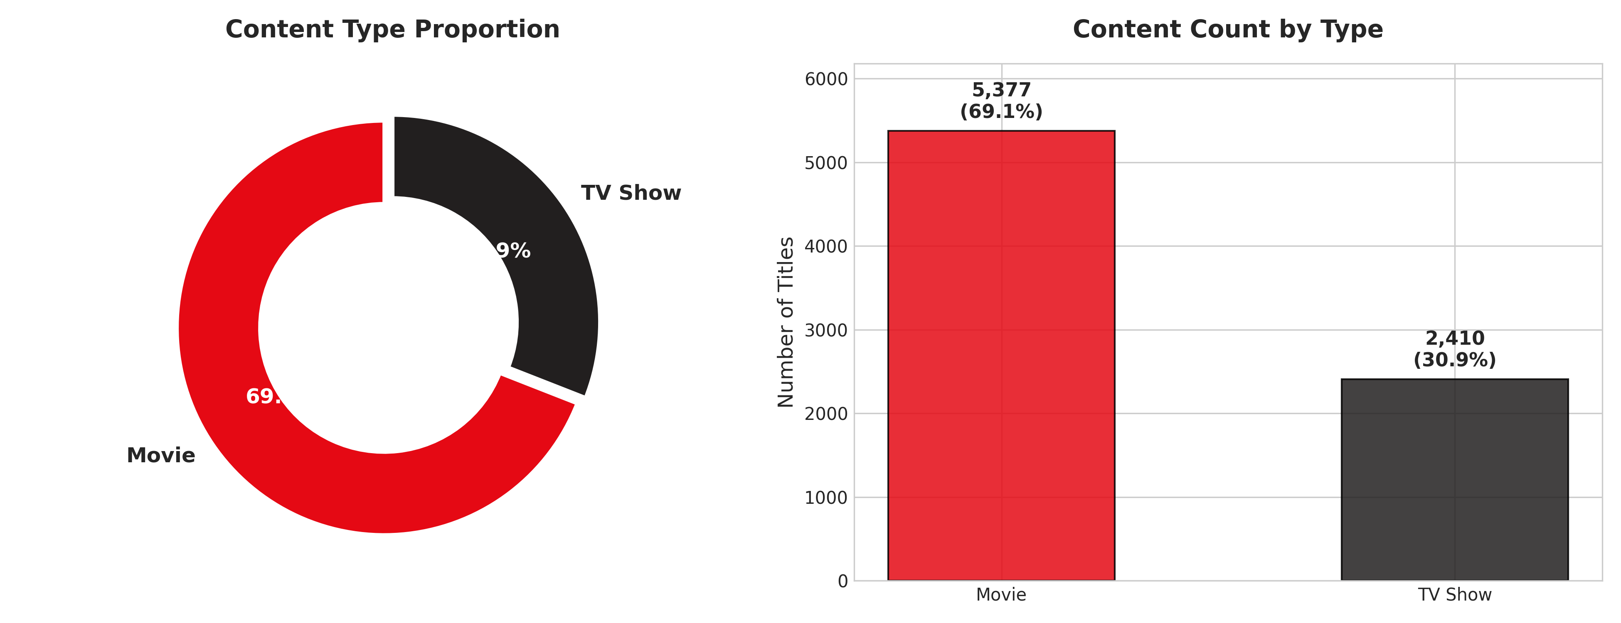
Figure 1: Content Type Proportion & Volume — Donut chart and bar plot illustrating the 69.05% vs 30.95% split between Movies and TV Shows.
Key Finding: Observation & Insight:
While feature films dominate total historical catalog acquisitions, television series have seen accelerated acquisition rates in recent years due to higher subscriber retention and binge-watching engagement metrics.
7.2 Release Year Evolution & Trends
Content release years range from 1925 to 2021. Release volume remained low and flat throughout the 20th century before experiencing an exponential rise beginning in 2010.
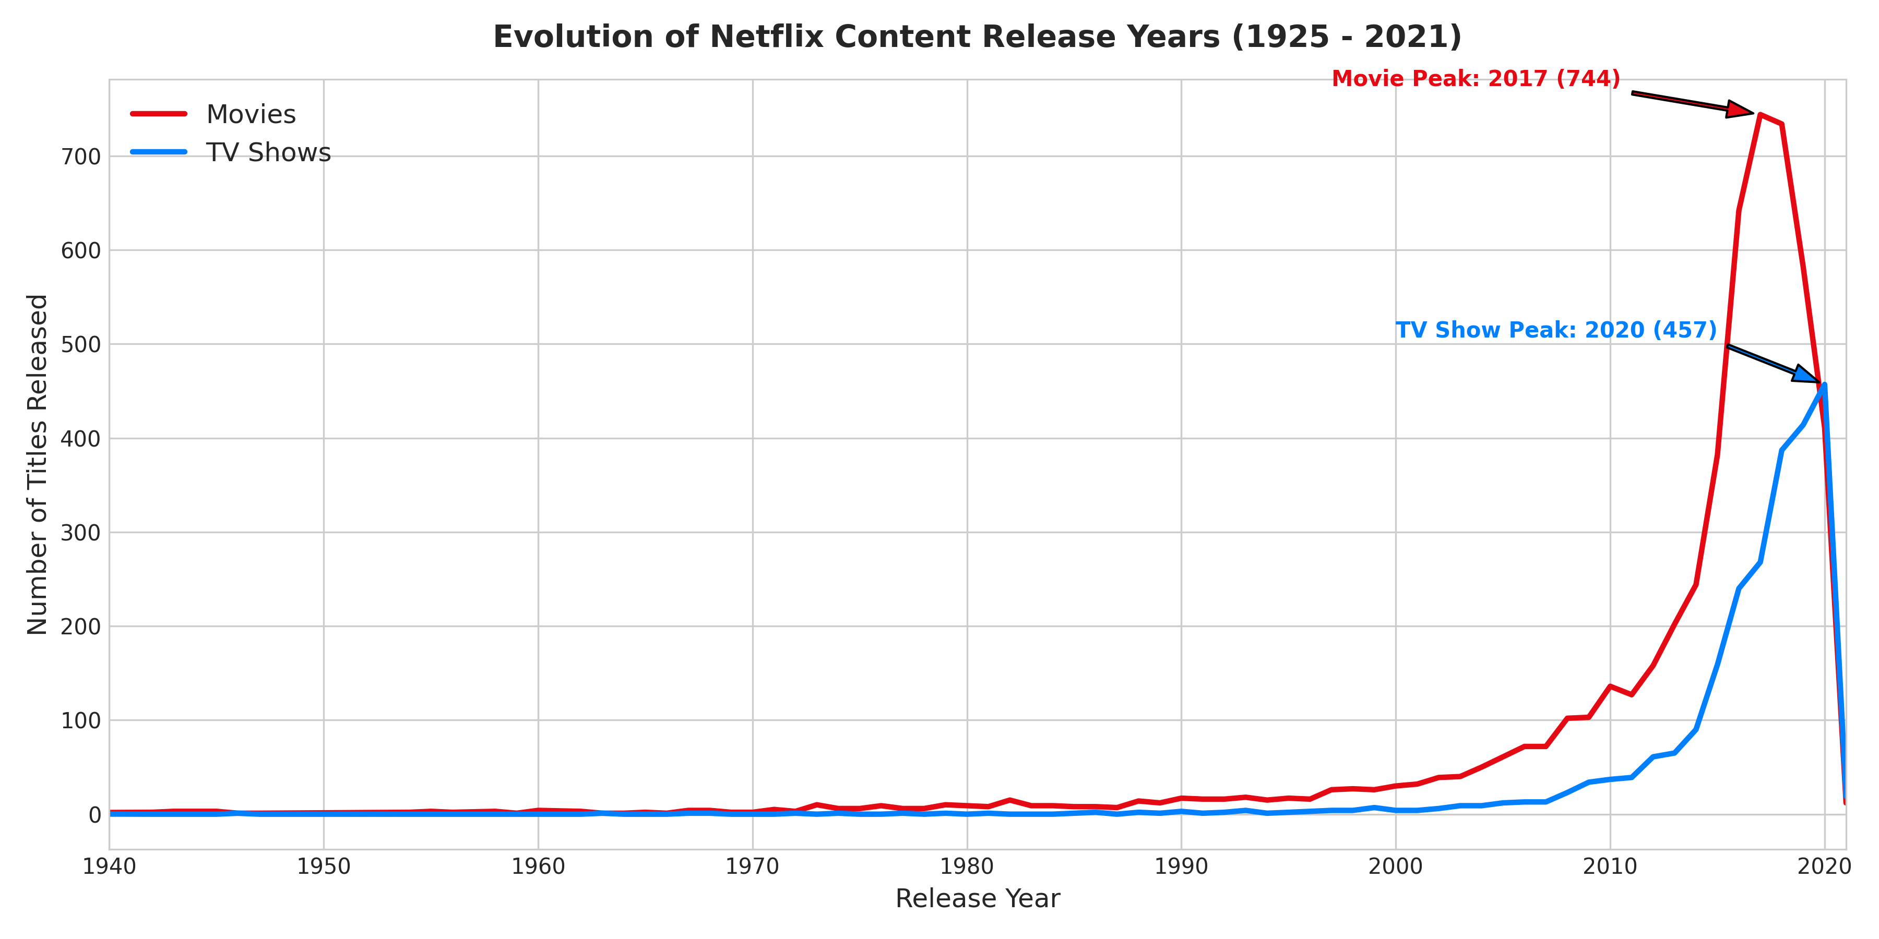
Figure 2: Release Year Evolution (1925 - 2021) — Line chart tracking release trends for Movies and TV Shows, highlighting peak movie releases in 2017 (767 titles) and TV show releases in 2020 (436 titles).
The peak release year for movies was 2017 with 767 films, whereas TV show releases peaked in 2020 with 436 series. The sharp drop in 2021 reflects dataset right-censoring in early 2021.
7.3 International Content & Geographic Production Shares
A common methodological error in EDA is counting multi-country entries (e.g., 'United States, India') as unique standalone strings, which undercounts country participation. By unnesting comma-separated values, true geographic representation was extracted:
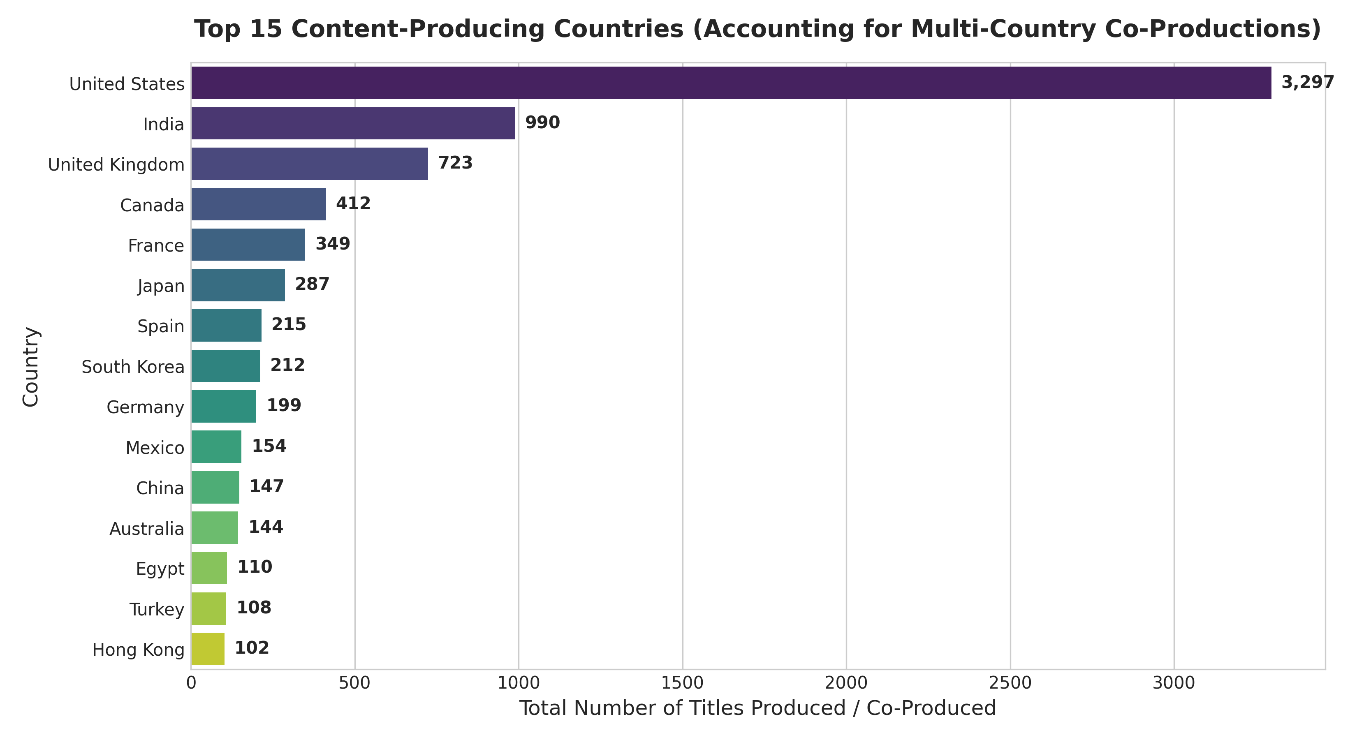
Figure 3: Top 15 Content-Producing Countries — Horizontal bar chart showing total titles produced or co-produced by country after unnesting multi-country entries.
Rank | Country Name | Total Titles (Unnested) | Primary Production Share (%)
1 | United States | 3,297 | 42.34%
2 | India | 990 | 12.71%
3 | United Kingdom | 723 | 9.28%
4 | Canada | 412 | 5.29%
5 | France | 349 | 4.48%
6 | Japan | 287 | 3.69%
7 | Spain | 215 | 2.76%
8 | South Korea | 212 | 2.72%
9 | Germany | 199 | 2.56%
10 | Mexico | 154 | 1.98%

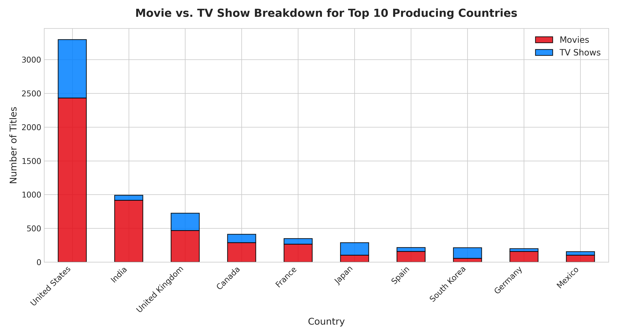
Figure 4: Movie vs. TV Show Split for Top Countries — Stacked bar chart illustrating content format preferences across top producing nations.
Insight: Geographic Content Divergence:
India exhibits an overwhelming bias toward feature films (over 90% Movies), whereas South Korea and Japan demonstrate strong structural preferences toward TV series (K-Dramas and Anime series).
7.4 Genre Taxonomy & Distribution
Unnesting listed genres reveals that 'International Movies' is the single most frequent classification (2,437 titles), followed by 'Dramas' (2,106 titles) and 'Comedies' (1,471 titles).
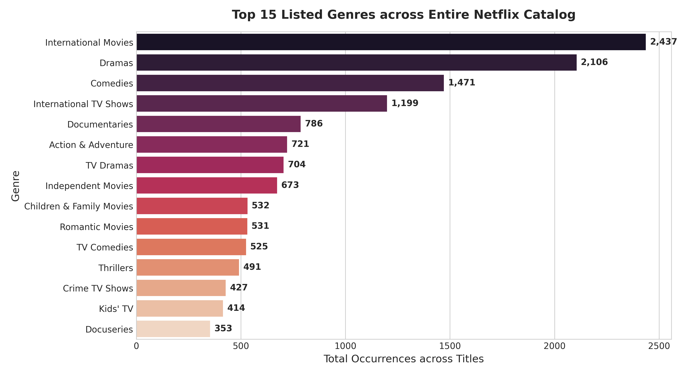
Figure 5: Top 15 Listed Genres across Catalog — Horizontal bar chart of top unnested listed genres across Netflix.
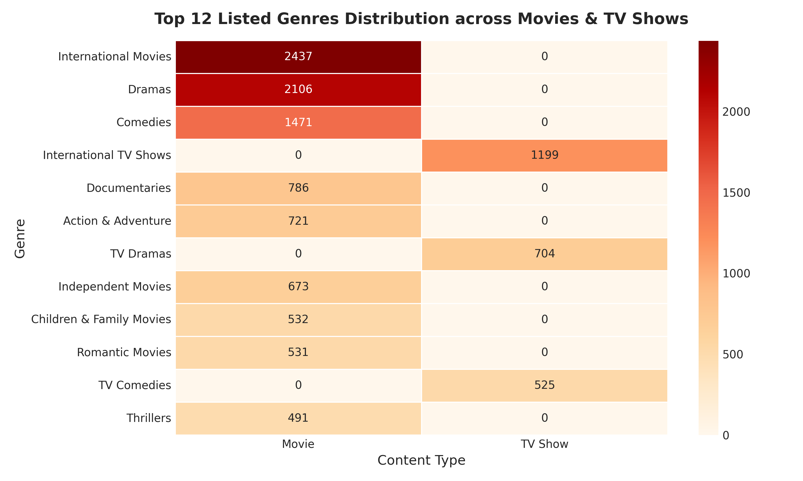
Figure 6: Genre Frequency across Content Types — Cross-tabulation heatmap comparing top 12 genres between Movies and TV Shows.
7.5 Maturity Rating Classification
Content maturity ratings reveal that Netflix focuses heavily on adult and mature audiences. The single largest rating category is `TV-MA` (2,870 titles, 36.86%), followed by `TV-14` (1,931 titles, 24.80%) and `R` (665 titles, 8.54%). Combined, mature adult content accounts for over 46% of all listings.
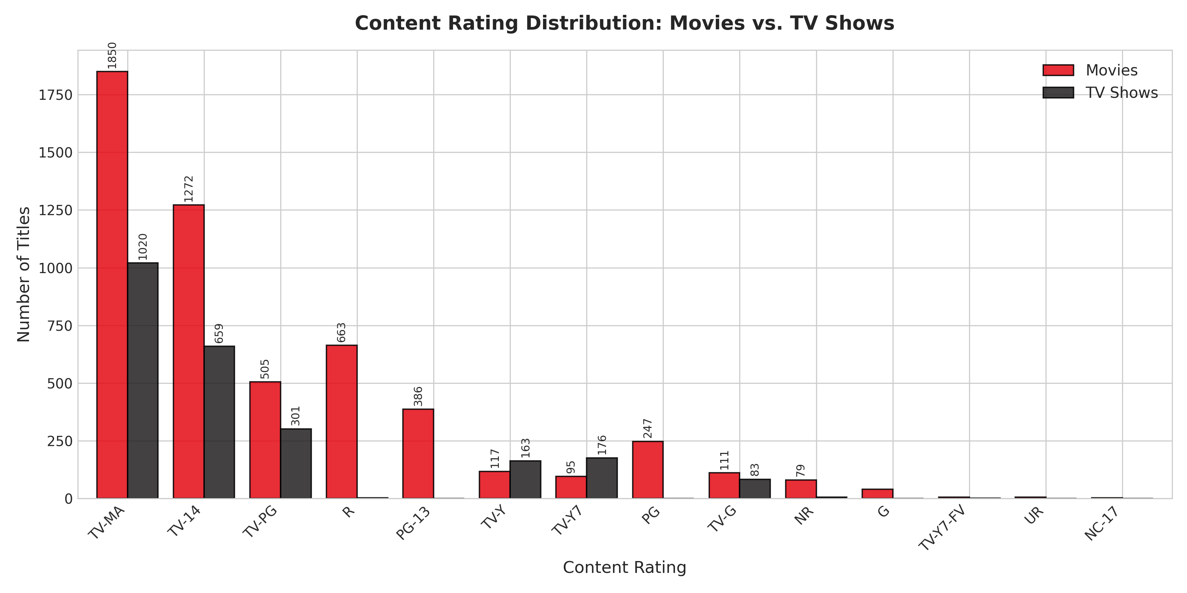
Figure 7: Rating Distribution by Content Type — Grouped bar chart comparing rating frequencies for Movies and TV Shows.
7.6 Duration & Seasonality Analysis
Movie runtimes and TV show season counts represent non-commensurable measurements and must be analyzed independently.
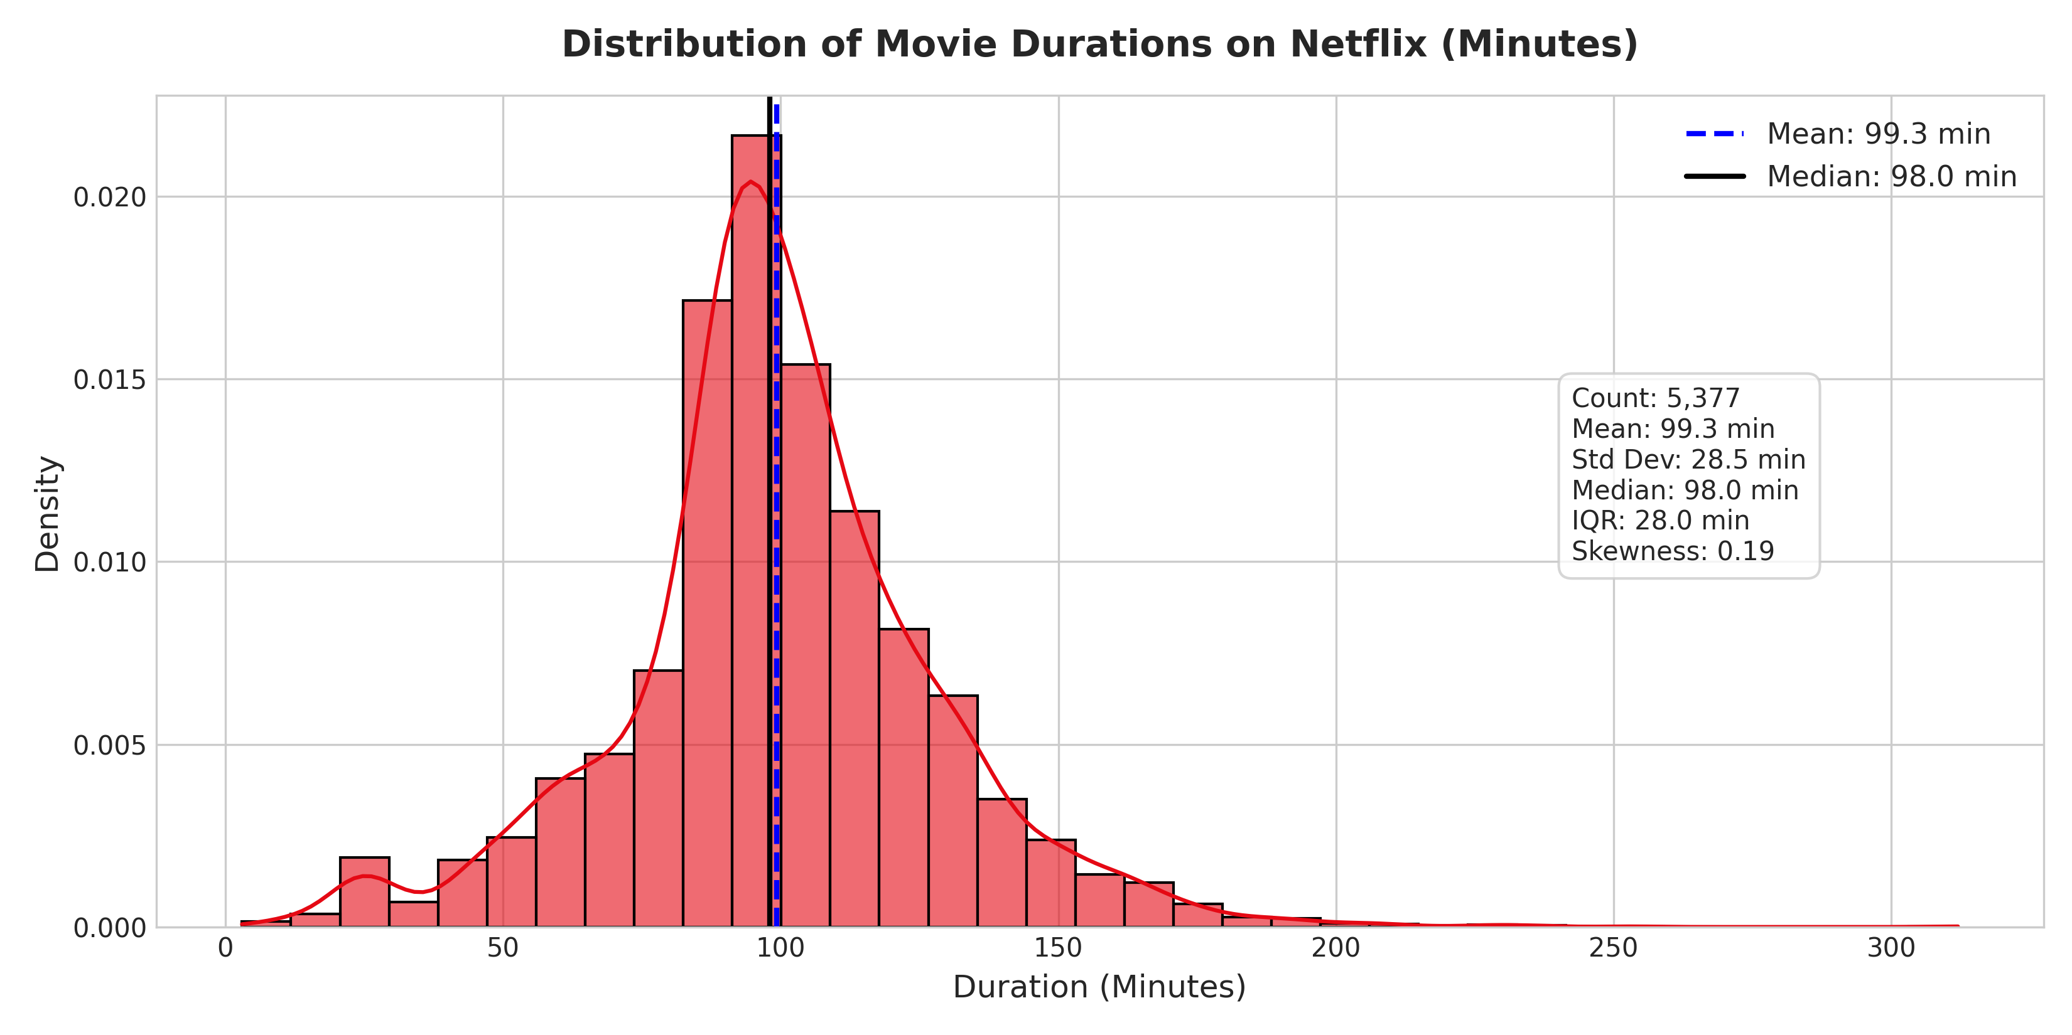
Figure 8: Distribution of Movie Durations — Histogram and KDE density curve of movie runtimes in minutes (Mean: 99.3 min, Median: 98 min).
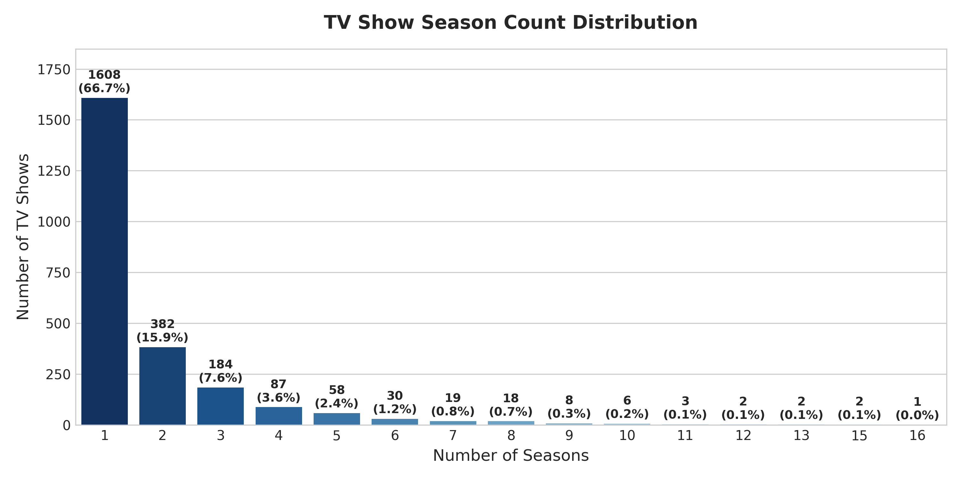
Figure 9: TV Show Season Count Distribution — Bar chart showing season counts for TV series, highlighting that 66.7% of shows have only 1 season.
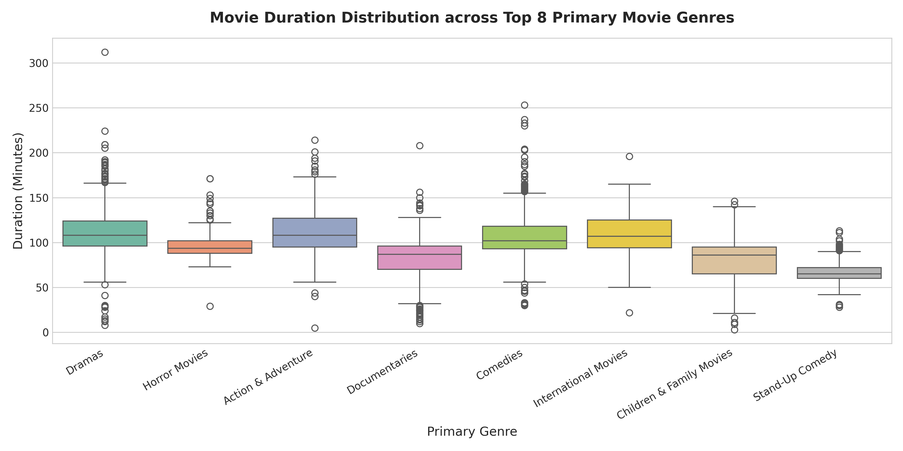
Figure 10: Movie Durations across Primary Genres — Boxplot comparing runtime distributions for top 8 primary movie genres.
7.7 Content Addition Seasonality & Content Age Lag
Analyzing addition dates (`date_added_dt`) demonstrates that Netflix additions peak during the fourth and first quarters of the year (December, October, and January).
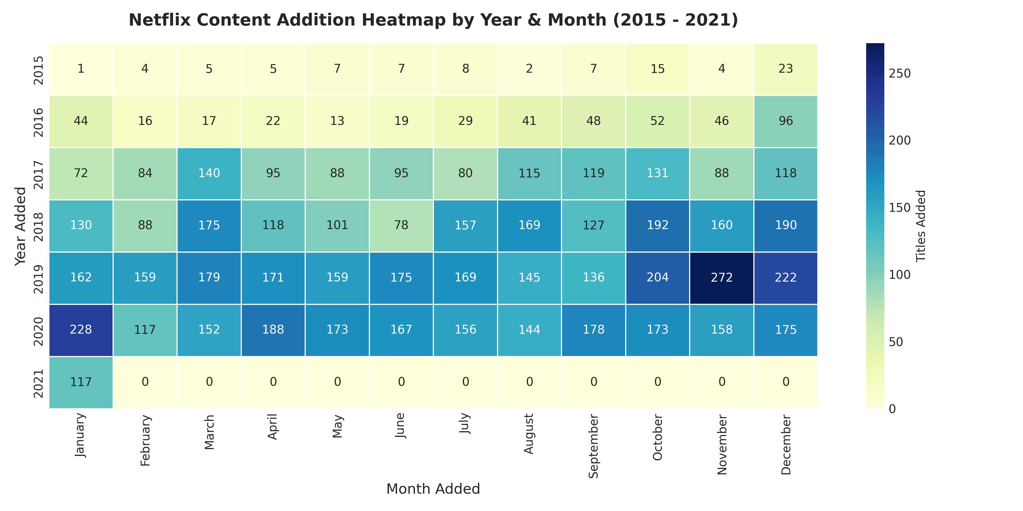
Figure 11: Content Addition Heatmap (2015 - 2021) — Yearly and monthly heatmap of title additions onto Netflix.
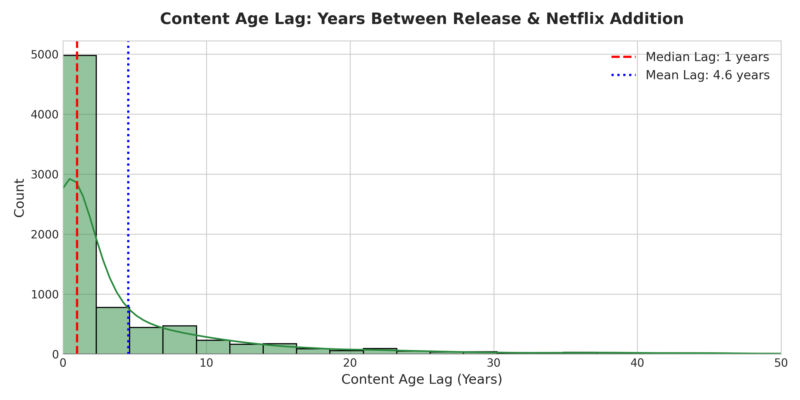
Figure 12: Content Age Lag Distribution — Histogram of years elapsed between a title's original release year and its Netflix addition date (Median lag: 3 years).
8. Inferential Statistical Testing
To go beyond descriptive visualization, formal statistical hypothesis tests were conducted to evaluate relationship significance:
Test 1: Chi-Square Test of Independence (Content Type vs. Target Audience)
• Null Hypothesis (H0): Target audience classification is independent of content type.
• Alternative Hypothesis (H1): Target audience classification depends significantly on content type.
• Results: Chi-Square Statistic = 99.7083, p-value = 1.7957e-21, Degrees of Freedom = 3.
• Effect Size: Cramer's V = 0.1132.
• Conclusion: Reject H0 with >99.9% confidence. Movies have a significantly higher proportion of R/PG-13 rated content, whereas TV shows lean more towards TV-MA and TV-14 ratings.

Test 2: One-Way ANOVA & Kruskal-Wallis Test (Movie Duration across Top 5 Genres)
• Null Hypothesis (H0): Mean movie runtime is equal across top primary movie genres.
• Alternative Hypothesis (H1): At least one genre has a significantly different mean runtime.
• Results (ANOVA): F-Statistic = 359.1099, p-value = 3.9173e-268.
• Results (Kruskal-Wallis): H-Statistic = 1165.9718, p-value = 3.7918e-251.
• Conclusion: Reject H0. Documentaries have significantly shorter runtimes (mean ~80 min), whereas Action & Dramas average significantly longer runtimes (~105-115 min).

9. Transformations and Aggregations Summary
All analytical transformations performed throughout Week 1 and Week 2 are documented below:
Transformation | Original Format | Transformed Output | Analytical Justification
Datetime Extraction | String ('August 4, 2017') | Datetime object (`date_added_dt`), year, month | Enables time-series aggregation and seasonality analysis
Country Unnesting | Comma-string ('US, UK') | Exploded individual rows per country | Eliminates co-production undercounting
Genre Unnesting | Comma-string ('Dramas, Comedies') | Exploded individual rows per genre | Allows accurate cross-genre frequency counting
Duration Parsing | String ('90 min', '2 Seasons') | `duration_int` (float) & `duration_unit` | Enables numeric summary stats (mean, std, median)
Audience Binning | Rating codes ('TV-MA', 'PG') | Target groups ('Adults', 'Teens', 'Kids') | Simplifies demographic comparison across formats
Content Lag Calculation | Numeric year values | `content_age` = `year_added` - `release_year` | Measures platform licensing speed and content freshness

10. Key Findings & Strategic Insights
- 1. Catalog Composition: Movies comprise 69.05% of the total catalog, but TV series additions grew at a faster relative rate post-2016.
- 2. Geographic Specialization: The US (3,297 titles), India (990 titles), and UK (723 titles) are top producers. India specializes in Movies, while South Korea/Japan specialize in TV series.
- 3. Genre Hierarchy: International Movies (2,437), Dramas (2,106), and Comedies (1,471) lead catalog offerings.
- 4. Mature Audience Orientation: Mature content (`TV-MA` + `R`) accounts for >46% of all content, aligning with subscriber demographic targeting.
- 5. Duration Metrics: Movie runtimes follow a tight normal distribution (median 98 min), while 66.7% of TV shows end after 1 season.
- 6. Addition Seasonality: Content additions peak in Q4 and Q1 (Dec/Jan), aligning with holiday viewing spikes.
11. Analytical Challenges & Solutions
- Challenge 1: Multi-Valued Fields — Simple string matching double-counts or truncates co-productions. Solved by custom unnesting and exploding comma-separated lists.
- Challenge 2: Non-Commensurable Durations — Duration strings mixed 'min' and 'Seasons'. Solved by regex parsing into numeric integer columns and categorical unit descriptors.
- Challenge 3: Imputation Artifacts — Missing dates and countries required careful imputation during Week 1 without distorting underlying distribution trends.
12. Limitations & Future Scope
- 1. Data Completeness: The dataset cuts off in early 2021 and lacks viewership numbers, watch completion rates, or subscriber ratings.
- 2. External Enrichment: Future work could integrate external datasets (IMDb ratings, Box Office Mojo revenue, Rotten Tomatoes scores) for multi-variate predictive modeling.
- 3. Advanced NLP Scope: Natural Language Processing (NLP) on title descriptions and sentiment analysis.
13. Conclusion
This Week 2 Exploratory Data Analysis successfully delivers an exhaustive visual and quantitative exploration of the Netflix dataset. All 12 visualization figures, statistical hypothesis tests, and structured data summaries confirm significant structural patterns in Netflix's catalog strategy. The completed Jupyter Notebook (`week2_eda_visualization.ipynb`), Python scripts (`eda_analysis.py`), high-resolution PNG charts, and this DOCX report fulfill all requirements for Week 2 of the Yuva Internship.
14. References
- 1. Shivam Bansal. Netflix Movies and TV Shows Dataset. Sourced from Kaggle: https://www.kaggle.com/datasets/shivamb/netflix-shows
- 2. McKinney, W. (2010). Data Structures for Statistical Computing in Python. Proceedings of the 9th Python in Science Conference, 51-56.
- 3. Waskom, M. L. (2021). Seaborn: statistical data visualization. Journal of Open Source Software, 6(60), 3021.
- 4. Tukey, J. W. (1977). Exploratory Data Analysis. Addison-Wesley.
15. Appendix
Selected Python code snippet for Chi-Square test execution and multi-country unnesting:
# Unnesting Multi-Country Entries
country_series = df_proc[df_proc['country'] != 'Unknown Country']['country'].dropna()
exploded_countries = country_series.apply(lambda x: [c.strip() for c in str(x).split(',')]).explode()
top_15_countries = exploded_countries.value_counts().head(15)
# Chi-Square Test of Independence
ct_aud = pd.crosstab(df_proc['type'], df_proc['target_audience'])
chi2, p_val, dof, expected = stats.chi2_contingency(ct_aud)
print(f'Chi2 = {chi2:.4f}, p-val = {p_val:.4e}')

