YUVA INTERNSHIP PROGRAM — WEEK 3 DELIVERABLE

Unsupervised Learning and Clustering Analysis
Netflix Movies and TV Shows — K-Means and Hierarchical Clustering of Catalogue Metadata
Metadata Field | Details
Student Name | Vikhyath Bharadwaj K S
Project Title | Netflix Movies and TV Shows — Unsupervised Learning and Clustering Analysis
Dataset | Netflix Movies and TV Shows by Shivam Bansal (Kaggle)
Records analysed | 7,787 titles (5,377 Movies; 2,410 TV Shows)
Primary models | K-Means, K=4 (Movies) and K=4 (TV Shows); random_state=42
Environment | Python | Pandas | NumPy | Matplotlib | Seaborn | Scikit-learn | SciPy
Submission Date | October 03, 2026

Table of Contents
1. Abstract
2. Introduction
3. Dataset Description
4. Tools and Technologies
5. Methodology
6. Data Preprocessing
7. K-Means Clustering
8. Hierarchical Clustering
9. Cluster Visualization
10. Cluster Analysis and Interpretation
11. Model Evaluation and Comparison
12. Key Findings
13. Challenges and Solutions
14. Limitations and Future Scope
15. Conclusion
16. References
17. Appendix
18. Validation Checklist
1. Abstract
This report applies unsupervised clustering to the cleaned Netflix Movies and TV Shows catalogue prepared in Weeks 1–2. The objective is to group titles by available content metadata — release timing, type-specific length, audience band, frequent genres, and grouped production country — without using show identifiers or titles as clustering features.
Movies and TV Shows were modelled separately because runtime minutes and season counts are not commensurate. Numeric fields were scaled with RobustScaler; audience and country groups were one-hot encoded; frequent genres were multi-hot encoded from listed_in. K-Means (n_init=10, random_state=42) was evaluated for K=2…10 using inertia, silhouette, Davies–Bouldin, Calinski–Harabasz, size balance, and interpretability. Silhouette is highest at K=2 for both subsets because a compact older-catalogue minority separates from a contemporary majority. K=4 is reported as a practical descriptive resolution, not a unique optimum: the elbow is gradual, and the extra clusters expose interpretable format and genre/country patterns. Movie K=4 silhouette = 0.187; TV K=4 silhouette = 0.384. Ward hierarchical clustering on stratified samples of 250 titles shows moderate agreement with K-Means (movie ARI = 0.495; TV ARI = 0.448). Clusters describe catalogue metadata structure only; they are not evidence of Netflix’s recommender or of viewer preferences.
2. Introduction
Supervised learning predicts a labelled target. Unsupervised learning has no such target: the algorithm must recover groups, densities, or components from the feature geometry alone. Clustering is the branch that assigns each observation to a group so that within-group similarity is high relative to between-group similarity under a chosen distance.
Clustering is useful in data analysis when labels are unavailable or expensive, when one needs a compact taxonomy of records, or when one wants to audit whether engineered features actually separate known domain concepts. In a streaming catalogue, metadata clustering can surface recency bands, format length profiles, and genre–geography co-occurrence — always as properties of the table, not of hidden user data.
2.1 Assignment objectives
- 1. Prepare a justified, leakage-free feature matrix from the Week 1 processed table.
- 2. Implement K-Means with a documented search over K and multiple validation indices.
- 3. Implement agglomerative clustering with a readable dendrogram via sampling if required.
- 4. Visualise and interpret clusters using original-scale statistics and descriptive labels.
2.2 Relevance of the dataset
The Kaggle Netflix titles table is a public catalogue snapshot (author: Shivam Bansal). Week 2 showed strong type, country, genre, and duration structure. Those findings motivate clustering but also warn against mixing movie minutes with TV seasons. The dataset contains no watch history.
3. Dataset Description
Source: Kaggle, Netflix Movies and TV Shows, Shivam Bansal. Original size 7,787 × 12. Week 1 retained all rows and engineered temporal, duration, genre, country, and audience fields (processed size 7,787 × 28). This week uses that processed file.
Attribute | Role in clustering | Notes
show_id, title | Interpretation only | Never used as numeric features
type | Split key | Separate Movie and TV Show models
release_year, content_age | Release year and addition lag | Robust-scaled; distinct timing dimensions
duration_int | Length within type | Minutes for movies; seasons for TV
genre_count, country_count | Numeric complexity | Robust-scaled
target_audience | One-hot | Kids / Teens / Adults / Unrated
primary_country grouped | One-hot | US, India, UK, Unknown, Other
listed_in (frequent tags) | Multi-hot | 12 movie genres; 10 TV genres

Limitations carried forward: unknown country/cast/director placeholders; 10 unparsed date_added values already handled in content_age; multi-valued countries reduced to a primary country plus a count; 42 raw genre tags compressed to frequent indicators.
4. Tools and Technologies
- Python: end-to-end scripting, notebook execution, and report generation.
- Pandas: table loading, subsetting, and cluster characterisation.
- NumPy: numeric matrices and summary calculations.
- Matplotlib / Seaborn: evaluation charts and dendrograms.
- Scikit-learn: KMeans, AgglomerativeClustering, PCA, RobustScaler, and cluster metrics.
- SciPy: Ward linkage and dendrogram construction.
- Jupyter Notebook: documented, executable analysis narrative.
5. Methodology
The workflow is linear and reproducible:
- 1. Ingest — Load netflix_processed.csv from Week 1.
- 2. Scope — Split by type; drop identifiers from the feature matrix.
- 3. Transform — Encode audience/country/genres; Robust-scale numeric columns.
- 4. Select K — Fit K-Means for K=2…10; compute inertia, silhouette, DB, CH, size ratios.
- 5. Fit & profile — Fit K=4; attach labels to show_id/title; profile original-scale features.
- 6. Hierarchical — Ward/average/complete on a 250-title stratified sample; dendrogram.
- 7. Visualise & compare — PCA scatter, centroid heatmap, genre/audience charts; compare algorithms.
No combined duration model
A single K-Means run on all 7,787 rows with a shared duration column would treat 90 minutes and 3 seasons as nearby numbers. That design was rejected. Type is used as a hard split, not as a dummy beside mixed length.

6. Data Preprocessing
6.1 Feature matrix
Movie matrix: 5377 rows × 26 columns. TV matrix: 2410 rows × 24 columns. Binary columns were left as 0/1.
6.2 Missing values
Clustering numeric and encoded fields have zero missing values after Week 1. Unknown Country remains an explicit group so imputed geography is visible rather than silently merged into the United States mode.
6.3 Encoding
One-hot encoding is used where categories have no defensible numeric order (country group; Unrated audience). Multi-hot encoding represents co-listed genres without forcing a single primary_genre. Ordinal encoding of raw MPAA/TV ratings was avoided because Unrated/NR/UR and the Kids–Teens–Adults collapse are not a single interval scale.
6.4 Scaling
RobustScaler subtracts the median and divides by the IQR. It is preferred to StandardScaler here because content age and movie runtime are skewed and have outliers. Release year and content age capture original release timing and catalogue-addition lag, respectively. MinMaxScaler would still stretch with those maxima. Scaling is fit within each type subset only (no leakage from TV into movie geometry).
6.5 Code excerpt
numeric_cols = ['release_year','duration_int','content_age','genre_count','country_count']
scaler = RobustScaler()
X_num = scaler.fit_transform(subset[numeric_cols])
X = np.hstack([X_num, audience_one_hot, country_one_hot, genre_multi_hot])
km = KMeans(n_clusters=4, random_state=42, n_init=10)
7. K-Means Clustering
7.1 Algorithm
K-Means maintains K centroids. Each title is assigned to the nearest centroid in Euclidean space; centroids are then replaced by the mean of their assigned points. The objective is inertia (within-cluster sum of squares). k-means++ initialisation and n_init=10 reduce empty-cluster and unlucky-seed risk. Limitations include the implicit spherical cluster assumption, the requirement to choose K, and distortion from mixed binary features.
7.2 Configuration
Setting | Value
Algorithm | sklearn.cluster.KMeans
Candidate K | 2 through 10
Reported K (Movies / TV) | 4 / 4
random_state | 42
n_init | 10
Distance (implied) | Euclidean on the scaled mixed matrix
Silhouette-best K (both subsets) | 2

7.3 Elbow method
Movie inertia falls from 34,313 (K=2) to 25,374 (K=4) to 23,610 (K=5). TV inertia falls from 24,144 (K=2) to 16,512 (K=4) to 14,227 (K=5). The gains taper gradually; there is no uniquely sharp elbow.
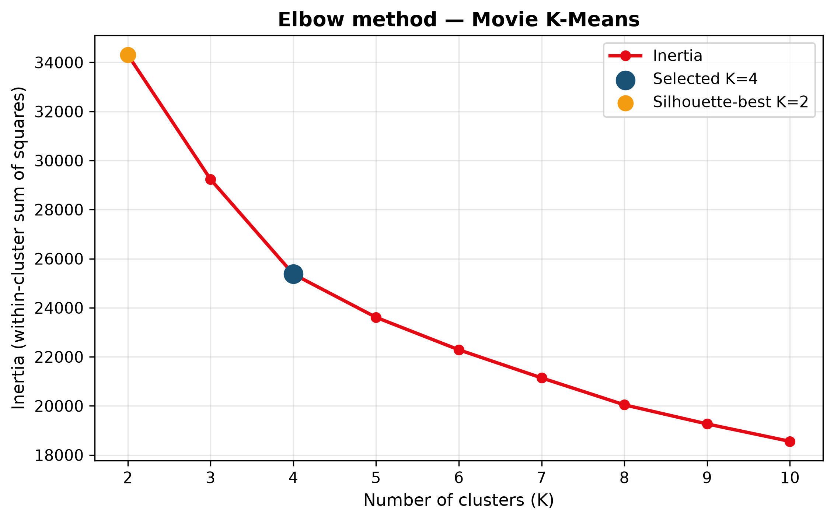
Figure 1: Movie elbow curve — Inertia versus K for movies. Blue marker: reported K=4; orange would indicate silhouette-best K=2 where plotted.
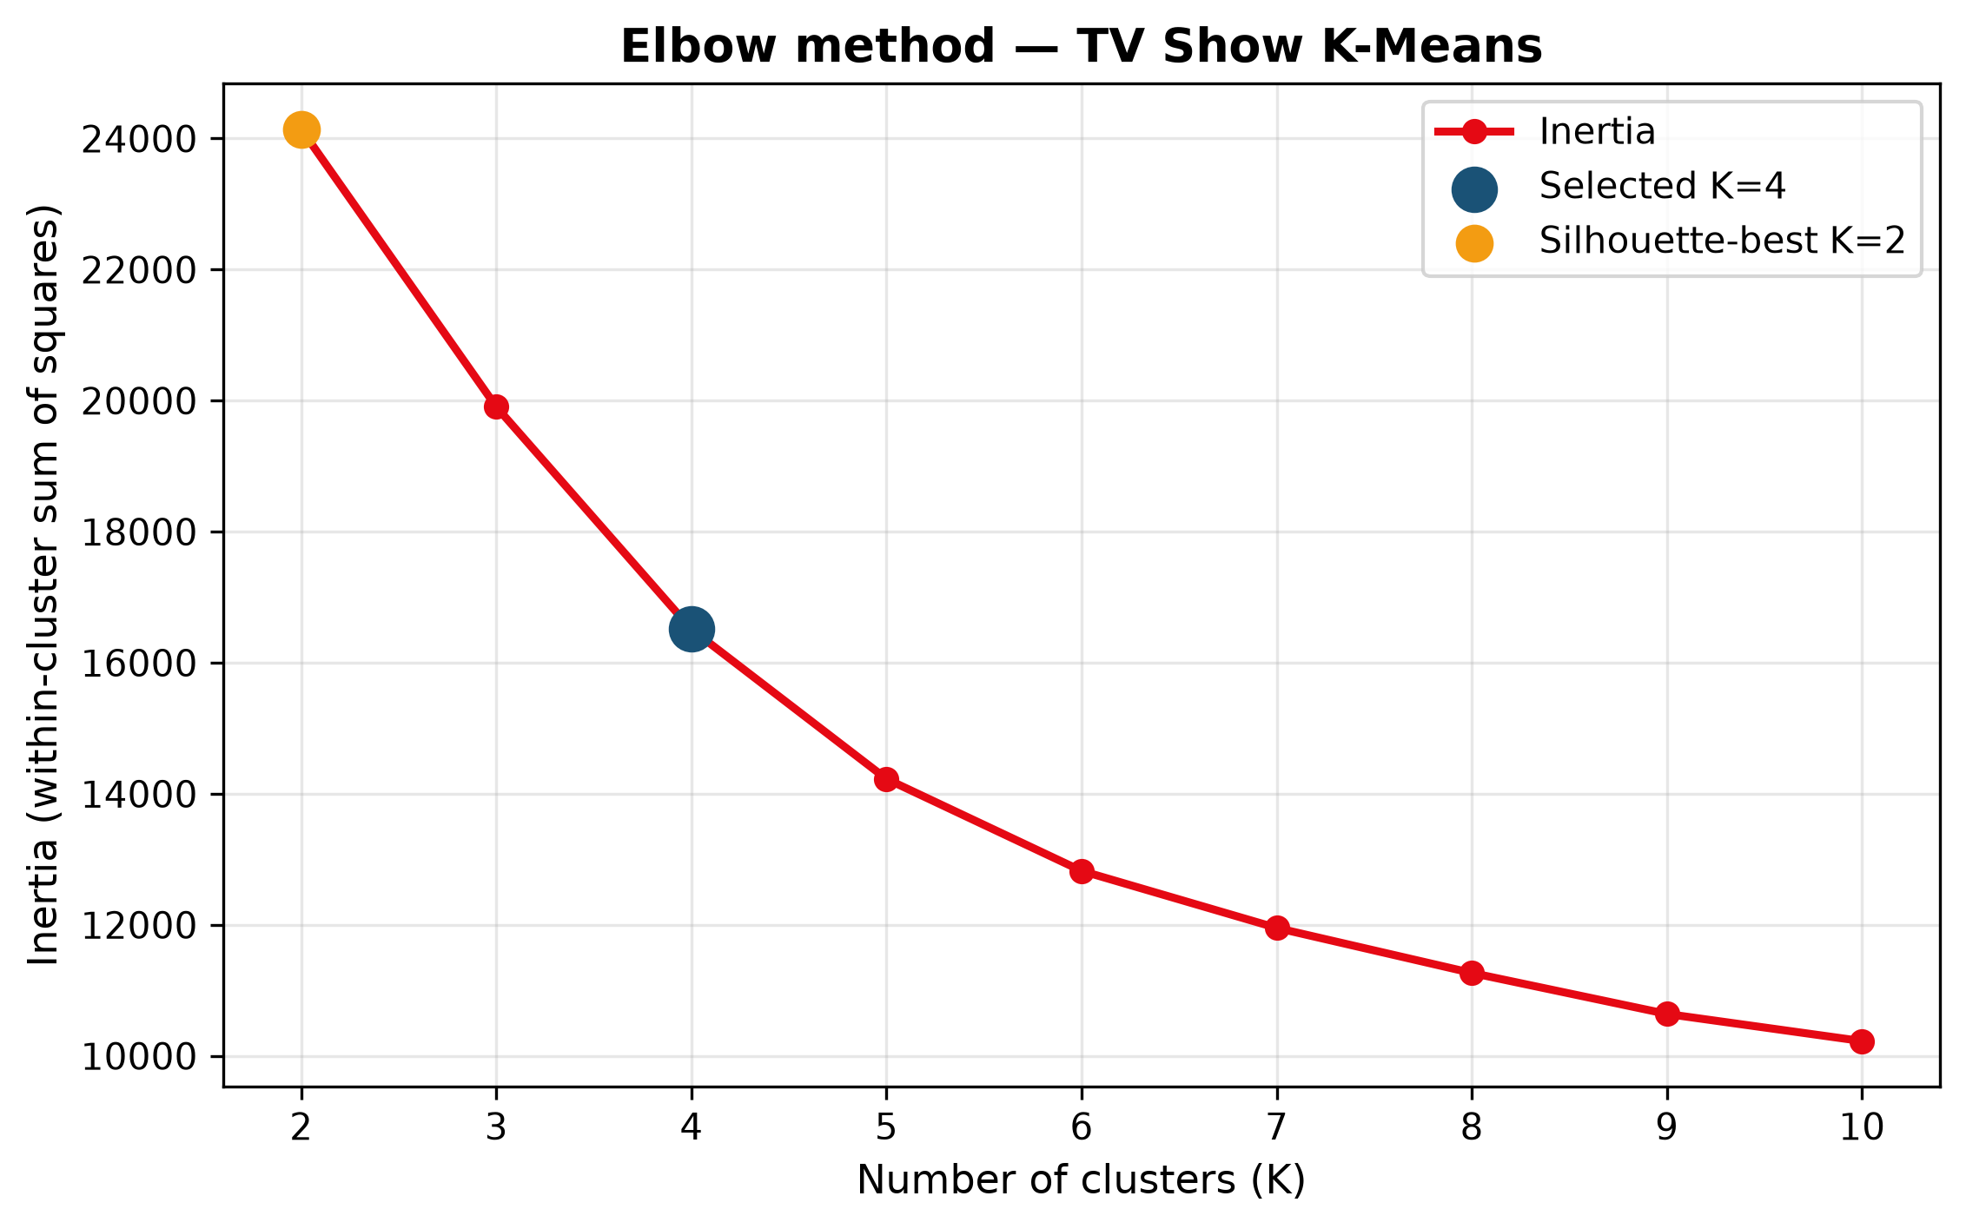
Figure 2: TV Show elbow curve — Inertia versus K for TV Shows with the reported K=4 highlighted.
7.4 Silhouette and additional indices
Movie silhouette peaks at K=2 (0.511) and is 0.187 at K=4. TV silhouette peaks at K=2 (0.665) and is 0.384 at K=4. At K=2, the smaller/larger cluster sizes are movies: 475/4,902; TV: 108/2,302. That recency split is real but coarse. Davies–Bouldin and Calinski–Harabasz are reported alongside size ratios so that a single index cannot dictate K.
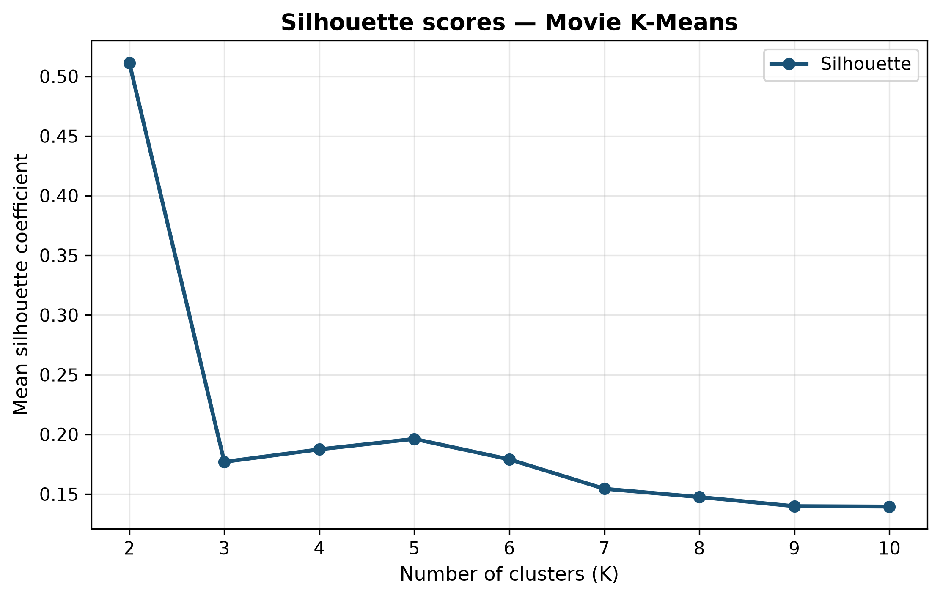
Figure 3: Movie silhouette vs K — Mean silhouette coefficient for movie K-Means. High K=2 scores reflect the older-catalogue minority.
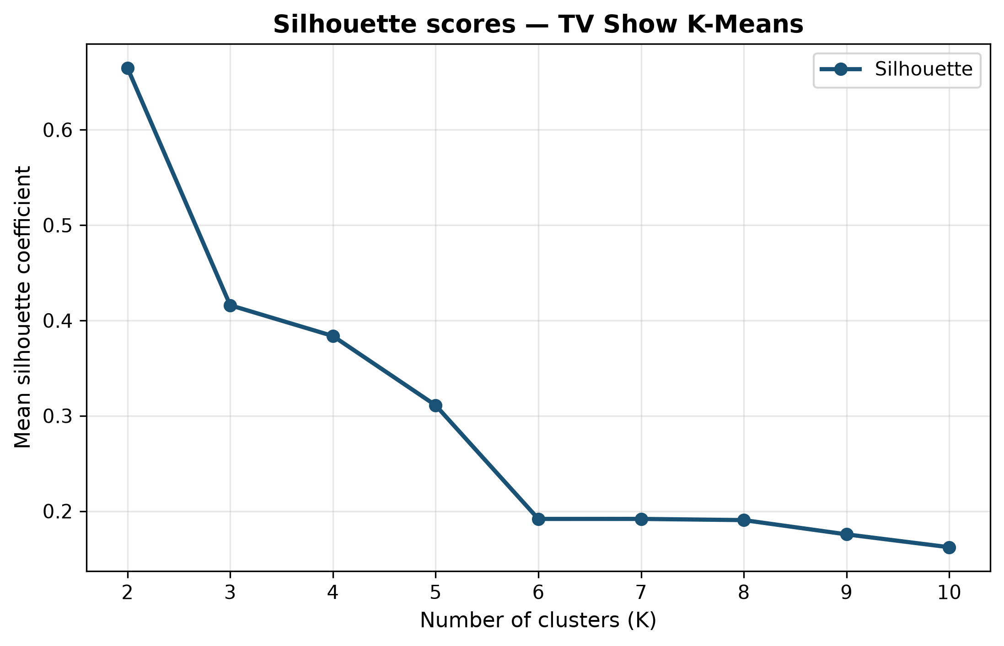
Figure 4: TV silhouette vs K — Mean silhouette coefficient for TV K-Means.
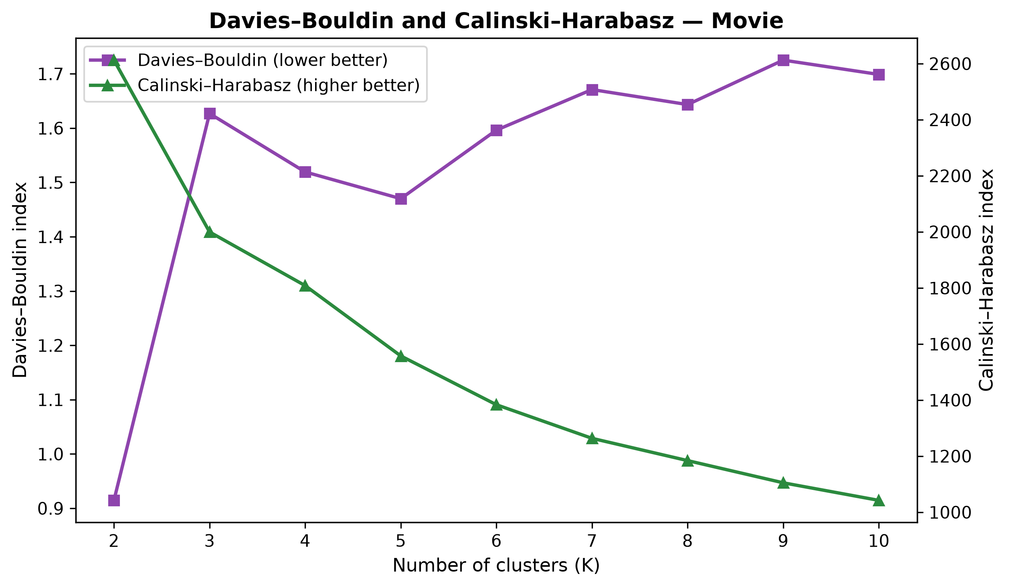
Figure 5: Movie Davies–Bouldin and Calinski–Harabasz — Complementary indices for movies. Lower Davies–Bouldin and higher Calinski–Harabasz are preferred.
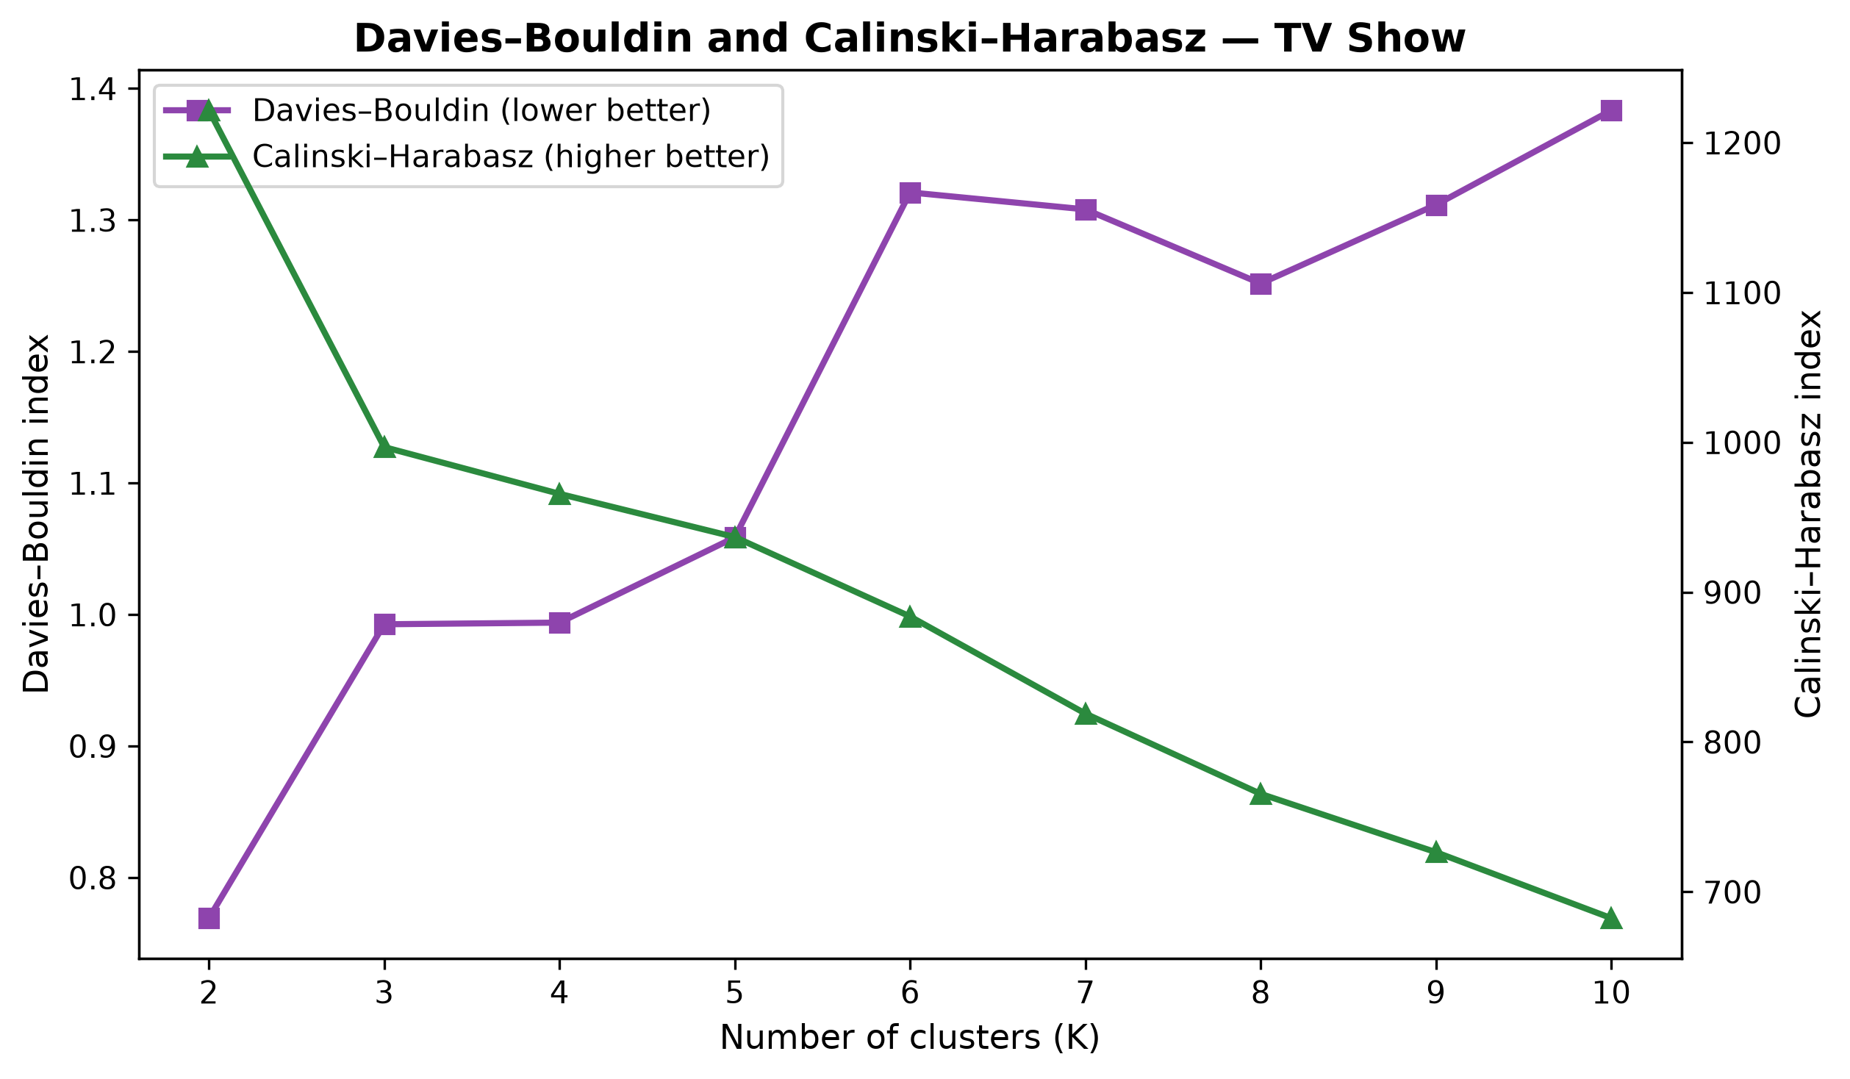
Figure 6: TV Davies–Bouldin and Calinski–Harabasz — Complementary indices for TV Shows.
7.5 Reported K-Means results
Subset | K | Inertia | Silhouette | Davies–Bouldin | Calinski–Harabasz
Movies (full) | 4 | 25373.6 | 0.187 | 1.519 | 1808.2
TV Shows (full) | 4 | 16511.7 | 0.384 | 0.994 | 965.6

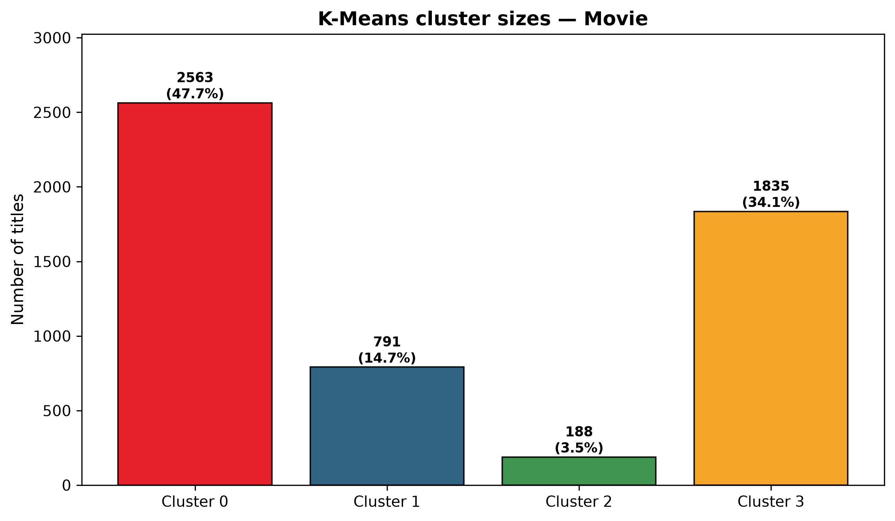
Figure 7: Movie cluster sizes — K=4 movie assignment counts and percentages.
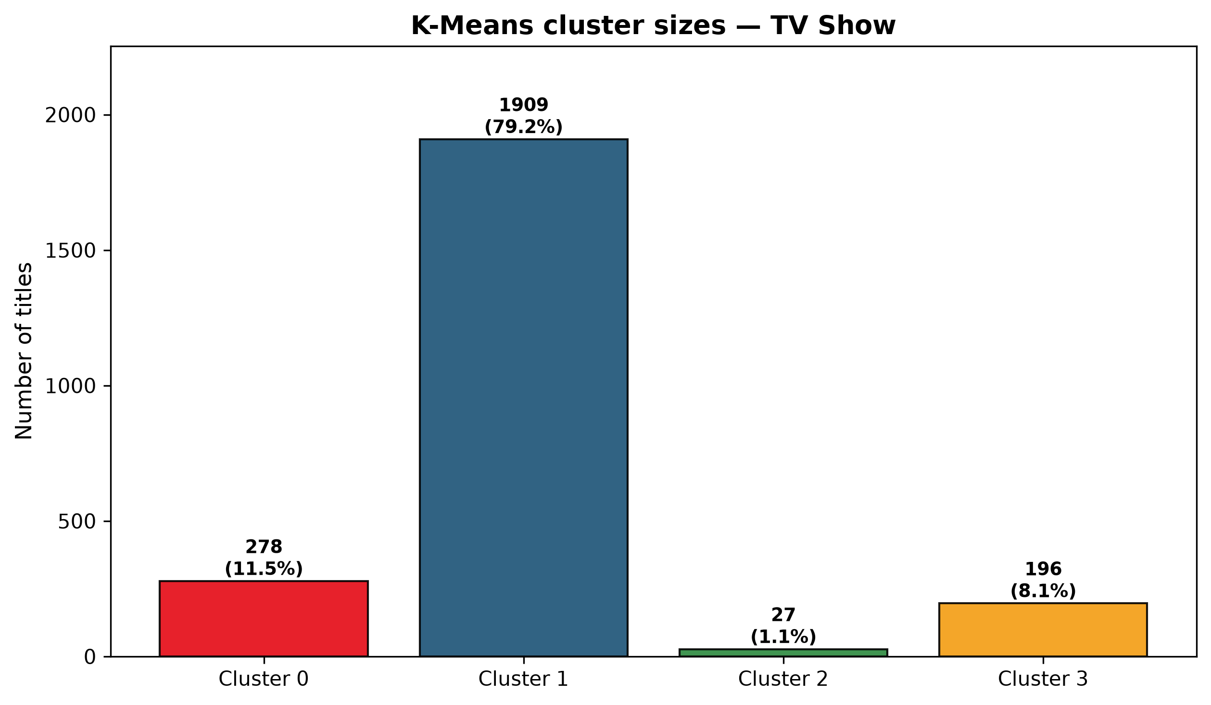
Figure 8: TV cluster sizes — K=4 TV assignment counts. The small legacy group is a minority and should be interpreted cautiously.
8. Hierarchical Clustering
Agglomerative clustering merges nearest clusters until one tree remains. Ward linkage minimises the increase in variance and is paired with Euclidean distance. Average linkage uses mean pairwise distance; complete linkage uses the farthest pair. A full 5,377-leaf dendrogram is not readable, so each type uses a stratified sample of 250 titles (stratified by target_audience, seed 42).
Sampling limitation
Agglomerative clustering and the dendrogram use a stratified sample of 250 Movie titles. Sample results are not claimed to reproduce the full-catalogue partition.

Subset / linkage | Silhouette (sample) | Davies–Bouldin | Calinski–Harabasz
Movies Ward | 0.175 | 1.561 | 76.9
Movies Average | 0.369 | 0.717 | 47.2
Movies Complete | 0.184 | 1.266 | 72.6
TV Ward | 0.217 | 1.281 | 105.8
TV Average | 0.554 | 0.768 | 75.3
TV Complete | 0.451 | 0.674 | 64.2

Average (and, for TV, complete) linkage can outscore Ward on silhouette by isolating tiny compact groups. Ward is retained for the dendrogram because its clusters are closer in spirit to K-Means variance partitions and because movie ARI(K-Means, Ward) = 0.495 on the sample.
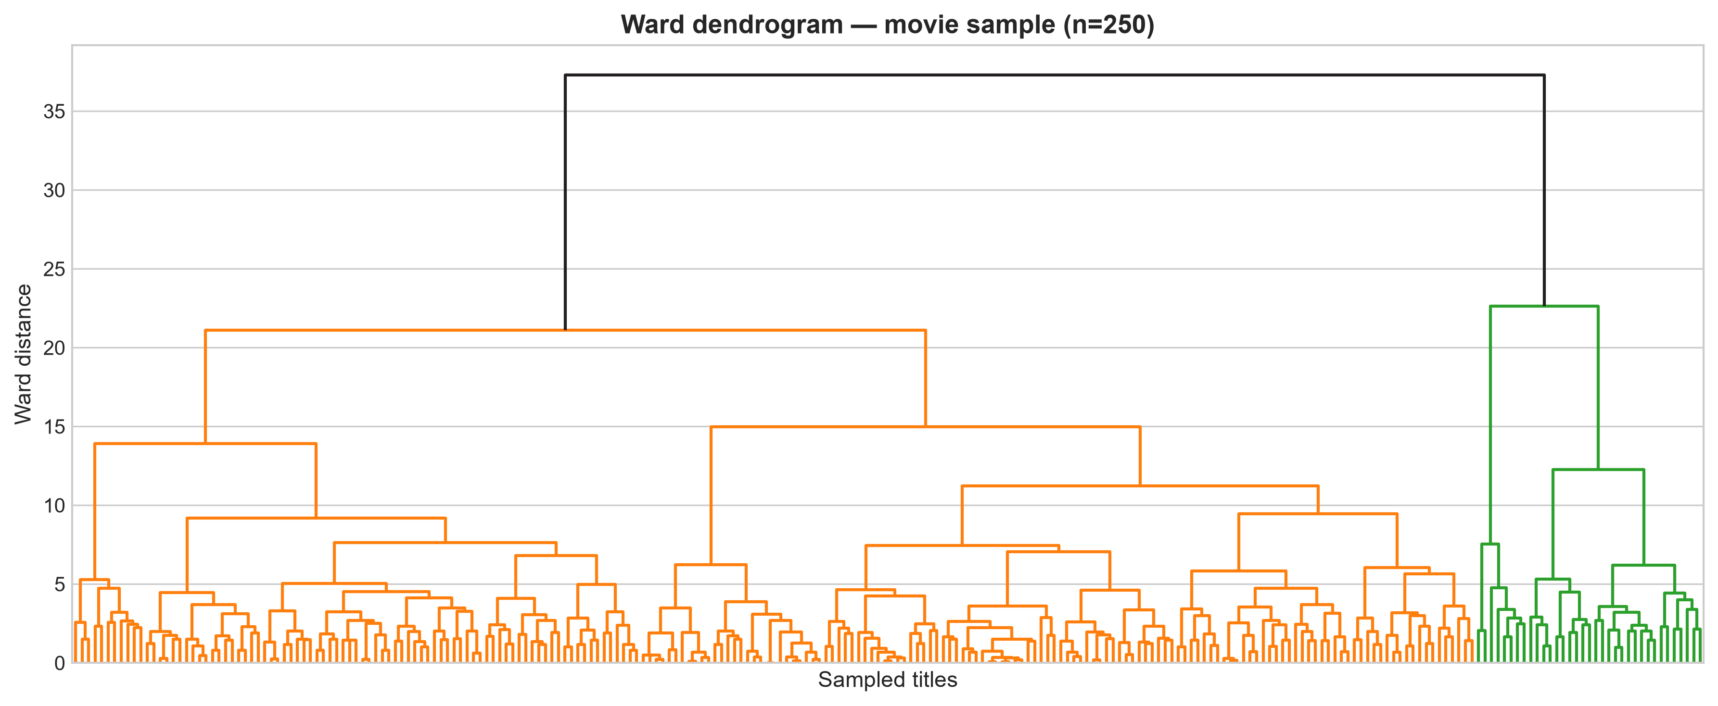
Figure 9: Movie Ward dendrogram — Hierarchical tree for 250 sampled movies. Height is Ward distance, not a catalogue-wide guarantee.
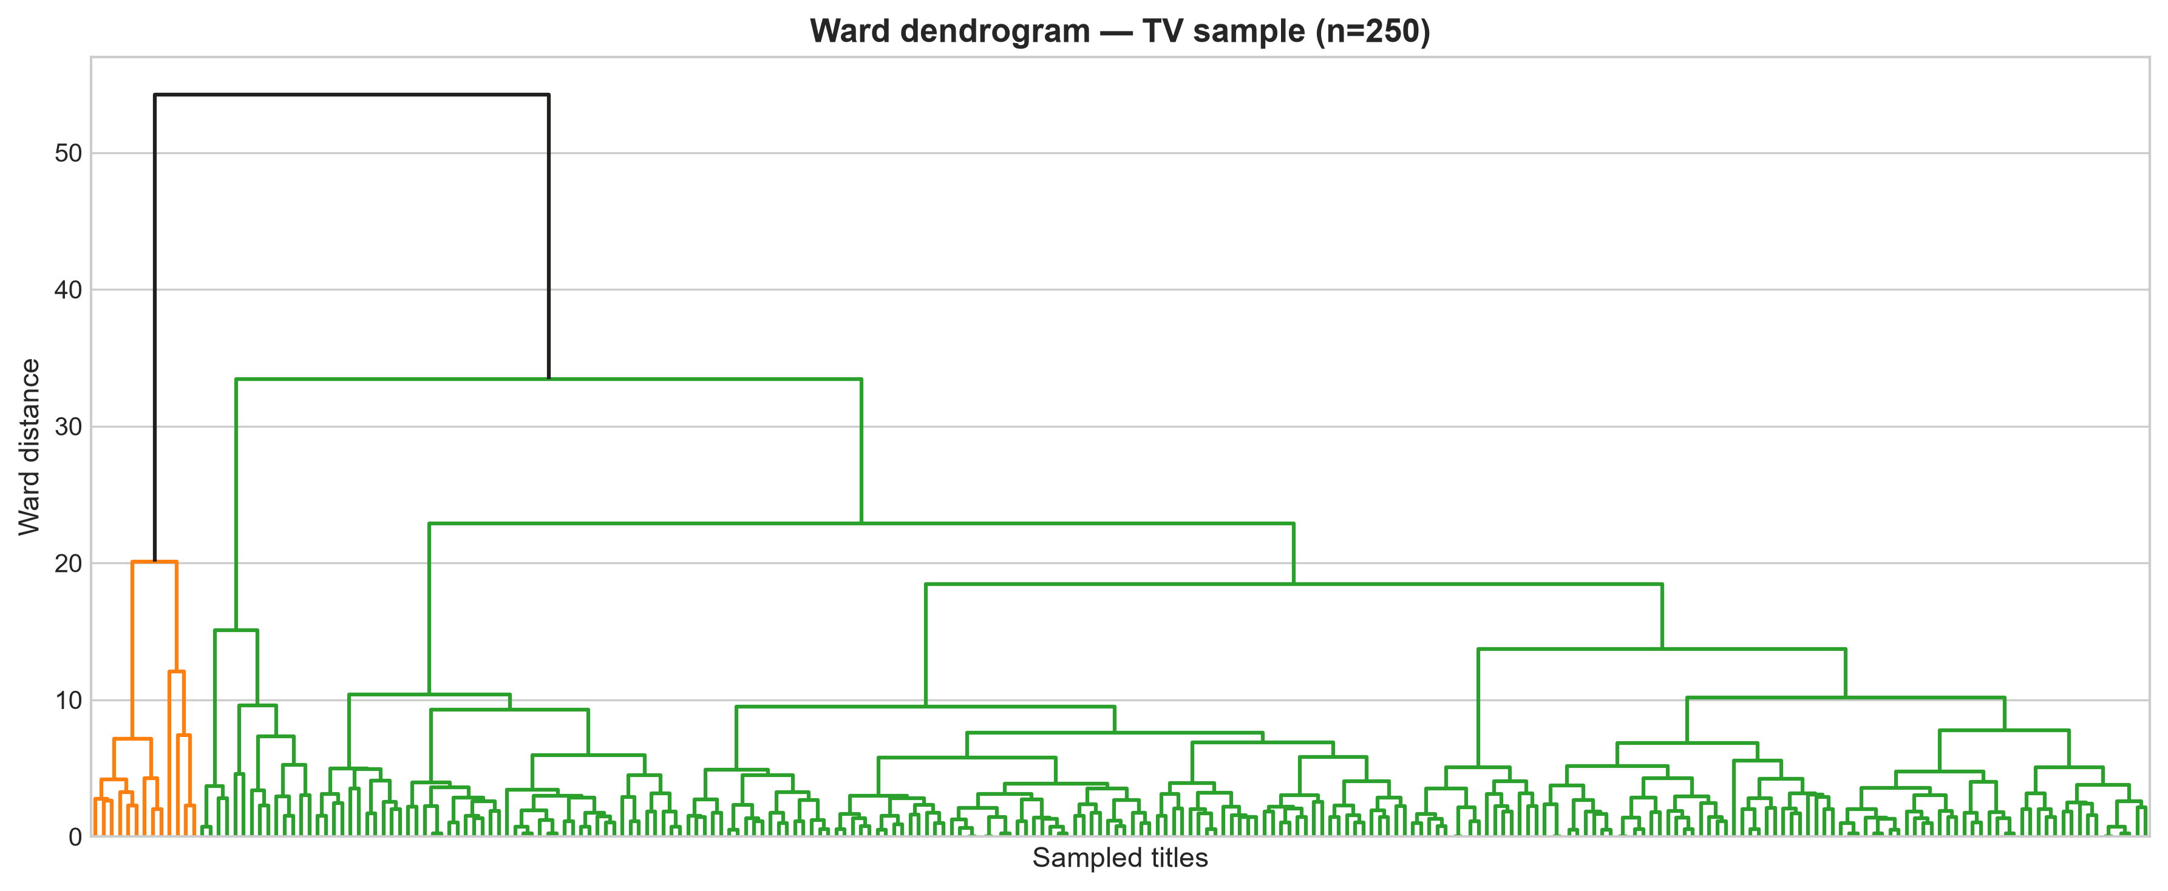
Figure 10: TV Ward dendrogram — Hierarchical tree for 250 sampled TV titles.
9. Cluster Visualization
Movie PCA retains 48.5% + 15.2% = 63.7% of scaled-matrix variance in two components. TV PCA retains 58.8% + 17.1% = 75.9%. Overlap in the scatter therefore does not prove that original-space centroids are identical.
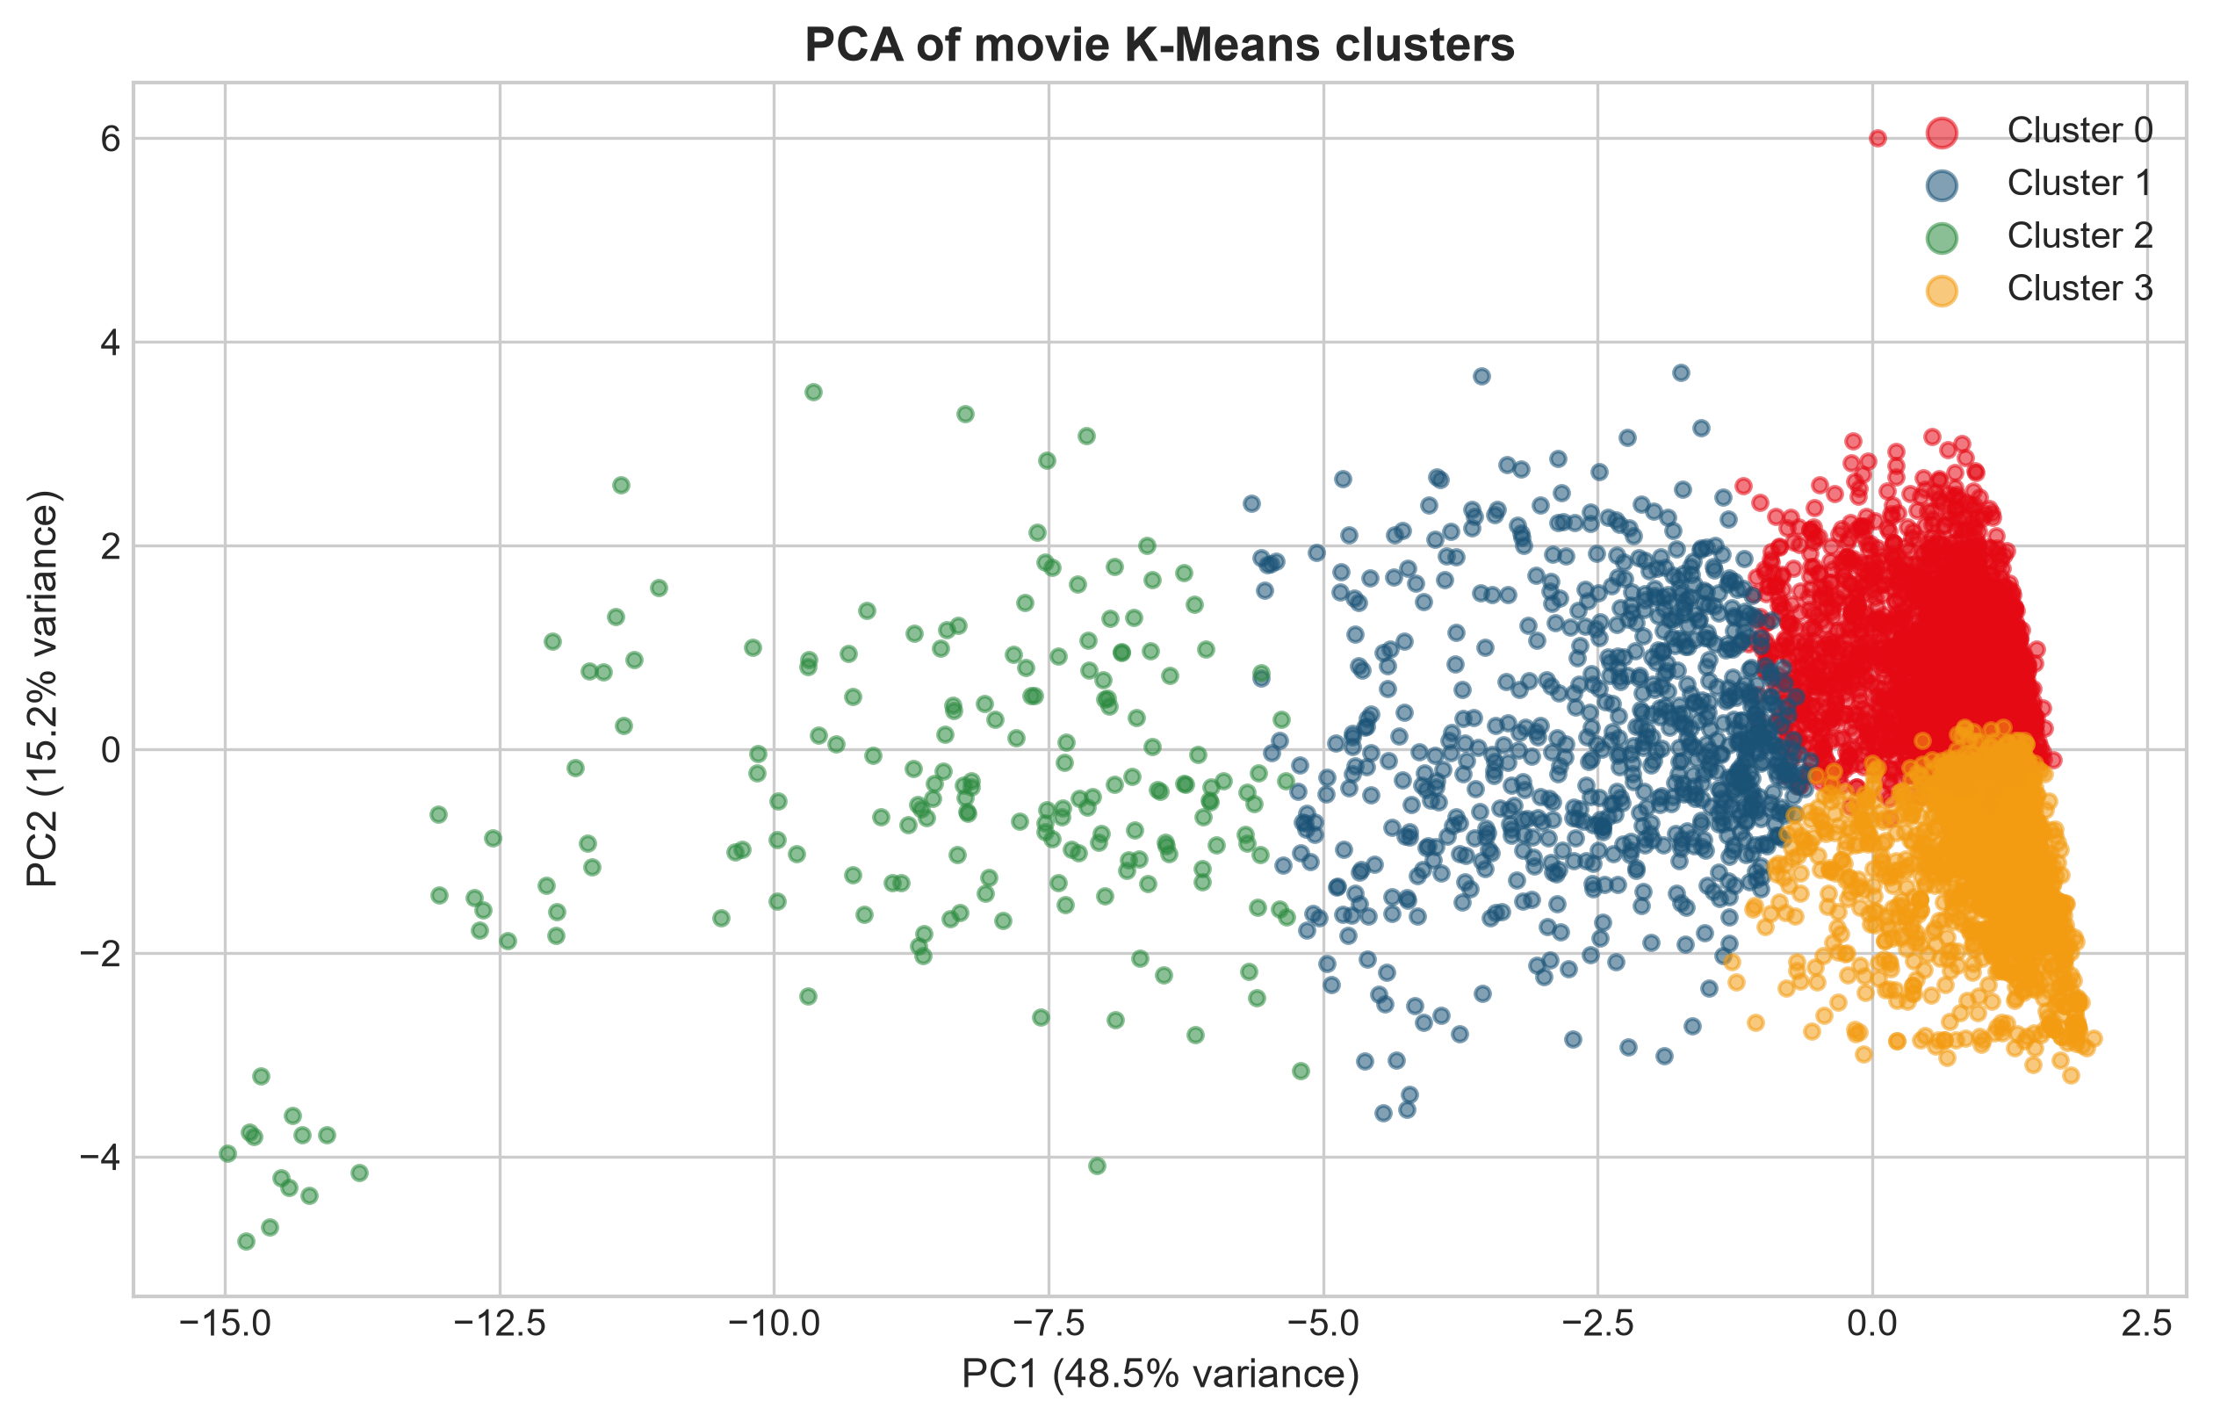
Figure 11: Movie PCA scatter — Two-dimensional projection of movie K-Means labels. A 2D view cannot preserve all pairwise distances.
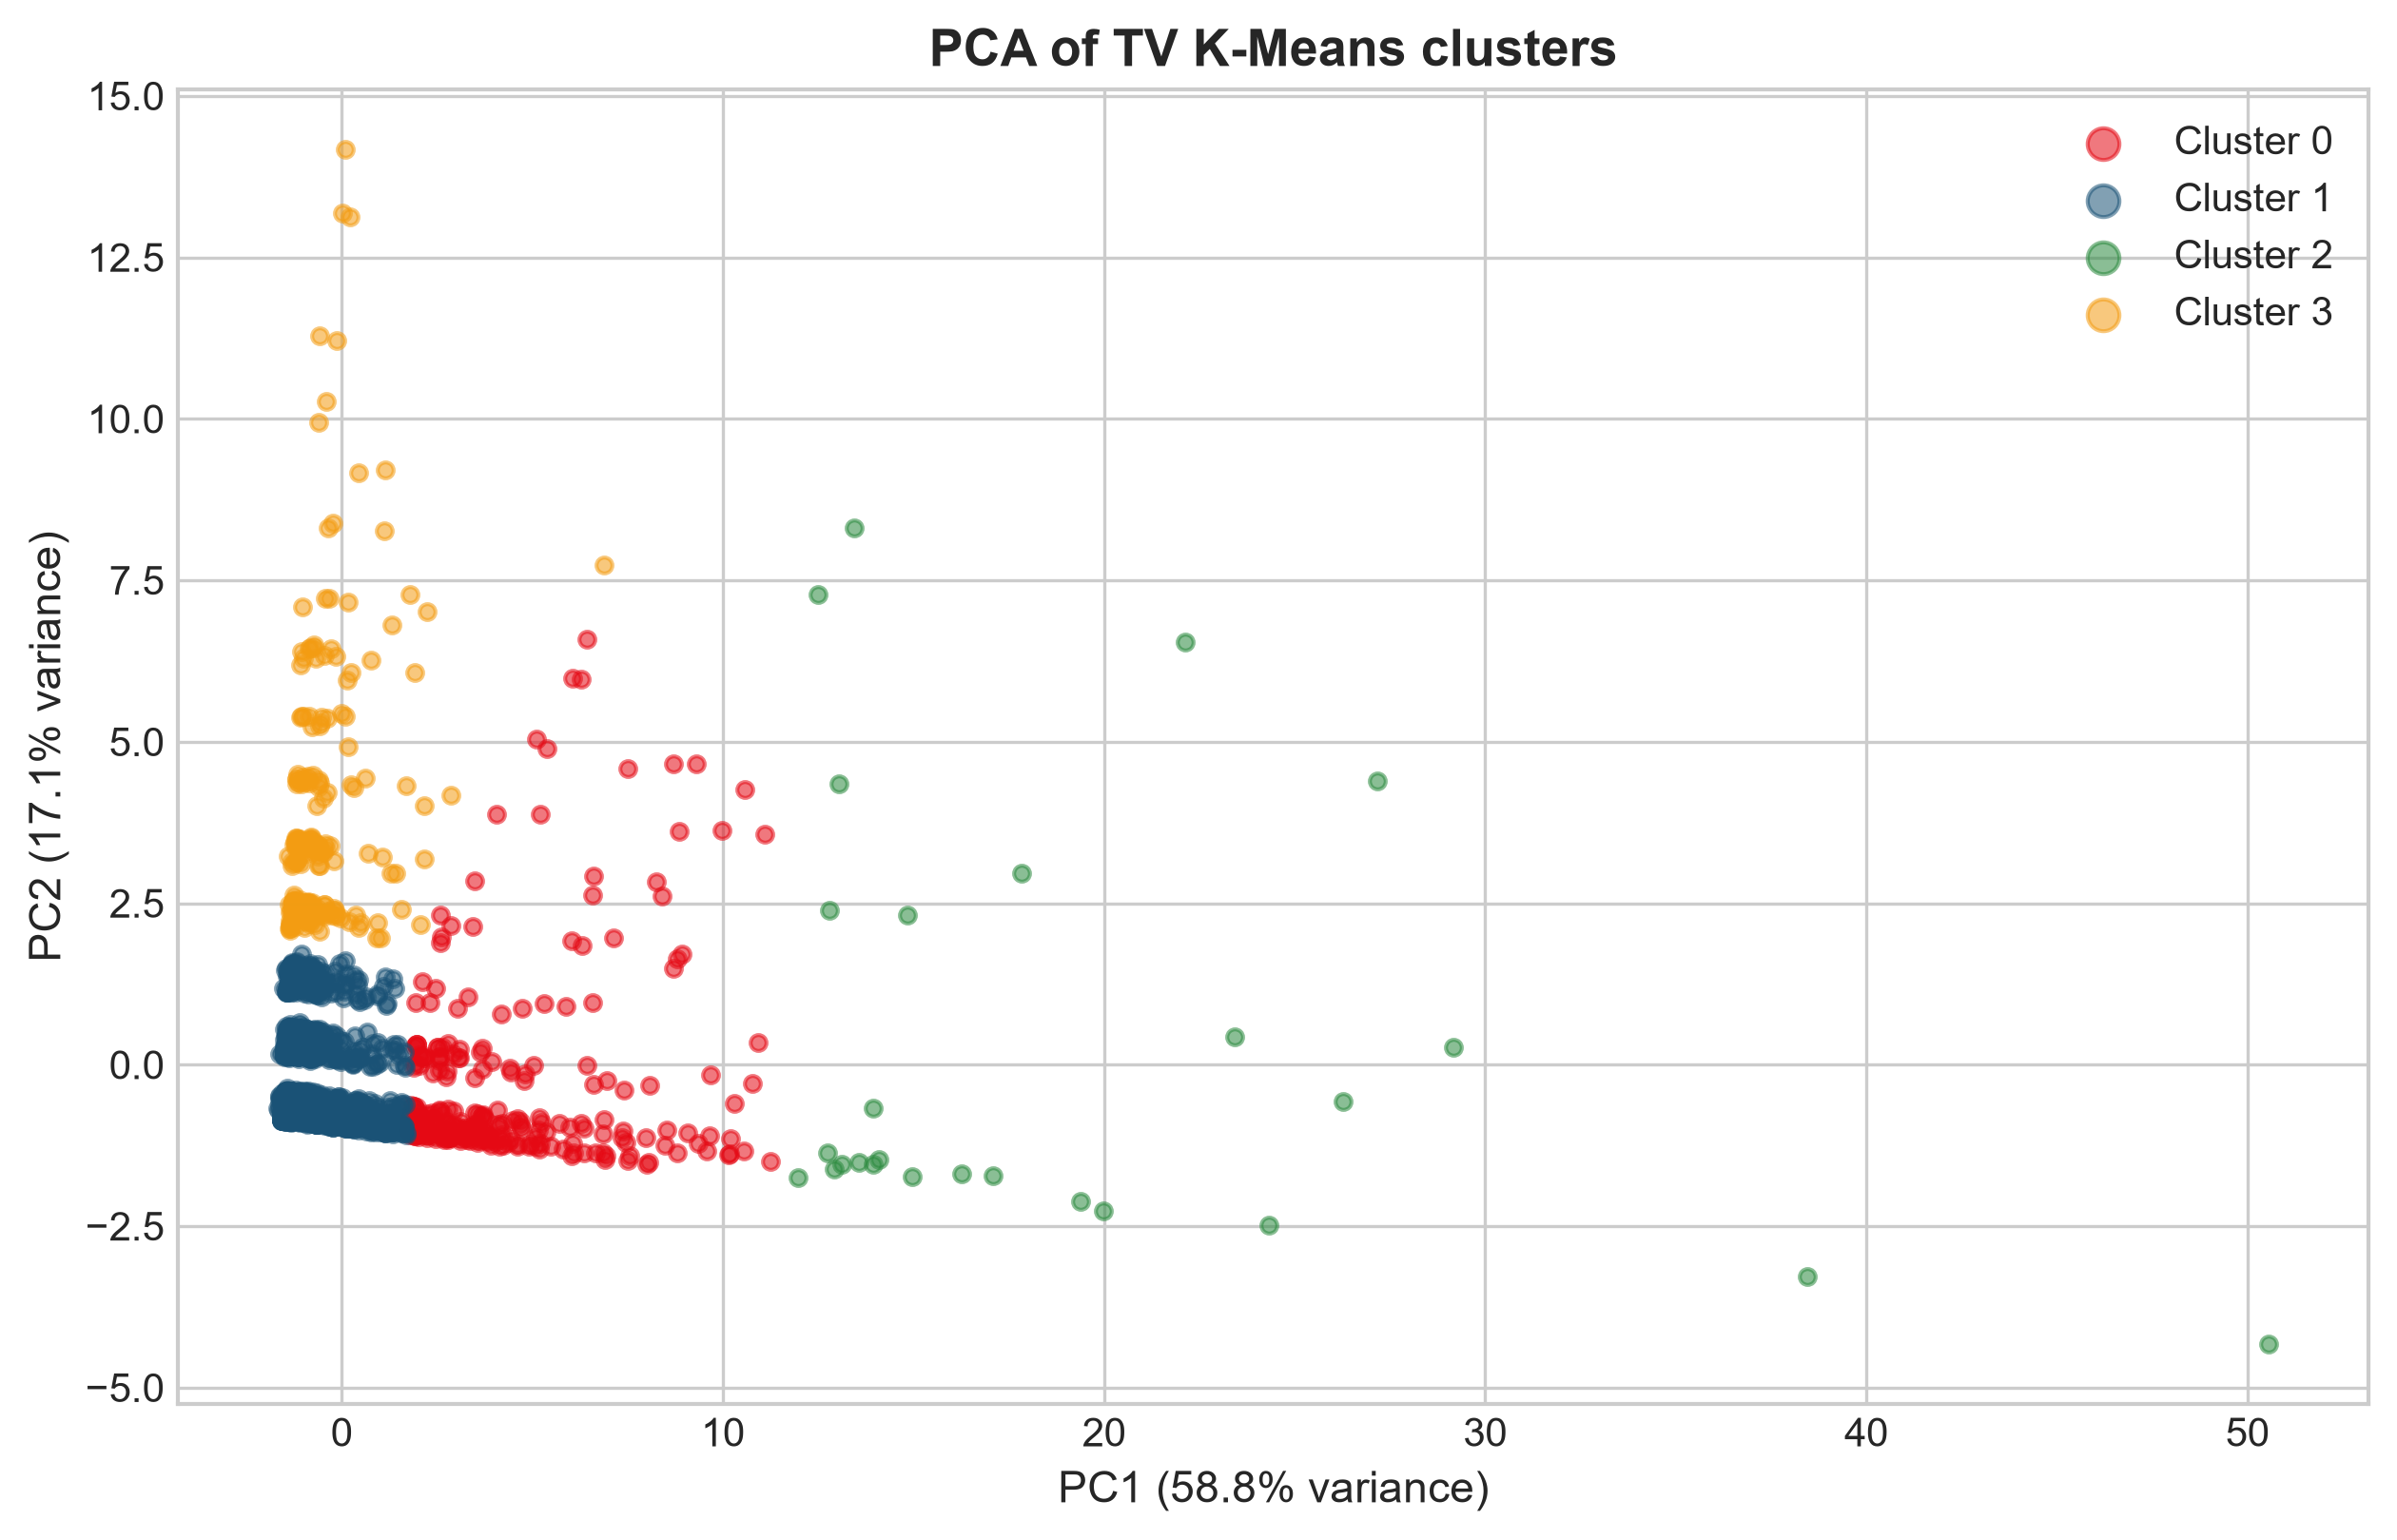
Figure 12: TV PCA scatter — Two-dimensional projection of TV K-Means labels.
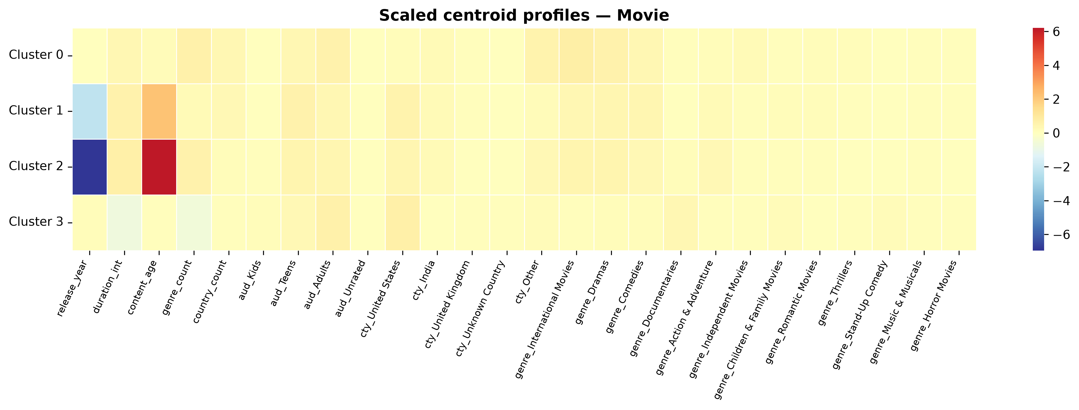
Figure 13: Movie scaled centroids — Heatmap of K-Means centres in the scaled movie feature space.
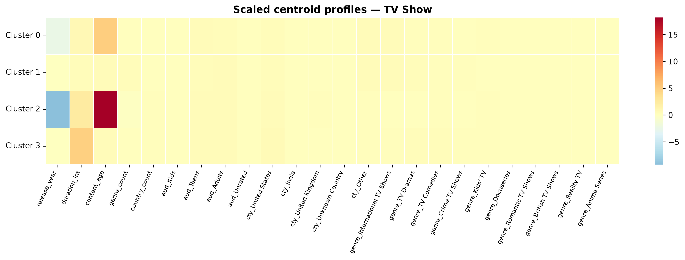
Figure 14: TV scaled centroids — Heatmap of K-Means centres in the scaled TV feature space.
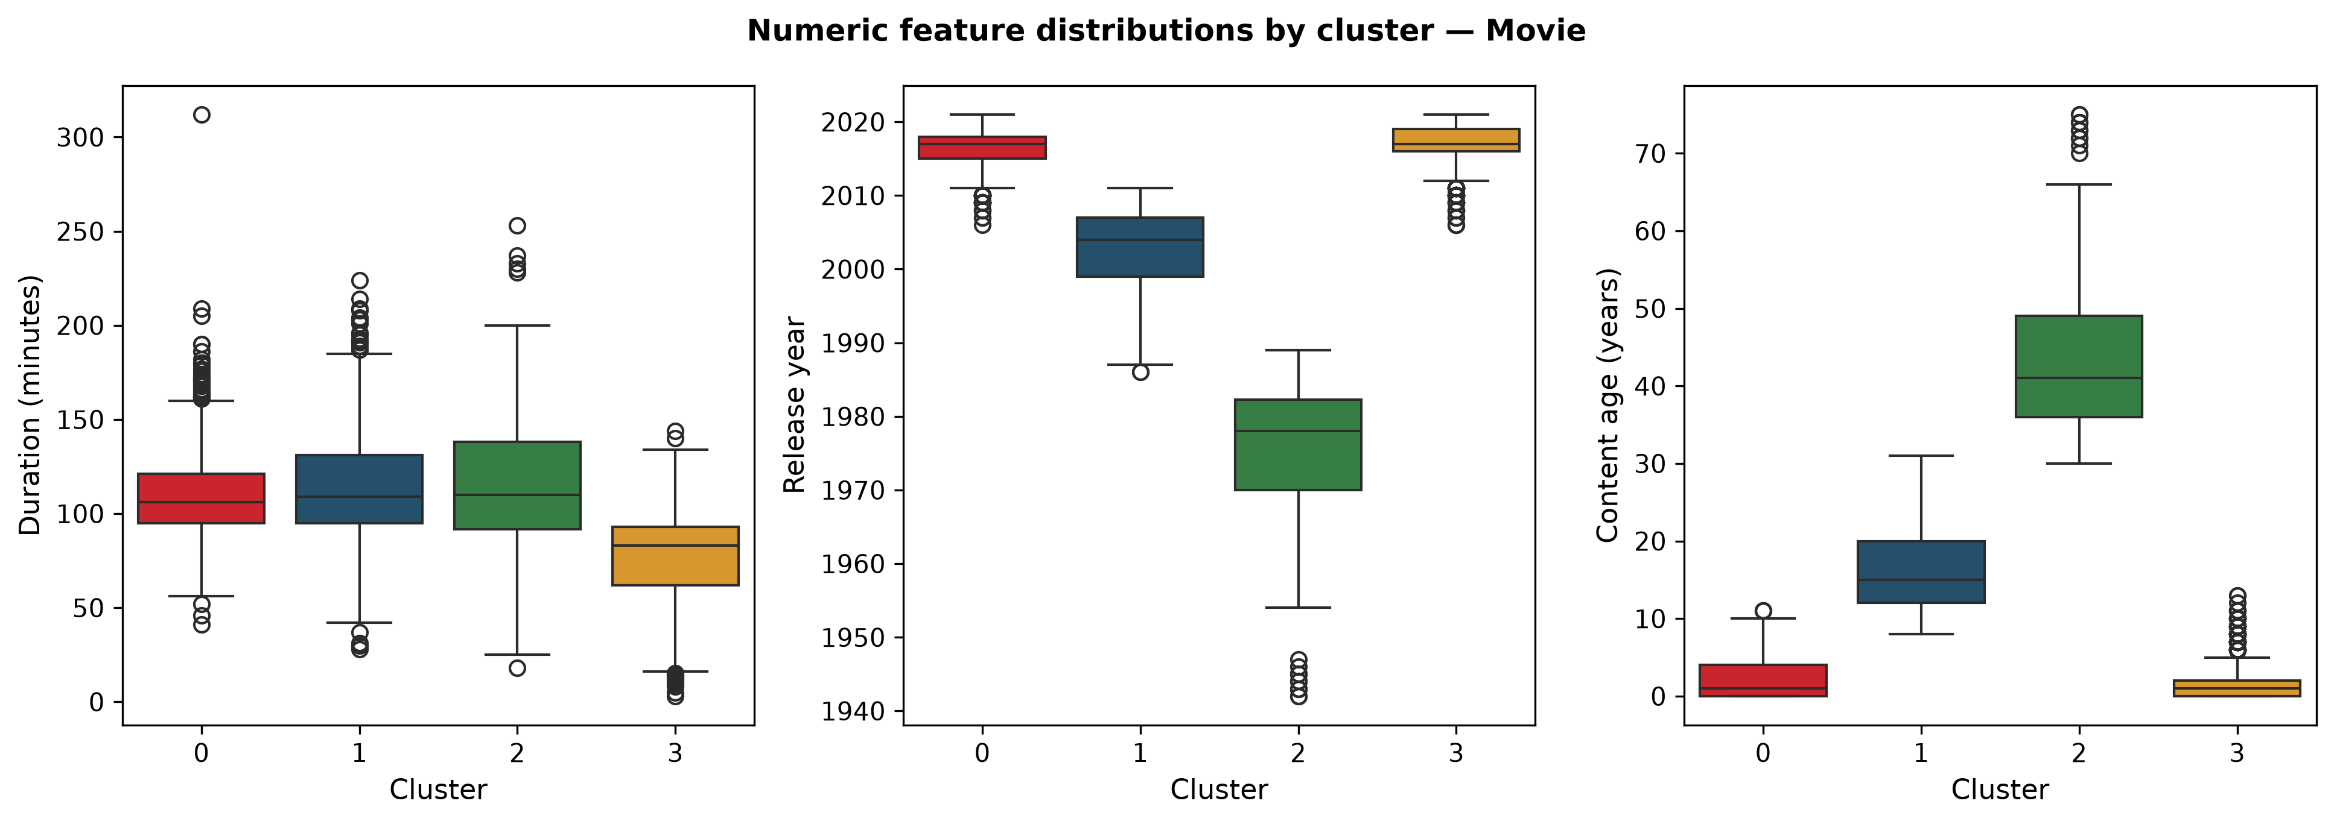
Figure 15: Movie numeric distributions — Duration, release year, and content age by movie cluster (original units).
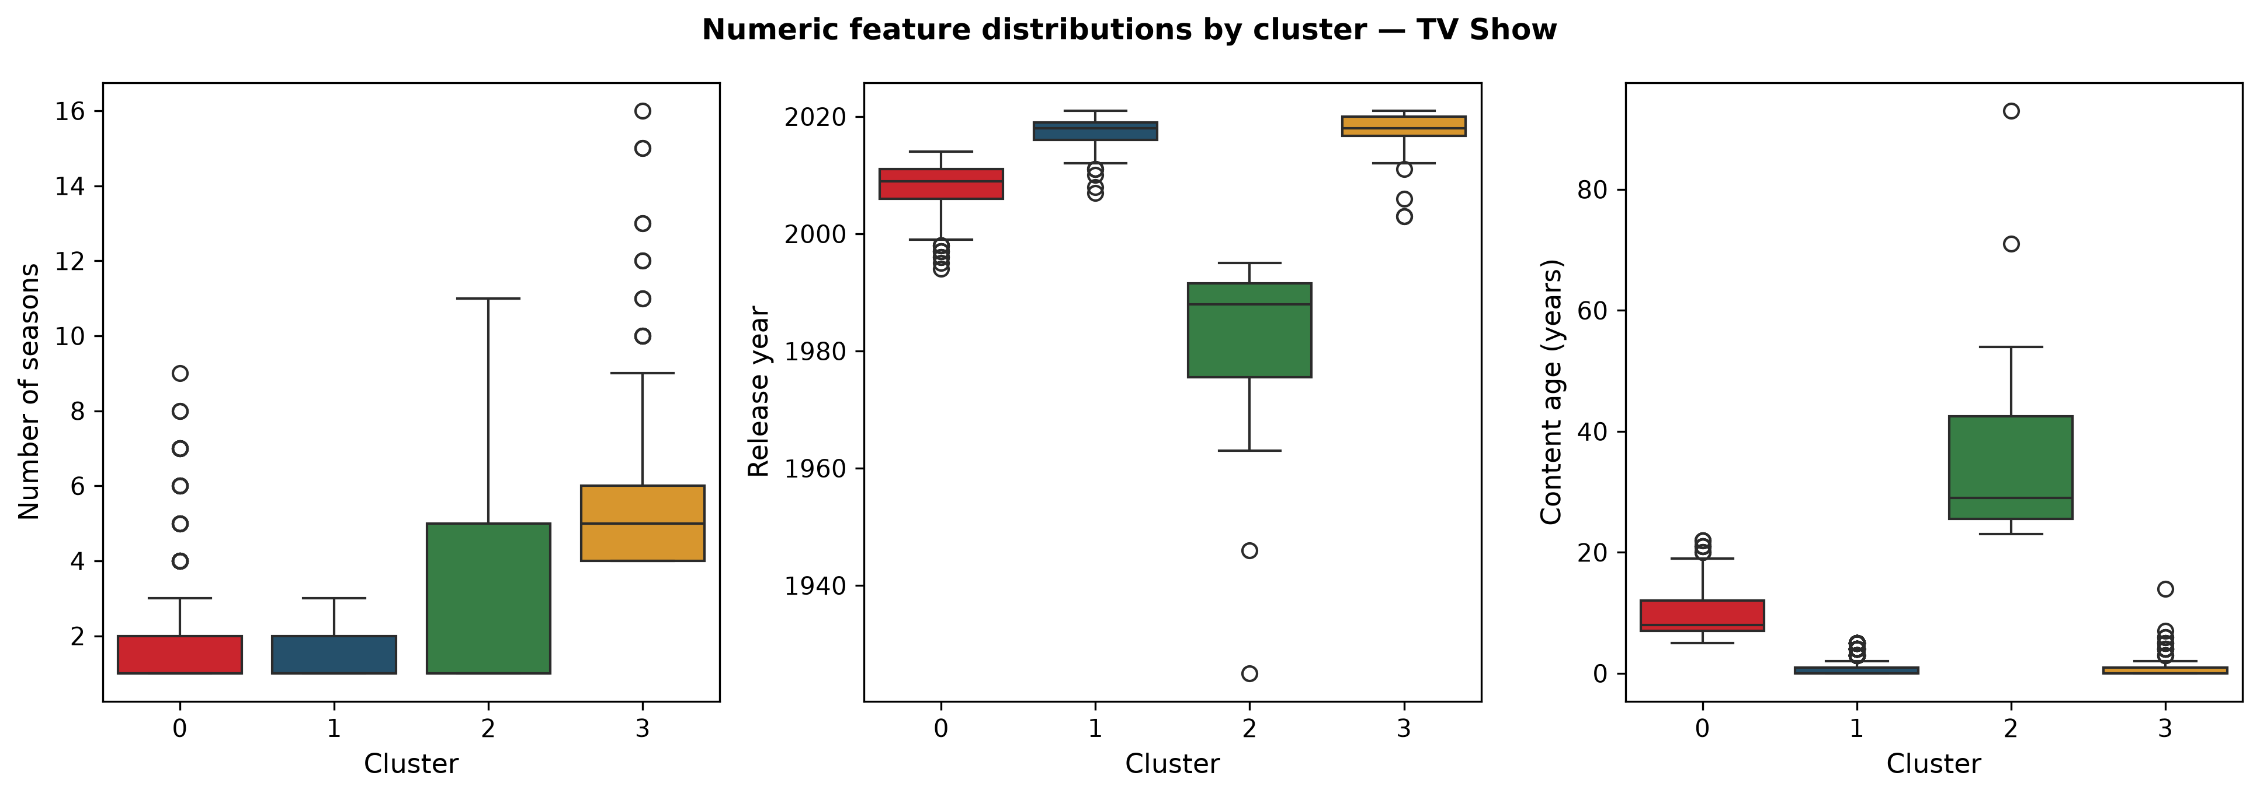
Figure 16: TV numeric distributions — Season count, release year, and content age by TV cluster.
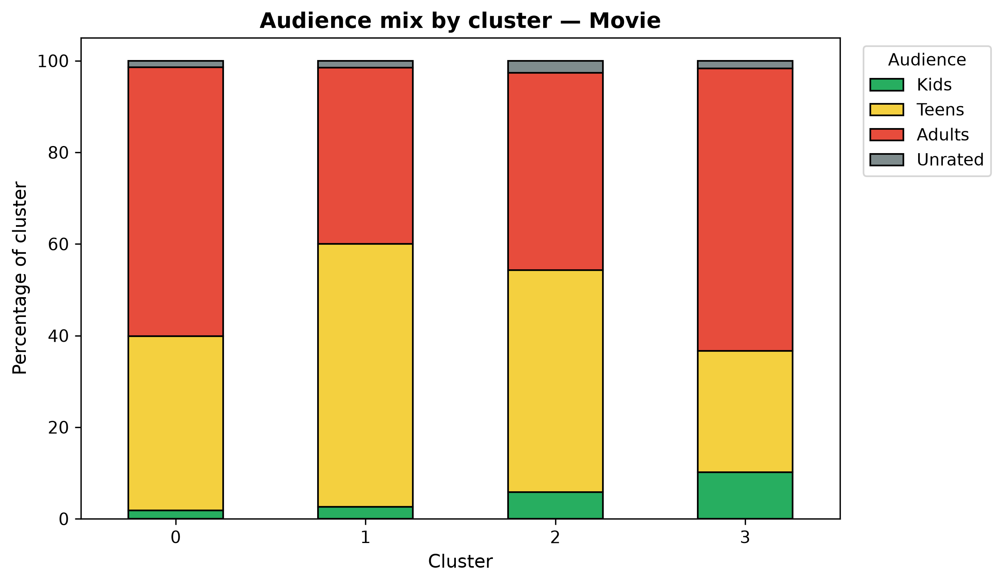
Figure 17: Movie audience mix — Stacked audience-band percentages by movie cluster.
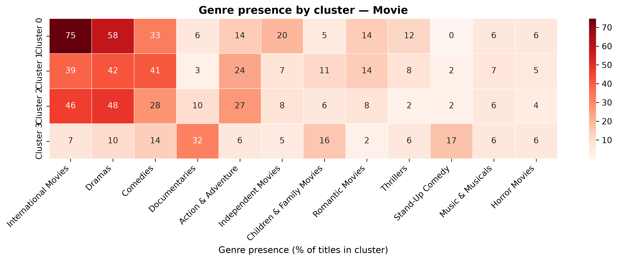
Figure 18: Movie genre presence — Percentage of titles in each movie cluster that list selected genres.
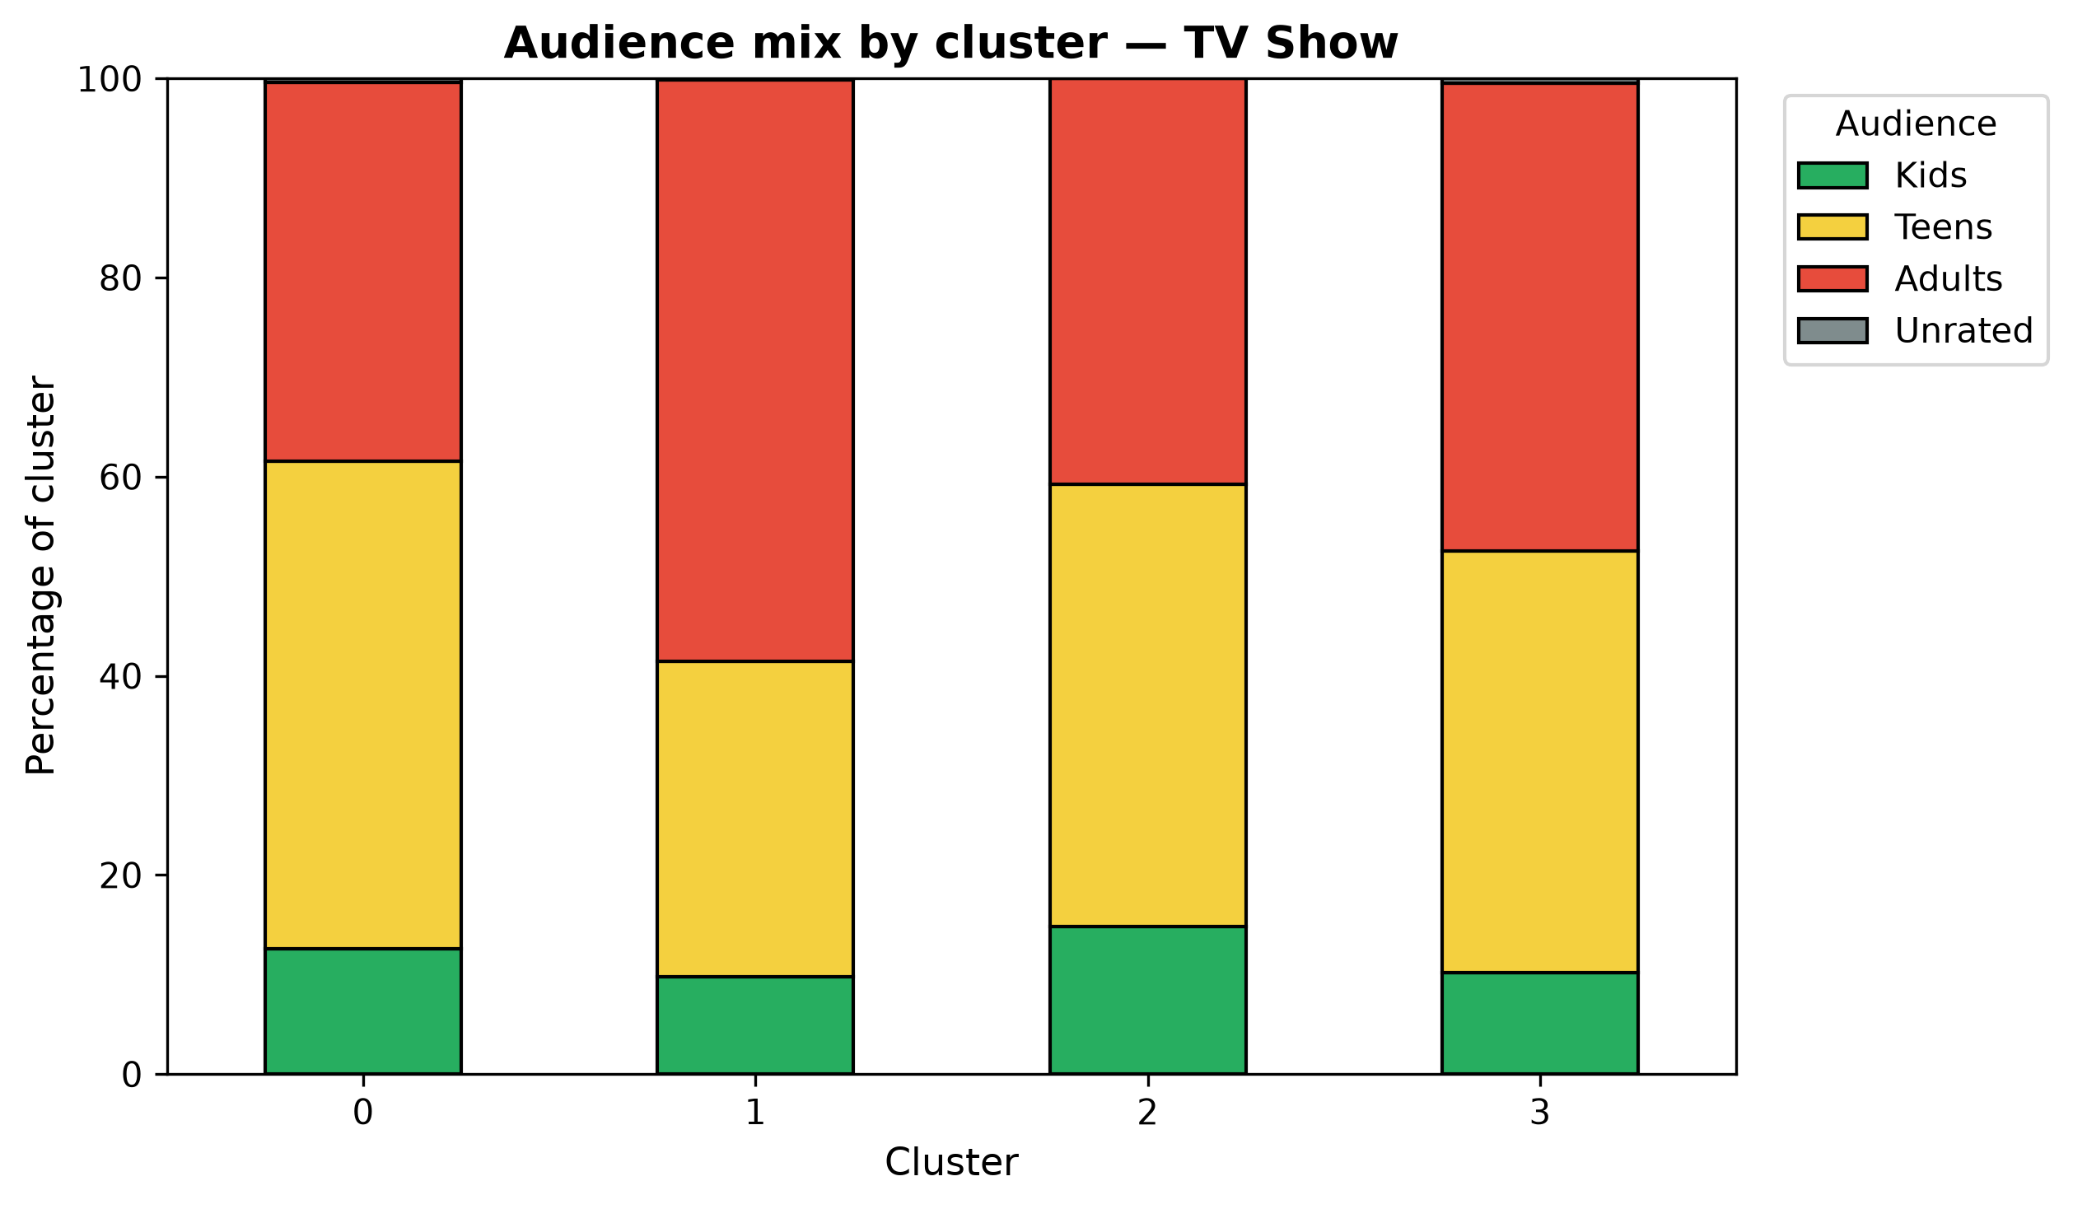
Figure 19: TV audience mix — Stacked audience-band percentages by TV cluster.
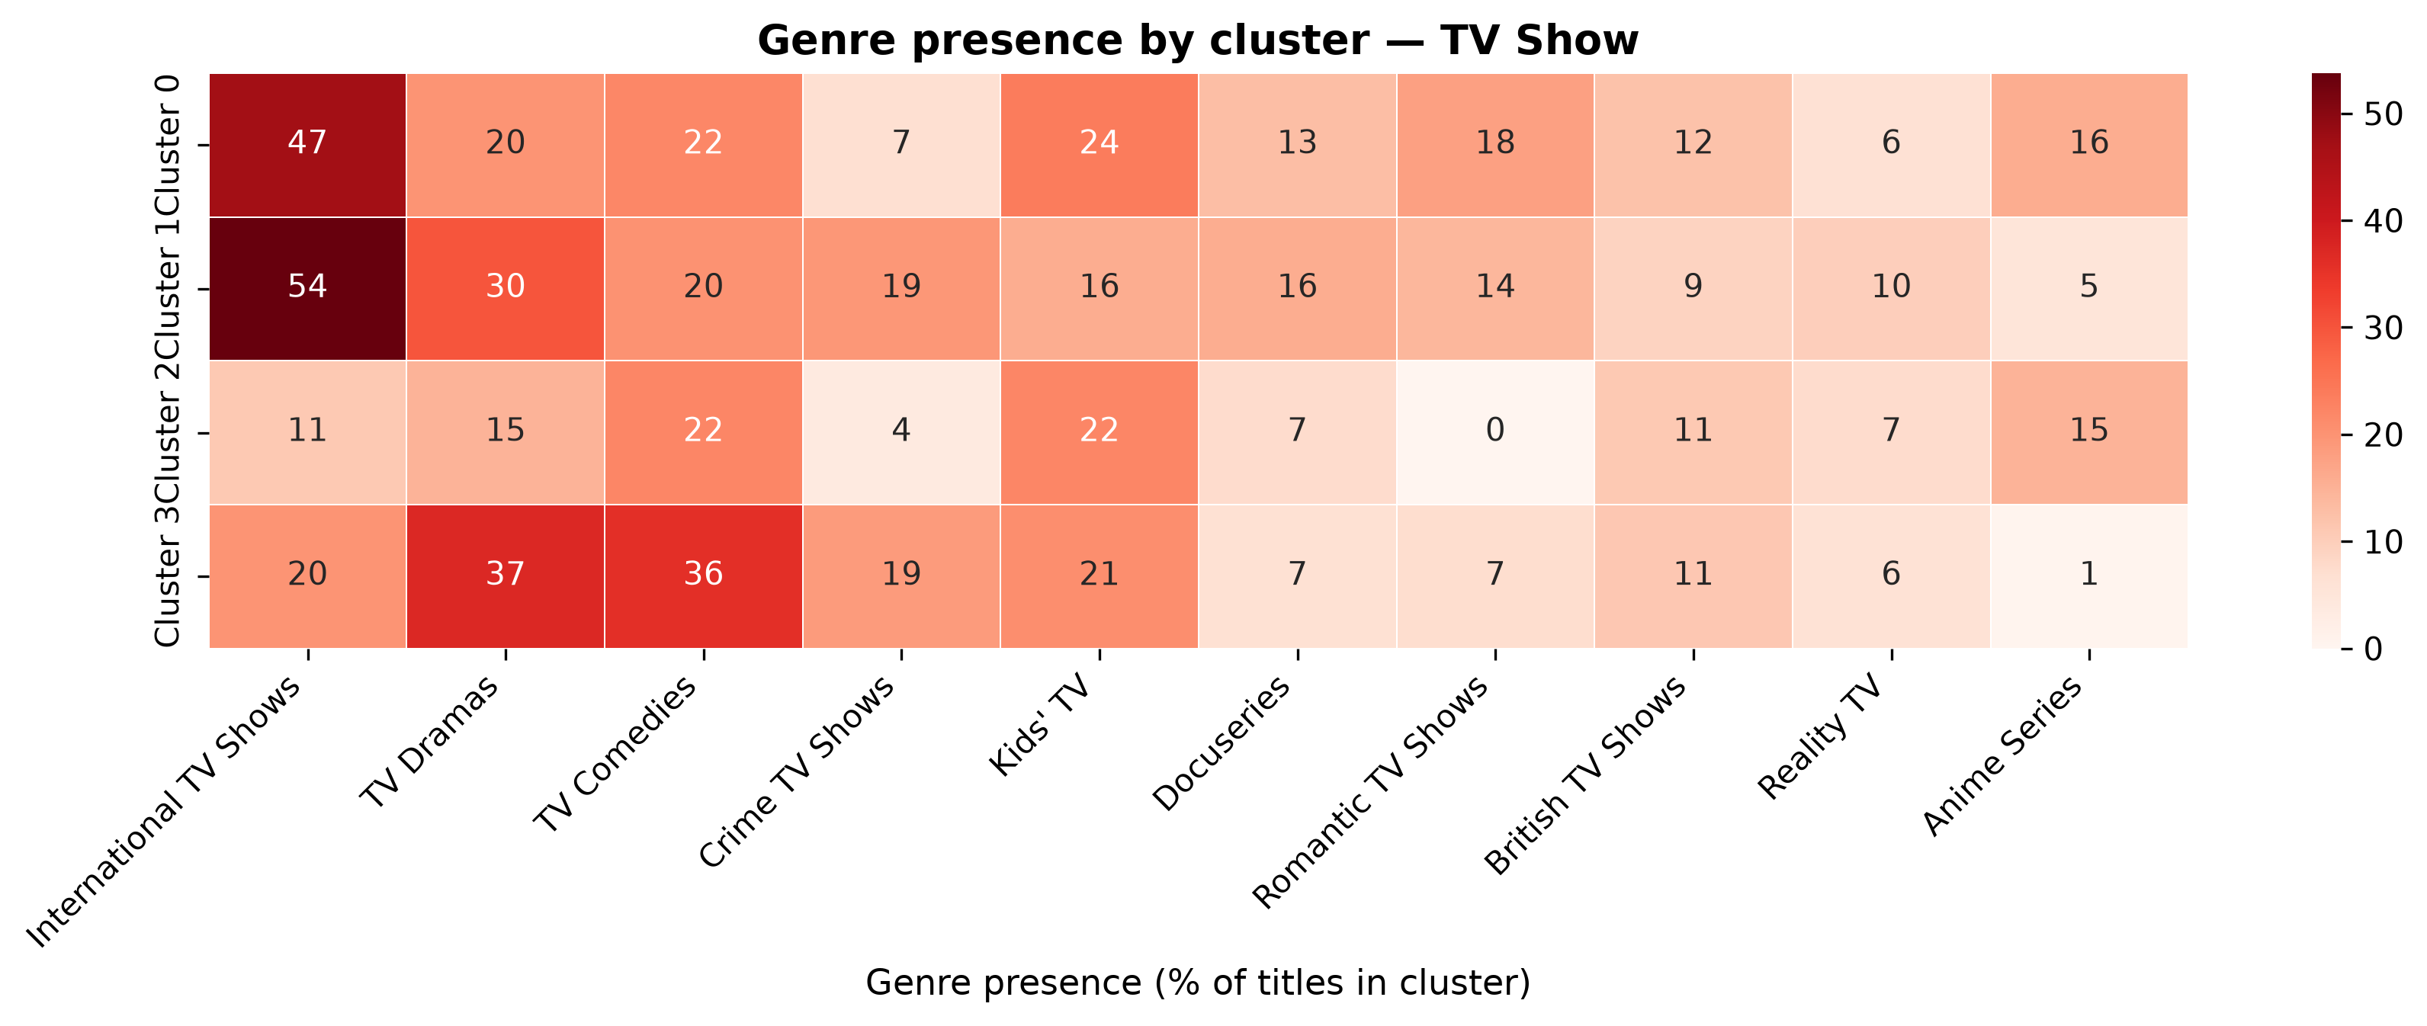
Figure 20: TV genre presence — Percentage of titles in each TV cluster that list selected genres.
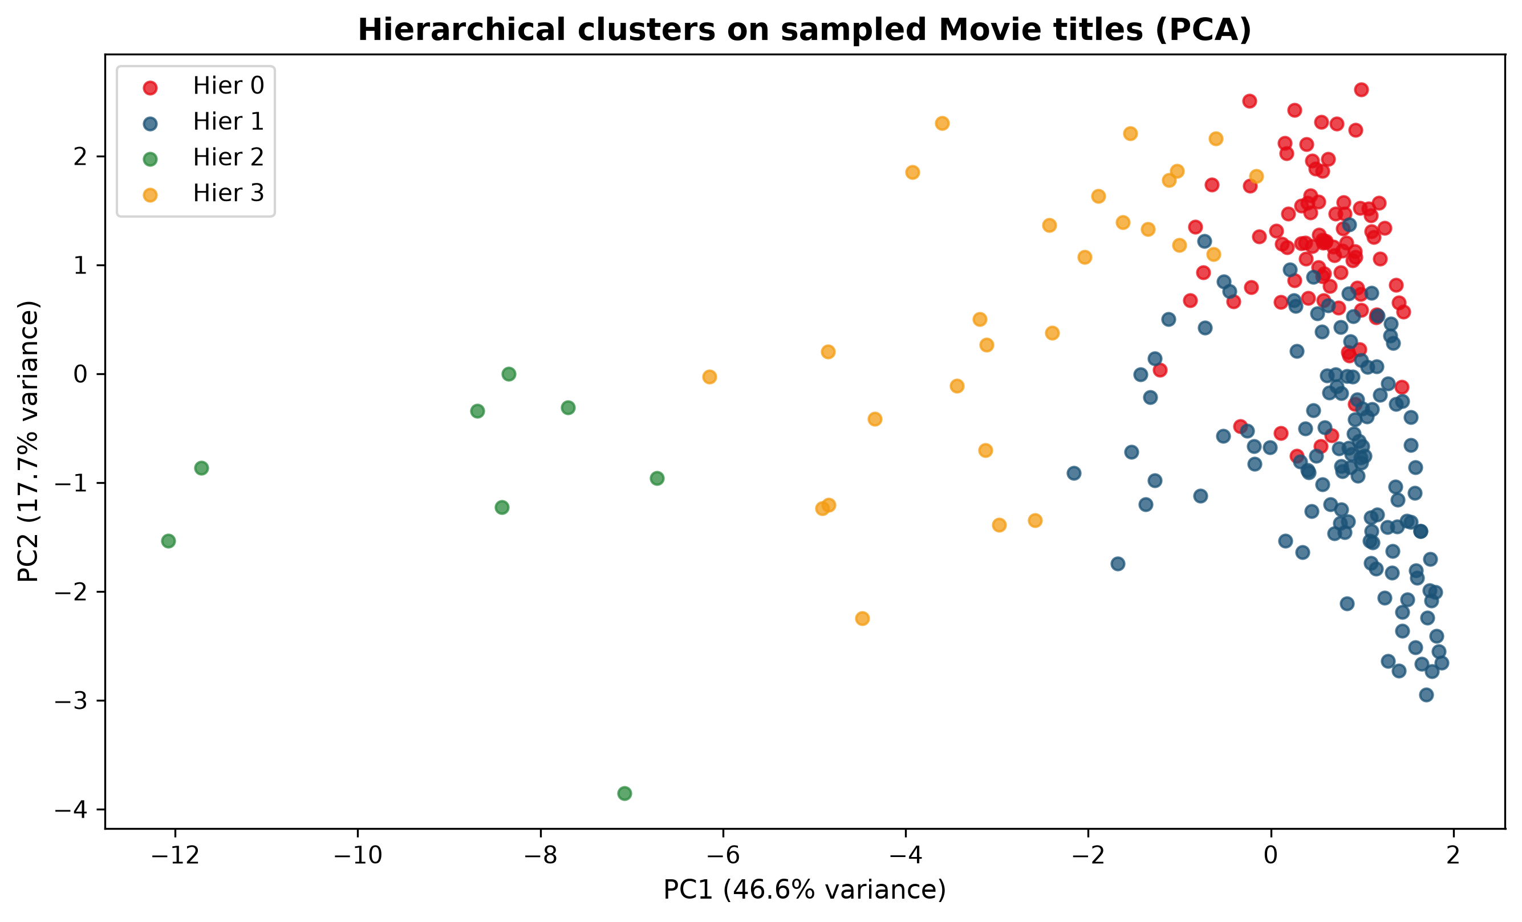
Figure 21: Movie hierarchical sample PCA — Ward labels on the 250-movie sample projected with PCA.
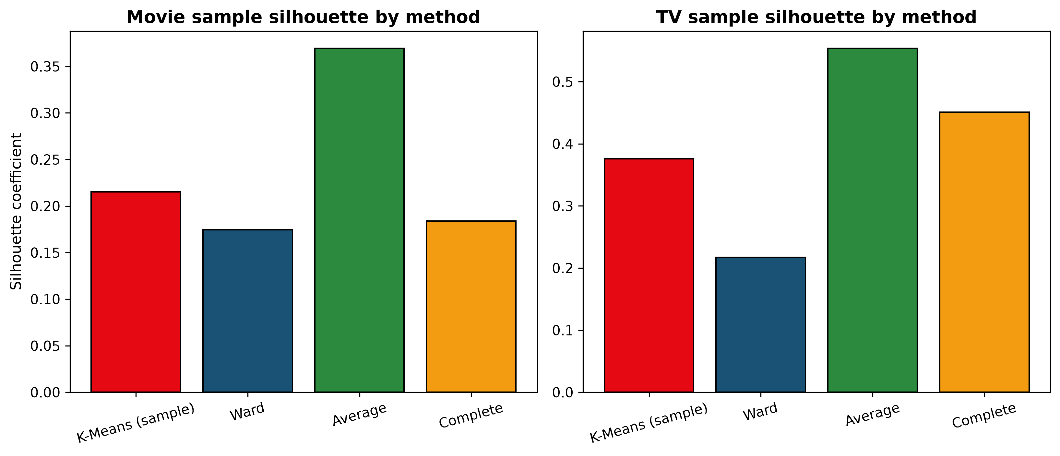
Figure 22: Sample silhouette by method — K-Means versus Ward/average/complete linkage on the stratified samples.
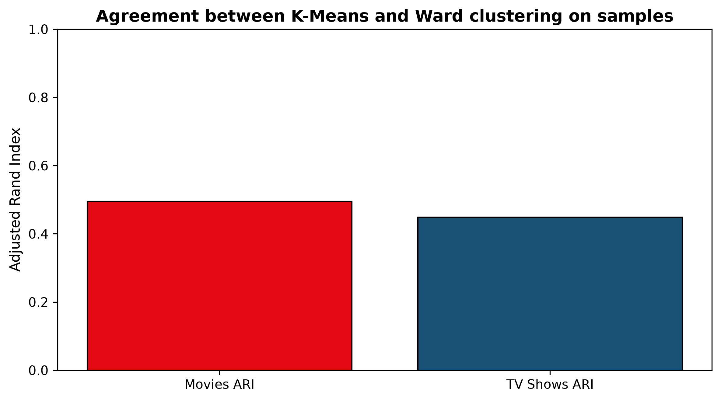
Figure 23: Adjusted Rand Index — Agreement between K-Means and Ward labels on the same samples (1 = identical partitions).
10. Cluster Analysis and Interpretation
Labels below are descriptive summaries of computed statistics. They are not Netflix internal genre systems and they do not imply audience demand.
10.1 Movie clusters
Movie Cluster 0: Contemporary international feature films
Size: 2,563 titles (47.67% of 5,377 movies).
- Release year: mean 2016.23, median 2017.
- Runtime: mean 109.12 min, median 106.0 min.
- Content age at addition: mean 2.3 years, median 1.0.
- Audience mix: Adults 58.7%; Teens 38.0%; Kids 1.9%; Unrated 1.4%
- Frequent listed genres: International Movies 74.7%; Dramas 58.3%; Comedies 32.7%; Independent Movies 19.7%; Action & Adventure 14.3%
- Primary-country groups: Other 52.8%; India 24.4%; United States 14.5%; United Kingdom 5.7%; Unknown Country 2.6%
- Common ratings: TV-MA 40.5%; TV-14 30.3%; R 9.8%; TV-PG 8.4%
This is the largest contemporary international feature group, with dense genre tagging. Possible use: sampling non-US catalogue records for metadata QA. Limitation: ‘International Movies’ is a catalogue genre tag, not a verified production nationality.
Movie Cluster 1: Mid-catalogue licensed features
Size: 791 titles (14.71% of 5,377 movies).
- Release year: mean 2002.64, median 2004.
- Runtime: mean 114.76 min, median 109.0 min.
- Content age at addition: mean 16.23 years, median 15.0.
- Audience mix: Teens 57.4%; Adults 38.4%; Kids 2.7%; Unrated 1.5%
- Frequent listed genres: Dramas 41.6%; Comedies 41.1%; International Movies 38.7%; Action & Adventure 23.6%; Romantic Movies 14.3%
- Primary-country groups: United States 50.8%; India 23.9%; Other 18.5%; United Kingdom 5.6%; Unknown Country 1.3%
- Common ratings: TV-14 23.8%; PG-13 22.5%; R 20.9%; PG 10.7%
This group has a longer addition lag and a teen-leaning US/India mix than the contemporary sets. Possible use: describing licensed back-catalogue features. Limitation: addition lag is not the same as cinematic importance or quality.
Movie Cluster 2: Classic and vintage cinema
Size: 188 titles (3.5% of 5,377 movies).
- Release year: mean 1974.31, median 1978.
- Runtime: mean 116.71 min, median 110.0 min.
- Content age at addition: mean 44.48 years, median 41.0.
- Audience mix: Teens 48.4%; Adults 43.1%; Kids 5.9%; Unrated 2.7%
- Frequent listed genres: Dramas 48.4%; International Movies 46.3%; Comedies 27.7%; Action & Adventure 27.1%; Documentaries 10.1%
- Primary-country groups: United States 41.5%; Other 29.8%; India 23.4%; United Kingdom 3.2%; Unknown Country 2.1%
- Common ratings: TV-14 34.0%; R 16.0%; TV-PG 14.9%; TV-MA 12.2%
This small vintage group differs from the newer catalogue in release year and addition lag. Possible use: flagging old titles for metadata review. Limitation: the group is small, so genre and rating percentages are less stable.
Movie Cluster 3: Short-form US docs, stand-up, and family titles
Size: 1,835 titles (34.13% of 5,377 movies).
- Release year: mean 2016.69, median 2017.
- Runtime: mean 77.16 min, median 83.0 min.
- Content age at addition: mean 1.53 years, median 1.0.
- Audience mix: Adults 61.6%; Teens 26.5%; Kids 10.2%; Unrated 1.7%
- Frequent listed genres: Documentaries 32.0%; Stand-Up Comedy 16.8%; Children & Family Movies 15.9%; Comedies 14.0%; Dramas 10.5%
- Primary-country groups: United States 68.0%; Other 14.6%; Unknown Country 8.1%; United Kingdom 8.0%; India 1.4%
- Common ratings: TV-MA 38.5%; TV-14 13.3%; R 11.8%; TV-PG 11.2%
This group is shorter and US-heavy, with documentary, stand-up, and family tags. Possible use: reviewing specials and shorter titles. Limitation: family titles and adult stand-up share a cluster, so it is also driven by length.
10.2 TV Show clusters
TV Cluster 0: Older acquired television catalogue
Size: 278 titles (11.54% of 2,410 TV Shows).
- Release year: mean 2008.29, median 2009.
- Season count: mean 1.74 seasons, median 1.0.
- Content age at addition: mean 9.8 years, median 8.0.
- Audience mix: Teens 48.9%; Adults 38.1%; Kids 12.6%; Unrated 0.4%
- Frequent listed genres: International TV Shows 47.1%; Kids' TV 23.7%; TV Comedies 21.9%; TV Dramas 19.8%; Romantic TV Shows 18.0%
- Primary-country groups: Other 47.8%; United States 30.6%; United Kingdom 11.2%; Unknown Country 7.9%; India 2.5%
- Common ratings: TV-14 37.4%; TV-MA 21.9%; TV-PG 16.2%; TV-Y7 11.5%
This group has a longer addition lag than the contemporary majority. Possible use: reviewing older acquired series metadata. Limitation: addition lag does not imply a series is long-running.
TV Cluster 1: Contemporary mostly single-season series
Size: 1,909 titles (79.21% of 2,410 TV Shows).
- Release year: mean 2017.7, median 2018.
- Season count: mean 1.36 seasons, median 1.0.
- Content age at addition: mean 0.88 years, median 0.0.
- Audience mix: Adults 58.4%; Teens 31.7%; Kids 9.8%; Unrated 0.2%
- Frequent listed genres: International TV Shows 53.7%; TV Dramas 30.0%; TV Comedies 20.3%; Crime TV Shows 19.4%; Docuseries 15.8%
- Primary-country groups: Other 45.2%; United States 29.1%; Unknown Country 13.1%; United Kingdom 9.2%; India 3.5%
- Common ratings: TV-MA 46.0%; TV-14 25.3%; TV-PG 12.2%; TV-Y 7.0%
This contemporary group is mostly single-season and carries the listed genres shown above. Possible use: describing common catalogue metadata patterns. Limitation: multiple genres remain mixed within the group.
TV Cluster 2: Legacy and vintage television
Size: 27 titles (1.12% of 2,410 TV Shows).
- Release year: mean 1980.96, median 1988.
- Season count: mean 3.33 seasons, median 1.0.
- Content age at addition: mean 36.41 years, median 29.0.
- Audience mix: Teens 44.4%; Adults 40.7%; Kids 14.8%
- Frequent listed genres: Kids' TV 22.2%; TV Comedies 22.2%; Anime Series 14.8%; TV Dramas 14.8%; International TV Shows 11.1%
- Primary-country groups: United States 55.6%; United Kingdom 18.5%; Other 18.5%; Unknown Country 7.4%
- Common ratings: TV-14 33.3%; TV-PG 25.9%; TV-MA 14.8%; TV-G 11.1%
This small legacy group has earlier release years than the contemporary majority. Possible use: flagging older TV records for metadata review. Limitation: the group is small, so percentages are uncertain and do not imply programming strategy.
TV Cluster 3: Multi-season continuing series
Size: 196 titles (8.13% of 2,410 TV Shows).
- Release year: mean 2017.54, median 2018.
- Season count: mean 5.71 seasons, median 5.0.
- Content age at addition: mean 0.91 years, median 0.0.
- Audience mix: Adults 46.9%; Teens 42.3%; Kids 10.2%; Unrated 0.5%
- Frequent listed genres: TV Dramas 37.2%; TV Comedies 35.7%; Kids' TV 20.9%; International TV Shows 19.9%; Crime TV Shows 18.9%
- Primary-country groups: United States 65.3%; Other 20.9%; United Kingdom 12.2%; Unknown Country 1.5%
- Common ratings: TV-MA 38.8%; TV-14 32.1%; TV-Y7 10.2%; TV-PG 8.2%
This contemporary, US-leaning group has a much higher season count than the mostly single-season groups. Possible use: studying long-running records in the catalogue. Limitation: season count is metadata, not evidence of current renewal.
11. Model Evaluation and Comparison
Metrics are specific to these matrices. Hierarchical numbers use samples; K-Means numbers below use the full type subsets unless marked otherwise.
Experiment | K | Silhouette | Davies–Bouldin | Calinski–Harabasz | Notes
K-Means movies full | 4 | 0.187 | 1.519 | 1808.2 | Primary movie model
K-Means TV full | 4 | 0.384 | 0.994 | 965.6 | Primary TV model
K-Means movies sample | 4 | 0.215 | — | — | Same 250 rows as dendrogram
Ward movies sample | 4 | 0.175 | 1.561 | 76.9 | ARI vs K-Means 0.495
K-Means TV sample | 4 | 0.376 | — | — | Same 250 rows as dendrogram
Ward TV sample | 4 | 0.217 | 1.281 | 105.8 | ARI vs K-Means 0.448

K-Means and Ward disagree on a substantial fraction of sampled titles (ARI ≈ 0.45–0.50) because Ward sees only the sample, uses a different merge criterion, and because the feature space is mixed binary/numeric. Average linkage’s higher sample silhouette does not make it a better catalogue taxonomy; it often rewards chaining small outliers. Computationally, K-Means on 5,377 rows is cheap; a full Ward dendrogram is the bottleneck, which is why sampling was used.
12. Key Findings
- 1. The strongest geometric split in both types is recency / addition lag (K=2 silhouette peak).
- 2. At K=4, movies separate into international features, shorter US docs/stand-up/family titles, mid-catalogue licensed features, and vintage cinema.
- 3. At K=4, TV Shows separate into two contemporary mostly single-season groups with different genre/country mixes, a multi-season group, and a small legacy group.
- 4. Genre multi-hot flags matter but do not produce pure single-genre clusters — titles are multi-labelled.
- 5. PCA 2D views retain about 64% (movies) and 76% (TV) of variance; they are illustrations, not the clustering space.
13. Challenges and Solutions
- Incommensurate duration: Mixing minutes and seasons would manufacture false neighbours. Solution: split by type.
- Metric conflict: Silhouette favoured an uninformative majority/minority split. Solution: combine elbow, indices, sizes, and profiles; report K=2 and K=4.
- Sparsity: 42 genre tags would sparse-ify K-Means. Solution: frequent multi-hot lists only.
- Hierarchy scale: Full dendrograms are unreadable. Solution: n=250 stratified sample with an explicit non-generalisation statement.
- Timing features: Release year and content age are related but measure original release timing and catalogue addition lag. Solution: document both as distinct catalogue dimensions and scale them robustly.
14. Limitations and Future Scope
The table is catalogue metadata through early 2021, not a living service graph. Encoding and scaling choices change distances; another team using TF-IDF on descriptions or Gower mixed-type distance would obtain different groups. Cluster count remains uncertain. High-dimensional binary features weaken Euclidean intuition. Future work could include Gaussian mixtures, HDBSCAN, clustering on a Gower matrix, topic models on descriptions, or stability via bootstrap adjusted Rand indices — still without claiming recommender insight.
15. Conclusion
Week 3 delivered a reproducible unsupervised analysis of the Netflix catalogue: type-separated feature matrices, Robust scaling, K-Means with a documented K search, Ward hierarchical clustering on qualified samples, PCA and profile visualisations, and interpretation that stays inside the metadata. The skills demonstrated are mixed-type preprocessing for distance methods, multi-criteria model selection, and cautious cluster storytelling.
16. References
- 1. Shivam Bansal. Netflix Movies and TV Shows. Kaggle. https://www.kaggle.com/datasets/shivamb/netflix-shows
- 2. Pedregosa et al. (2011). Scikit-learn: Machine Learning in Python. JMLR 12:2825–2830. https://scikit-learn.org/stable/modules/clustering.html
- 3. sklearn.cluster.KMeans and sklearn.metrics (silhouette, Davies–Bouldin, Calinski–Harabasz) documentation.
- 4. scipy.cluster.hierarchy linkage and dendrogram documentation.
- 5. Jain, A. K. (2010). Data clustering: 50 years beyond K-means. Pattern Recognition Letters.
- 6. Rousseeuw, P. J. (1987). Silhouettes: a graphical aid to the interpretation and validation of cluster analysis.
17. Appendix
17.1 Movie K-search table
K | Inertia | Silhouette | Davies–Bouldin | Calinski–Harabasz | Min n | Max n
2 | 34312.9 | 0.511 | 0.915 | 2612.6 | 475 | 4902
3 | 29234.8 | 0.177 | 1.627 | 1999.7 | 421 | 2908
4 | 25373.6 | 0.187 | 1.519 | 1808.2 | 188 | 2563
5 | 23610.5 | 0.196 | 1.470 | 1557.5 | 188 | 2376
6 | 22287.8 | 0.179 | 1.596 | 1383.4 | 150 | 2129
7 | 21142.5 | 0.154 | 1.671 | 1263.6 | 91 | 1658
8 | 20045.6 | 0.147 | 1.643 | 1184.1 | 53 | 1360
9 | 19266.1 | 0.140 | 1.725 | 1104.9 | 91 | 1311
10 | 18557.1 | 0.139 | 1.699 | 1042.3 | 26 | 1273

17.2 TV K-search table
K | Inertia | Silhouette | Davies–Bouldin | Calinski–Harabasz | Min n | Max n
2 | 24143.9 | 0.665 | 0.769 | 1221.6 | 108 | 2302
3 | 19905.2 | 0.416 | 0.993 | 996.8 | 27 | 2081
4 | 16511.7 | 0.384 | 0.994 | 965.6 | 27 | 1909
5 | 14226.5 | 0.311 | 1.059 | 936.8 | 10 | 1766
6 | 12822.8 | 0.192 | 1.321 | 883.7 | 10 | 1109
7 | 11952.3 | 0.192 | 1.308 | 818.9 | 10 | 1052
8 | 11265.3 | 0.191 | 1.252 | 765.4 | 2 | 1038
9 | 10639.6 | 0.176 | 1.312 | 726.4 | 2 | 909
10 | 10225.2 | 0.162 | 1.383 | 682.4 | 2 | 803

17.3 Feature lists
Movie features: release_year, duration_int, content_age, genre_count, country_count, aud_Kids, aud_Teens, aud_Adults, aud_Unrated, cty_United States, cty_India, cty_United Kingdom, cty_Unknown Country, cty_Other, genre_International Movies, genre_Dramas, genre_Comedies, genre_Documentaries, genre_Action & Adventure, genre_Independent Movies, genre_Children & Family Movies, genre_Romantic Movies, genre_Thrillers, genre_Stand-Up Comedy, genre_Music & Musicals, genre_Horror Movies
TV features: release_year, duration_int, content_age, genre_count, country_count, aud_Kids, aud_Teens, aud_Adults, aud_Unrated, cty_United States, cty_India, cty_United Kingdom, cty_Unknown Country, cty_Other, genre_International TV Shows, genre_TV Dramas, genre_TV Comedies, genre_Crime TV Shows, genre_Kids' TV, genre_Docuseries, genre_Romantic TV Shows, genre_British TV Shows, genre_Reality TV, genre_Anime Series
18. Validation Checklist
Check | Status
Week 3 notebook executed from a fresh Jupyter kernel | Completed
Clustering script executed (src/clustering.py) | Completed
Movies and TV Shows clustered separately | Completed
K-Means K=2…10 evaluated with multiple metrics | Completed
Elbow, silhouette, DB, CH charts saved | Completed
PCA and dendrogram figures saved under visualizations/week3/ | Completed
Cluster labels backed by computed profiles | Completed
Hierarchical comparison documented as sample-based | Completed
Week 1 and Week 2 reports/notebooks left in place | Completed
Identifiers excluded from the feature matrix | Completed
No credentials committed | Completed
DOCX generated from the same metrics JSON as the pipeline | Completed
DOCX rendered for page-by-page visual QA | Pending: LibreOffice soffice.exe unavailable

