**RFID BASED AUTOMATED TOLLCOLLECTION SYSTEM USING SMART CARD**

Valli@Poornima.P, Kowsalya.R, Priyanka.P, Priyanka.R (Final year IT)

Mrs. Sumithra.M Asst.Professor, Grade-1, Dept of IT,

Panimalar Engineering College, Chennai

**Abstract-** This research paper describes the automated toll collection system for tollgate based on SMART card technology. Most of the toll collection system is in manual transaction. Nowadays, there is a huge rush in toll plaza in order to pay the toll tax. It results in traffic jam, fuel waste and time waste. The objective of this paper is to transform manual transaction to automated toll collection system using SMART card technology. The automation of toll plaza is by using the combination of microcontroller, RFID reader and Smart card. There are four portions in the toll collection system. They are RFID system, GSM interface, TWO-WAY deduction, and SMART CARD barring. For the RFID system, 13.56 MHz high frequency RFID reader and SMART tags are used. The balance deduction is implemented with GSM. Embedded C is used to implement this system. The PIC microcontroller is used to display every detail on the LCD. This paper proposes a system, which automatically identifies a forthcoming vehicle and records vehicle’s number and time. If the vehicle is an authorized one, automatically the toll gate opens and a predetermined amount is automatically deducted from its smart card. By using this system, it will save time, reduces fuel consumption and no need to stop vehicle at the toll gate.

1. INTRODUCTION

Nowadays, increasing traffic causes congestions at the toll plaza. Therefore a new technique is required to solve the problem of congestions. Automated toll collection is one of the best methods to solve this problem. The automated system is composed of several subsystems. The SMART CARD technology, power supply, database, microcontroller, GSM interface, and the two-way deduction system. Automated system will save time and reducing human worker.

The SMART tag and RFID reader are contained in SMART CARD technology. SMART card is the advanced version of RFID. RFID means Radio Frequency Identification that consists of two tags which can be either active or passive tag. Passive tag do not have own power supply, much cheaper to manufacture, smaller in size and small coil antenna is also used. On the other hand, active tags have longer range and large memories. But it needs external power supply.

1. RELATED WORKS

In [6], the author mentioned that the micro simulation model for the automated toll plaza system using RFID technology. The PIC microcontroller is used for the control system. With this simulator, the optimal operation strategy of highway tollgate was proposed by benefit-cost analysis on the basis of benefit in saving total waiting time and operating cost. The signal is sent to the PC via RS-232 cable from the PIC and the output will be displayed on the LCD display. And then, the microcontroller sent the signal to the motor driver for opening the traffic gate. The author also described about the GSM modem to update the balance amount in the user account. In [7], the author mentioned that the Central server is used in the RFID based toll deduction system. Central server is connected to LAN (local area network). All computer system of LAN is connected to a central database via a WAN (wide area network). The whole record of toll deduction will be stored at the Central server and monthly transaction will be sent to the consumer from the Central server. The account number is included on the statement. Consumer will receive a statement of accounts on the monthly basis from the Central server.

In [5], the author explained that the RFID based automatic toll gate system. The 928 MHz frequency is used for the communication between RFID and control system. The microcontroller was programmed using c language and Visual Basic was used in serial communication. The database was developed using Microsoft Access because it can contain up to 32768 records of object.

1. DESIGN AND IMPLEMENTATION FOR THE SYSTEM

In order to design and implement the automated toll collection system using smart card it is divided into two parts. They are hardware design and software implementation of the system.

1. Hardware Design for the system

The RFID based automated system using SMART CARD technology can be divided into two modules. They are vehicle module and base module. The vehicle module consists of passive RFID tag. The RFID reader, SMART CARD, host computer

system and gate control system are composed as the base module. The general RFID based toll tax collection image in figure1.

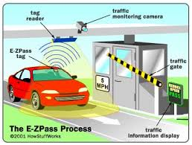

Figure1.General RFID based toll collection images

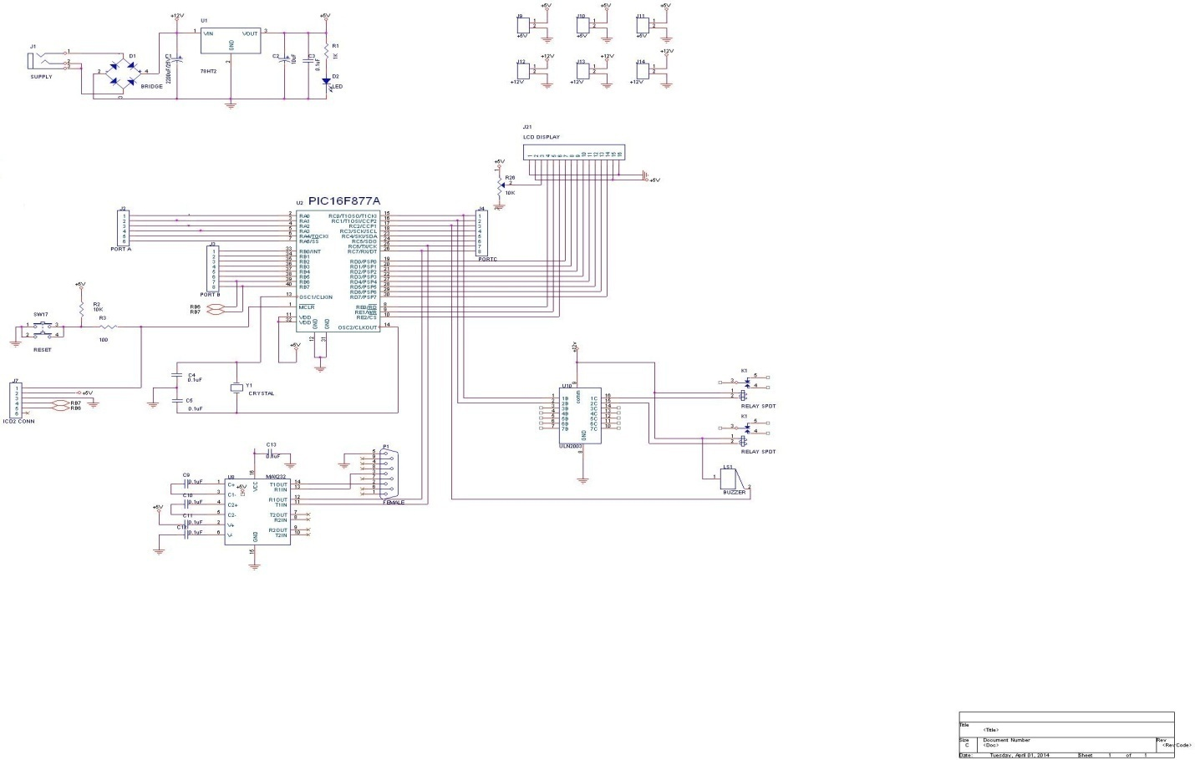

Figure2.CircuitDiagram of tollgate system using smart cards

The major component of the toll plazza system are as follow:

* PIC 16F877A
* LCD display
* RFID reader
* Smart card
* Power supply unit
* GSM interface

1. PIC 16F877A microcontroller

The PIC 16F877A is a 16 bit microcontroller which contais a program memory of 8-kbytes, data memory of 368 bytes, powerful (200 nanosecond instruction execution) easy-to-program (only 35 single word instructions) CMOS FLASH-based 8-bit microcontroller into an 40- or 44-pin package and is upwards compatible. The PIC16F877A features 256 bytes of EEPROM data memory, self program, an ICD, 2 Comparators, 8 channels of 10-bit Analog-to-Digital (A/D) converter, 2 detain/evaluate/PWM function, the synchronous series port can be configured as either 3-wire Serial Peripheral Interface (SPI™) or the 2-wire Inter-Integrated Circuit (I²C™) bus and a Universal Asynchronous Receiver Transmitter (USART). All of these features make it ideal for more advanced level A/D applications in automotive, industrial, and consumer appliances.

1. Liquid Crystal Display(LCD)

This module used for dislay the present status of the system. This is interface into 4 bit mode with microcontroller LCD screen consist of two lines with sixteen character each.

1. RFID Reader

RFID is a complete system solution that operates in the electromagnetic spectrum to transmit data without contact. It is an automatic identification and data collection technology utilizing “electronic” programmable tags for track, tracing and identification of objects. RFID is a system with the following components:

• Transponder (or Tag)

• Reader/Writer (Interrogator)

• Antenna

• Host computer

RFID does not require line of sight or contact for transmitting or receiving information. Thus, tagged items can be identified within the field without regard to orientation or position of the affixed tag.

1. SMART Card

Smart card is the advanced version of RFID. Smart card technology is used in many applicatons such as payphones, mobile communication, banking and retail, electronic purse,health care, id verification and access control.In electronic purse a smart card can be used to store a monetary value. The amount will be retrieved from the card by the reader, and subtract the amount for the goods or services being purchased. Radio-read smart cards avoid the needs of ticketing machine and will allow the free flow of people through transport systems.

1. Power Supply Unit

The DC power supply unit is vital component in modern electronic devices as they need a wide range of DC voltages for their operations. The purpose of a power supply is to provide the required amount of power specified voltage from primary source.

1. GSM Interface

GSM is a TDMA based wireless network technology. [GSM phones](http://www.mobileburn.com/definition.jsp?term=GSM) make use of a SIM card to spot the user's account. The use of the SIM card that allows [GSM network](http://www.mobileburn.com/definition.jsp?term=GSM) users to rapidly move their phone number from one GSM phone to another by merely moving the SIM card. Currently GSM networks operate on the frequency band of 850MHz, 900MHz, 1800MHz, and 1900M.

1. Software Implementation for the system

To accomplish the system, the choosing of software is very important. The Embedded C, Proteus and MP LAB are used to implement the system. The C language is familiar with many of the users and suitable for GUI design.

* Embedded C

Embedded C is the extension for the programming language C to support embedded processors, enabling portable and proficient application programming for embedded system. An embedded system is the combination of computer hardware and software, either fixed in capability. C language is small, simpler to learn, understand program and debug. C compilers are available for almost all embedded devices and it is convenient for all users.

* MP Lab

MPLAB is comprehensive software that has control, project managing and propose in it. It used in the development of embedded system application using microcontroller. Assembly language is a language that is used for programming the microcontroller. First it is converted into machine language so that the microcontroller can easily understand, and then we programmed these assembly language instructions into microcontroller memory. This conversion is done by software called assembler in MPLAB.

* Proteus

ISIS provides the development environment for PROTEUS VSM. This software combines mixed mode simulation, micro-processor models and interactive component models to allow the simulation of complete micro-controller based designs. In addition, a number of graph objects can be placed on the schematic to enable predictable time, frequency and sweep variable simulation to be performed. The features are correct Mixed Mode simulation based on Berkeley SPICE3F5 with extensions for digital simulation and true mixed mode operation.

1. EXPERIMENTAL RESULTS OF THE SYSTEM

The experimental results of the system which is implemented are described. The overview of the kit

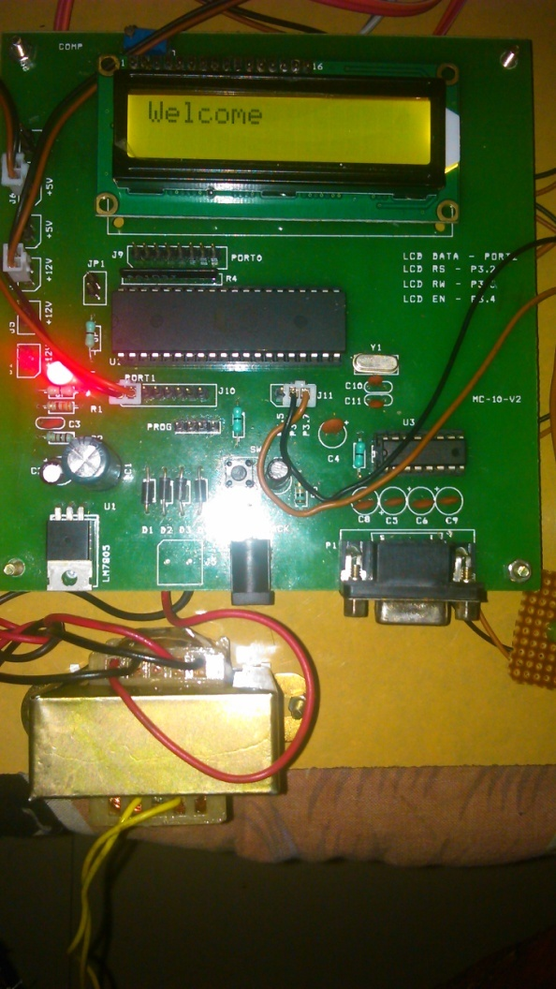

Once the reader detects the smart card the GSM interface will send the message to the owner. Initially the message contains original amount and the location. After crossing the toll booth the message contains location of current toll, time at which the vehicle crosses the toll booth, balance amount after crossing the toll. When the vehicle crosses the toll-booth the “UP amount will be taken from the smart card and the timer will also be start. If the vehicle crosses the same toll-booth again within the certain amount of time the “UP- DOWN” amount will be taken. Eg : if the “up” amount is 50 ,down amount is 50 and the up-down amount is 75 .If it reaches within the time 75rs will be taken otherwise 100rs will be taken. In case of car theft the message will be send to the owner regarding the toll-booth he /she crosses. Then the owner will immediately call to the smart card authority to block the card. If he/she uses the car at the next toll he will be deducted and he cannot be able to use the card.

1. CONCULSION

This system mainly reviewed the research and development of the tax collection at the toll gate on highway with the help of RFID using SMART CARD technology. By developing this system, the knowledge of RFID system PIC microcontroller, GUI design are realized. For this system, passive tags are better than the active tags because of low cost low power consumption and also radio signals environmental factors. By using smart card system, the vehicle can check for security with the passing time, save time and reduce traffic congestion at the toll plaza. Therefore, the RFID based SMART CARD technology is the best way for toll collection at the toll gate.

REFERENCES

1. ” ALLOCATION OF ELECTRONIC TOLL COLLECTION LANES AT TOLL PLAZA CONSIDERING SOCIAL OPTIMIZATION OF SERVICE TIMES AND DELAY”- Crispin Emmanuel D.Diaz, Jim Joel Madrigal,Aileen U.Mappala, Hilario Sean Palmiano,Richardo.
2. “ ELECTRONIC TOLL COLLECTION SYSTEM DEVELOPED IN MALAYSIA”-Dr. Ismail Md.Salleh, En.Khair Ul-Anwar Mohd Yusoff,Pn.Zaida Bt.Abdu Aziz.

3. ” ELECTRONIC TOLL COLLECTION SYSTEM USING PASSIVE RFID TECHNOLOGY”-Khadijah Kamarulazizi, Dr. Widad Ismail.

4. ” RFID BASED AUTOMATED TOLLGATE SYSTEM(RATS)”- Lovemore Gunda, Lee Masuka, Reginald Gonye, Samson Mhlanga, Lungile Nyanga.

5. “DYNAMIC APPROACH TOWARDS TOLL TAX COLLECTION AND VEHICLE TRACKING WITH THE HELP OF RFID”-R.M.Hushangabade,S.V.Dhopte.

6. “AUTOMATED TOLL PLAZA SYSTEM USING RFID”-Sachin Bhosale, Dnyaneshwar Nata Wahval.

7. “RFID BASED TOLL DEDUCTION SYSTEM”- Asif Ali Laghari, M.Sulleman Memon and Agha Sheraz Pathan

8. “SMART AUTOMATION TOLLGATE USING BLOOM FILTER ALGORITHM”- S.Rajalakshmi,M.Sailaja

9. “PAYMENT AUTOMATION AT TOLLGATE USING RFID AND SMS ALERT”- Elipe.NageswaraRao,G.Tirumala Vasu,N.G.N.Prasad,Kranthi Kumar,V.Rajesh.

10. “ADVANCED TRACKING SYSTEM WITH AUTOMATED TOLL”- Pritam Mhatre , Parag Ippar , Vinod Hingane,Yuvraj Sase , Sukhadev Kamble.