**Depletion of Solar radiation in atmosphere**

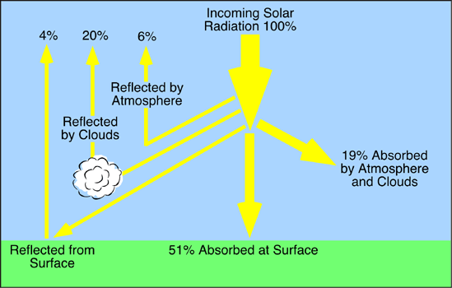

The loss of solar energy in passing through the atmospheric layers is called the atmodeflection. Depicts how solar radiation has to traverse thick and dense layers of the atmosphere in reaching the earth's surface.

The longer the path traversed, the greater the amount of radiant energy depleted. Various processes whereby heat energy is lost through the atmosphere are known as scattering, diffusion, absorption, and reflection.

**Scattering:**

The atmosphere is composed of molecules of air, water vapour and dust particles. These molecules scatter the shorter ultraviolet waves in different directions. This process, in meteorological parlance, is known as scattering.

But the red colour spectrum with larger wave-lengths manages to reach the surface of the earth. Thus, when we look at the sky away from the direct rays of the sun, we see more of blue light which was more readily scattered.

At sunrise and sunset the oblique rays have to pass through the longest path of the atmosphere, hence all the colour spectrums except the red and orange are scattered. It is only the red and the orange colours that reach our eyes. This accounts for the reddish hue of the sky during the twilight hours.

**Diffusion:**

When diameter of the particles is larger than the wave-length of the incident beam of light, true scattering does not occur, and the effect of the particles is of the nature of diffuse reflexion or diffusion. It is effective for all wave- lengths.

Since the process of diffusion is non-selective, component colours of the incident light do not get separated. That is why the light reflected from a cloud, when the sun is behind the observer, is pure white. The sun, for the same reason, appears white when seen through a fog composed of principally due to the diffusion of light in all possible directions by the dust particles present in the air that we have sufficient working light before the sunrise and after the sunset. This diffused light is called the twilight.

The astronomical and civil twilights last till the sun has sunk below the horizon 18° and 6° respectively. The twilights are of longer duration in high latitudes than in low latitudes.

It is of interest to note that it is mainly due to diffuse reflection that there is light in the rooms and under the trees. Thus, solar radiation suffers loss through diffuse reflection by larger particles, such as cloud droplets which occur in greater quantities at low altitudes in the atmosphere.

There is difference in the effects of small particles and cloud particles that are relatively larger. The molecules or small particles scatter a larger percentage of light of shorter wave­lengths causing the direct beam to be richer in red rays, and the scattered light to be richer in blue rays than the incident light.

On the contrary, the larger particles in a cloud are incapable of producing any change in the relative intensities of the different wave-lengths.

When a cloud appears reddish in colour, it should not be taken to be the result of a selective scattering effect produced by the cloud particles themselves. It is on account of the loss of blue light by scattering from the beam illuminating the cloud.

**Absorption:**

Absorption has been defined as the process in which the incident radiation is retained by a substance and is irreversibly convered to some other form of energy. There is a certain amount of radiant energy loss by the process of absorption in the atmosphere.

It may be pointed out that gases do not play very significant role, since they are selective absorbers. Their capacity to absorb solar radiation differs for different wavelengths. When a gas molecule absorbs light waves, this energy is transformed into internal molecular motion which causes a rise in temperature.

Nitrogen is a very poor absorber of incoming solar radiation. Oxygen and ozone are said to be the good absorbers of solar radiation shorter than 0.29 micrometer. At high altitudes oxygen absorbs most of the ultraviolet rays. In the stratosphere ozone removes ultraviolet radiation of relatively longer wave-lengths.

The most important and efficient absorber of ultraviolet radiation is water vapour which along with oxygen and ozone absorbs roughly 15 percent of the total solar radiation within the atmosphere.

In addition, carbon dioxide gas, which is present in the atmosphere in very small quantity up to the great heights, is an efficient absorber of incoming solar radiation that comes in the wave-lengths of about 15 microns.

In the direct absorption of incoming solar radiation, the water vapour present in the lowermost layer of the atmosphere plays the most significant part. In the electromagnetic spectrums a larger percentage is comprised of the infra-red waves.

According to Kendrew, about 43 percent of the incoming solar radiation is received through these longer infra-red waves. A larger percentage of these longer waves is directly absorbed by water vapour.

It may be mentioned that after the gases absorb incoming solar radiation they become heated by the conversion of radiant energy into heat. Thereafter, these absorbing gases start radiating the converted heat as long-wave radiation.

The cloud drops as well as the dust particles have little contribution to make in the absorption of incoming solar radiation. They are important for the purposes of scattering and diffuse reflection.

Thus, it is clear that the loss of incoming solar radiation in the atmosphere is in direct proportion to the amount of water vapour present. Since water vapour is mostly transparent to the shorter ultraviolet rays and opaque to the longer infra-red rays, it acts as a screen to long-wave radiation.

The shorter ultraviolet rays pass through this gas clearly, but the longer waves of the incoming solar radiation are partly absorbed. Similarly, water vapour is an effective absorber of long wave terrestrial radiation.