ADVANCED SQL(mandatory hand-on)
Exercise 1: Ranking and Window Functions
Input:
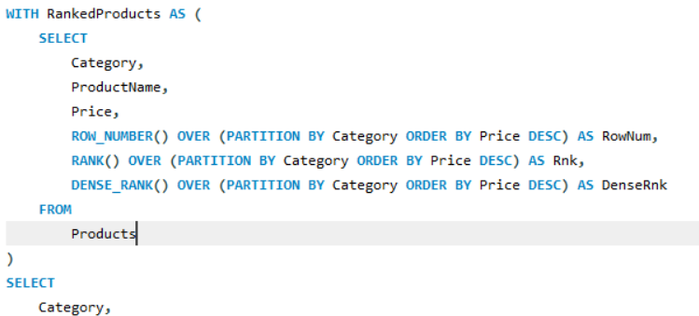
Output:
Exercise 2: Create a Stored Procedure
INPUT:
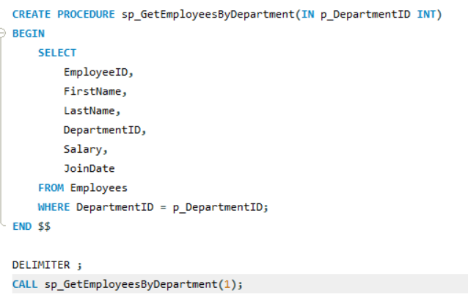
Output:
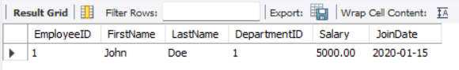
Exercise 3: Return Data from a Stored Procedure
INPUT:
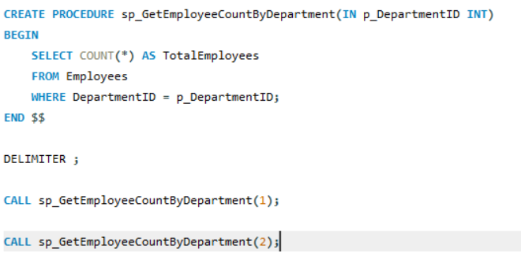
Output:
