MLG Pratical Work 01
Rapport

3. Quick numpy introduction

Max of each row and max of each column

Code
On utilise la fonction amax pour récupérer un tableau des plus grands éléments selon un axe donné.
print("The max of each row is {}".format(np.amax(array1, axis = 1)))
print("The max of each column is {}".format(np.amax(array1, axis = 0)))

Output
The max of each row is [3 6]
The max of each column is [4 5 6]

Print the elements of array1 that are less than 4

Code
On crée un masque sur la condition < 4 et on l’applique ensuite au tableau.
mask = array1 < 4
print("Elements of array1 that are < 4: {}".format(array1[mask]))

Output
Elements of array1 that are < 4: [1 2 3]

Convert the values of array2 to the range [0, 1]

Code
On utilise ici la valeur maximum du tableau pour normaliser les valeurs du tableau entre 0 et 1 (valeur max → 1, 0 → 0).
max = np.amax(array2)
ranger = np.vectorize(lambda t : t/max)
ranger(array2)

Output
array([0.55555556, 0.88888889, 0.22222222, 1. , 0.44444444,
0.33333333])

5. Quick Introduction to Pandas

Code
print(df.groupby('class').describe()['alcohol'])

Output
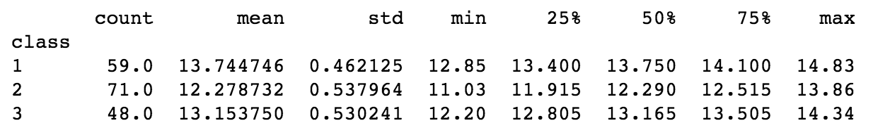

Classe | % d’alcool en moyenne | Médiane % d’alcool | Max % d’alcool | Min % d’alcool
1 | 13.74 | 13.75 | 14.83 | 12.85
2 | 12.28 | 12.29 | 13.86 | 11.03
3 | 13.15 | 13.17 | 14.34 | 12.20

