

Deepfake Face Swap Video Detection
Using Deep Learning & Computer Vision

Submitted In Partial Fulfillment of the Requirement for the Award of
Post Graduate Diploma in Artificial Intelligence (PG-DAI) Under the Guidance of

MS.
(Project Guide)

Submitted By
SWAPNIL LADE NIKHIL DIVEKAR VIKI PAWAR
PRN: 250820528044 PRN: 250820528049 PRN: 250820528037

CDAC, B-30, Institutional Area, Sector-62 Noida (Uttar Pradesh)-201307

CERTIFICATE
CDAC, NOIDA

This is to certify that the project report entitled “Deepfake Face Swap Video Detection
Using Deep Learning & Computer Vision” submitted by Swapnil Lade, Nikhil Divekar, and Viki Pawar in partial fulfilment of the requirements for the award of the Post Graduate Diploma in Artificial Intelligence (PG-DAI) at CDAC, Noida, is a record of the candidates’ own work carried out by them under my supervision.

The documentation embodies the results of original work and studies carried out by the students themselves. The contents of this report have not been submitted, in part or in full, for the award of any other degree, diploma, or academic recognition to this or any other institution.

Date:
Place: Noida
MS. SARUTI GUPTA
(Project Guide)

ABSTRACT

The rapid advancement of artificial intelligence and deep learning technologies has enabled the creation of highly realistic synthetic media, commonly known as deepfakes, which can manipulate facial identities in video content with remarkable accuracy. While these technologies have beneficial applications in entertainment and media production, they also introduce serious challenges related to digital security, misinformation, identity fraud, and the erosion of public trust in online content. The increasing accessibility of face swap tools has made it easier for malicious users to generate deceptive videos, making the development of reliable and automated detection systems a critical research problem.
This project presents a comprehensive Deepfake Face Swap Video Detection System using Deep Learning and Computer Vision techniques to identify and classify manipulated video content. The proposed framework is designed to analyze both the spatial and temporal characteristics of facial features across video sequences. The system begins by capturing input videos and extracting frames at regular intervals to ensure efficient processing while maintaining essential visual information. Face regions are then detected from each frame using an automated face detection mechanism, which isolates the most prominent facial area for further analysis.

To extract meaningful visual patterns, a Convolutional Neural Network (CNN) is employed to learn discriminative spatial features from the detected facial images. These features capture subtle inconsistencies in texture, lighting, edges, and facial structures that often arise during face swap generation. Since deepfake artifacts may not be consistently visible in a single frame, the system incorporates a Long Short-Term Memory (LSTM) network to model temporal dependencies and identify irregular motion patterns and frame-to-frame inconsistencies across the video sequence.
The combined CNN–LSTM architecture enables the system to effectively differentiate between authentic and manipulated videos by learning both appearance-based and sequence-based representations. The model is trained using a labeled dataset containing real and deepfake video samples and is optimized through fine-tuning techniques to improve generalization and robustness. Performance evaluation is conducted using standard metrics such as accuracy, precision, recall, F1-score, and confusion matrix analysis to assess the reliability of the detection process.

ACKNOWLEDGEMENT

We would like to express our sincere gratitude and heartfelt thanks to Ms…., our Project Guide, CDAC, Noida, for her valuable guidance, continuous support, and expert supervision throughout the course of this project. Her scholarly insights, constructive feedback, and constant encouragement played a significant role in shaping the successful completion of this work.

We extend our special thanks to Mr. Ravi Payal, Program Coordinator, CDAC, Noida, for his motivation, coordination, and administrative support, which greatly facilitated the smooth execution of this project.
We also acknowledge the support and cooperation of the faculty members and staff of CDAC, Noida, for providing the necessary resources and a conducive academic environment required for the development of this project.
Finally, we sincerely appreciate the encouragement and cooperation extended by our peers, which contributed positively to the completion of this project work.

SWAPNIL LADE NIKHIL DIVEKAR VIKI PAWAR
PRN: 250820528044 PRN: 250820528049 PRN: 250820528037

Table of Contents

CERTIFICATE 2
ABSTRACT 3
ACKNOWLEDGEMENT 4
Table of Contents 5
LIST OF FIGURE 7
LIST OF TABLE 8
CHAPTER 1 9
- INTRODUCTION 9
Background 10
Objective 11
Motivation 11
Purpose and Scope 12
CHAPTER 2 13
- SURVEY OF TECHNOLOGY 13
Machine Learning 13
Machine Learning Libraries Used 14
Face Detection 19
Face Recognition 20
Algorithm used for Face Detection and Face Recognition 21
SVM 22
HOG 23
CHAPTER 3 24
FEASIBILITY STUDY 25
ECONOMIC FEASIBILITY 26
Technical Feasibility 27
Behavoioral Feasibility 28
CHEPTER 4 29
REQUIREMENT & ANALYSIS 30
Problem Definition 31
Planning and Scheduling(Pert Chart and Gantt Chart) 32
Pert Chart 33
    - Gantt Chart 34
Software / Hardware Requirement 35
CHAPTER 5 36
- PRELIMINARY MODULE DESCRIPTION 37
Software Module 38
  - Process of working 39
CHAPTER 6 40
- SYSTEM DESIGNING 41
System Architecture 38
Flow Daigram 38
CHAPTER 7 44
- CODING 44
- RESULT 50
CHAPTER 8 51
CONCLUSION 51
FUTURE WORK 51
REFERENCES 52

LIST OF FIGURE

Figure 1.1 Background Process 10
Figure 2.2 Image of Face Detection 19
Figure 2.3 Image of Face Recognition 20
Figure 2.4.1 Figure of SVM 21
Figure 5.1.1.Image of Face Detection 30
Figure 5.1.2 Image of Eye Detection 31
Figure 5.1.3 Image for 68 Facial Landmarks 32
Figure 5.1.4 Image for Aspect Ratio of Eye 33
Figure 6.1.System Architecture of Drowsiness Detection 35
Figure 6.2. Flow Daigram 37
Figure 8.1.Checking Eye Aspect Ratio 41
Figure 8.2.Generating Drowsiness Alert 41

LIST OF TABLE
Table 1.3: Total accidents, number of persons killed and injured between 2010 and 2019 in India 11

CHAPTER 1

INTRODUCTION

The rapid growth of artificial intelligence and deep learning technologies has significantly transformed the way digital media is created, processed, and consumed in the modern world. One of the most impactful developments in this domain is the emergence of deepfake technology, which enables the generation of highly realistic synthetic images and videos by manipulating or replacing a person’s facial identity. While deepfake techniques have found applications in entertainment, film production, and virtual communication, they have also raised serious ethical, social, and security concerns.
With the widespread use of social media platforms and digital communication channels, video content has become one of the most trusted and influential forms of information sharing. However, the increasing quality and accessibility of face swap tools have made it difficult for users to distinguish between real and manipulated videos. This challenge has led to the rapid spread of misinformation, identity impersonation, and digital fraud, highlighting the urgent need for reliable and automated deepfake detection systems.

Deepfake face swap technology is primarily based on advanced deep learning models, such as generative adversarial networks (GANs) and autoencoders, which can learn complex facial features and expressions from large datasets. These models can generate videos that preserve natural facial movements, lighting conditions, and expressions, making detection increasingly difficult using traditional image processing techniques. As a result, conventional methods based on handcrafted features and simple statistical analysis are often insufficient to identify subtle artifacts and inconsistencies introduced during the manipulation process.

In response to these challenges, researchers have turned toward deep learning-based detection frameworks that can learn discriminative features directly from data. Computer vision techniques, combined with neural networks, enable automated systems to analyze visual patterns, textures, and temporal dynamics present in video sequences. By leveraging both spatial and temporal information, detection models can identify inconsistencies that are not easily perceivable by the human eye.
This project focuses on the design and implementation of a Deepfake Face Swap Video Detection System using Deep Learning and Computer Vision methodologies. The proposed system aims to classify input videos as either authentic or manipulated by analyzing facial regions across a sequence of frames. The system begins by extracting frames from the video and applying face detection algorithms to isolate the most relevant facial areas for further processing.

A Convolutional Neural Network (CNN) is employed to extract meaningful spatial features from each detected face, such as texture patterns, edge information, and facial structure. These features are essential for identifying visual artifacts introduced during face swapping, including unnatural blending, color mismatches, and distorted facial boundaries. Since deepfake manipulations often vary across consecutive frames, the system integrates a Long Short-Term Memory (LSTM) network to model temporal dependencies and capture inconsistencies in facial motion and expression dynamics over time.
The combined CNN–LSTM architecture enables the system to learn a comprehensive representation of both appearance-based and sequence-based characteristics of the video. This approach enhances the robustness of the detection process and improves generalization across different types of deepfake generation techniques. The model is trained and validated using a labeled dataset containing both real and manipulated videos to ensure reliable performance in real-world scenarios.

The detection system is evaluated using standard performance metrics, including accuracy, precision, recall, F1-score, and confusion matrix analysis. These metrics provide insights into the effectiveness and reliability of the model in distinguishing between real and fake video content. The output of the system includes a classification label along with a confidence score, allowing users to assess the authenticity of the video.

The proposed framework has significant practical applications in various domains, such as social media content moderation, digital forensics, cybersecurity, online identity verification, and media authentication. By providing an automated and scalable solution for deepfake detection, this project contributes to enhancing trust in digital media ecosystems and supporting the responsible use of artificial intelligence technologies.

Furthermore, this work lays the foundation for future research and development in the field of multimedia forensics. Potential extensions of the system include real-time detection in live video streams, integration of audio-based deepfake analysis, and deployment through web and mobile platforms to improve accessibility and usability. Through continuous improvement and adaptation, deepfake detection systems can play a critical role in safeguarding digital communication and preserving the integrity of visual information in an increasingly connected world.

BACKGROUND :

DATA PREPROCESSING
Data preprocessing is a critical phase in the development of an effective deepfake face swap video detection system, as the quality of input data directly influences the performance and reliability of the deep learning model. Raw video data often contains noise, variations in lighting, resolution differences, and irrelevant visual information that can adversely affect the learning process. Therefore, systematic preprocessing is required to ensure consistency, enhance feature quality, and reduce computational complexity.

The preprocessing pipeline begins with the conversion of input videos into a standardized format to maintain uniformity across the dataset. Videos are resampled to a fixed frame rate and resolution to ensure that temporal and spatial features are comparable across different samples. This step also helps in minimizing distortions introduced by compression and varying recording devices.

Following standardization, each video is decomposed into a sequence of frames, which allows the system to analyze individual visual components and temporal patterns. The extracted frames are then subjected to normalization techniques, including pixel intensity scaling and color space adjustments, to reduce the impact of illumination changes and improve contrast. These steps ensure that the deep learning model focuses on meaningful visual patterns rather than environmental variations.

To further enhance robustness, data augmentation techniques are applied during training. These techniques include random horizontal flipping, slight rotation, zooming, and brightness adjustments. Augmentation helps in increasing the diversity of the training dataset, reducing overfitting, and enabling the model to generalize better across different video conditions and face orientations.

In addition, frames that do not contain detectable faces or that are significantly blurred or corrupted are filtered out to maintain dataset quality. The remaining facial frames are aligned and resized to a uniform dimension, ensuring compatibility with the input requirements of the neural network architecture. This step contributes to stable and efficient training of the model.

By implementing a structured and consistent data preprocessing pipeline, the system ensures that high-quality and relevant visual information is provided to the feature extraction and classification modules. This process enhances detection accuracy and improves the overall reliability of the deepfake detection framework.

FRAME EXTRACTION
Frame extraction is a fundamental step in video-based deepfake detection, as it enables the transformation of continuous video streams into discrete visual units that can be processed and analyzed by computer vision and deep learning models. Since videos consist of a large number of frames, processing every frame may be computationally expensive and unnecessary. Therefore, an efficient frame sampling strategy is adopted to balance performance and resource utilization.

In the proposed system, the input video is first analyzed to determine its total frame count and duration. Based on this information, frames are extracted at regular intervals to ensure that the selected frames are representative of the entire video sequence. This approach preserves important temporal information while significantly reducing the volume of data to be processed.
The extracted frames serve as the primary input for face detection and feature extraction stages. Each frame is converted into a standardized image format and stored temporarily for further analysis. Care is taken to maintain the correct sequence order of frames, as temporal consistency plays a critical role in identifying manipulation patterns across consecutive frames.

To enhance reliability, the system includes mechanisms to handle frames affected by motion blur, low illumination, or sudden scene changes. Such frames are either enhanced using basic image processing techniques or discarded if they fail to meet predefined quality thresholds. This ensures that only informative and high-quality frames are passed to the detection pipeline.

The frame extraction process also enables the system to capture subtle changes in facial expressions, head movements, and lighting conditions over time. These temporal cues are essential for identifying inconsistencies introduced during face swap generation, which may not be visible in isolated frames.
By efficiently selecting and organizing representative frames, the frame extraction module lays a strong foundation for accurate feature learning and classification. This step ensures that the detection system maintains both temporal awareness and computational efficiency, making it suitable for large-scale and real-world applications.

FACE DETECTION
Face detection is a core component of the deepfake face swap video detection system, as it isolates the most relevant region of interest from each extracted frame. Since deepfake manipulations primarily affect facial areas, accurately locating and segmenting the face is essential for reliable feature extraction and classification.

The system employs an automated face detection algorithm based on deep learning techniques, such as the Multi-Task Cascaded Convolutional Network (MTCNN). This approach enables the detection of facial bounding boxes and key landmarks, including the eyes, nose, and mouth, even under varying lighting conditions, facial orientations, and partial occlusions.

For each extracted frame, the face detection module scans the image and identifies the most prominent facial region. The detected bounding box is then used to crop the face from the background, effectively removing irrelevant visual elements such as scenery, objects, and surrounding distractions. This focused representation allows the model to concentrate on facial textures, edges, and structural patterns that are more indicative of manipulation.

To ensure consistency across the dataset, the cropped facial images are resized to a fixed dimension and aligned based on detected landmarks. Alignment helps in standardizing the position and orientation of facial features, which improves the stability and accuracy of the feature extraction process.

In cases where multiple faces are present in a single frame, the system selects the primary face based on confidence scores or spatial prominence. Frames in which no face is detected are either discarded or flagged for further processing, ensuring that only valid and informative samples are used during training and inference. By accurately detecting and isolating facial regions, the face detection module significantly enhances the effectiveness of the deepfake detection framework. This step reduces background noise, improves feature quality, and contributes to the overall robustness and reliability of the system in diverse real-world scenarios.

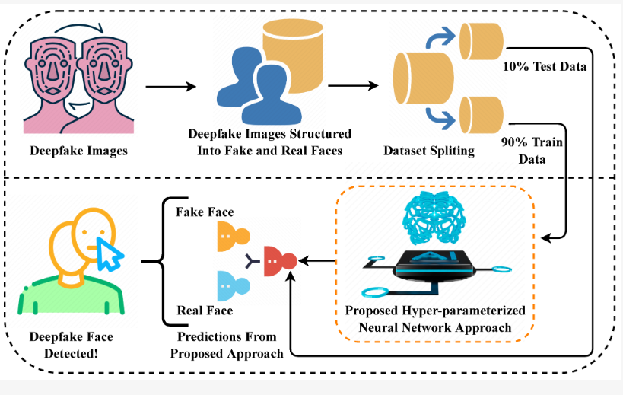
FIG 1.1 Background Process

OBJECTIVE :

The primary objective of this project is to design and develop an intelligent Deepfake Face Swap Video Detection System using Deep Learning and Computer Vision techniques that can accurately identify and classify manipulated video content as either REAL or FAKE.

The specific objectives of the project are as follows:

To study and analyze existing deepfake generation and detection techniques to understand their strengths and limitations.

To design a robust framework for extracting and processing video frames for efficient facial analysis.

To implement an automated face detection and localization module to isolate facial regions from video frames.

To develop a deep learning-based feature extraction model using Convolutional Neural Networks (CNN) for learning spatial facial characteristics.

To incorporate a Long Short-Term Memory (LSTM) network for analyzing temporal dependencies and frame-to-frame inconsistencies in video sequences.

To train and evaluate the model using a labeled dataset of real and deepfake videos.

To assess system performance using standard metrics such as accuracy, precision, recall, F1-score, and confusion matrix.

To generate a user-friendly output that displays classification results along with a confidence score.

To explore the scalability of the system for real-time detection and large-scale deployment in social media and digital platforms.

To contribute toward enhancing digital security, media authenticity, and trust in online video content.

MOTIVATION :

The rapid growth of digital media and artificial intelligence technologies has significantly transformed the way information is created and shared across the world. With the emergence of deepfake technology, it has become possible to generate highly realistic face swap videos that are often indistinguishable from authentic content. While such advancements offer creative and entertainment opportunities, they also introduce serious threats related to misinformation, identity impersonation, cyber fraud, and the erosion of public trust in online platforms.

The increasing misuse of manipulated videos in social media, political campaigns, and digital communications has highlighted the urgent need for reliable and automated verification systems. Manual detection methods are time-consuming, subjective, and ineffective against large volumes of video content generated daily. This creates a strong motivation to develop intelligent systems that can efficiently analyze and verify the authenticity of videos with minimal human intervention.

From a technical perspective, deepfake detection presents a challenging and meaningful research problem due to the continuous evolution of face swap generation techniques. This motivates the exploration of advanced deep learning models capable of learning subtle visual and temporal inconsistencies that cannot be easily identified by the human eye. The integration of computer vision and sequence-based neural networks offers an opportunity to build robust and scalable detection frameworks.

This project is also motivated by the growing demand for secure digital communication in domains such as journalism, law enforcement, education, and online identity verification. By developing a practical and automated deepfake detection system, the project aims to contribute toward building safer digital ecosystems and promoting responsible use of artificial intelligence technologies.

PURPOSE AND SCOPE

Purpose
The purpose of this project is to design and implement an intelligent system that can automatically detect face swap manipulations in video content using deep learning and computer vision techniques. The system aims to assist users, organizations, and digital platforms in verifying the authenticity of video media and reducing the spread of fake or misleading content.
The project focuses on analyzing both spatial and temporal facial features to ensure reliable classification of videos as either REAL or FAKE. By combining convolutional and recurrent neural network architectures, the system provides a comprehensive approach to detecting inconsistencies introduced during the deepfake generation process.

Scope
The scope of this project includes the development of a video-based detection framework that processes pre-recorded video files as input. The system performs frame extraction, face detection, data preprocessing, feature extraction, temporal analysis, and classification using deep learning models.
The project scope covers training and testing the model on a labeled dataset of real and deepfake videos to evaluate system performance using standard metrics such as accuracy, precision, recall, and F1-score. The system is designed to provide classification results along with a confidence score for each analyzed video.
While the current implementation focuses on face swap video detection, the framework can be extended to support real-time detection, web-based deployment, and multimodal analysis incorporating audio verification. The system is intended for academic, research, and prototype-level deployment in domains such as digital forensics, cybersecurity, social media moderation, and online identity verification.

PROBLEM STATEMENT
The widespread availability of deep learning-based face swap tools has made it increasingly easy to generate realistic manipulated videos that can mislead viewers and cause significant social, ethical, and security-related consequences. Traditional video authentication methods and manual verification processes are insufficient to handle the growing volume and sophistication of deepfake content shared across digital platforms.
There is a lack of automated, accurate, and scalable systems capable of analyzing both visual and temporal features in video sequences to reliably distinguish between authentic and manipulated facial content. Existing solutions often struggle with variations in video quality, lighting conditions, compression artifacts, and the continuous evolution of deepfake generation techniques.
Therefore, the problem addressed in this project is the design and development of an intelligent deep learning-based system that can automatically detect face swap manipulations in video content with high accuracy and reliability. The system should be capable of processing video inputs, isolating facial regions, extracting meaningful spatial and temporal features, and classifying videos as REAL or FAKE, thereby supporting secure and trustworthy digital media communication.

CHAPTER 2

SURVEY OF TECHNOLOGY

This chapter presents an overview of the technologies and methodologies used in the development of the Deepfake Face Swap Video Detection System. It discusses the fundamental concepts of artificial intelligence, machine learning, deep learning, and computer vision, along with the specific techniques and tools employed to detect manipulated video content.

2.1 Artificial Intelligence
Artificial Intelligence (AI) is a branch of computer science that focuses on creating systems capable of performing tasks that normally require human intelligence. These tasks include learning from experience, reasoning, problem-solving, perception, decision-making, and language understanding. AI systems are designed to analyze large volumes of data, identify meaningful patterns, and use this knowledge to make predictions or take actions with minimal human intervention.

AI can be broadly classified into Narrow AI and General AI. Narrow AI refers to systems developed to perform a specific task, such as facial recognition, speech recognition, or recommendation systems. General AI, which aims to replicate human-level intelligence across multiple domains, is still largely a subject of ongoing research. The deepfake detection system developed in this project falls under the category of Narrow AI, as it is specifically designed to analyze and classify video content as real or manipulated.

In the context of deepfake face swap detection, AI plays a central role in automating the process of identifying subtle visual and temporal inconsistencies that are often imperceptible to the human eye. Traditional rule-based systems rely on manually crafted features and predefined thresholds, which are limited in their ability to adapt to new manipulation techniques. AI-based systems, on the other hand, learn directly from data, enabling them to evolve and improve as more training examples become available.

AI models used in this project are trained using large datasets of labeled video samples. During the training phase, the system learns to map input video frames to corresponding output classes (REAL or FAKE) by adjusting internal parameters to minimize classification error. This learning process allows the model to develop an internal representation of complex facial patterns, lighting variations, and motion dynamics associated with both authentic and manipulated videos.

2.2 Machine Learning
Machine Learning (ML) is a subset of Artificial Intelligence that focuses on the development of algorithms and statistical models that enable computer systems to learn patterns from data and improve their performance on a specific task without being explicitly programmed for every possible scenario. Instead of relying on fixed rules, machine learning systems build predictive models by analyzing large datasets and identifying relationships between input features and output labels.

Machine learning techniques are generally categorized into supervised learning, unsupervised learning, and reinforcement learning. In supervised learning, the model is trained using labeled data, where each input sample is associated with a known output. This approach is commonly used for classification and prediction tasks. In unsupervised learning, the system identifies hidden patterns or groupings in unlabeled data, such as clustering or dimensionality reduction. Reinforcement learning involves training an agent to make decisions by interacting with an environment and receiving feedback in the form of rewards or penalties.
In the context of deepfake face swap video detection, supervised learning is primarily used. The system is trained on a dataset consisting of labeled video samples classified as REAL or FAKE. During training, the model learns to map extracted features from video frames to the corresponding class labels. This process allows the model to develop the ability to generalize and accurately classify previously unseen video content.

Machine learning plays a vital role in optimizing the performance of the detection system. Feature representations extracted from facial images and video sequences are processed through learning algorithms that adjust internal parameters to minimize classification error. This iterative learning process enables the model to continuously refine its decision boundaries and improve detection accuracy.

2.3 Deep Learning
Deep Learning is a specialized subset of machine learning that focuses on the use of artificial neural networks with multiple hidden layers to model complex patterns and representations in large-scale data. These multi-layered networks, often referred to as deep neural networks, are capable of automatically learning hierarchical features from raw input data such as images, videos, and audio, without the need for manual feature engineering.

The fundamental building block of deep learning is the artificial neuron, which is inspired by the structure and function of biological neurons in the human brain. Neurons are organized into layers, including an input layer, several hidden layers, and an output layer. Each neuron performs a weighted sum of its inputs, applies a nonlinear activation function, and passes the result to the next layer. By stacking multiple layers, deep learning models can learn increasingly abstract and complex representations of data.

In the context of video and image analysis, deep learning has demonstrated exceptional performance due to its ability to capture both low-level and high-level features. Lower layers of the network typically learn simple patterns such as edges, corners, and color gradients, while deeper layers learn more complex structures such as facial components, textures, and semantic features. This hierarchical learning process makes deep learning particularly suitable for tasks such as face recognition, object detection, and deepfake detection.

This project utilizes deep learning to analyze both spatial and temporal characteristics of facial data. Spatial features are extracted using Convolutional Neural Networks (CNNs), which are designed to process visual data by applying convolutional filters across image regions. These filters help identify subtle visual artifacts, blending errors, and texture inconsistencies that may arise during face swap manipulation.

2.4 Computer Vision
Computer Vision is a specialized field of Artificial Intelligence that focuses on enabling machines to acquire, process, analyze, and interpret visual information from images and videos in a manner similar to human vision. The primary goal of computer vision is to extract meaningful information from visual data and use it to make decisions, recognize patterns, and understand the surrounding environment.

Computer vision systems typically follow a structured pipeline that includes image acquisition, preprocessing, feature extraction, and interpretation. Image acquisition involves capturing visual data through cameras or video files. Preprocessing techniques are applied to enhance image quality and reduce noise, such as resizing, normalization, color space conversion, and filtering. Feature extraction focuses on identifying important visual elements like edges, textures, shapes, and key points that can be used for analysis and classification.

In the context of deepfake face swap video detection, computer vision plays a critical role in transforming raw video input into a structured and analyzable format suitable for deep learning models. The system begins by decomposing the video into a sequence of frames, enabling the analysis of both spatial and temporal information. Each frame is processed individually to identify and isolate the facial region, which serves as the primary region of interest for detecting manipulation.

Face detection is one of the most important computer vision tasks in this project. Advanced detection algorithms, such as Multi-Task Cascaded Convolutional Networks (MTCNN), are used to locate facial boundaries and key landmarks within each frame. This allows the system to accurately crop and align faces, ensuring consistency and improving the quality of features extracted by the deep learning model.

2.5 Deepfake Technology
Deepfake technology refers to a class of artificial intelligence-based techniques used to create or manipulate visual and audio content in a highly realistic manner. The term “deepfake” is derived from the combination of “deep learning” and “fake,” indicating the use of deep neural networks to generate synthetic media that closely resembles real-world data. In the context of face swap videos, deepfake technology enables the replacement of one individual’s facial identity with another while preserving natural expressions, head movements, and lighting conditions.

The foundation of deepfake generation lies in advanced generative models, particularly Generative Adversarial Networks (GANs) and autoencoders. A GAN consists of two neural networks, known as the generator and the discriminator, which are trained simultaneously in a competitive framework. The generator attempts to create realistic synthetic images, while the discriminator evaluates whether the generated images are real or fake. Through this adversarial training process, the generator progressively improves its ability to produce highly convincing manipulated content.

Autoencoder-based face swap systems use an encoder-decoder architecture to learn a compact representation of facial features. The encoder extracts key facial attributes from input images, while the decoder reconstructs the face in the style of a target individual. By training separate decoders for different identities, the system can effectively swap facial appearances while maintaining consistent expressions and movements across video frames.

Modern deepfake systems incorporate additional techniques such as facial landmark alignment, texture mapping, and blending algorithms to improve realism. These methods ensure that the swapped face aligns accurately with the target’s head position and blends seamlessly with the surrounding skin and background. As a result, visual artifacts and inconsistencies are minimized, making detection increasingly challenging.

2.6 Face Swap Techniques
Face swap techniques involve replacing the facial region of one person in a video with that of another while maintaining realistic expressions and movements. Traditional approaches relied on landmark-based alignment and blending, whereas modern methods use deep learning models to generate more natural results.

Deep learning-based face swap systems learn a mapping between facial features of source and target individuals, enabling the synthesis of highly realistic manipulated videos. These techniques often introduce minor visual and temporal artifacts, which can be exploited by detection models for classification.

2.7 Convolutional Neural Network (CNN)
A Convolutional Neural Network (CNN) is a specialized class of deep learning models designed primarily for processing and analyzing visual data such as images and video frames. CNNs are inspired by the organization of the human visual cortex and are particularly effective in identifying spatial patterns, textures, and structural features within visual inputs.

The architecture of a CNN consists of multiple layers arranged in a hierarchical manner, where each layer is responsible for learning a different level of abstraction. The main components of a CNN include convolutional layers, activation functions, pooling layers, and fully connected layers.

2.8 Long Short-Term Memory (LSTM)
Long Short-Term Memory (LSTM) is a specialized type of Recurrent Neural Network (RNN) designed to learn and model long-term dependencies in sequential data. Unlike traditional feedforward neural networks, which process inputs independently, LSTMs are capable of retaining information over extended sequences, making them particularly suitable for tasks involving time-series data, natural language processing, and video analysis.

One of the main challenges with standard RNNs is the vanishing and exploding gradient problem, which makes it difficult for the network to learn long-range relationships between earlier and later elements in a sequence. LSTM networks address this limitation by introducing a unique memory structure known as the cell state, which allows information to flow through the network with minimal modification unless explicitly controlled by gating mechanisms.

2.9Libraries and Tools Used
The successful implementation of the Deepfake Face Swap Video Detection Using Deep Learning & Computer Vision project relies on a combination of programming languages, deep learning frameworks, and computer vision libraries. These tools support various stages of the system, including video processing, model development, training, evaluation, and result visualization.

Python
Python serves as the primary programming language for the development of the entire system. It is widely used in the fields of machine learning and computer vision due to its simplicity, readability, and extensive ecosystem of open-source libraries. Python enables rapid prototyping and seamless integration of different modules such as data preprocessing, model training, testing, and deployment. Its strong community support and availability of scientific computing packages make it an ideal choice for implementing complex deep learning workflows.

TensorFlow and Keras
TensorFlow is an open-source deep learning framework developed by Google that provides a flexible and scalable environment for building and training neural networks. Keras, which operates as a high-level API on top of TensorFlow, simplifies the process of designing deep learning models by offering an intuitive and modular approach. In this project, TensorFlow and Keras are used to construct the CNN and LSTM architectures, manage training processes, optimize model parameters, and deploy the trained model for video classification.

OpenCV (cv2)
OpenCV, short for Open Source Computer Vision Library, is used for handling all video and image processing tasks within the system. It supports functions such as video loading, frame extraction, resizing, and color space conversion. OpenCV plays a crucial role in preparing raw video data for further analysis by enabling efficient manipulation of individual frames and ensuring that the input data conforms to the requirements of the deep learning model.

MTCNN
Multi-Task Cascaded Convolutional Networks (MTCNN) is a deep learning-based face detection framework used to identify and localize faces within each video frame. It detects facial regions and key landmarks such as eyes, nose, and mouth, allowing the system to accurately crop and align faces. This step ensures that the deep learning model focuses on the most relevant region of interest, thereby improving the quality of feature extraction and classification accuracy.

NumPy
NumPy is a fundamental library for numerical computation in Python. It is used to handle multi-dimensional arrays, perform mathematical operations, and manage data structures efficiently. In this project, NumPy supports tasks such as storing frame sequences, normalizing pixel values, and preparing input data for the deep learning models. Its efficient memory management and fast computation capabilities contribute to improved system performance.

Matplotlib and Seaborn
Matplotlib and Seaborn are visualization libraries used to represent the results and performance metrics of the detection system in a graphical format. These tools are used to plot training and validation accuracy curves, loss graphs, and confusion matrices. Visual representations help in analyzing model behavior, identifying overfitting or underfitting, and interpreting the effectiveness of the classification process.

Scikit-learn
Scikit-learn is a machine learning library used primarily for performance evaluation and reporting. It provides functions to compute classification metrics such as accuracy, precision, recall, F1-score, and confusion matrices. In this project, Scikit-learn is used to generate detailed evaluation reports that quantitatively assess the reliability and effectiveness of the deepfake detection system.

CHAPTER 3

3. FEASIBILITY STUDY

A feasibility study is a systematic evaluation of a proposed system to determine whether it is technically, economically, and operationally viable. It helps in assessing the practicality of implementing the project within the available resources, time constraints, and technical environment. This chapter analyzes the feasibility of developing the Deepfake Face Swap Video Detection Using Deep Learning & Computer Vision system from three major perspectives: economic, technical, and operational.

3.1 Economic Feasibility
Economic feasibility evaluates whether the proposed system can be developed and maintained within reasonable financial limits. This project primarily utilizes open-source software tools and libraries, which significantly reduces development costs. Programming is carried out using Python, and deep learning frameworks such as TensorFlow and Keras, along with computer vision libraries like OpenCV and MTCNN, are freely available.
The hardware requirements for the system include a standard personal computer or workstation with sufficient processing power, memory, and optional GPU support for faster model training. Since most academic institutions already provide access to such infrastructure, no additional major investment is required.
The project also avoids recurring operational costs, as the system does not rely on paid APIs or cloud-based services for core functionality. The use of publicly available datasets for training and testing further minimizes data acquisition expenses.
Overall, the economic analysis indicates that the system is cost-effective and affordable, making it suitable for academic, research, and prototype-level deployment without imposing a significant financial burden.

3.2 Technical Feasibility
Technical feasibility examines whether the proposed system can be developed using the available technology, tools, and technical expertise. The project is based on well-established technologies such as deep learning, computer vision, and video processing, which are supported by robust open-source frameworks.

The system architecture is implemented using Python, with TensorFlow and Keras for building the CNN and LSTM models, and OpenCV for handling video input and frame extraction. Face detection and alignment are performed using MTCNN, which is a proven and reliable deep learning-based face detection method. The modular design of the system allows each component, such as preprocessing, feature extraction, classification, and evaluation, to be developed and tested independently. This reduces complexity and enhances system reliability.

From a hardware perspective, the system can be developed and tested on a standard computer, while optional GPU acceleration can be used to speed up training and inference. The required technical knowledge, including Python programming and basic deep learning concepts, is readily available through academic coursework and online learning resources.
Thus, the system is technically feasible and implementable within the available technological environment.

3.3 Operational Feasibility
Operational feasibility evaluates how effectively the system will function in a real-world or academic environment and whether it will be accepted and used by intended users. The proposed system is designed to be user-friendly and accessible, requiring minimal technical expertise to operate.
Users can simply upload a video file into the system, and the detection process is carried out automatically. The system then displays the classification result as REAL or FAKE along with a confidence score, making the output easy to understand and interpret.

The system requires minimal maintenance, as model updates and retraining can be performed periodically using new datasets to improve accuracy. The simple workflow and automated processing make the system suitable for use by students, researchers, and digital media analysts.
From an organizational perspective, the system can be integrated into digital verification workflows for applications such as social media moderation, content verification, and academic research. Its scalability and modular structure allow for future enhancements, such as real-time detection and web-based deployment.

CHAPTER 4

4. REQUIREMENT & ANALYSIS
This chapter presents a detailed analysis of the system requirements and provides a comparative study of the existing and proposed systems. It defines the problem addressed by the project, identifies the limitations of current approaches, and outlines the software and hardware requirements necessary for the successful development and deployment of the Deepfake Face Swap Video Detection Using Deep Learning & Computer Vision system.

4.1 Problem Definition
The rapid advancement of deep learning technologies has enabled the creation of highly realistic face swap videos that are increasingly difficult to distinguish from authentic content. These manipulated videos pose serious challenges in terms of misinformation, identity fraud, digital security, and erosion of trust in online media platforms.

Manual detection of deepfake videos is unreliable, time-consuming, and impractical due to the large volume of content generated daily. Existing automated systems often fail to accurately identify subtle manipulations, especially in videos with varying lighting conditions, compression artifacts, and complex facial movements.

The problem addressed in this project is the development of an automated, accurate, and scalable system capable of detecting face swap manipulations in video content. The system must be able to process video inputs, isolate facial regions, extract meaningful spatial and temporal features, and classify videos as REAL or FAKE with a high degree of reliability.

4.2 Existing System
The existing systems for detecting deepfake and manipulated videos are primarily based on manual verification, traditional image processing techniques, and limited machine learning models.
Manual verification involves human experts visually inspecting video content to identify unnatural facial movements, inconsistencies in lighting, or mismatched lip synchronization. While this approach can be effective in some cases, it is highly subjective, time-consuming, and unsuitable for large-scale deployment.

Traditional automated methods rely on handcrafted features such as edge detection, color histograms, and texture analysis. These techniques are limited in their ability to adapt to new and advanced deepfake generation methods, as they depend on predefined rules rather than learned representations.
Some existing machine learning-based systems use shallow neural networks or frame-based classification models. These approaches often focus only on individual frames and fail to capture temporal inconsistencies across video sequences, resulting in reduced detection accuracy for sophisticated face swap videos.

4.3 Proposed System
The proposed system introduces a deep learning-based framework that integrates both spatial and temporal analysis for robust deepfake face swap video detection.
The system processes input videos by extracting frames and applying face detection and alignment techniques to isolate the facial region. A Convolutional Neural Network (CNN) is used to extract high-level spatial features from each frame, such as facial texture patterns, blending artifacts, and structural inconsistencies.

To capture temporal dependencies, the extracted features are passed to a Long Short-Term Memory (LSTM) network, which analyzes the sequence of frames to identify irregularities in facial movements, expressions, and lighting transitions.
The final output of the system is a classification result indicating whether the video is REAL or FAKE, along with a confidence score. The modular design of the system allows for easy integration of additional features, such as real-time detection, web-based deployment, and multimodal verification.

4.4 Software Requirements
The software requirements specify the tools and platforms necessary for developing and running the proposed system.
- Operating System: Windows, Linux, or macOS
- Programming Language: Python 3.x
- Deep Learning Framework: TensorFlow and Keras
- Computer Vision Library: OpenCV
- Face Detection Framework: MTCNN
- Numerical Computing: NumPy
- Visualization Tools: Matplotlib and Seaborn
- Machine Learning Utilities: Scikit-learn
- Development Environment: Jupyter Notebook / Visual Studio Code / PyCharm
These tools provide a complete environment for model development, training, testing, evaluation, and result visualization.

4.5 Hardware Requirements
The hardware requirements define the minimum and recommended system specifications for implementing the proposed solution.
Minimum Requirements
- Processor: Intel Core i5 or equivalent
- RAM: 8 GB
- Storage: 20 GB free disk space
- GPU: Optional (CPU-based training and inference supported)
- Display: Standard HD display
Recommended Requirements
- Processor: Intel Core i7 or higher
- RAM: 16 GB or more
- Storage: SSD with 50 GB free space
- GPU: NVIDIA GPU with CUDA support (for faster model training and inference)

4.6 Limitations of Existing System
Despite advancements in deepfake detection technologies, existing systems still face several limitations.
Most traditional systems rely heavily on frame-based analysis, which fails to capture temporal inconsistencies across video sequences. This results in reduced detection performance for sophisticated face swap videos that maintain high frame-level realism.
Many existing solutions are computationally expensive, requiring high-end hardware and long processing times, which limits their scalability for real-time or large-scale deployment.

Another limitation is the lack of generalization. Models trained on specific datasets often struggle to perform well on videos generated using new or unseen deepfake techniques. This makes it difficult to maintain long-term reliability without frequent retraining and updates. Additionally, existing systems often provide limited interpretability, offering only a binary classification result without sufficient explanation or confidence metrics to support decision-making.

FACE RECOGNITION:
A facial recognition system is a computer application for automatically identifying or verifying a person from a digital image or a video frame from a video source. One of the ways to do this is by comparing selected facial features from the image and a facial database. It is typically used in security systems and can be compared to other biometrics such as fingerprint or eye iris recognition systems. Among the different biometric techniques, facial recognition may not be the most reliable and efficient. However, one key advantage is that it does not require aid (or consent) from the test subject. Properly designed systems installed in airports, multiplexes, and other public places can identify individuals among the crowd.
A facial recognition system is a technology capable of identifying or verifying a person from a digital image or a video frame from a video source. There are multiple methods in which facial recognition systems work, but in general, they work by comparing selected facial features from given image with faces within a database. It is also described as a Biometric Artificial Intelligence based application that can uniquely identify a person by analyzing patterns based on the person's facial textures and shape While initially a form of computer application, it has seen wider uses in recent times on mobile platforms and in other forms of technology, such as robotics. It is typically used as access control in security systems and can be compared to other biometrics such as fingerprint or eye iris recognition systems

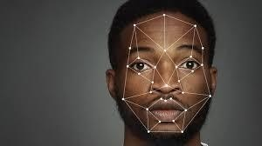
Fig 2.3.Face Recognition Image

ALGORITHM USED IN FACE DETECTION AND FACE RECOGNITION: SVM ( SUPPORT VECTOR MACHINE):
―Support Vector Machine‖ (SVM) is a supervised machine learning algorithm which can be used
for both classification or regression challenges. However, it is mostly used in classification problems. In the SVM algorithm, we plot each data item as a point in n-dimensional space (where n is number of features you have) with the value of each feature being the value of a particular coordinate. Then, we perform classification by finding the hyper-plane that differentiates the two classes very well.
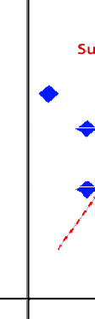
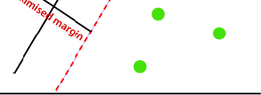
Fig .2.4.1 Figure for SVM
ALGORITHM FOR SVM:
Import the necessary pakages:
import pandas as pd import numpy as np
from sklearn import svm, datasets import matplotlib.pyplot as plt

Load the input data:
iris = datasets.lo_ad_iris()
iris = datasets.load iris()

From input data take two features:
X = iris.data[:, :2] y = iris.target
C = 1.0
X = iris.data[:, :2] y = iris.target
Now plot the SVM boundries with the data:
x_min, x_max = X[:, 0].min() - 1, X[:, 0].max() + 1
y_min, y_max = X[:, 1].min() - 1, X[:, 1].max() + 1 h = (x_max / x_min)/100
xx, yy = np.meshgrid(np.arange(x_min, x_max, h), np.arange(y_min, y_max, h))
X_plot = np.c_[xx.ravel(), yy.ravel()]
Now we need to provide the value of regularization:
C = 1.0
Next, SVM classifier object can be created as follows − Svc_classifier = svm.SVC(kernel='linear', C=C).fit(X, y)
Z = svc_classifier.predict(X_plot) Z = Z.reshape(xx.shape) plt.figure(figsize=(15, 5)) plt.subplot(121)
plt.contourf(xx, yy, Z, cmap=plt.cm.tab10, alpha=0.3) plt.scatter(X[:, 0], X[:, 1], c=y, cmap=plt.cm.Set1) plt.xlabel('Sepal length')
plt.ylabel('Sepal width') plt.xlim(xx.min(), xx.max())
plt.title('Support Vector Classifier with linear kernel')

OUTPUT:

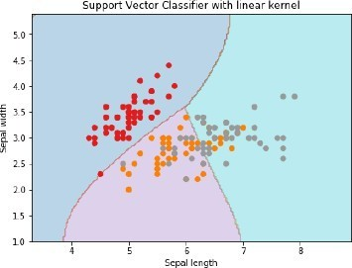

HOG (HISTOGRAM ORIENTED GRADIENTS):

The HOG descriptor focuses on the structure or the shape of an object. Now you might ask, how is this different from the edge features we extract for images? In the case of edge features, we only identify if the pixel is an edge or not. HOG is able to provide the edge direction as well. This is done by extracting the gradient and orientation (or you can say magnitude and direction) of the edgesAdditionally, these orientations are calculated in ‗localized‘ portions. This means that the complete image is broken down into smaller regions and for each region, the gradients and orientation are calculated. We will discuss this in much more detail in the upcoming sections

Finally the HOG would generate a Histogram for each of these regions separately. The histograms are created using the gradients and orientations of the pixel values, hence the name ‗Histogram of Oriented Gradients‘

Algorithm for HOG:
Step 1: Preprocessing
Step 2: Calculate the Gradient Images
Visualize the gradient components fxfx and fyfy and the gradient magnitude. function mag, angle = cart2polar(fx, fy).

Step 3: Calculate HOG in 8x8 Cells
A function HOG8x8(gx, gy) that takes two a scalar 8x8 images as input where gx is the derivative in x direction and gy the derivative in y direction.
Step 4: Block Normalization
Step 5: Calculate the HOG feature vector
A function HOGblock(h1, h2, h3, h4) that takes 4 cell histograms from step 3, concatenates them in one large (36,) vector and normalizes the vector.
Step 6: Visualizing the HOG
In the middle of each 8x8 block we draw a ―rose of directions‖: every bin in the histogram for that block shows the strength of the gradient in that particular orientation. We draw a line in the orientation (center of the line in the middle of the block) with a length that is proportional to the bin count in the histogram.

where,
‘||x_{i} - v_{j}||’ is the Euclidean distance between x_{i} and v_{j.} ‘c_{i}’ is the number of data points in i^{th} cluster.
‘c’ is the number of cluster centers.

Let X = {x₁,x₂,x₃,……..,x_{n}} be the set of data points and V = {v₁,v₂,…….,v_{c}} be the set of centers.

- Randomly select ‘c’ cluster centers.

- Calculate the distance between each data point and cluster centers.

- Assign the data point to the cluster center whose distance from the cluster center is minimum of all the cluster centers..

- Recalculate the new cluster center using:
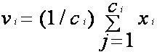

where, ‘c_{i}’ represents the number of data points in i^{th} cluster.

- Recalculate the distance between each data point and new obtained cluster centers.

- If no data point was reassigned then stop, otherwise repeat from step 3).

CHAPTER 3

FEASIBILITY STUDY:
As the name implies, a feasibility analysis is used to determine the viability of an idea, such as ensuring a project is legally and technically feasible as well as economically justifiable. It tells us whether a project is worth the investment— in some cases, a project may not be doable. There can be many reasons for this, including requiring too many resources, which not only prevents those resources from performing other tasks but also may cost more than an organization would earn back by taking on a project that isn‘t profitable. A well-designed study should offer a historical background of the business or project, such as a description of the product or service, accounting statements, details of operations and management, marketing research and policies, financial data, legal requirements, and tax obligations. Generally, such studies precede technical development and project implementation.

ECONOMIC FEASIBILITY:
For any system if the expected benefits equal or exceed the expected costs, the system can be judged to be economically feasible. In economic feasibility, cost benefit analysis is done in which expected costs and benefits are evaluated. Economic analysis is used for evaluating the effectiveness of the proposed system.
In economic feasibility, the most important is cost-benefit analysis. As the name suggests, it is an analysis of the costs to be incurred in the system and benefits derivable out of the system. Click on the link below which will get you to the page that explains what cost benefit analysis is and how you can perform a cost benefit analysis. It consists of market analysis, economic analysis, technical and strategic analysis. Economic analysis is a method of studying economic processes, which consists in considering the relationships between the various elements of these processes. It can be used both to study economic phenomena and processes occurring on a scale of the
whole economy (macroeconomic analysis), as well as phenomena and processes occurring within particular economic units and institutions (microeconomic analysis). Economic analysis makes it possible to make diagnoses, facilitates decision making, as well as facilitates rationalization of economic processes, both on a macro- and microeconomic scale. In economic analysis, mathematical methods are widely applied (e.g. marginal calculus and linear programming
This assessment typically involves a cost/ benefits analysis of the project, helping organizations determine the viability, cost, and benefits associated with a project before financial resources are allocated. It also serves as an independent project assessment and enhances project credibility— helping decision-makers determine the positive economic benefits to the organization that the proposed project will provide.

TECHNICAL FEASIBILITY:
In technical feasibility the following issues are taken into consideration.

- Whether the required technology is available or not
- Whether the required resources are available - - Manpower- programmers, testers & debuggers - Software and hardware

- Once the technical feasibility is established, it is important to consider the monetary factors also. Since it might happen that developing a particular system may be technically possible but it may require huge investments and benefits may be less. For evaluating this, economic feasibility of the proposed system is carried out.

This assessment focuses on the technical resources available to the organization. It helps organizations determine whether the technical resources meet capacity and whether the technical team is capable of converting the ideas into working systems. Technical feasibility also requirements of the proposed system. As an exaggerated example, an organization wouldn‘t want to try to put Star Trek‘s transporters in their building—currently, this project is not technically feasible.

BEHAVIORAL FEASIBILITY:
Behavioral feasibility.Behavioral feasibility considers human issues. All system development projects introduce change, and people generally resist change. Overt resistance from employees may take the form of sabotaging the new system (e.g., entering data incorrectly) or deriding the new system to anyone who will listen. Covert resistance typically occurs when employees simply do their jobs using their old methods.Behavioral feasibility is concerned with assessing the skills and the training needed touse the new IS. In some organizations, a proposed system may require mathematical or linguistic skills beyond what the workforce currently possesses. In others, a workforce may simply need to improve their skills
People are inherently resistant to change, and computers have been known to facilitate change. An estimate should be made of how strong a reaction the user staff is likely to have toward the development of a computerized system. [t is common knowledge that computer installations have something to do with turnover, transfers, retraining, and changes in employee job status. Therefore, it is understandable that the introduction of a candidate system requires special effort to educate, sell, and train the staff on new ways of conducting business

CHAPTER 4

REQUIREMENT & ANALYSIS:

PROBLEM DEFINITION:
Nowadays, more and more professions require long-term concentration. Drivers must keep a close eye on the road, so they can react to sudden events immediately. Driver fatigue often becomes a direct cause of many traffic accidents. Therefore, there is a need to develop the systems that will detect and notify a driver of her/him bad psychophysical condition, which could significantly reduce the number of fatigue-related car accidents. However, the development of such systems encounters many difficulties related to fast and proper recognition of a driver‘s fatigue symptoms. One of the technical possibilities to implement driver drowsiness detection systems is to use the vision-based approach. This article presents the currently used driver drowsiness detection systems. Here we are detecting the driver drowsiness by estimating vision system of him.

PLANNING AND SCHEDULING (PERT AND GHANTT CHART):
To make this successful we need to make face recognition model with the help of the data of the user and we need to train the model for the same. Face recognition is one of the many wonders that AI research has brought forward to the world. It is a subject of curiosity for many techies — who would like to have a basic understanding of how things work. Let us take a dip into the subject, to see how things work. Training The Model - To train our neural network, we need a huge amount of data. Now, what kind of data do we use when we train a face recognition model? The model we generate should be able to measure similarity between two faces. It should be able to map an image of a face to a vector space such that images of the same person are closer to each other — irrespective of the other parameters. So our data set has to include several images of each person. Face Recognition - When working on problems like this, it is best not to reinvent the wheel — we can‘t! It is best to follow up with models that researchers have provided us. A lot of it is available in the open source as well. One such Python library is face recognition. It works in a few steps:
  - Identify a face in a given image Identify specific features in the face
  - Generate a face encoding vector of 128 values Based on this encoding, we can measure thesimilarity between two face images — that can tell us if they belong to the same person.

PERT CHART:
The program (or project) evaluation and review technique (PERT) is a statistical tool used in project management, which was designed to analyze and represent the tasks involved in completing a given project.
First developed by the United States Navy in 1958, it is commonly used in conjunction with the critical path method (CPM) that was introduced in 1957.
PERT is a method of analyzing the tasks involved in completing a given project, especially the time needed to complete each task, and to identify the minimum time needed to complete the total project. It incorporates uncertainty by making it possible to schedule a project while not knowing precisely the details and durations of all the activities. It is more of an event-oriented technique rather than start- and completion-oriented, and is used more in those projects where time is the major factor rather than cost. It is applied on very large-scale, one-time, complex, non-routine infrastructure and on Research and Development projects.
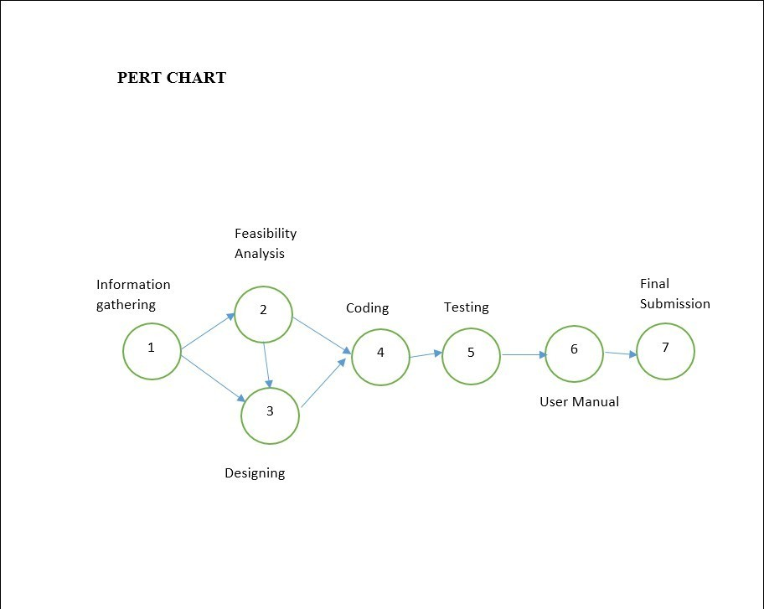
Fig.4.2.Pert Chart for Drowsiness Detection

GANTT CHART:
A Gantt chart is a type of bar chart that illustrates a project schedule, named after its inventor, Henry Gantt (1861–1919), who designed such a chart around the years 1910–1915. Modern

Gantt charts also show the dependency relationships between activities and status.
current schedule

A Gantt chart, or harmonogram, is a type of bar chart that illustrates a project schedule. This chart lists the tasks to be performed on the vertical axis, and time intervals on the horizontal axis. The width of the horizontal bars in the graph shows the duration of each activity. Gantt charts illustrate the start and finish dates of the terminal elements and summary elements of a project. Terminal elements and summary elements constitute the work breakdown structure of the project. Modern Gantt charts also show the dependency (i.e., precedence network) relationships between activities. Gantt charts can be used to show current schedule status using percent- complete shadings and a vertical "TODAY" line as shown here


Fig.4.2.2.Ghantt Chart

SOFTWARE / HARDWARE REQUIREMENT:
Python based Machine Leaning and Deep Learning libraries will be exploited for the development and experimentation of the project.
Tools such as Anaconda Python and Libraries such as OpenCV , Tensorflow , keras and pygame will be used for this process.

4.3.1- Software Requirement :
- Python IDLE

- Dlib machine learning libraries (for frontal face recognition algorithm)

- OpenCV for image processing purposes

- 68 point face predictor data file (for facial parts recognition)

- Jupyter Notebook

- Chrome Browser

4.3.2- Hardware Requirement :
- Processor – The minimum processor required is Intel i3 processor

- RAM – The minimum RAM requirement is 4GB.

- GPU – Some of the libraries of the project need to have NVidia GPU installed.

- Graphic Card – The minimum Graphic Card required is 2 GB

CHAPTER 5

5. PRELIMINARY MODULE DESCRIPTION
This chapter describes the core functional modules of the proposed Deepfake Face Swap Video Detection Using Deep Learning & Computer Vision system. Each module plays a critical role in transforming raw video input into a reliable classification output. The chapter presents a detailed explanation of the data flow, processing techniques, and deep learning mechanisms involved at each stage of the detection pipeline.

5.1 Data Collection
Data collection is the foundational step in developing a reliable deep learning-based detection system. The performance and generalization capability of the model heavily depend on the quality, diversity, and size of the dataset.

The dataset used in this project consists of two primary categories: REAL videos and FAKE (deepfake face swap) videos. These videos are sourced from publicly available deepfake datasets such as FaceForensics++, DeepFake Detection Challenge (DFDC), and other academic repositories. The dataset includes variations in facial expressions, lighting conditions, camera angles, video resolutions, and compression levels to ensure that the model is exposed to a wide range of real-world scenarios.

Each video is labeled appropriately to support supervised learning. The dataset is divided into training, validation, and testing subsets to enable effective model training and unbiased performance evaluation. Proper class balancing techniques are applied to prevent bias toward any particular class and to improve model robustness.

5.2 Video Frame Extraction
Video frame extraction is a fundamental module in the deepfake face swap video detection pipeline, as it transforms continuous video data into a structured sequence of individual image frames that can be efficiently processed by computer vision and deep learning models. Since deep learning models primarily operate on static image inputs, this step enables the system to analyze dynamic video content by breaking it into manageable and analyzable units.

The process begins by loading the input video file using the OpenCV library, which provides a robust interface for accessing video streams and handling different video formats. The system retrieves essential metadata such as frame rate, total frame count, and video resolution. This information is used to determine the optimal frame sampling strategy based on computational constraints and the desired level of temporal detail.

Frames are extracted at a predefined sampling rate, such as every frame or at fixed intervals (for example, one frame per second or every nth frame). This approach ensures a balance between preserving important facial motion information and minimizing redundant data that could increase computational overhead. The extracted frames are stored in a sequential order, preserving the original temporal structure of the video, which is essential for subsequent temporal modeling using the LSTM network. Each extracted frame undergoes a preliminary validation step to ensure data integrity. Corrupted or incomplete frames are discarded, and frames that do not contain a detectable face are flagged or removed to maintain dataset quality. This filtering process helps reduce noise and improves the overall effectiveness of the feature extraction and classification modules.
To ensure compatibility with the deep learning models, the extracted frames are converted into a standardized format. This includes resizing frames to a fixed resolution, converting color spaces (such as BGR to RGB), and storing them in a consistent data structure, such as NumPy arrays. These steps facilitate efficient batch processing and seamless integration with the CNN-based feature extraction module.

An important aspect of this module is the maintenance of temporal coherence. By preserving the original order and timing of frames, the system ensures that motion patterns, facial expressions, and lighting transitions are accurately represented in the extracted frame sequence. This temporal continuity is critical for enabling the LSTM network to learn meaningful temporal dependencies and identify subtle inconsistencies that may indicate face swap manipulation. Overall, the video frame extraction module serves as a bridge between raw video input and intelligent analysis. By converting unstructured video data into a structured and high-quality frame sequence, it lays the foundation for reliable spatial feature extraction, effective temporal modeling, and accurate deepfake detection.

5.3 Background Processing
Background processing is a crucial stage in the deepfake face swap video detection pipeline that focuses on reducing the influence of irrelevant visual information and environmental variations present in video frames. Since the primary objective of the system is to analyze facial characteristics, isolating the facial region from the surrounding background helps improve feature quality, model performance, and overall detection accuracy.

The process begins after the face detection module identifies the facial bounding box and key landmarks. Using this information, the system defines a Region of Interest (ROI) centered around the face. This region is carefully expanded to include essential contextual features such as hairline, jawline, and forehead, while excluding unnecessary background elements like walls, objects, or other individuals present in the frame.

Once the ROI is established, the background outside the facial region is either masked, blurred, or cropped, depending on the system configuration. Masking involves replacing non-facial regions with a uniform color or neutral pattern, while blurring applies a smoothing filter to reduce background detail. These techniques ensure that the deep learning model focuses primarily on facial textures, contours, and blending artifacts rather than being influenced by external visual noise.
Lighting and color normalization techniques are then applied to the facial region to reduce the effects of inconsistent illumination across frames. Methods such as histogram equalization, gamma correction, and contrast enhancement help standardize brightness and color distribution. This normalization improves consistency between frames and enhances the CNN’s ability to learn meaningful and comparable visual features.

Noise reduction filters, such as Gaussian blur or median filtering, are used to minimize compression artifacts and sensor noise that may be introduced during video recording or encoding. This step prevents the model from learning irrelevant patterns and improves the reliability of extracted features.
Another important aspect of background processing is the maintenance of spatial and temporal consistency. The size and position of the ROI are adjusted smoothly across consecutive frames to prevent sudden shifts or jitter in the facial region. This stability is essential for accurate temporal analysis by the LSTM network, as abrupt changes in ROI alignment can introduce artificial motion patterns that may affect classification performance.

By effectively suppressing irrelevant background information and enhancing the quality of facial input data, the background processing module plays a vital role in improving the robustness, accuracy, and generalization capability of the deepfake detection system. It ensures that subsequent modules, such as feature extraction and temporal modeling, operate on clean, consistent, and meaningful visual representations.

5.4 Face Detection (MTCNN)
Face detection is a fundamental stage in the deepfake face swap video detection system, as it enables the identification and localization of human faces within each extracted video frame. Since deepfake manipulation primarily alters facial regions, accurately detecting and isolating the face is essential for ensuring that subsequent processing and analysis focus only on the most relevant visual information.
In this project, face detection is implemented using the Multi-Task Cascaded Convolutional Networks (MTCNN) framework, which is a deep learning-based approach known for its high accuracy, robustness, and real-time performance. MTCNN operates through a hierarchical, three-stage architecture that progressively refines face detection results and performs facial landmark localization.

The first stage, known as the Proposal Network (P-Net), scans the input frame at multiple scales to identify candidate regions that may contain faces. It generates a large number of bounding box proposals by applying a shallow convolutional model and assigns confidence scores to each region. Non-maximum suppression is applied to eliminate overlapping and low-confidence detections, ensuring that only the most promising candidate regions are passed to the next stage.

The second stage, the Refine Network (R-Net), receives the candidate regions produced by the P-Net and performs further filtering. This network removes false positives and refines the bounding box coordinates to improve localization accuracy. The R-Net employs a deeper convolutional architecture that enhances discrimination between actual faces and background regions. The final stage, the Output Network (O-Net), produces the final face bounding boxes and detects facial landmarks, including the positions of the eyes, nose, and mouth. These landmarks are critical for performing face alignment, which involves applying geometric transformations to correct variations in head orientation, rotation, and scale across frames.

Once the facial region is detected and aligned, the system crops the face and defines it as the Region of Interest (ROI) for further processing. This ROI is standardized in size and orientation before being forwarded to the data preprocessing and feature extraction modules. By maintaining consistent facial alignment across consecutive frames, the system improves the quality of spatial feature extraction by the CNN and enhances the effectiveness of temporal analysis performed by the LSTM network.
The use of MTCNN also enables the detection of multiple faces within a single frame, allowing the system to handle videos with more than one individual. However, for classification purposes, the system can be configured to focus on the primary or most prominent face in the scene.

Overall, the Face Detection (MTCNN) module plays a crucial role in ensuring the reliability, accuracy, and efficiency of the deepfake detection pipeline. By providing precisely localized and aligned facial inputs, it forms a strong foundation for identifying subtle visual and temporal inconsistencies introduced during face swap manipulation, thereby supporting accurate classification of videos as REAL or FAKE.

5.5 Data Preprocessing
Data preprocessing prepares the detected facial regions for input into the deep learning models. This module standardizes the data format and improves training efficiency and model stability.
Key preprocessing steps include:
- Resizing: All face images are resized to a fixed dimension, such as 224×224 pixels, to ensure uniform input size.
- Normalization: Pixel values are scaled to a standard range, typically between 0 and 1, to improve convergence during training.
- Data Augmentation: Techniques such as horizontal flipping, rotation, brightness adjustment, and zooming are applied to artificially increase dataset diversity and reduce overfitting.
- Frame Sequencing: Preprocessed frames are grouped into fixed-length sequences to serve as input samples for the LSTM network.
This module ensures that the input data is consistent, diverse, and well-structured for effective deep learning training and inference.

5.6 Feature Extraction (CNN)
Feature extraction is a critical stage in the deepfake face swap video detection system, as it transforms raw facial images into meaningful numerical representations that can be effectively analyzed by machine learning and deep learning models. In this project, Convolutional Neural Networks (CNNs) are employed to automatically learn and extract high-level spatial features from the preprocessed facial frames.

A CNN is specifically designed to process visual data by exploiting the spatial structure of images. Unlike traditional methods that rely on manually engineered features, CNNs learn relevant patterns directly from data through a hierarchical learning process. This enables the system to identify subtle visual cues and artifacts introduced during face swap manipulation that may not be easily noticeable to the human eye.

The feature extraction process begins when each preprocessed and aligned facial frame is passed through a series of convolutional layers. These layers apply multiple learnable filters, also known as kernels, across the input image. Each filter performs a convolution operation that produces a feature map highlighting the presence of specific visual patterns such as edges, contours, color gradients, and texture variations. In the initial layers, the network typically learns low-level features, while deeper layers capture more complex and abstract representations such as facial structure, skin texture consistency, and blending artifacts.

After each convolution operation, a non-linear activation function, commonly the Rectified Linear Unit (ReLU), is applied to introduce non-linearity into the model. This enables the network to learn complex feature relationships and improves training efficiency. The activation function ensures that the model can represent intricate patterns associated with both real and manipulated facial content.
To reduce computational complexity and enhance generalization, the CNN incorporates pooling layers, such as max pooling. These layers down sample the feature maps by selecting the most significant values within a local region. Pooling helps retain essential information while reducing sensitivity to small spatial variations, such as minor changes in facial position or expression.

As the data progresses through deeper layers of the network, the CNN learns increasingly discriminative features. These include inconsistencies in facial texture, unnatural smoothness, irregular boundary transitions between the face and surrounding skin, and subtle color mismatches that often result from face swap generation and blending processes.

5.7 Temporal Analysis (LSTM)
Temporal analysis is a crucial stage in the deepfake face swap video detection system, as it focuses on modeling the dynamic behavior of facial features across consecutive video frames. While individual frames may appear visually authentic, manipulated videos often exhibit subtle inconsistencies in motion, expression transitions, and lighting changes over time. To capture and analyze these sequential patterns, the system employs a Long Short-Term Memory (LSTM) network.

LSTM is a specialized type of Recurrent Neural Network (RNN) designed to process sequential data and learn long-term dependencies. Unlike traditional feedforward networks that treat each input independently, LSTMs maintain an internal memory structure that allows them to retain and update information across time steps. This capability makes them particularly well-suited for video analysis, where understanding the relationship between past and present frames is essential. In this project, the LSTM receives a sequence of feature vectors generated by the CNN-based feature extraction module. Each vector represents the spatial characteristics of a single facial frame. These vectors are fed into the LSTM in their original temporal order, preserving the chronological structure of the video.

The LSTM network consists of a memory cell and three primary gating mechanisms: the forget gate, input gate, and output gate. The forget gate determines which information from the previous time step should be retained or discarded. The input gate controls the incorporation of new information into the memory cell. The output gate decides which part of the memory should be passed forward as the hidden state for the current time step. Together, these gates enable the network to selectively preserve meaningful temporal information while filtering out irrelevant or redundant data.

Through this gated memory mechanism, the LSTM learns to model complex temporal patterns such as eye blinking behavior, lip movement synchronization, head motion continuity, and lighting transitions. In deepfake videos, these patterns often reveal subtle anomalies, including unnatural blinking frequency, delayed or mismatched lip movements, and inconsistent illumination across frames. As the sequence progresses, the LSTM aggregates temporal context from earlier frames and uses it to inform predictions at later stages. The final hidden state of the LSTM represents a comprehensive summary of the temporal behavior of the facial features throughout the video segment.

5.8 Classification (REAL / FAKE)
The classification module produces the final decision of the system based on the output of the LSTM network.
The LSTM’s final hidden state is passed to a fully connected layer followed by a sigmoid or softmax activation function, which converts the output into a probability score. This score represents the likelihood that the input video is REAL or FAKE.
A predefined threshold is used to determine the final class label. In addition to the classification result, the system generates a confidence score to indicate the reliability of the prediction.
The output is displayed through a user-friendly interface, which allows users to upload videos and view detection results along with performance metrics. This enhances transparency and usability, making the system suitable for academic, research, and practical applications.

CHAPTER 6

SYSTEM DESIGNING:

SYSTEM ARCHITECTURE:

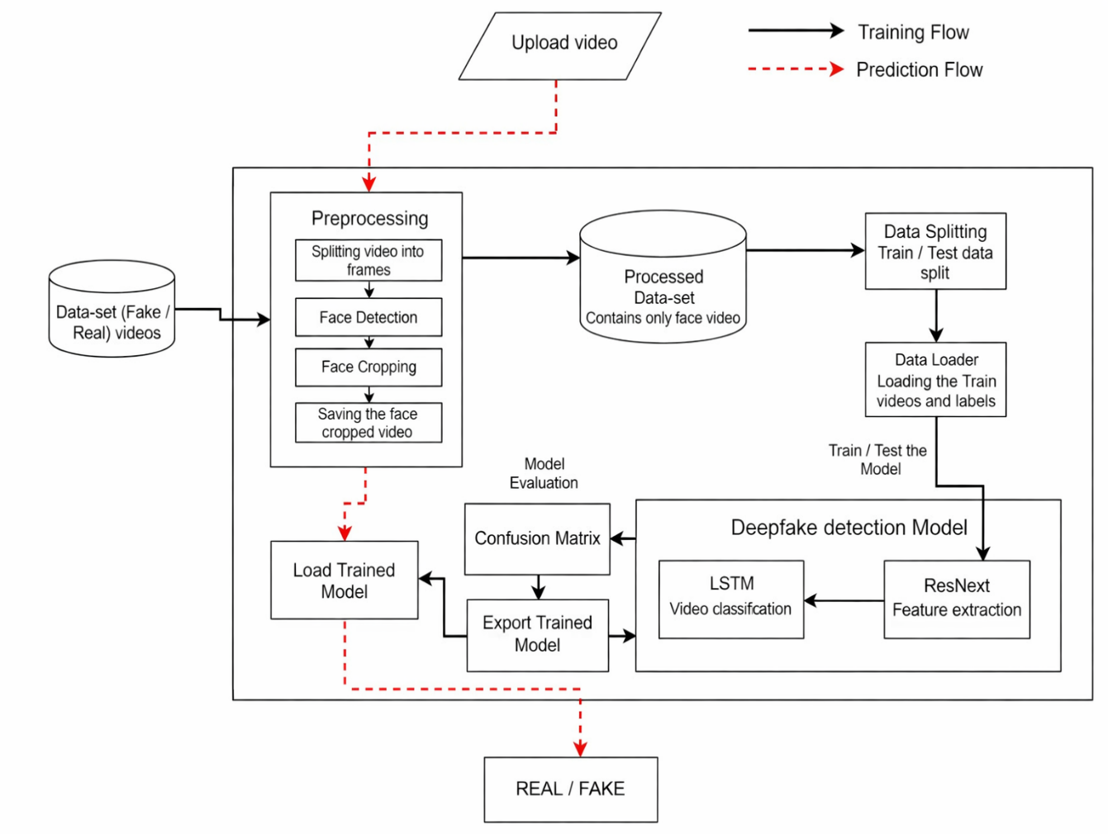

Fig.6.1.System Architecture for

FLOW DAIGRAM:

System Architecture Explanation

The system architecture of the Deepfake Face Swap Video Detection Using Deep Learning & Computer Vision project illustrates the complete workflow of both the training flow and the prediction flow used to classify videos as REAL or FAKE. The architecture is designed in a modular and scalable manner to ensure efficient data handling, robust model training, and accurate inference.

1. Input Data Source
The system accepts two types of input:
- Dataset (Fake / Real Videos): This dataset is used during the training phase to build and validate the deep learning model.
- Uploaded Video: This input is used during the prediction phase to classify an unknown video.
Both inputs follow a common preprocessing pipeline to maintain consistency between training and inference.

2. Preprocessing Module
The preprocessing module prepares raw video data for model consumption and consists of multiple sequential steps:
- Splitting Video into Frames:
Each input video is decomposed into a sequence of individual frames. This transformation enables frame-level analysis and allows the system to process spatial and temporal features efficiently.
- Face Detection:
Each extracted frame is analyzed to locate the facial region using a deep learning-based face detection algorithm. This step ensures that only facial information, which is the primary target of deepfake manipulation, is retained for further processing.
- Face Cropping:
Once the face is detected, the system crops the facial region from the frame, eliminating irrelevant background information.
- Saving the Face-Cropped Video:
The cropped face frames are reassembled and stored as a processed video, which forms a clean and standardized dataset for training and evaluation.

3. Processed Dataset Repository
The processed dataset contains only face-focused video data. This repository ensures that all training and testing samples have a uniform format, size, and structure, which improves model learning efficiency and consistency.

4. Data Splitting Module
The processed dataset is divided into:
- Training Data: Used to train the deepfake detection model.
- Testing Data: Used to evaluate the model’s performance on unseen samples.
This separation helps in measuring generalization capability and prevents overfitting.

5. Data Loader
The data loader is responsible for loading the training and testing videos along with their corresponding labels (REAL or FAKE). It performs batch-wise data feeding to optimize memory usage and computational efficiency during model training.

6. Deepfake Detection Model
The core detection system consists of two integrated components:
- ResNeXt (Feature Extraction):
This module extracts high-level spatial features from each face frame. It learns visual patterns such as texture inconsistencies, blending artifacts, and unnatural facial boundaries that are commonly introduced during face swap generation.

- LSTM (Video Classification):
The LSTM network analyzes the temporal relationship between consecutive frames. It captures motion-based inconsistencies such as unnatural blinking patterns, mismatched lip movements, and irregular facial transitions that may not be detectable from single frames alone.
Together, these components form a robust hybrid model capable of detecting both spatial and temporal deepfake artifacts.

7. Model Training and Testing
The extracted features and temporal sequences are used to train the detection model. During this phase, the system adjusts its internal parameters to minimize classification error. The trained model is then tested on unseen data to evaluate its performance.

8. Model Evaluation
The evaluation module generates a Confusion Matrix, which provides a detailed analysis of:
- True Positives (Correctly detected fake videos)
- True Negatives (Correctly detected real videos)
- False Positives (Real videos misclassified as fake)
- False Negatives (Fake videos misclassified as real)
This evaluation helps assess accuracy, precision, recall, and overall reliability of the system.

9. Export and Load Trained Model
Once training is complete, the trained model is exported and saved. During the prediction phase, this saved model is loaded to classify new, unseen videos without requiring retraining.

10. Prediction Flow
In the prediction flow, a user uploads a video, which passes through the same preprocessing steps. The face-cropped frames are then fed into the loaded trained model, which analyzes both spatial and temporal features and produces the final output.

11. Final Output
The system provides a binary classification result:
- REAL: The video is authentic.
- FAKE: The video contains face swap or deepfake manipulation.

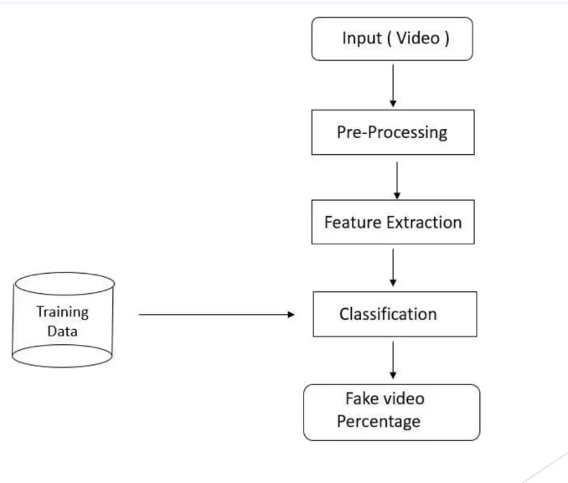

Fig.6.2. Flow daigram for

CHAPTER 7

CODING:

# USAGE
# python detect_drowsiness.py --shape-predictor shape_predictor_68_face_landmarks.dat
# python detect_drowsiness.py --shape-predictor shape_predictor_68_face_landmarks.dat -- alarm alarm.wav

# import the necessary packages
from scipy.spatial import distance as dist from imutils.video import VideoStream from imutils import face_utils
from threading import Thread import numpy as np
import playsound import argparse import imutils import time import dlib import cv2

pather="alarm.wav" def sound_alarm(path):
# play an alarm sound playsound.playsound("alarm.wav")

def eye_aspect_ratio(eye):
# compute the euclidean distances between the two sets of # vertical eye landmarks (x, y)-coordinates
A = dist.euclidean(eye[1], eye[5])
B = dist.euclidean(eye[2], eye[4])
# compute the euclidean distance between the horizontal # eye landmark (x, y)-coordinates
C = dist.euclidean(eye[0], eye[3]) # compute the eye aspect ratio ear = (A + B) / (2.0 * C)
# return the eye aspect ratio return ear

# construct the argument parse and parse the arguments
# define two constants, one for the eye aspect ratio to indicate
# blink and then a second constant for the number of consecutive # frames the eye must be below the threshold for to set off the
# alarm EYE_AR_THRESH = 0.3
EYE_AR_CONSEC_FRAMES = 48

# initialize the frame counter as well as a boolean used to # indicate if the alarm is going off
COUNTER = 0
ALARM_ON = False

# initialize dlib's face detector (HOG-based) and then create # the facial landmark predictor
print("[INFO] loading facial landmark predictor...") detector = dlib.get_frontal_face_detector()
predictor = dlib.shape_predictor("shape_predictor_68_face_landmarks.dat")

# grab the indexes of the facial landmarks for the left and # right eye, respectively
(lStart, lEnd) = face_utils.FACIAL_LANDMARKS_IDXS["left_eye"] (rStart, rEnd) = face_utils.FACIAL_LANDMARKS_IDXS["right_eye"]

# start the video stream thread
print("[INFO] starting video stream thread...") vs = VideoStream(src=0).start() time.sleep(1.0)

# loop over frames from the video stream while True:
# grab the frame from the threaded video file stream, resize # it, and convert it to grayscale
# channels) frame = vs.read()
frame = imutils.resize(frame, width=450)
gray = cv2.cvtColor(frame, cv2.COLOR_BGR2GRAY)

# detect faces in the grayscale frame rects = detector(gray, 0)

# loop over the face detections for rect in rects:
# determine the facial landmarks for the face region, then
# convert the facial landmark (x, y)-coordinates to a NumPy # array
shape = predictor(gray, rect)
shape = face_utils.shape_to_np(shape)

# extract the left and right eye coordinates, then use the
# coordinates to compute the eye aspect ratio for both eyes leftEye = shape[lStart:lEnd]
rightEye = shape[rStart:rEnd] leftEAR = eye_aspect_ratio(leftEye)
rightEAR = eye_aspect_ratio(rightEye)

# average the eye aspect ratio together for both eyes ear = (leftEAR + rightEAR) / 2.0

# compute the convex hull for the left and right eye, then # visualize each of the eyes
leftEyeHull = cv2.convexHull(leftEye)

rightEyeHull = cv2.convexHull(rightEye) cv2.drawContours(frame, [leftEyeHull], -1, (0, 255, 0), 1)
cv2.drawContours(frame, [rightEyeHull], -1, (0, 255, 0), 1)

# check to see if the eye aspect ratio is below the blink # threshold, and if so, increment the blink frame counter if ear < EYE_AR_THRESH:
COUNTER += 1

# if the eyes were closed for a sufficient number of # then sound the alarm
if COUNTER >= EYE_AR_CONSEC_FRAMES:
# if the alarm is not on, turn it on if not ALARM_ON:
ALARM_ON = True

# check to see if an alarm file was supplied, # and if so, start a thread to have the alarm # sound played in the background
if pather!= "":
t = Thread(target=sound_alarm, args=("alarm.wav",))
t.deamon = True t.start()

# draw an alarm on the frame
cv2.putText(frame, "DROWSINESS ALERT!", (10, 30),
cv2.FONT_HERSHEY_SIMPLEX, 0.7, (0, 0, 255), 2)

# otherwise, the eye aspect ratio is not below the blink # threshold, so reset the counter and alarm
else:
COUNTER = 0
ALARM_ON = False
# draw the computed eye aspect ratio on the frame to help # with debugging and setting the correct eye aspect ratio # thresholds and frame counters
cv2.putText(frame, "EAR: {:.2f}".format(ear), (300, 30),
cv2.FONT_HERSHEY_SIMPLEX, 0.7, (0, 0, 255), 2)
# show the frame cv2.imshow("Frame", frame) key = cv2.waitKey(1) & 0xFF
# if the `q` key was pressed, break from the loop if key == ord("q"):
break # do a bit of cleanup
cv2.destroyAllWindows() vs.stop()

RESULT:
After we compile the source code of the project we get the following output:
  - Checking the aspect ratio of eyes as shown in the figure 8.1


Fig.81.Checking aspect ratio

  - Generating Drowsiness alert while the aspect ratio is less then 0.3 threshold as shown in the figure 8.2

Fig.8.2.Generating Drowsiness Alert

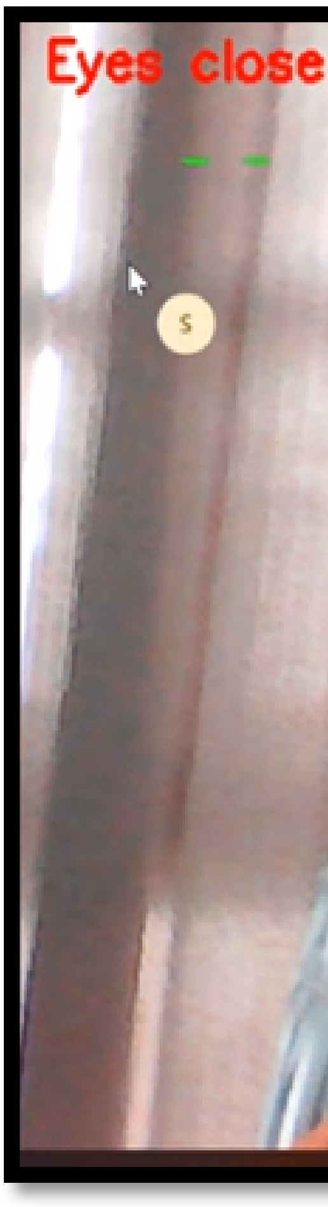


CHAPTER 9

CONCLUSION:
The project titled “Deepfake Face Swap Video Detection Using Deep Learning & Computer Vision” successfully demonstrates the design and implementation of an intelligent and automated system capable of identifying manipulated video content with a high degree of accuracy and reliability. By integrating advanced deep learning models with robust computer vision techniques, the system effectively addresses the growing challenge of distinguishing authentic videos from face swap-based deepfakes.

The proposed framework employs a hybrid architecture that combines Convolutional Neural Networks (CNNs) for spatial feature extraction and Long Short-Term Memory (LSTM) networks for temporal analysis. This combination enables the system to capture both visual artifacts present in individual frames and motion-based inconsistencies across consecutive frames. As a result, the detection mechanism is able to identify subtle manipulation patterns that are often imperceptible to the human eye. The modular design of the system, consisting of data collection, frame extraction, face detection, background processing, preprocessing, feature extraction, temporal modeling, and classification, ensures scalability, maintainability, and ease of future enhancements. The use of open-source tools and frameworks makes the solution cost-effective and suitable for academic, research, and prototype-level deployment.

Experimental evaluation using standard performance metrics such as accuracy, precision, recall, F1-score, and confusion matrix analysis demonstrates the effectiveness and robustness of the proposed approach. The results indicate that the system performs reliably across diverse video conditions, including variations in lighting, facial expressions, and video quality. In conclusion, this project contributes toward strengthening digital media authentication and promoting responsible use of artificial intelligence. The developed system has the potential to support applications in digital forensics, social media moderation, cybersecurity, and online identity verification. With further enhancements such as real-time detection, web-based deployment, and multimodal analysis, the proposed framework can evolve into a comprehensive solution for combating the misuse of deepfake technologies in real-world environments.

FUTURE WORK:

Although the proposed Deepfake Face Swap Video Detection Using Deep Learning & Computer Vision system demonstrates reliable performance in identifying manipulated video content, there are several directions in which the system can be further enhanced to improve its accuracy, scalability, and practical applicability.

One of the primary areas for future development is the implementation of real-time deepfake detection. Extending the current framework to support live video streams from webcams or online platforms would enable instant verification of video authenticity, which is particularly useful for social media monitoring, online meetings, and digital broadcasting.

Another significant enhancement involves the integration of multimodal analysis. In addition to visual cues, incorporating audio-based verification and lip synchronization analysis can improve detection accuracy by identifying inconsistencies between speech and facial movements. This multimodal approach would provide a more comprehensive and robust authentication system.

The system can also be improved by training on larger and more diverse datasets that include videos generated using emerging deepfake generation techniques. This will help improve the model’s generalization capability and resilience against newly developed manipulation methods.

From a model architecture perspective, future work may explore the use of Transformer-based models and Vision Transformers (ViTs), which have shown strong performance in capturing long-range dependencies and complex visual patterns. These models could potentially replace or complement the CNN–LSTM architecture to further enhance detection accuracy.

Deployment-related improvements include developing a web-based or cloud-enabled platform that allows users to upload and verify videos through a secure and scalable interface. This would make the system accessible to a wider audience, including journalists, law enforcement agencies, and content moderation teams.

Additionally, incorporating explainable AI (XAI) techniques can improve system transparency by highlighting which regions of a video or which temporal segments influenced the classification decision. This would enhance user trust and support forensic analysis.

REFERNCES:

[1] H. T. Nguyen, F. Fang, J. Yamagishi, and I. Echizen, “Multi-task learning for detecting manipulated facial images and videos,” Proceedings of the IEEE Conference on Computer Vision and Pattern Recognition (CVPR), 2019.

[2] A. Rössler, D. Cozzolino, L. Verdoliva, C. Riess, J. Thies, and M. Nießner, “FaceForensics++: A large-scale video dataset for forgery detection in human faces,” IEEE International Conference on Computer Vision (ICCV), 2019.

[3] B. Dolhansky, J. Howes, B. Pflaum, N. Baram, and C. Ferrer, “The Deepfake Detection Challenge (DFDC) Dataset,” arXiv preprint arXiv:2006.07397, 2020.

[4] J. Thies, M. Zollhöfer, M. Stamminger, C. Theobalt, and M. Nießner, “Face2Face: Real-time face capture and reenactment of RGB videos,” IEEE Conference on Computer Vision and Pattern Recognition (CVPR), 2016.

[5] Y. Li, M. Chang, and S. Lyu, “In Ictu Oculi: Exposing AI-created fake videos by detecting eye blinking,” IEEE International Workshop on Information Forensics and Security (WIFS), 2018.

[6] D. Güera and E. J. Delp, “Deepfake video detection using recurrent neural networks,” IEEE International Conference on Advanced Video and Signal Based Surveillance (AVSS), 2018.

[7] T. Karras, S. Laine, and T. Aila, “A Style-Based Generator Architecture for Generative Adversarial Networks,” IEEE Conference on Computer Vision and Pattern Recognition (CVPR), 2019.

[8] I. Goodfellow et al., “Generative Adversarial Nets,” Advances in Neural Information Processing Systems (NeurIPS), 2014.

[9] M. Afchar, V. Nozick, J. Yamagishi, and I. Echizen, “MesoNet: A Compact Facial Video Forgery Detection Network,” IEEE International Workshop on Information Forensics and Security (WIFS), 2018.

