BUG-001
Title: "Official Government Resources" link on Housing tasks does not point to a government website
Reported By | Vignesh Murali
Date Found | July 17, 2026
Last Verified | July 18, 2026 (against production)
Severity | Medium — misleading, not a crash or data-loss issue
Priority | Medium–High — appears on a "Critical" task for most user types
Status | Open (documented, not yet fixed)
Where | Dashboard → Checklist tab → "Find Housing" / "Find Student Housing" task

Description
On the Housing and Student Housing task screens, there is a section labeled "Official Government Resources" containing a button labeled "Official Application Portal." The label implies the link leads to a real Canadian or Ontario government website.
Instead, the link opens a private real estate listings website — the same commercial site that is already advertised, honestly, further up the same screen as a paid "Recommended Service." The app effectively shows one company's website twice on the same screen: once correctly labeled as a recommended partner, and once mislabeled as an official government source.
Affected tasks:
• "Find Housing" — shown to Work Permit, Permanent Resident, and Visitor/Traveler profiles. Link points to rentals.ca.
• "Find Student Housing" — shown to International Student profiles. Link points to places4students.com.

Steps to Reproduce
1. Open the SettleIn app and click "Get Started."
2. Choose any profile (e.g., "Permanent Resident").
3. Fill in City, Family Status, and Arrival Date, then click "Create My Checklist."
4. On the Checklist tab, click the task called "Find Housing" (or "Find Student Housing" for the Student profile).
5. Scroll to the bottom of the task detail panel on the right.
6. Locate the section titled "Official Government Resources" and check where the "Official Application Portal" button actually links to (hover to preview the URL, or click through).

Current Behavior (Actual)
The "Official Application Portal" link under "Official Government Resources" opens:
• www.rentals.ca — for the "Find Housing" task
• www.places4students.com — for the "Find Student Housing" task
Neither is a government domain. Both are commercial listings sites, and rentals.ca is the exact same company already promoted as a paid partner higher up on the same screen.

Expected Behavior
A link labeled "Official Government Resources" should open an actual government website — a domain ending in .gc.ca or ontario.ca (or the equivalent for the applicable province).
If no relevant government resource page exists to link to, the section should not be labeled as a government resource at all — e.g. it could be renamed to something accurate like "Helpful Housing Websites" instead of implying it is an official source.

Screenshots
Task detail panel for "Find Housing," showing Rentals.ca promoted twice on the same screen — once honestly as a "Top Pick" recommended service, and once further down mislabeled as "Official Government Resources":
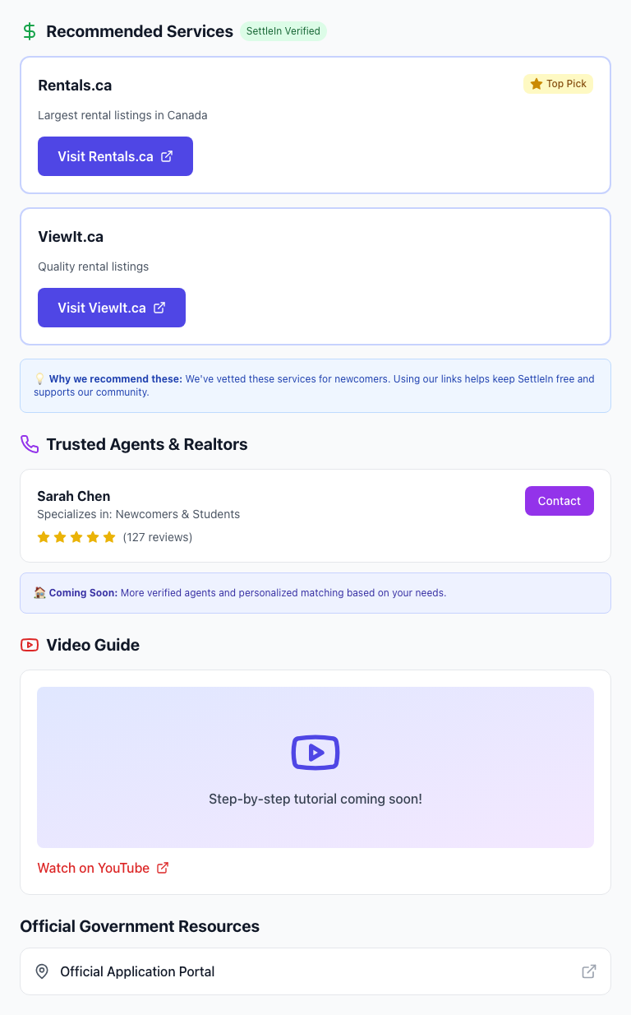
Figure 1 — "Find Housing" task detail panel (production, settle-in.vercel.app)

Build / System Info
Application | SettleIn (Next.js 14.2.35, React 18.2.0)
Environment | Production — https://settle-in.vercel.app
Affected file(s) | components/TaskDetail.js (renders the link for any task.link value, without checking the domain); lib/tasks.js (task ids "housing" and "student_housing")
OS | macOS (Darwin 24.6.0)
Browser | Chromium (Playwright-managed), Desktop Chrome and Pixel 7 mobile viewports
Test automation | Playwright Test v1.61.1 (JavaScript) and pytest-playwright (Python)
Automated tests | tests/known-issues.spec.js (JS); python-tests/test_known_issues.py (Python) — both reproduce this on demand
This was confirmed with two independent, automated browser tests (not a one-off manual check) — one in JavaScript, one in Python, both using Playwright. Each test completes onboarding, opens the Housing task, reads the actual URL behind "Official Application Portal," and asserts it belongs to a government domain. Both assertions fail as of the date above, confirming the bug is present in production. Anyone can re-run these tests at any time to check whether it has since been fixed.

