Логотип: 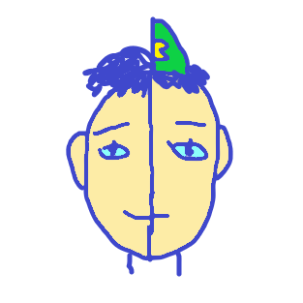

Люди:

* <https://www.behance.net/gallery/63729293/Characters-Series-Vol-03-Stranger-Things?tracking_source=project_owner_other_projects>
* 