Mediastreaming

This is our folder structure

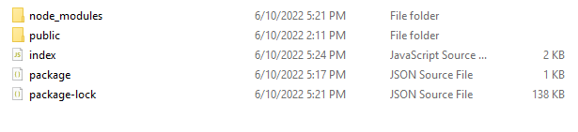

* Dependency Requirement

1. express
2. fs-extra

Download dependency:

In root folder run this command

npm run dependency-name

Index.js

const express = require("express")

const app1 = express();

const PORT = 3000;

const fs = require('fs-extra')

// read all file into the 'D:\download-test\public\assets'

app1.get('/list', async(req,res) => {

// read all file from folder

const fileNames = await fs.readdir(__dirname+'/public/assets');

res.json(fileNames)

})

app1.get("/download/:filename", (req, res) => {

// filepath -> variable to hold the full path of the file which will be downloaded.

// req.params.filename -> to obtain the name of the file to be downloaded from URL parameter. like Banjaara.png

const filePath = __dirname + "/public/assets/" + req.params.filename;

// res.download() is used to download a file on the user’s computer. It takes 3 parameters.

// In the above usage,

// filepath-> Path to the file.

// “downloaded-book.png” -> Alternate name for the file when a user downloads it. (optional)

// (err) => {} -> Error callback. (optional)

res.download(

filePath,

req.params.filename,

(err) => {

if (err) {

res.send({

error : err,

msg : "Problem downloading the file"

})

}

});

});

app1.listen( PORT, () => console.log("Server listening to port " + PORT))

In the public folder we have also another folder which name assets (here we have all assets ex: mp3 , mp4 file )

In the index.js project we have two api first give the list of all assets and another give the download permission (http://localhost:3000/download/**’asset-name’)**