REFLECTION

From: Richard

Date 5/30/ 2017

Teacher: Brad Fulk.

Project Manager: Richard Ma

Subject: Pokenom Final Project Reflection.

Accomplishments

This Project was much more difficult than I had originally envisioned. In reality, I had wanted to make a simple RPG based battling game, and was overruled by my other two group members to Pokenom. I fully accepted the idea, as it incorporated large amounts of what I had wanted to do. However, never in my wildest dreams did I expected it to be so difficult yet so rewarding. I was **Project Manager** of the team, and I organized my team to create the product that we today are presenting. I corralled the team together to work on different portions of the project. In addition, I completed Status reports and Specifications to provide the team with a clear goal of what to focus upon next, and what are issues we needed to address immediately. In respect to coding, I created the **battling system**, based upon RPG styled battle that I had so wanted. However, as we implemented the code, I had to change the battling significantly to fit the dimensions of the code. I worked the **backgrounds** for a long period of time, testing different possible ways that we could possibly use for the map. Eventually we found a good one on a different platform, as it worked best with the GUI. I also helped with the **icons** we used in our game, cropping the backgrounds out of all the images we used to provide a satisfying gaming experience. It was most rewarding as a leader within a group to see the final project roll out, with all our work combined for the final product.

Learning Experience

Out of the many lessons I’ve learned throughout the project, I think the most impactful to me was teamwork and efficiency. Throughout the first and second week, our group didn’t have much time to work as a team to make out large portions of our code. Once we were able to meet together and flesh out backend and large coding portions for our program, the entire project moved much faster. We could freely communicate what we were having problems on, help each other, and discuss coding logic without hinderance. Without the entire group, it was much more difficult, as one thing might work and the other was be lacking. Together, I could code on battling logic while another did game structure, and another on GUI. Since everything tied together in the end, working together whilst constantly updating each other progress. This greatly upped our efficiency in the coding process. We were able to work separately without worrying too much about fitting the code together. However, I learned more than just teamwork and leadership skills. I learned from my group members as well. From Vikram, I learned how to carefully think through the code, and create code based upon a plan and structure. This way, it’s easy to find logic errors and debug. From Keontrye I learned basic icon and picture making. From finding the best pictures and integrating them into code, to cropping and editing images, I learned much from him as well.

Objectives

Challenge: At first, I had no idea how the program should go, and how I could lead the team to be the very best it could be. But by learning bits from my group, and unending searches online, I was able to create what we finished with. The Battle System logic was much more difficult than I had anticipated. Creating several classes to work together for basic function required more time than I had anticipated. After that, I need to change my code to fit the game that we were creating, and again that was much different than I had expected.

Effort: Time flies past when you get stuck on an issue and are trying to debug code. Everyday out of class, I would take at least 30 minutes a day to look over what we had completed, and finish a little more so that we could meet our deadline. On the weekends, I would sometimes spend hours trying to understand an example, asking myself how I could implement it in my code and make it work.On the last couple days, Me and my group worked several hours at a time, together in a Starbucks, or a table in the mall. However, I feel that the end product is worth all my time I spent.

Quality: I felt that the work I was able to finish was of high quality. I could run it outside the game itself and it would work. Change it a little, and it would run smoothly within the game. The images I cropped were without blemish.

Problem Solving: If I did run into problems, I tried my best to run it through a search online and my group members. Similarly, I tried my best to answers question that my group mate had about certain portions of functionality. Since I did do a good portion, I could answer questions about the game functionality, how to do basic GUI, and a bit about the background. As I was also group manager, I also kept close tabs on the deadlines, so I could keep the group together and on schedule.

Results: As I did a the Battle Section, and helped with icons and Background, my results with coding and leadership were helpful to the final product. The Battle was the battling portion of our game, and my help on the background and icon allowed a clean final product. Keeping everyone together, I feel is also important, and I did to the best of my ability.

Teamwork: I tried my best to shift loads equally, so that no one had an excessive amount of work that he could not keep up with. I did all the odd jobs, along with the battle coding. I think I was an integral of the team, as well as a leader of the team. I think, without the teamwork of our entire group, this project would not be as amazing as it is now.

Overall Assessment: A-

I completed Battle Code, Led, and helped GUI. I learned from everyone, and utilized all my resources to help others with learning. With the previous notes on the objectives, I believe that my efforts deserve an A-. I can’t say that I did perfectly on everything, I did screw around sometimes. However, this grade, I feel, is befitting my efforts and fun I had completing this project.

Lastly, I want to Thank: My group mates for going with me to the end for this fabulous project.

Mr. Fulk, for answering my questions and explaining things to me.

I had a fantastic time together with everyone.

REFLECTION

From: Vikram Miryala

Date 5/30/2017

Teacher: Brad Fulk.

Accomplishments:

When we first received this project, I wanted to create a game that was more of an FPS. I wanted to recreate a game similar to diep.io or call of duty. However, we decided to try to recreate a game similar to one of the most popular games from back when we were younger, pokemon. Originally, we were going to create an almost exact replica to pokemon, but at the beginning of the project, we decided to make a more simplified version with a little twist. This resulted in Pokenom, a combination of a pacman type game (in the sense that the main character goes around the screen eating berries) accompanied with the battle aspect of pokemon. My role in this project was to create the GUI and create the backend of the project. I was also in charge of coding all of the classes other than the battle class and making the main character move with the arrow keys. I designed the structure of the code and implemented the code to make our finished project successful. I had to connect with both my members as I was the “bridge” between the two in terms of the project.

Learning Experience:

My most valuable experience that i took from this project is coding with efficiency. The limited time frame and the difficulty of the project caused us to have to budget our time very effectively. At first, all of us were extremely busy with ap testing so, we were not able to get much work done. However, we pulled it together down the stretch of the project and we were able to make a complete project by the time deadline rolled around. I also learned the importance of making a detailed design prior to beginning the actual coding process. Our original idea was very vague and we did not know exactly what we were doing. Once we had the idea, we jumped directly into the coding process which caused us to lose a lot of time. If we had designed our code prior to starting, we would have been able to do far more with this project.

Objectives:

Challenges:

This project was very challenging for me. Since we wanted to make an aesthetically pleasing user interface, we decided that we would use the program Greenfoot to create our project. This was very challenging when we first started as none of were familiar with Greenfoot, and it was basically like a foreign language to us. The fact that we had to learn and understand this new

Effort:

I worked very hard on this project as I spent a lot of time on it.

Quality:

I did my work very well as the project turned out very well.

Results:

My efforts were very useful as the game turned out very successful and I created the logic behind it.

Teamwork:

I was a very good team player as I listened and incorporated most of my groupmates ideas.

Overall Assessment: A-

I completed the Background class, and made the majority of the GUI. I learned a lot throughout the project and I feel that this grade expresses my contributions to this project.

In loving memory of Mr. Fulk:

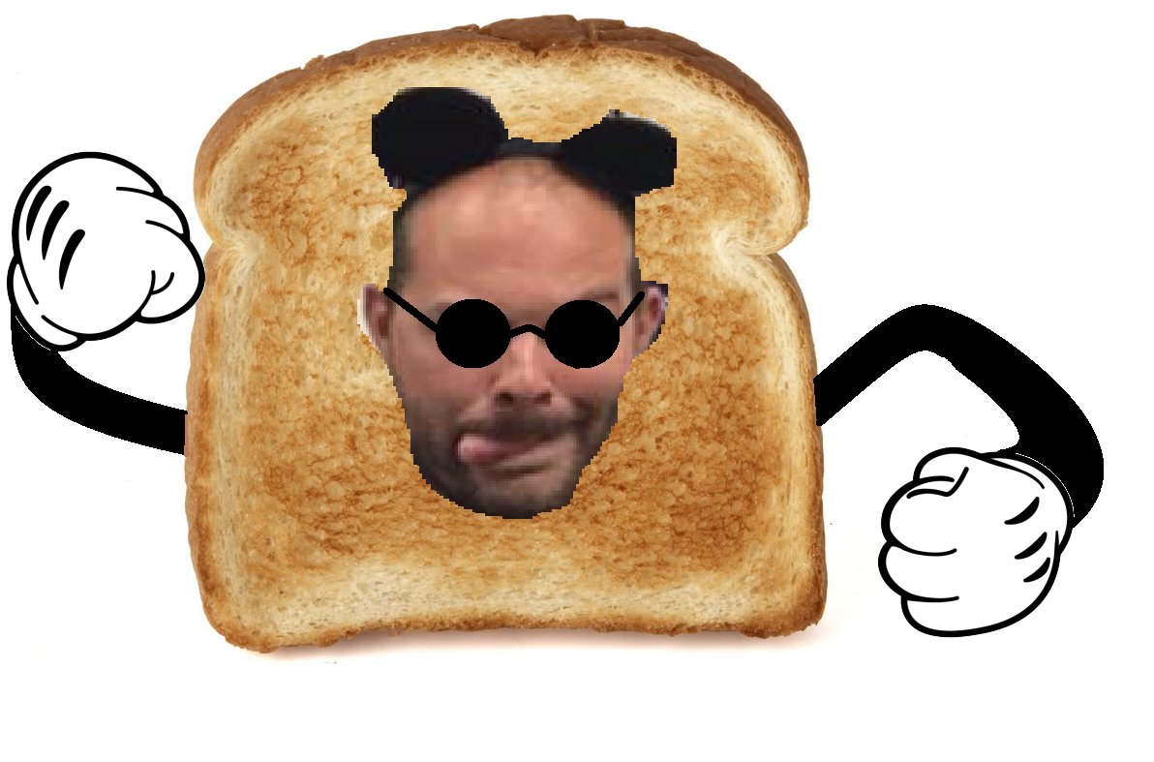

Bread Fulk.

REFLECTION

From: Keontrye Hsieh

Date 5/29/ 2017

Teacher: Brad Fulk.

Accomplishments:

Richard had the original idea of making a flash rpg, and Vikram jumped aboard. It was when we were discussing the idea of Pokemon that I had a great idea: Pokenom, where the character would eat everything instead of catching everything. We created a great project plan, thinking it would be quite simple to code. I came up with most of the idea: the character would run around in a map, eat berries and collect exp, and encounter random monsters that were disguised as berries. We also created a few objectives that were I was in charge of graphic design, as well as part of the testing methods. I also worked with Richard to submit the code checks and status reports, and was the main designer for our presentation. About halfway through the project, we realized that we had made the game too complicated. Consequently, a couple of cuts needed to be made. Unfortunately, one of those cuts included the final boss, Bread Fulk. As the graphic designer, I was in charge of finding and creating the objects and characters of our game. In addition, I had created multiple characteristics of battle that were later cut, such as a screen for every action, and different moves for the characters. Finally, after meeting up, we decided to simplify our code a lot, and we decided to split up code amongst ourselves. I implemented the testing methods for each individual character. Presentation wise, I was in charge of designing it so it would be entertaining as well as informative. Hopefully, whoever is reading this enjoyed our presentation.

Learning Experience

I learned throughout the project that at times, we all have to face our weaknesses. In my group, I was not the best coder. While Vikram and Richard both came up with ideas of how to code, I merely followed instructions and did as I was told, and hence, was not coding that efficiently. Vikram and Richard were also the ones who faced the challenges of coding. For example, both of them took the time to figure out how we were going to use Greenfoot, and then taught me the basics so I could help a little. I coded the characteristics of the characters while the others coded the entire map and functionality. In this project, I also learned how to create graphic designs. I would create a sprite on paint, modify it to the size and characteristics to our liking, and then work with Richard to give the sprite transparency. Vikram and Richard both taught me how to code in Greenfoot, which is similar to eclipse but not quite the same thing. In addition, they also taught me time management, as we were constantly pushed to finish our deadlines on time.

Objectives

Challenge: In the beginning, we had planned for our characters to have multiple features. For example, Munchlax would only unlock certain moves at certain levels. When reaching level 50, Munchlax was supposed to evolve. Finally, after evolving, Snorlax would fight a boss called Bread Fulk. However, coding this turned out to be too difficult, and we ended up scratching the ideas although I had already made the graphics for them. Despite this challenge, we were still able to make an efficient game by merely modifying some of our ideas. Instead of making Munchlax unlock moves, we would just make it more difficult to use some moves (solarbeam, the most powerful move, requires the user to hit the key ‘s’ and the key ‘b’ at the same time, making it more time consuming to use the move). Also, we changed the game to getting Munchlax to level 20 instead of 50, making it easier to beat the game.

Effort: We spent a lot of time in class working hard, and we had to finish some things at home throughout the project. However, we spent a lot of time during the long weekend finalizing our project. I feel like our meeting outside of class was the most productive, as we were able to code the tester, parts of the game (although the majority was finished), and finalize the presentation. We spent roughly 6 hours on Sunday, and we spent Monday’s afternoon, (4 hours), on video chat finalizing our project and going over submissions.

Quality: My group and I all thought that this project was hard. Going over the initial idea, we thought we had an easy project, but it turned out to be a lot harder to code. Consequently, after a lot of hard work put into this project and finishing it, I feel that this project is the highest quality possible.

Problem Solving: The only problems I encountered was during graphic design, when my image sprites were not transparent. I worked together with the group, and Richard and I discovered how to apply transparency.

Results: I am overall very pleased with the game, the graphics, and the presentation of our project.

Teamwork: Our teamwork was phenomenal. We had defined roles since the very beginning of the project, and not only did we complete our tasks, we were also able to help others with their tasks.

Overall Assessment: B+ . Although I feel like I did a lot of work, I don’t think I coded nearly enough to deserve an A. I did code a couple parts, but the parts I coded were small and detailed portions. My groupmates coded the main portion of the code.

In loving memory of Brad Fulk.



Bread Fulk.