GENZ-SARC
Gen-Z-Aware Multimodal Sarcasm, Sentiment & Social-Media Intelligence
Complete Team Documentation • Novelty • Dataset • Workflow • Architecture • Zero-Expense Plan

1. Executive Summary
GenZ-SarC is a research-oriented multimodal NLP system for social-media sarcasm and sentiment analysis.
It accepts single posts or bulk datasets containing text, images, or both. It is designed for modern Gen-Z
language, emojis, code-mixed/multilingual expressions, memes and text-image contradictions.
The core system combines traditional ML baselines, contextual Transformer models (DeBERTa and XLM-R),
sentiment and emotion analysis, vision-language processing, OCR, cross-modal fusion, contrastive/alignment
learning and an explicit incongruity engine. A sarcasm classifier produces the research prediction. An LLM
is used primarily to explain the evidence and interpret natural-language dashboard commands. Results are
stored and visualized through a 3D React/Three.js dashboard.

2. Project Goal
The goal is not simply to classify a sentence as sarcastic. The system should understand:
(1) what the user literally wrote, (2) what the context suggests they intended, (3) Gen-Z/slang usage,
(4) language and code-mixing, (5) sentiment and emotion, (6) what an attached image contains, and
(7) whether text and image agree or conflict.

3. Problem Being Solved
- Literal positive language can carry negative intent.
- Gen-Z slang changes meaning with context.
- Emojis can strengthen, reverse or modify apparent sentiment.
- Indian/South-Asian posts frequently mix English with regional languages and Romanized forms.
- Images and memes can contradict the caption.
- Sarcasm can be ambiguous even for humans.
- A prediction is more useful when the system can explain its evidence.

4. Project Scope
Input/Domain | Scope
Input | Text, text+image, CSV, XLSX, JSON
Languages | English plus multilingual/code-mixed content supported by the selected models/data
Domains | Food, brands, products, sports, gaming, technology, entertainment, personal posts, memes, reviews
Output | Sarcasm, literal/intended sentiment, emotion, language/code-mixing, Gen-Z cues, visual context, explanation
UI | Interactive 3D web dashboard, not Streamlit

5. Complete Architecture
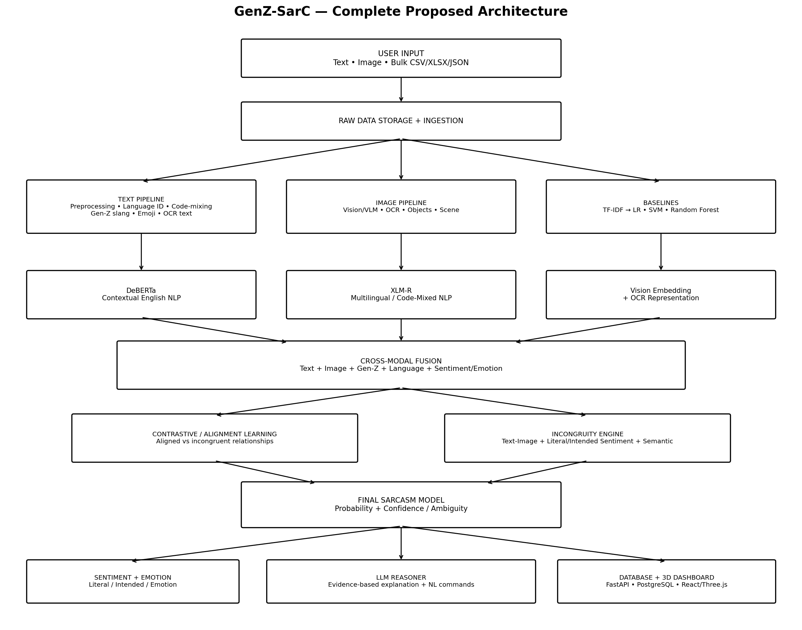
Figure 1. Proposed complete architecture
INPUT
↓
Raw storage
↓
TEXT: preprocessing → language ID → code-mixing → Gen-Z/emoji → DeBERTa/XLM-R
IMAGE: vision/VLM → OCR → objects/scene → image embedding
↓
Cross-modal fusion
↓
Contrastive/alignment learning
↓
Incongruity engine
├─ Text ↔ Image conflict
├─ Literal ↔ Intended sentiment conflict
└─ Semantic/contextual conflict
↓
Sarcasm model
↓
Sentiment + Emotion + Sarcasm probability
↓
LLM explanation
↓
Database
↓
3D React/Three.js dashboard

6. Complete Workflow — Step by Step
Step 1 — Input: Accept a single post or bulk file. Preserve original text/image and assign a post ID.
Step 2 — Raw storage: Store original data separately from derived features so the pipeline can be re-run.
Step 3 — Text preprocessing: Normalize carefully, tokenize, preserve useful punctuation, capitalization, repeated characters and emojis.
Step 4 — Language identification: Identify the language or languages present in the post.
Step 5 — Code-mixing detection: Detect English + Indian-language mixing, including supported Romanized forms.
Step 6 — Gen-Z analysis: Detect slang, abbreviations and internet expressions; interpret them contextually rather than by dictionary alone.
Step 7 — Emoji analysis: Extract emojis and their contextual relationship to the text.
Step 8 — DeBERTa: Fine-tune a pretrained DeBERTa model for contextual text representation and sarcasm experiments.
Step 9 — XLM-R: Evaluate XLM-R as the multilingual/code-mixed Transformer candidate.
Step 10 — Sentiment: Predict literal sentiment and, where labels support it, intended/contextual sentiment.
Step 11 — Emotion: Predict emotional context such as joy, anger, frustration, amusement or mockery.
Step 12 — Vision: Process an attached image with an open-source vision/VLM model.
Step 13 — OCR: Extract text inside memes/screenshots and send it through the NLP path.
Step 14 — Fusion: Combine text, image, OCR, Gen-Z, language, sentiment and emotion representations.
Step 15 — Contrastive learning: Teach the multimodal representation to distinguish aligned and selected incongruent text-image relationships.
Step 16 — Incongruity: Explicitly compute text-image, sentiment and semantic/contextual mismatch.
Step 17 — Sarcasm model: Produce sarcasm probability and uncertainty/ambiguity.
Step 18 — LLM reasoner: Turn structured evidence into a human-readable explanation and parse natural-language commands.
Step 19 — Database: Store predictions, features and explanations for analytics.
Step 20 — 3D dashboard: Visualize the results interactively and allow filtering, exploration and natural-language queries.

7. DeBERTa and XLM-R — Their Exact Roles

DeBERTa
DeBERTa is the main contextual NLP candidate for English/text experiments. It converts tokenized text into contextual representations and is fine-tuned with a task-specific sarcasm classifier.
Text → tokenizer → DeBERTa → contextual embedding → sarcasm/sentiment heads

XLM-R
XLM-R (XLM-RoBERTa) is the multilingual candidate. It is particularly relevant to code-mixed and multilingual social-media content. It should be experimentally compared with DeBERTa rather than automatically placed alongside it.
Text → language/code-mix processing → XLM-R → multilingual embedding → classifier

8. Gen-Z + Code-Mixing Examples
Example | Detected cues | Interpretation
Bro thought he cooked 💀 | bro, cooked, 💀 | Potential mockery; context-dependent
Bro inniku class semma boring da 💀 | English+Tamil, slang, emoji | Code-mixed frustration/sarcasm candidate
Bhai ye phone toh ekdum fire hai | Hindi+English, fire | Positive Gen-Z-style praise; not automatically sarcastic
This movie semma mass da 🔥 | English+Tamil, emoji | Mixed-language positive expression
Great, another exam tomorrow 💀 | Positive wording + negative context | Strong sarcasm candidate

9. Dataset — What We Must Create First
The first technical deliverable should be a dataset schema and a small pilot annotation set. The final
model should not be trained on random examples. The dataset should contain both ordinary and difficult
examples, and it should explicitly separate literal sentiment from intended sentiment where possible.

Recommended dataset fields
Field | Purpose | Example
post_id | Unique record ID | P0001
text | Original post text | Great, another exam tomorrow 💀
image_path | Image reference if present | images/P0001.jpg
category | Food/brand/sports/etc. | Education
language | Language(s) present | English+Tamil
is_code_mixed | Multiple languages? | 1
language_spans | Optional token/span language labels | English/Tamil
genz_terms | Gen-Z cues | cooked, bro
emoji_list | Emoji cues | 💀
sarcasm_label | 0/1/uncertain | 1
literal_sentiment | What is literally expressed | Positive
intended_sentiment | Likely intended meaning | Negative
emotion | Emotion label | Mockery/Frustration
ocr_text | Text inside image | Best food ever
image_description | Visual context | Burnt pizza
text_image_relation | Aligned/incongruent/uncertain | Incongruent
incongruity_label/score | Evidence of mismatch | High
annotator_notes | Reason for difficult label | Positive text conflicts with image
source/license | Rights information | Public/permission

Example records
Text | Image | Sarcasm | Literal | Intended | Code-mix | Relation
Great, another Monday 💀 | None | 1 | Positive | Negative | No | N/A
Bro thought he cooked 💀 | None | 1 | Positive/boastful | Mocking | No | N/A
Bro inniku class semma boring da 💀 | None | 1/uncertain* | Negative | Negative | Yes | N/A
Best pizza ever! | Burnt pizza | 1/uncertain* | Positive | Negative | No | Incongruent
This pizza is fire 🔥 | Good pizza | 0 | Positive | Positive | No | Aligned
*These are examples of annotation design, not claimed ground-truth labels.

Annotation rules
- Use Yes/No/Uncertain for sarcasm when context is insufficient.
- Annotate literal sentiment and intended sentiment separately.
- Annotate text-image relation separately from sarcasm.
- Record difficult-case notes.
- Use multiple annotators for a pilot subset if possible and measure agreement.

10. Traditional ML Baselines
Model | Input representation | Purpose
Logistic Regression | TF-IDF | Simple classical baseline
SVM | TF-IDF | Strong classical text baseline
Random Forest | TF-IDF/engineered features | Tree-based baseline
Optional XGBoost | Engineered/TF-IDF features | Additional benchmark
These models are experimental baselines. They are not the main multimodal deployment architecture.

11. Proposed Research Progression
- Baseline 1 — TF-IDF + Logistic Regression.
- Baseline 2 — TF-IDF + SVM.
- Baseline 3 — TF-IDF + Random Forest.
- Model 4 — DeBERTa text-only.
- Model 5 — DeBERTa + Gen-Z/emoji.
- Model 6 — DeBERTa/XLM-R + multilingual/code-mixing.
- Model 7 — Text + image multimodal.
- Model 8 — Multimodal + explicit incongruity.
- Model 9 — Multimodal + contrastive/alignment learning + incongruity.
- Final system — model + explanation + dashboard.

12. Where Is the Novelty?
Do not claim that DeBERTa, XLM-R, multimodal learning or contrastive learning themselves are novel.
The defensible novelty is the combination, specialization, dataset and evaluation strategy.
Potential contribution | How we position it
Gen-Z-aware NLP | Contextual handling of slang, abbreviations and emojis
Indian/South-Asian code-mixing | English + regional-language + supported Romanized social-media language
Literal vs intended sentiment | Explicitly model the gap between wording and intended meaning
Multimodal incongruity | Use text-image contradiction as an explicit sarcasm feature
Contrastive/alignment learning | Train representations to distinguish aligned and incongruent relationships
Explainability | Return evidence supporting the sarcasm prediction
Natural-language analytics | Allow users to query the analyzed database in normal language
3D social-media intelligence | Interactive 3D exploration of sarcasm, sentiment, emotion and language
Ablation study | Quantitatively prove the contribution of each component

13. Contrastive Learning — Exact Idea
Contrastive/alignment learning gives the multimodal model an additional training signal. An aligned pair
such as “Delicious pizza!” with an appetizing pizza image should have a compatible representation. A selected
incongruent pair such as “Delicious pizza!” with a badly burnt pizza image should be distinguishable.
Incongruity is evidence, not automatic proof of sarcasm.
Aligned pair → compatible representations
Incongruent pair → distinguishable representations
↓
additional multimodal learning signal
A total training objective can conceptually combine classification and contrastive losses:
L_total = L_sarcasm + λ1 L_sentiment + λ2 L_emotion + λ3 L_contrastive
The λ values are hyperparameters selected experimentally.

14. Final Sarcasm Decision
The final classifier consumes the fused representation and produces a probability.
Sarcastic = 0.94
Non-sarcastic = 0.06
Interpretation = Likely sarcastic
Do not promise 100% detection. Use an uncertainty/ambiguous category and report calibrated test performance.

15. LLM Reasoner
The LLM is not the only sarcasm detector. The trained classifier produces the prediction and structured
evidence. The LLM converts that evidence into a concise explanation and can interpret natural-language
dashboard commands.
Evidence:
Sarcasm = 0.94
Literal sentiment = Positive
Intended sentiment = Negative
Emoji = 💀
Text-image conflict = High
LLM → “Likely sarcastic because the positive wording conflicts with the visual/contextual evidence...”

16. Natural-Language Commands
User command | Structured interpretation
Show me sarcastic food posts. | FILTER: category=food; sarcasm=true
Show positive posts that actually mean negative. | literal=positive; intended=negative
Compare English and English-Tamil sarcasm. | group by language/code-mix; compare sarcasm
Which brands are getting roasted? | entity=brand; sarcasm/mockery; aggregate count

17. 3D Dashboard
The dashboard is a web application, not Streamlit.
Technology | Role
React / Next.js | Frontend
Three.js / React Three Fiber | 3D visualization
Framer Motion | UI animation
Tailwind CSS | Styling
FastAPI | Backend API
PostgreSQL | Database
D3/ECharts/Plotly | 2D analytics where useful

Dashboard modules
- 3D social-media post network.
- Single-post analysis panel.
- Bulk dataset upload and analytics.
- 3D sentiment/sarcasm/emotion landscape.
- Gen-Z language explorer.
- Multilingual/code-mixing analytics.
- Text-image incongruity explorer.
- Model comparison and confusion matrix.
- Natural-language command bar.

18. API Design — ₹0 Core Architecture
The project's main API is its own FastAPI backend, running locally during development/demo. This avoids
a paid external API dependency.
POST /analyze
POST /bulk-analyze
POST /image-analyze
POST /nlp-command
GET /post/{post_id}
GET /analytics/summary
GET /analytics/genz
GET /analytics/languages
GET /analytics/models

External services
Service | Use | Zero-cost role
Hugging Face Hub | Download public models/datasets | Repository/download source; do not rely on paid inference
Google Colab | Training experiments | Free GPU/TPU access subject to limits
Kaggle Notebooks | Alternative training | Free GPU option subject to availability
Optional Gemini API | LLM explanation experiments | Use only within current free tier; not required
Local OCR | Image text extraction | No API charge
Local LLM | Explanation/commands | No API charge

19. Zero-Expense Implementation
The project is designed to have ₹0 required software/API expenditure. This means the final architecture
must not require a paid API key, paid cloud GPU or paid hosted database.
- Use open-source Python/JavaScript libraries.
- Run FastAPI and PostgreSQL locally.
- Run DeBERTa/XLM-R and vision models locally or in free Colab/Kaggle sessions.
- Use a small local LLM through Ollama/llama.cpp for explanation and command parsing.
- Use Hugging Face primarily as a model/dataset repository.
- Treat external free-tier inference as optional.
- Cache embeddings and checkpoints to reduce free-GPU usage.
Important: “₹0” does not mean unlimited compute. Free Colab/Kaggle resources have limits and availability can vary. It also assumes the team already has access to a computer and internet connection.

20. Dataset and Model Licensing
Before using any dataset, model or vision package in the final submission, record its license and usage conditions. Do not assume that “available online” means unrestricted. For a student academic prototype, prefer datasets/models with clear research or open licenses and keep attribution in the README/report.

21. Evaluation
- Accuracy
- Precision
- Recall
- F1-score
- Macro-F1
- ROC-AUC where appropriate
- Confusion matrix
- Per-language performance
- Code-mixed vs monolingual performance
- Text-only vs multimodal performance
- Aligned vs incongruent performance
- Ambiguous-case analysis
- Inference time/resource usage

22. Error Analysis
Inspect false positives and false negatives. Important categories include ambiguous sarcasm, unfamiliar
slang, code-mixed spelling, meme-specific meaning, missing context, misleading images and genuine
positive/negative statements that superficially look sarcastic.

23. Team Work Division
Team role | Responsibilities
NLP member | DeBERTa/XLM-R, tokenization, Gen-Z, emoji, code-mixing, sarcasm
Dataset member | Collection, annotation, quality control, train/validation/test split
Vision/multimodal member | Vision model, OCR, fusion, contrastive learning, incongruity
Backend/AI member | FastAPI, database, model serving, LLM explanation, command parser
Frontend/3D member | React/Next.js, Three.js, analytics dashboard
All | Testing, evaluation, ablation, error analysis, report and presentation

24. Development Plan
- Phase 1 — Literature review and research-gap confirmation.
- Phase 2 — Dataset schema and pilot annotation.
- Phase 3 — Traditional ML baselines.
- Phase 4 — DeBERTa fine-tuning.
- Phase 5 — XLM-R multilingual/code-mixed experiment.
- Phase 6 — Gen-Z + emoji + sentiment/emotion features.
- Phase 7 — Vision + OCR.
- Phase 8 — Cross-modal fusion.
- Phase 9 — Incongruity engine.
- Phase 10 — Contrastive/alignment learning.
- Phase 11 — LLM explanation and natural-language commands.
- Phase 12 — FastAPI + PostgreSQL.
- Phase 13 — React/Three.js dashboard.
- Phase 14 — Final evaluation, ablation, error analysis and documentation.

25. Suggested Repository
GenZ-SarC/
├── data/
│ ├── raw/
│ ├── processed/
│ ├── annotations/
│ └── splits/
├── notebooks/
├── src/
│ ├── preprocessing/
│ ├── nlp/
│ ├── vision/
│ ├── fusion/
│ ├── contrastive/
│ ├── sarcasm/
│ └── explanation/
├── backend/
├── frontend/
├── models/
├── database/
├── configs/
├── tests/
├── requirements.txt
└── README.md

26. One Real Example — Complete Journey
Input: “Best pizza ever 💀” + image of a severely burnt pizza.
Stage | Example output
Language | English
Gen-Z/emoji | 💀 contextual cue
DeBERTa | Contextual text representation
Literal sentiment | Positive
Intended sentiment | Potentially negative/mockery
Vision | Pizza/food/burnt visual context
OCR | Any text inside image, if present
Fusion | Text + image + auxiliary features
Contrastive relation | Potentially incongruent pair
Incongruity | High text-image conflict
Sarcasm | High probability (actual value learned by model)
LLM | Evidence-based explanation
Dashboard | Interactive visualization and analytics

27. What We Should NOT Claim
- Do not claim 100% sarcasm detection.
- Do not claim DeBERTa or XLM-R themselves are novel.
- Do not claim that any text-image contradiction automatically means sarcasm.
- Do not claim unlimited free GPU/API usage.
- Do not claim universal understanding of every Gen-Z term or every language.
- Do not claim a free API is permanently free; free tiers can change.

28. Final Team Pitch
“GenZ-SarC is a Gen-Z-aware, multilingual/code-mixed and multimodal social-media intelligence system.
It combines traditional ML baselines with DeBERTa/XLM-R contextual NLP, Gen-Z and emoji analysis, sentiment
and emotion modeling, vision-language processing and OCR. Text and image representations are fused, and
contrastive alignment plus an explicit incongruity engine are used to model relationships between literal
meaning, intended meaning and visual context. A final sarcasm classifier produces probability and uncertainty,
while an LLM explains the evidence. The system supports single and bulk analysis and presents results through
a 3D React/Three.js dashboard with natural-language commands. The core implementation is designed to require
no paid APIs or cloud services.”

29. Official Sources Checked for the Zero-Cost Plan
- Google Colab FAQ: https://research.google.com/colaboratory/intl/en-GB/faq.html
- Kaggle Notebooks: https://www.kaggle.com/docs/notebooks
- Hugging Face Inference Providers pricing: https://huggingface.co/docs/inference-providers/pricing
- Google Gemini API pricing: https://ai.google.dev/gemini-api/docs/pricing
- Google Gemini API rate limits: https://ai.google.dev/gemini-api/docs/rate-limits
- Ultralytics licensing (if used): https://github.com/ultralytics/ultralytics

30. Final Mental Model
BASELINES
TF-IDF + LR/SVM/RF
↓
CONTEXTUAL NLP
DeBERTa / XLM-R
↓
GEN-Z + CODE-MIXING
↓
SENTIMENT + EMOTION
↓
VISION + OCR
↓
MULTIMODAL FUSION
↓
CONTRASTIVE / ALIGNMENT
↓
INCONGRUITY
↓
SARCASM
↓
LLM EXPLANATION
↓
FASTAPI + DATABASE
↓
3D DASHBOARD

