**Index.html**

<!DOCTYPE html>

<head>

<title>Store management system</title>

</head>

<body>

<a href="summary.php"><button>Summary</button></a>&nbsp&nbsp&nbsp&nbsp&nbsp&nbsp&nbsp&nbsp&nbsp&nbsp<a href="sell.html"a><button>Sell ITEM</button></a><br><br><br>

<form action="entry.php" method="POST" style="border:1px solid black; width:300px;padding:15px;">

<table >

<caption><bold>Add Items</bold></caption>

<tr><td>Product name</td><td><input type="text" name="name"></td></tr>

<tr><td>Product_ID</td><td><input type="text" name="id"></td></tr>

<tr><td>Price</td><td><input type="text" name="price"></td></tr>

<tr><td>Quantity</td><td><input type="text" name="quantity"></td></tr>

<tr></tr><tr><td></td><td><input type="submit"></td></tr>

</table>

</form>

</body>

</html>

Entry.php

<?php

$name = $_POST['name'];

$id = $_POST['id'];

$price = $_POST['price'];

$quantity = $_POST['quantity'];

$date=date('Y-m-d');

$host="localhost";

$dbUsername="root";

$dbPassword=" ";

$dbname="store";

$conn=new mysqli($host,$dbUsername,$dbPassword,$dbname);

if($conn->connect_error){

die('Connection failed : '.$conn->connect_error);

}

else{

$stmt = $conn->prepare("insert into items(name,pr_id,price,quantity,date) values(?,?,?,?,?)");

$stmt->bind_param("sssss",$name,$id,$price,$quantity,$date);

$stmt->execute();

?><script>alert("Product Added");</script><?php

$stmt->close();

$conn->close();

}

header( "Location:index.html" );

?>

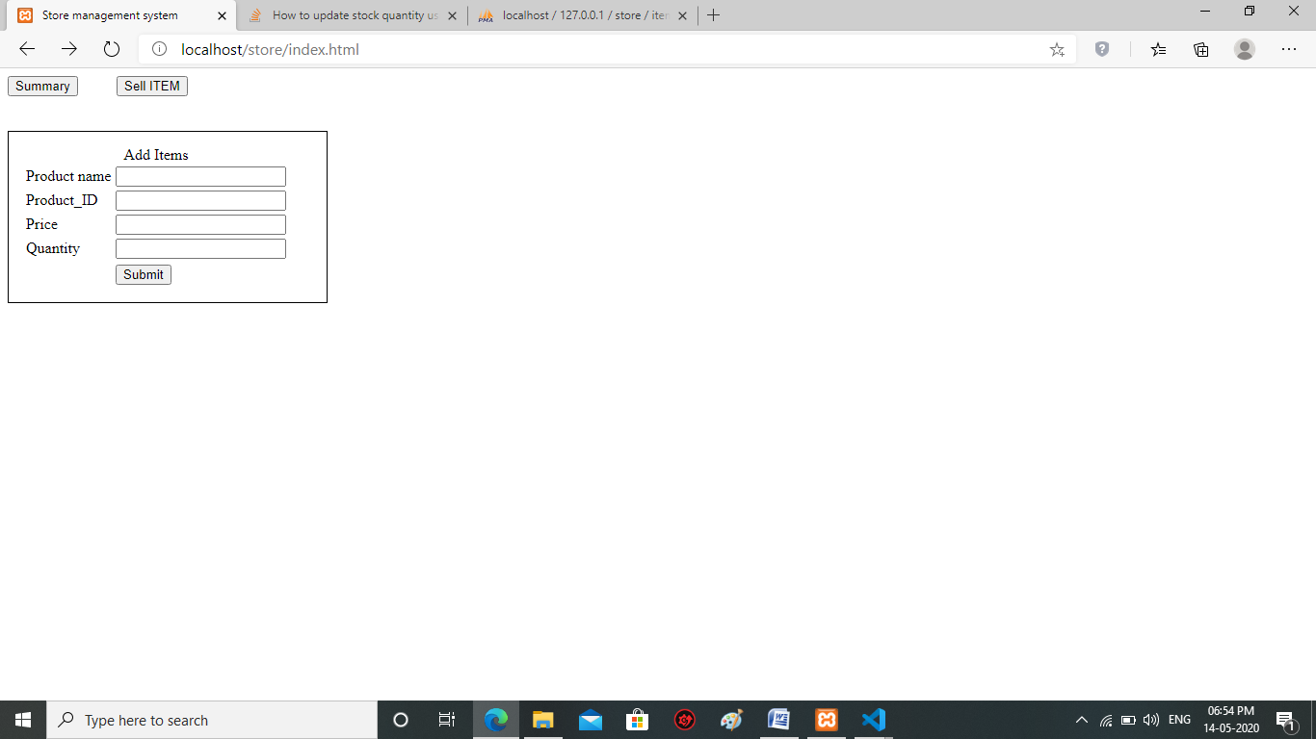

**Summary.php**

<?php

$host="localhost";

$dbUsername="root";

$dbPassword=" ";

$dbname="store";

$conn=new mysqli($host,$dbUsername,$dbPassword,$dbname);

if ($conn->connect_error) {

die("Connection failed: " . $conn->connect_error);

}

?>

<centre><h3>Welcome to Store</h3></centre><br>

<h3>Available Items</h3>

<?php

$sql = "SELECT * FROM items";

$result = $conn->query($sql);

if (!empty($result)) {

// output data of each row?>

<table style="border:2px solid black;padding:10px;">

<tr><th>Product Name</th><th>Product_id</th><th>Price</th><th>Quantity</th><th>Date Available</th><tr>

<?php while($row = $result->fetch_assoc()) {

?>

<tr><td><?php echo $row['name'];?></td><td><?php echo $row['id']; ?></td><td><?php echo $row['price']; ?></td><td><?php echo $row['quantity']; ?></td><td><?php echo $row['date']; ?></td><tr>

<?php } }

$conn->close();

?>

</table>

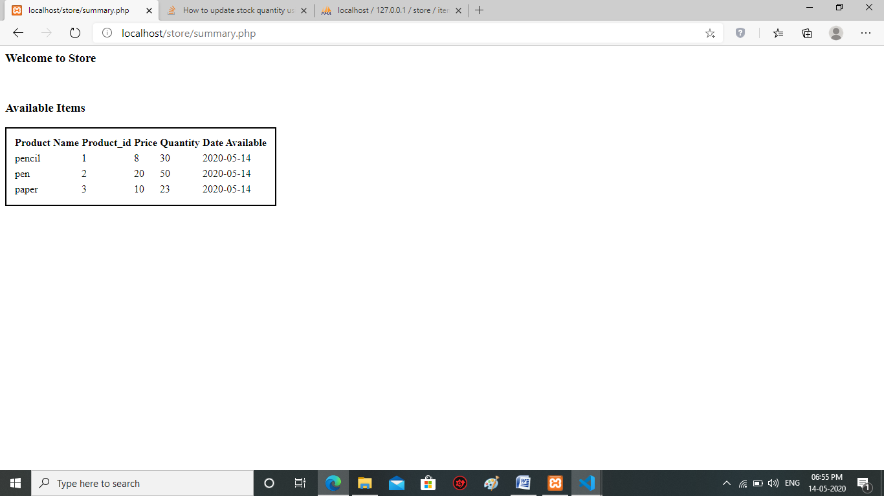

**Sell.html**

<!DOCTYPE html>

<head>

<title>sell</title>

</head>

<body>

<form action="sell.php" method="POST">

<table>

<tr><td>Enter the item to sell</td><td><input type="text" name="sellitem"></td></tr>

<tr><td>Enter the Quantity</td><td><input type="number" name="sellquantity"></td></tr>

<tr></tr><tr><td></td><td><input type="submit"></td></tr>

</table>

</form>

</body>

</html>

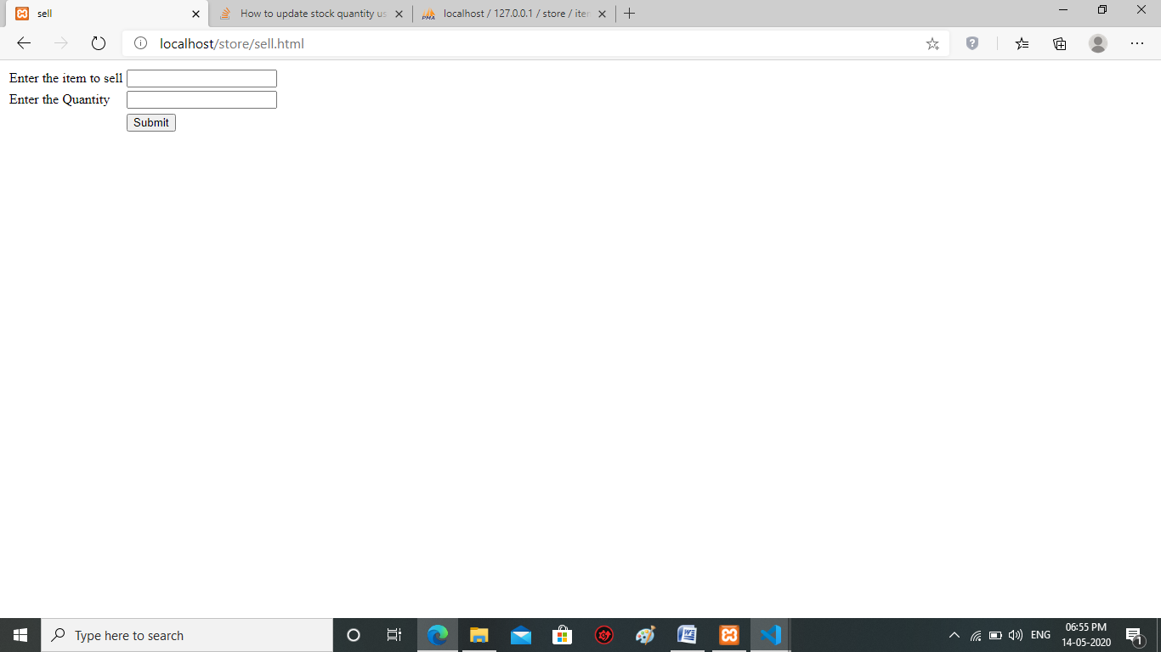

**Sell.php**

<?php

$fitem = $_POST['sellitem'];

$fquantity = $_POST['sellquantity'];

$host="localhost";

$dbUsername="root";

$dbPassword=" ";

$dbname="store";

$conn=new mysqli($host,$dbUsername,$dbPassword,$dbname);

if ($conn->connect_error) {

die("Connection failed: " . $conn->connect_error);

}

$sql = "UPDATE items SET quantity=quantity-'$fquantity' WHERE id='$fitem'";

$result=mysqli_query($conn,$sql);

if ($conn->query($sql) === TRUE) {

echo "Record updated successfully";

} else {

echo "Error updating record: " . $conn->error;

}

$conn->close();

?>