Figures — ESKAPE Defence Systems ML Study

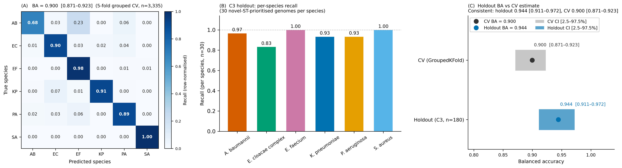

FIG 1. Species classification performance of the defence-system Random Forest classifier. (A) Row-normalised confusion matrix from phylogenetically grouped five-fold cross-validation (n = 3,335 genomes; 309 phylogroups; 359 defence system binary features). Diagonal values are per-species recall. Balanced accuracy = 0.900 [95% CI: 0.871–0.923]; macro-F1 = 0.896 [0.843–0.949]. S. aureus recall = 1.000; E. faecium = 0.985; K. pneumoniae = 0.909; E. cloacae complex = 0.901; P. aeruginosa = 0.893; A. baumannii = 0.683 (23% of AB genomes misclassified as E. faecium; see Results §1 for mechanism). Class abbreviations: AB, A. baumannii; EC, E. cloacae complex; EF, E. faecium; KP, K. pneumoniae; PA, P. aeruginosa; SA, S. aureus. (B) Per-species recall on the C3 holdout set (180 NCBI complete genomes withheld entirely from training; 30 per ESKAPE species; novel-ST-prioritised; Supplementary Table S16). (C) Holdout balanced accuracy (0.944 [0.911–0.972]) plotted alongside the grouped cross-validation estimate (0.900 [0.871–0.923]), confirming generalisation beyond the training cohort. Horizontal bars show 95% CIs. Error bar on the CV estimate is the 95% CI from phylogroup cluster bootstrap (2,000 iterations). Error bar on the holdout estimate is the 95% CI from bootstrap resampling of the 180 holdout genomes.

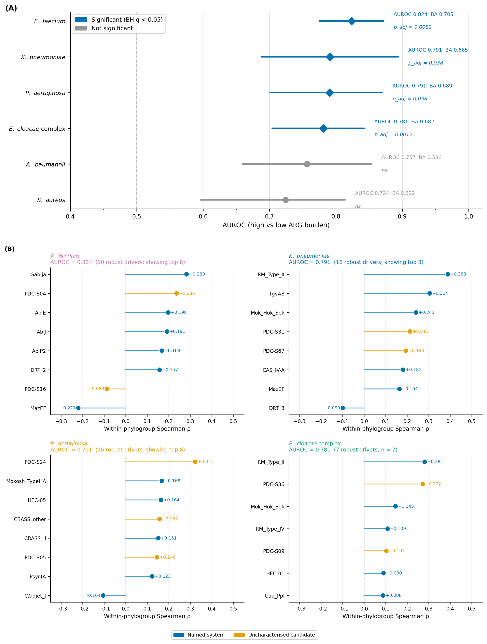

FIG 2. Association between defence system profiles and ARG burden across ESKAPE species. (A) Per-species AUROC from the Q2 ARG burden classifier (Random Forest, binary high vs low ARG tertile, phylogenetically grouped five-fold cross-validation). Error bars are 95% CIs from fold-level bootstrap (2,000 iterations). BH-adjusted significance (one-sample t-test against null BA = 0.5; q = 0.05) was confirmed in four species (EC, EF, KP, PA) and not confirmed in two (AB, SA; grey labels). AUROC was 0.824 [0.775–0.872] for EF (p_adj = 0.0082), 0.791 [0.688–0.894] for KP (p_adj = 0.038), 0.791 [0.701–0.870] for PA (p_adj = 0.038), 0.781 [0.704–0.843] for EC (p_adj = 0.0012), 0.757 [0.659–0.854] for AB (ns), and 0.724 [0.596–0.814] for SA (ns). The null (AUROC = 0.5) is shown as a dashed vertical line. (B) Within-phylogroup-robust ARG-burden drivers for the four Q2-significant species, ordered by within-phylogroup Spearman ρ descending. Each point represents a feature that survived the within-phylogroup gate (p_within_pg < 0.05 with sign preserved). Positive ρ denotes a facilitative association (higher defence system presence in high-ARG genomes within the same phylogroup). Negative ρ denotes a restrictive association. Blue dots indicate named systems with mechanistically characterised functions. Orange dots indicate uncharacterised candidate systems. Panel subtitles show AUROC, the count of all robust drivers, and the number shown (capped at 8 per panel for readability). Full driver lists in Supplementary Tables S2 and S13.

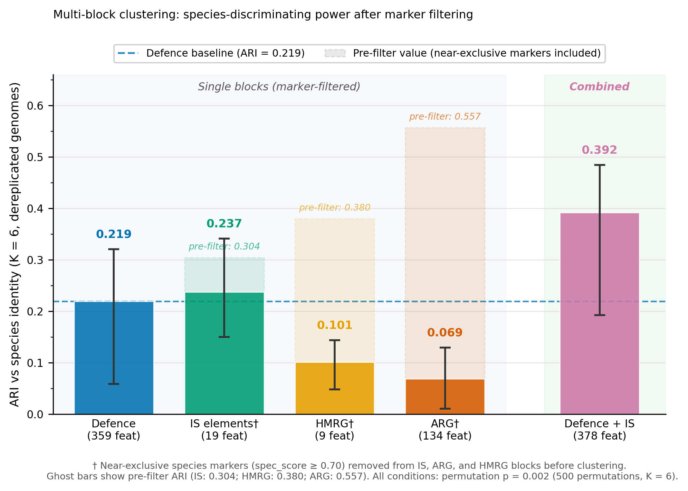

FIG 3. Species-discriminating power of four genomic feature blocks after near-exclusive marker removal. Bar chart of Adjusted Rand Index (ARI) between K-means partitions (K = 6) and species identity labels, computed on 309 dereplicated phylogroup representatives. The five conditions were defence only (359 features, identical to the primary Q3 analysis), IS element family presence (19 families after filtering), HMRG class presence (9 classes after filtering), ARG gene presence (134 genes after filtering), and Defence combined with IS elements (378 features after filtering). Near-exclusive species markers (spec_score ≥ 0.70) were removed from IS, ARG, and HMRG blocks before clustering to prevent taxonomically-concentrated features from inflating ARI. The same threshold was already applied to defence features in the primary analysis. Ghost bars (hatched outlines) show pre-filter ARI for each block, quantifying the marker-driven inflation. Error bars are 95% CIs from 2,000-iteration bootstrap resampling of the 309 genomes. All conditions were significant by permutation test (p = 0.002, 500 permutations, K = 6). The dashed blue line marks the Defence-only baseline (ARI = 0.219). † denotes blocks for which near-exclusive marker removal was applied.

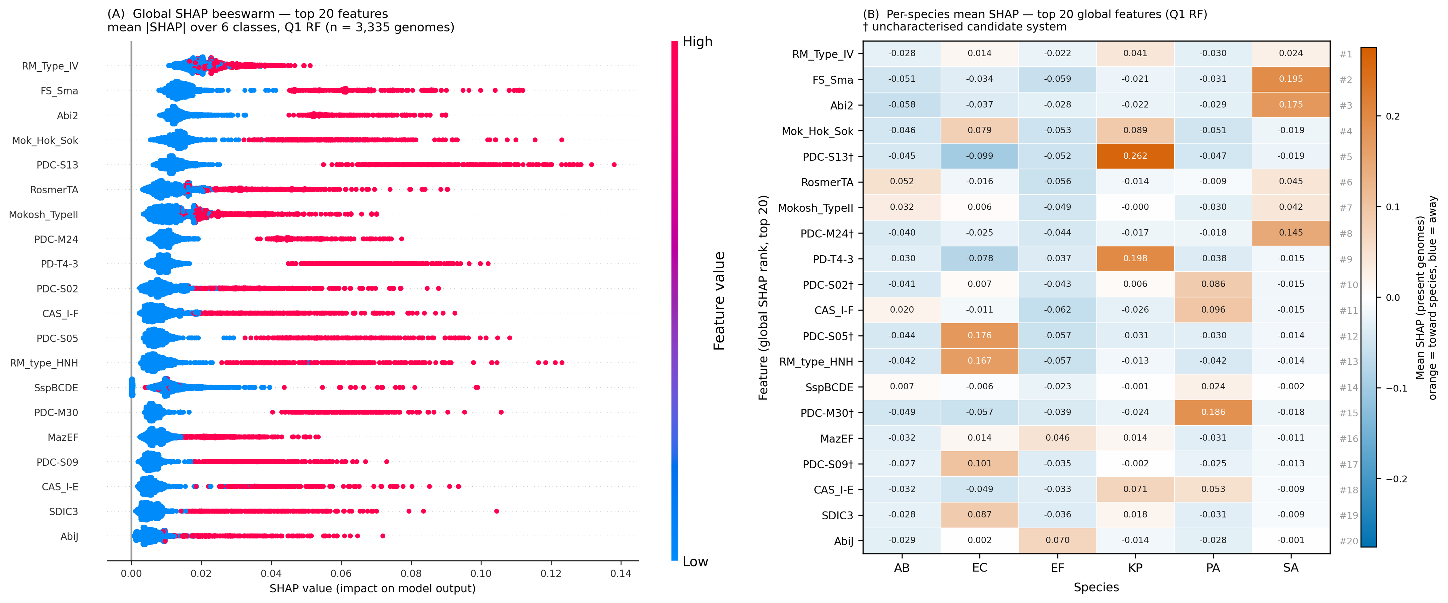

FIG 4. SHAP attribution of defence-system features to the Q1 species classifier. (A) Global SHAP beeswarm for the top 20 features by mean absolute SHAP value (averaged over all 3,335 genomes and all six species classes). Each row is one feature and each dot is one genome. Dot position on the x-axis is the mean absolute SHAP value (mean |SHAP| over the six class outputs) for that genome and feature. Dot colour encodes feature value, with orange-red indicating presence (value = 1) and blue indicating absence (value = 0). Features are ordered by descending global mean |SHAP|. All features shown are binary (defence system present/absent per genome). The x-axis reflects importance magnitude. Signed per-class effects are shown in panel B. (B) Per-species conditional mean SHAP for the global top 20 features. Heatmap of mean signed SHAP value among genomes where the feature is present. Orange indicates that feature presence increases model probability toward that species. Blue indicates that feature presence decreases model probability toward that species. Rows are ordered by global rank (rank 1 at top). Column abbreviations as in Fig. 1. Row-rank numbers (#1 to #20) on the right axis. † marks uncharacterised candidate systems. Because the heatmap conditions on feature presence, the magnitudes differ from panel A (which averages over all genomes including those where the feature is absent).

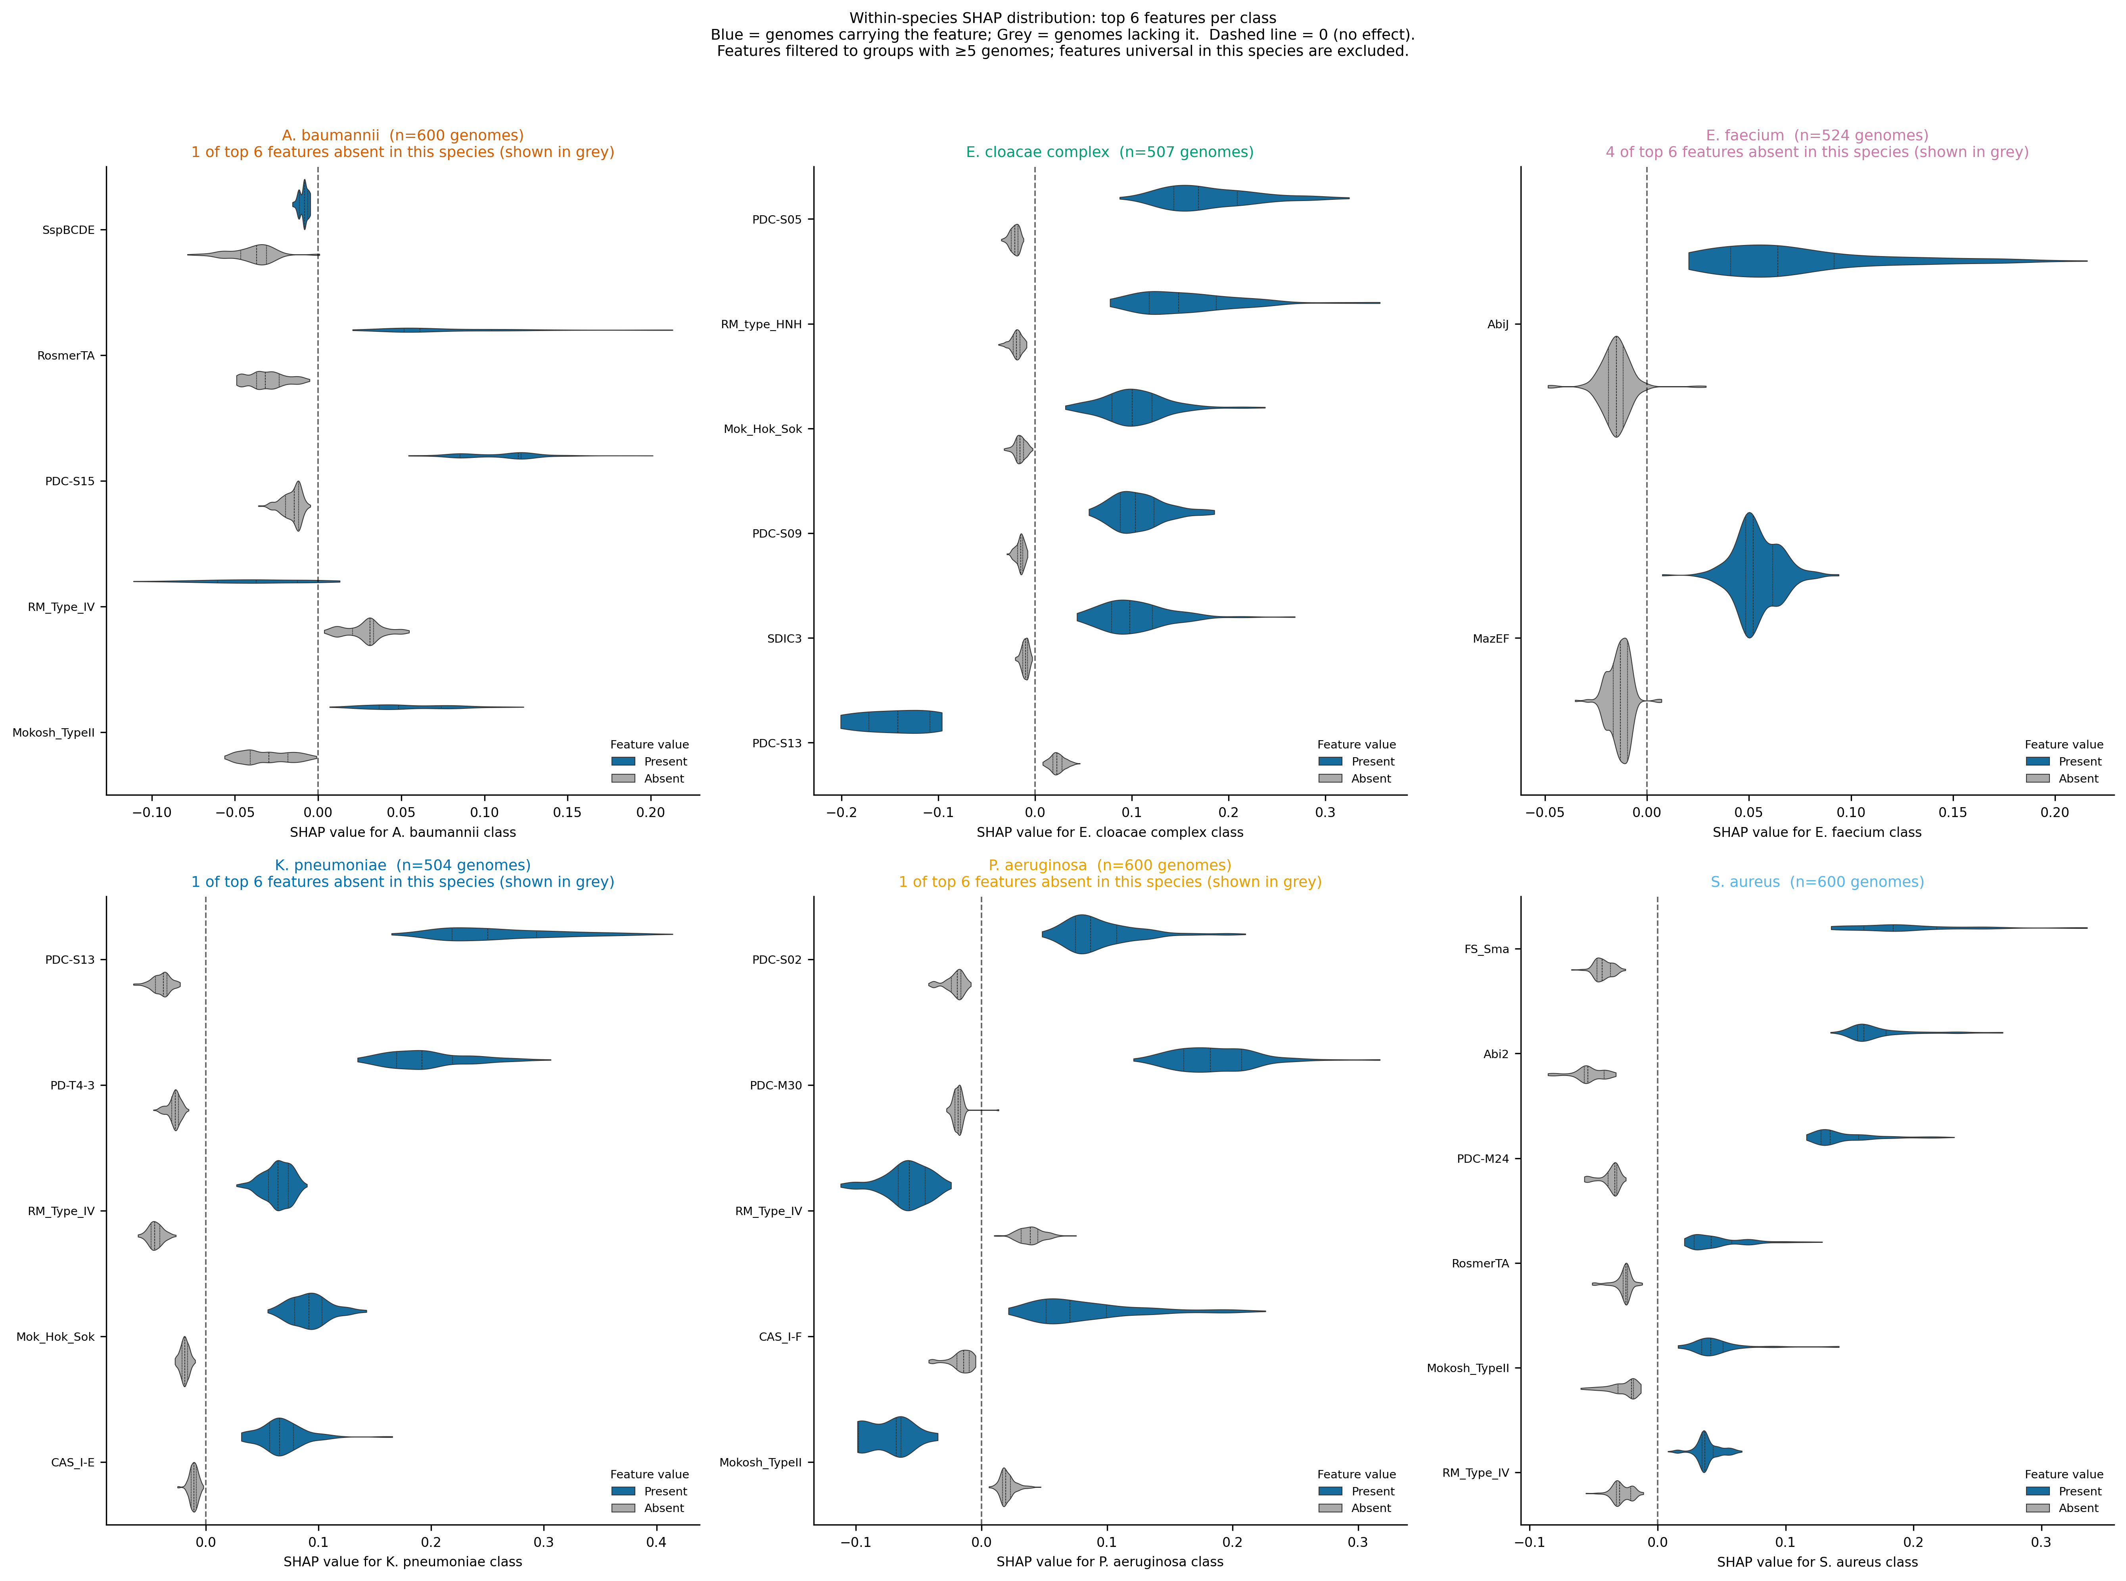

Supplementary Figure S-A. Within-species SHAP distributions for top-ranked defence system features. Violin plots of SHAP values (for the species-own class) for the top six features by mean absolute SHAP within each ESKAPE species class (Q1 RF). Plots are split by feature value, with blue indicating genomes in which the feature is present and grey indicating genomes in which the feature is absent. The dashed vertical line marks 0 (no contribution to class probability). Inner quartile lines show the 25th, 50th, and 75th percentiles. Features are excluded if either presence or absence group contains fewer than 5 genomes in that species. Panel subtitle indicates the number of top-six features excluded by this criterion (shown in grey in the title line). These plots show signed effects within the species of interest. Global signed effects across all species classes are shown in Fig. 4B.

