**Art Bible**

**Working Title:** Before Legends

**Version:** 1.0 18.03.2015

**3D Modelling – Axis**

The axis pointing upwards should always be the Y-axis. Please make sure the corresponding option is chosen when exporting.

3ds > Unity Axis conversion

Before exporting from 3ds to Unity the pivot point of every object should be adjusted, to avoid problems with rotation / axis orientation in Unity.

[**https://www.youtube.com/watch?v=fbeEac3Jcmw**](https://www.youtube.com/watch?v=fbeEac3Jcmw)

Further Information:

[**http://forum.unity3d.com/threads/how-to-get-the-xyz-axis-right-3ds-max-unity.10343/page-2**](http://forum.unity3d.com/threads/how-to-get-the-xyz-axis-right-3ds-max-unity.10343/page-2)

1. Select Object, then go to Hierarchy, choose “Affect Pivot Only”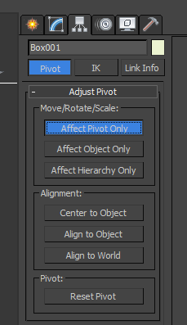

2. Rotate Pivot on X = 90

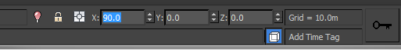

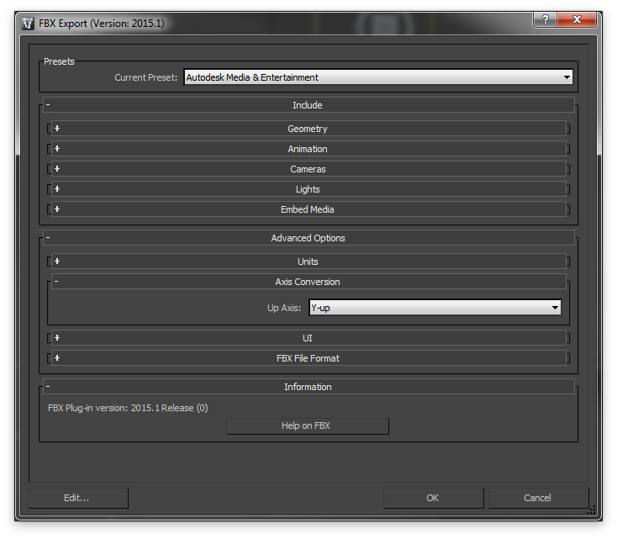

3. Save with Axis Conversion “Y-up”

**3D Modelling – Scaling**

For Blender and 3ds we will work with meters as unit.

**3ds:** Customize > Units Setup

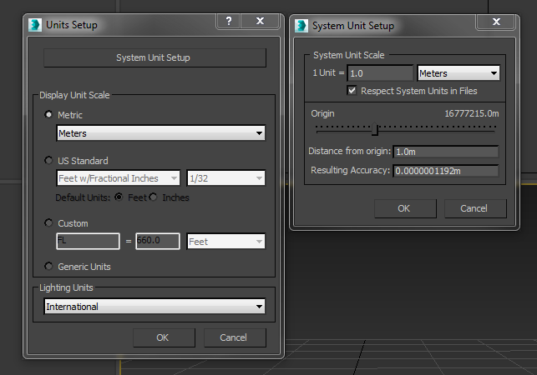

**Blender:**