**BEFORE LEGENDS**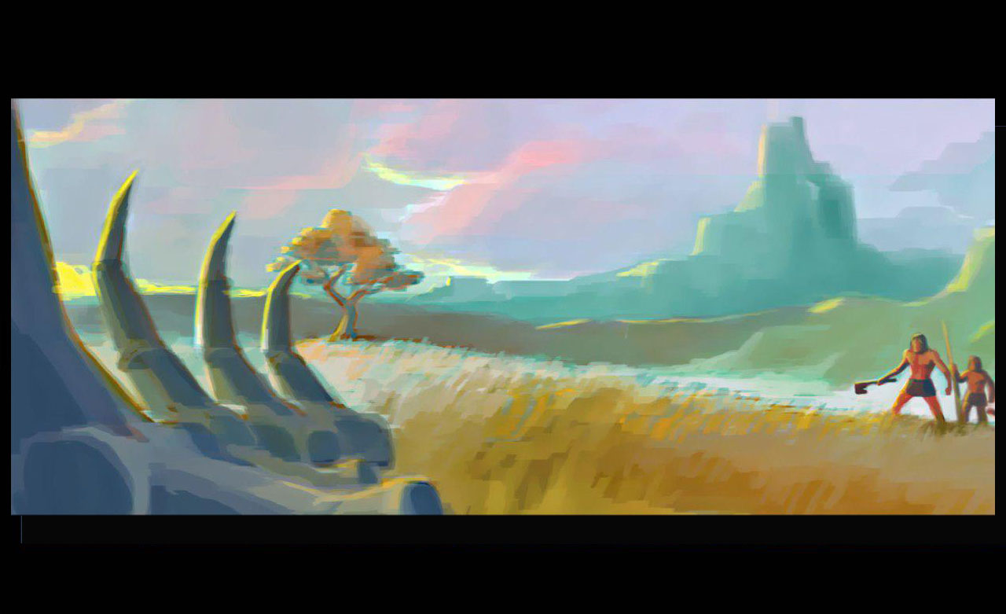

1. **The Team: *The Bonfire Elders***

Cudicio, Allan: Game Designer

Kollar, Raphael: 3D Artist

Koß, Benjamin: Programmer

Kalagin, Amon: 3D Artist

Komitski, Toma: Vision Keeper, Game Designer

Pekar, Viktor: Producer

Pinternagel, Andreas: 2D Artist

Pochert, Daniel: Programmer

1. **The Game´s Concept:**

*“Before Legends is a round based strategy-RPG fusion set in a prehistorical fantasy environment. The player will take charge of a small tribe and lead it in an epic journey on the way of becoming a civilization and thus forge the first legend of his people.”*

1. **Tools**

Unity3D, Photoshop, ZBrush, Microsoft Office, Blender, 3DSMax

*Pitch handout 17.04.2015*