BEFORE LEGENDS

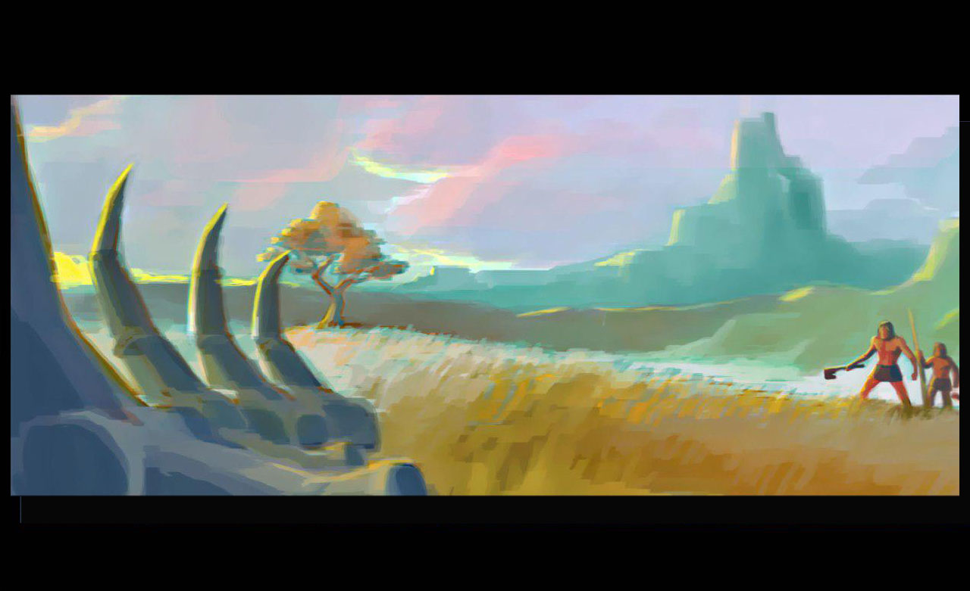

Team: The Bonfire Elders

-Pitch 17.04.2015-

# A Game before Legends

*Before Legends* is a game of survival, exploration and growth.

In this game you lead up to 7 heroes in order to make your tribe strong and successful throughout history.

## Prehistoric Heroes

The first hero is chosen by the player and the following appear when the tribe has enough food and glory. The heroes can engage in three activities, one in the tactical (ground level) map which is **combat**, the others in the strategic (bird eye view) map. The latter are **obtaining resources** and **crafting items.**

### Tactical Map Level - Combat

Before Legends’ heroes fighting skills are represented with these values:

* 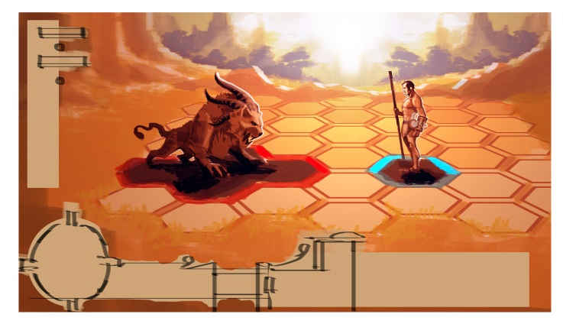**Health Points (HP):** Physical resistance and prowess. This value represents how many wounds the hero can take before falling.
* **Dodge:** Quick reactions, combat awareness. This value represents how good the hero is to avoid blows and it is opposed to precision.
* **Precision:** Hand Eye coordination, accuracy. For any given attack, this value is a sum of the raw character´s precision value and the weapon´s one. High precision is advantageous to hit high dodge opponents.
* **Damage:** These are the wounds dealt by the Hero’s blows. This value depends on the weapon. A weapon with high damage und low precision is good against slow enemies with high armor value (= though skin).

The total HP damage done an enemy is calculated in this way:

**[Attackers Precision (raw + weapon) - Enemy´s Dodge] + (Weapon Damage – Armor)**

Therefore high dodge enemies need high precision attacks and high armor enemies need more damage focused attacks.

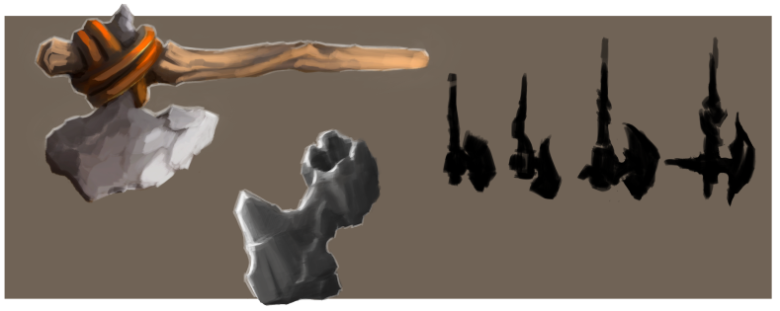Combats are round based and usually it is possible to perform a movement and an attack in one round.

### Strategic Map Level -Obtaining Resources & Creating Things

During the bird eye view of the game you can let your heroes gather these resources

* **Meat, bones & hides/furs:** this can be found **hunting**, exploiting a **herd** (or engaging in combat in the tactical map)
* **Plants** (cereals, roots, herbs etc.): These can be **gathered** or **cultivated**
* **Ores & Stones:** These can be **gathered** or **mined**

What types of resources are available always depends on each tile; tiles have different values depending on their dominant environment (e.g. forest or desert tile).

Plundering or trading other humanoids´(Neanderthals, sentient monsters) is another way to find resources.

The heroes can be used to craft these game elements as well:

* **Tools:** these are necessary to create the items below.
* **Food:** combining plant and meat resources provides advanced meals which are more efficient at staving off hunger (a hero can die if malnourished).
* **Weapons & Armors:** these are essential for combat.
* **Spirit Magic:** usually crafted amulets, they provide heroes with helpful bonuses
* 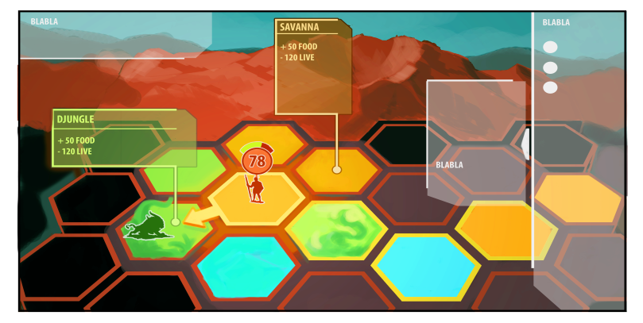**Buildings:** these are useful to strengthen the whole tribe and some are necessary to craft some items (e.g. forge for metals items)

### The Skilled Hero

Before Legends Heroes are not savages, they are prehistorical men and women who are extremely well adapted to hostile environments and who come up with clever solutions to daunting challenges.

Apart from their combat skills Heroes can improve their competency in making the aforementioned items. These improvements come as bonuses and they can be gained in two ways:

* **Heroic Skills** (through experience point “*Exp*” investment): most actions award Exp and these can be invested in character abilities, for instance improving the food value of cooked food or the damage of crafted weapons.
* **Tribal Knowledge** (through Glory points): Just as Exp, hero’s . These can be spent to strengthen some ability for all the characters such as a bonus that allows retrieving more meat when hunting.

So a Hero´s profile is always a mix of his or hers **heroic skills**, the shared **tribal knowledge** and any **carried equipment**.

## C:\Users\allan.cudicio\Documents\BeforeLegends\Game Design\MemoDocs\creatures 2legs fun.pngThe Others

In Before Legends the heroes are not alone. There are two types of creatures that roam the prehistoric lands, they are visible on the strategic map and ignore (**passive**) or attack (**active**) heroes based on their AI.

The three types are:

* **Spirits of the Land:** these powerful creatures are incarnations of spirits of the land. A Spirit of Ice looks like a hairy slumbering four legged creature where as a Spirit of the Savannah looks like a lean sand colored eyeless predator.

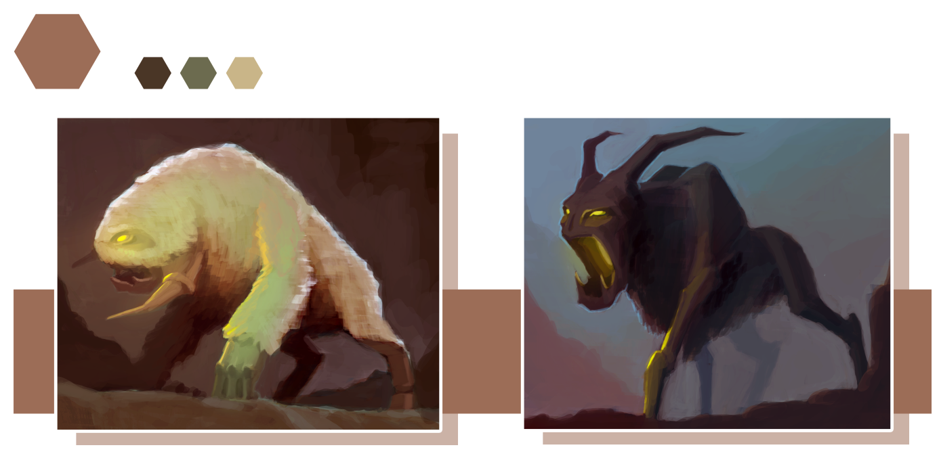

* **Animals:** This category covers all prehistoric and normal animals. Some of these animals might be fictional but still somehow recognizable.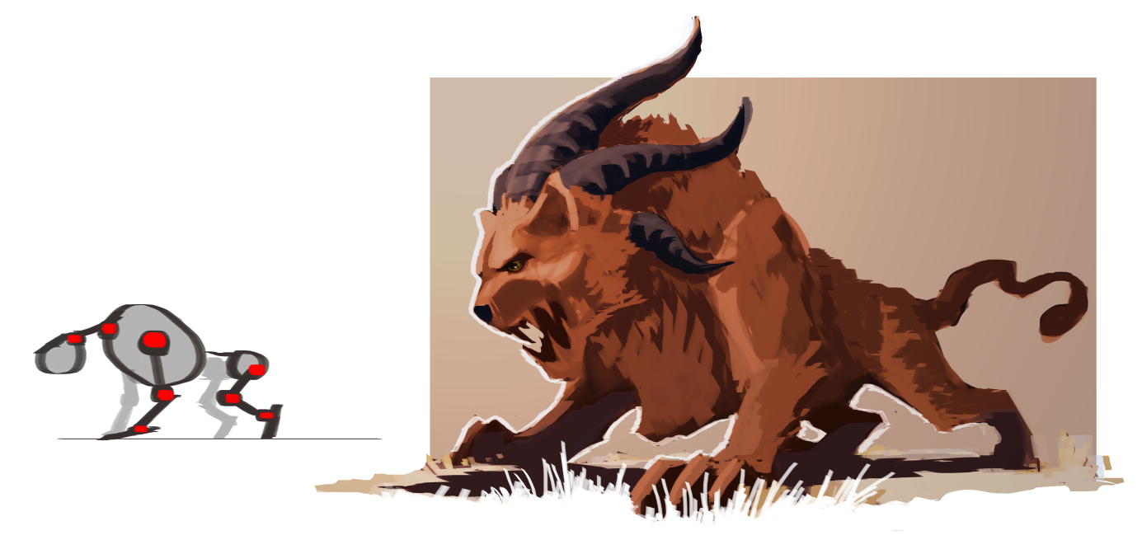

THE AGES SYSTEM

In Before Legends one of the main achievements is reaching new level of prehistoric development. The various ages the Tribe can reach are:

**Old Stone Age:** with simple tools and basic stone, wood and bone technology

**Middle Stone Age:** evolved tools but still mostly hunter-gatherers like in the previous age, first herding.

**New Stone Age:** Sedentary lifestyle finally available, pinnacle of stone tools, agriculture.

**Copper Age:** Transitional phase, first discoveries of metal.

**Bronze Age:** Wide possibilities with metal and developed tools.

**Iron Age:** The mighty Iron is discovered and this is the most developed, final, age.

* 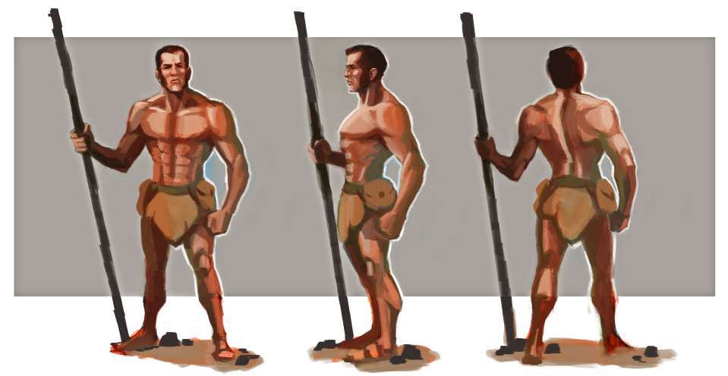**Humanoids:** Other humans obviously count in this group as well as Neanderthals and more obscure sentient creatures.

If engaging in combat with one of these creatures, the view switches from the large strategic map to the battle tactical map. Resources can usually be retrieved as loot after these battles.

## The Tribe and Game Victory: Growing through Eras

The main way to win the game is to gather enough Glory for the tribe. Glory is similar to experience points but it is gathered for the whole tribe. At certain thresholds the tribe enters a new Age of prehistory which allows new available Tribal Knowledge to be bought and new types of items to be crafted. Once the player goes beyond the Iron Age, the game is won.

The Tribe base (called **Village** if sedentary or **Tribal camp** if nomadic) is comprised of two main elements:

* **Buildings:** the Tribe´s buildings are necessary to craft some items, store resources and other varying functions.
* **The Totem:** This is a representation of the Tribe´s spiritual guardian. Gameplay-wise it is where all Tribal Knowledge bonuses can be selected and increased.

### Gameplay: Nomad VS Sedentary

There are two main gameplay styles, one more exploration based (nomadic) and the other based on resource optimization and management (sedentary):

* **Nomadic gameplay**: it focuses on keeping all characters mobile, and gathering all resources in an area until they are depleted and then moving on. Plundering and/or trade with other humanoids can become another way to gather resources (especially metalwork).
* **Sedentary gameplay:** it revolves around a stable village and is based on planning resources so that they renew (cultivation, herding).

All players start with the Nomadic gameplay and can decide around the Middle Stone Age to switch to the Sedentary one.