Client-Grouped Random Forest Classification of Content Decline Risk in Large-Scale Search Performance Data
Vikram Kumar
FlyRank ML Internship
Abstract. Content teams responsible for large web portfolios cannot manually audit every page on a recurring basis, which limits their ability to identify individual pages at risk of losing organic search visibility before measurable decline occurs. This study addresses that gap by developing a page-level classifier for content decline risk, trained on a production search-performance warehouse comprising 78,835,655 rows across 104 clients. An eight-feature Random Forest classifier was trained on 102,203 content items and evaluated using a client-grouped train/test split, ensuring that reported performance reflects generalization to previously unseen clients rather than memorization of specific accounts. The model achieved a ROC-AUC of 0.630 and a balanced accuracy of 0.585 on the held-out set, exceeding both a majority-class baseline and a transparent rule-based baseline. A naive row-level random split was also evaluated for comparison and found to overstate F1 by 0.156, demonstrating the practical importance of client-aware validation in this setting. The resulting system produces a ranked, reason-coded queue of at-risk content intended to support, rather than replace, human editorial judgment.
Keywords: content decline prediction; search engine optimization; Random Forest; client-grouped cross-validation; data leakage; content refresh strategy
1. Introduction
Content teams cannot manually review every page in a large portfolio on a recurring basis. This creates a practical gap between aggregate, portfolio-level knowledge of content decay, and the page-level decisions a team must make in practice. Prior internal research at FlyRank established a clear portfolio-level pattern: content performance tends to peak between 61 and 90 days after publication and declines sharply after approximately nine months [1]. This finding is informative at the portfolio level, but it does not indicate which specific pages, out of potentially thousands, are declining at a given point in time.
The present study addresses this gap by developing a page-level classifier that estimates the probability that an individual content item will decline in organic search impressions over the following 30 days, paired with a stated reason and a suggested corrective action. This is not intended to supersede the aggregate finding of [1], but to serve as a triage layer built upon it.
It is important to state explicitly what this model does not claim. It does not model the mechanism by which any individual page is ranked by a search engine, and it does not guarantee an outcome for any single page. It is offered as a decision-support signal; Sections 5 and 6 report, without qualification, how strong that signal is and where its reliability breaks down.
2. Related Work
The classification approach used here is a Random Forest ensemble [2], selected for its robustness to feature scaling differences and its compatibility with permutation-based interpretability methods. The present work differs from FlyRank's prior Health Score methodology [1] in scope: whereas the prior work aggregates signals into a single portfolio-level score with average position weighted at 43% importance, the present model is trained explicitly for page-level, forward-looking classification and is validated with client-level grouping, a distinction discussed further in Section 3.5.
3. Data and Methodology
3.1 Data Description
The dataset used in this study is the FlyRank ML Internship warehouse [3], a pseudonymized production search-performance dataset spanning approximately 17 months across 104 clients, released in Parquet format. The warehouse comprises 78,835,655 raw daily rows; 102,203 content items were retained for modeling after filtering, of which 63.3% met the decline criterion defined in Section 3.3. Two source tables were used: a daily table of impressions, clicks, and average position per content item per client, and a trailing 90-day table summarizing query-level performance per item.
Two temporal windows were defined relative to the most recent report date. All model features were drawn exclusively from the earlier window (60 to 31 days prior); the classification label was derived exclusively from the most recent 30-day window, with no feature permitted to draw on outcome-window data.
3.2 Feature Engineering and Exclusions
Eight features were retained for modeling: prior-window impressions, prior-window clicks, average position, click-through rate, count of distinct queries ranked for, share of rare or one-off query impressions, share of anonymized impressions, and concentration of impressions on top queries.
Several categories of fields were deliberately excluded. Client and content identifiers were excluded to prevent the model from memorizing specific entities rather than learning generalizable patterns. Outcome-window impressions and clicks were excluded as they directly define the label and their inclusion would constitute leakage by construction. Raw calendar dates were excluded, as the two-window design already encodes the relevant temporal structure. Client tenure and account-type fields were excluded as proxies for client identity rather than content behavior. Client names, URLs, and raw query text were never accessed, consistent with the pseudonymization of the source of release.
3.3 Label Definition
A content item was labeled as declining if its impressions over the most recent 30-day window fell more than 20% below its own impressions in the prior 30-day window. The comparison is made relative to each item's own historical baseline rather than a portfolio-wide average, in recognition of the substantial variance in baseline traffic across content items.
3.4 Baseline Models
Two baseline models were used for comparison. The first is a majority-class classifier that always predicts the more frequent label. The second is a transparent, interpretable rule: a page is flagged if its average position falls within the worst quartile across the portfolio.
3.5 Validation Design
Data were partitioned by client rather than by row, using a grouped split with 36 clients allocated to training and 13 held out entirely for testing, with zero client overlap between sets, confirmed programmatically. A conventional row-level random split was also evaluated for comparison; the resulting difference in reported performance is quantified in Section 4.2 and found to be substantial, motivating the use of client-grouped validation as the primary evaluation protocol.
3.6 Leakage Analysis
Three checks were performed against the final feature set prior to reporting results. First, the column defining the label was confirmed to be absent from the feature set. Second, a single-feature AUC sweep was conducted to identify any feature with suspiciously high standalone predictive power; the maximum observed value was 0.616, below the 0.90 threshold conventionally used to flag leakage. Third, the temporal windows were audited directly, revealing that the 90-day query-mix table partially overlaps with the 30-day outcome window. This overlap is disclosed rather than concealed: the four query-mix features are treated as directional and descriptive throughout the remainder of this study, rather than as strictly pre-outcome predictors.
4. Results
4.1 Model Performance
Table 1 reports precision, recall, F1, balanced accuracy, and ROC-AUC for the Random Forest model and both baselines, evaluated on the identical held-out client set.
Table 1. Model performance against baselines (held-out clients)
Method | Precision | Recall | F1 | Bal. Acc. | ROC-AUC
Majority-class baseline | 0.677 | 1.000 | 0.807 | 0.500 | —
Rule-based (position quartile) | 0.673 | 0.187 | 0.293 | 0.498 | —
Random Forest (honest split) | 0.782 | 0.411 | 0.538 | 0.585 | 0.630

The majority-class baseline's high F1 score (0.807) is an artifact of class imbalance rather than a meaningful result: because 63% of items are labeled declining, a classifier that always predicts the majority class scores well on F1 by construction. Balanced accuracy and ROC-AUC are not subject to this distortion; by these measures the proposed model exceeds chance-level performance (0.500) by a margin of 0.085 and 0.130, respectively.
4.2 Effect of Validation Design
To quantify the effect of validation design, the identical model and feature set were re-evaluated using a row-level random split in place of client grouping.
Table 2. F1 score under two validation designs, identical model
Split Design | F1
Random split (row-level) | 0.695
Grouped by client (honest) | 0.538

The observed gap of 0.156 F1 does not reflect increased model capability; it reflects information leakage arising from rows belonging to the same client appearing in both the training and test partitions, allowing the model to partially learn client identity rather than a generalizable pattern. This result is reported here as a methodological finding in its own right: it quantifies the extent to which validation design, independent of model architecture, can materially misstate real-world performance.
4.3 Feature Importance
Permutation importance, computed on the held-out test set using F1 as the scoring metric, was used in place of impurity-based importance, which is known to be biased toward continuous features.
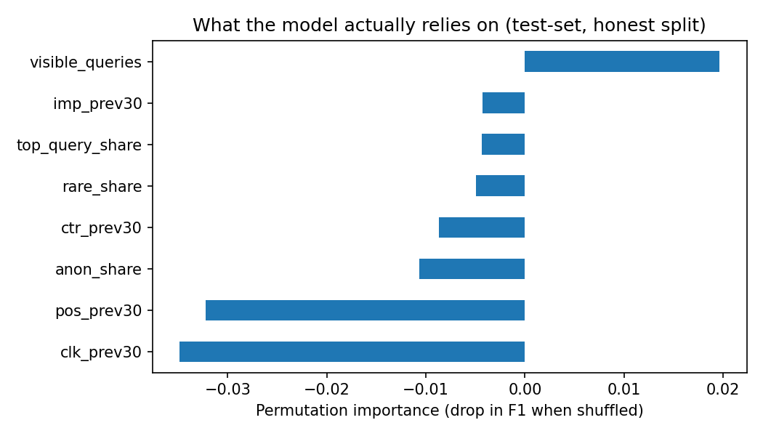
Figure 1. Permutation importance by feature (test set, honest split).
Average position, the feature identified as most predictive (43% importance) in FlyRank's prior Health Score methodology [1], exhibits negligible unique contribution in the present model once the remaining seven features are accounted for. Query breadth was the only feature demonstrating a clear, positive, independent contribution to predictive performance, suggesting that the topical diversity of a page's ranking footprint carries information not captured by position or click-based signals alone.
4.4 Error Analysis
On the held-out test set, the false positive rate was 7.8% and the false negative rate was 39.9%. The model's errors are therefore skewed toward missed declines rather than false alarms, a property relevant to how a downstream team should interpret a non-flagged result.
Figure 2 shows the distribution of predicted decline probabilities across the test-set queue.
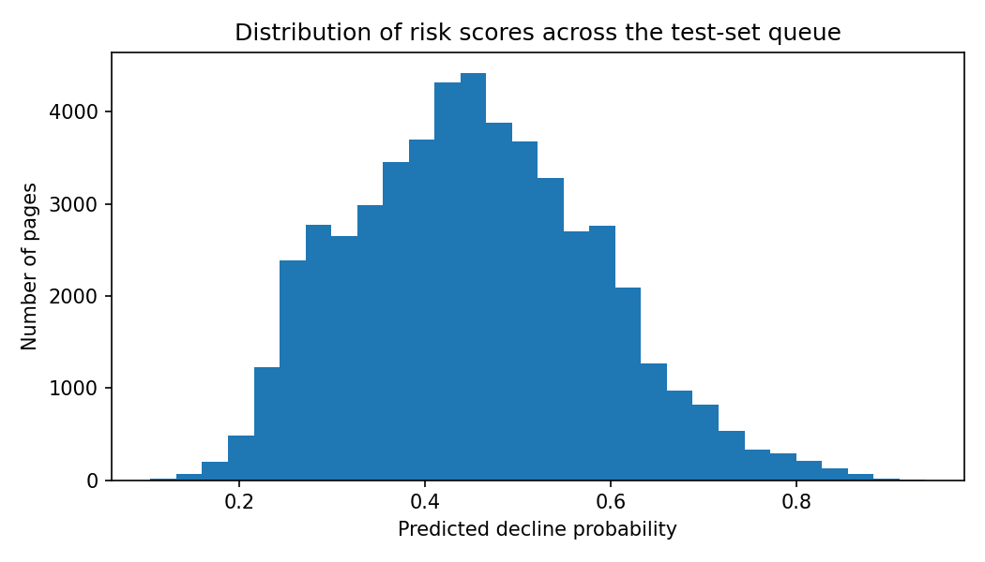
Figure 2. Distribution of predicted decline probability across the test-set queue.
The distribution is unimodal and centered near 0.45, with the majority of items falling between 0.3 and 0.6 rather than at the extremes. This pattern is consistent with the model's moderate ROC-AUC: the model expresses genuine uncertainty for most content items rather than confident separation, which is expected given the observed effect sizes in Section 4.3.
5. Limitations
Several limitations constrain the interpretation and applicability of these results.
- Non-causal design. All reported associations are observational. Position, click-through rate, and query-mix features are associated with decline but are not established as causal factors.
- Modest discriminative power. A ROC-AUC of 0.630 is meaningfully better than chance but is not strong in absolute terms. A recall of 0.41 indicates that approximately six of every ten declining pages are missed; the model is suited to triage rather than deterministic prediction.
- Restricted client scope. The model was validated on 49 of the 104 clients present in the warehouse (36 training, 13 test). No claim is made regarding generalization to client populations outside this industry and traffic-pattern mix.
- Temporal window overlap. As reported in Section 3.6, the four query-mix features exhibit partial overlap with the outcome window and are treated as directional rather than strictly predictive.
- Absence of external context. The model cannot distinguish an organic decline from a seasonal effect, a manual search-engine penalty, or a site migration.
- Fold-level base-rate asymmetry. The training and test folds exhibit differing base decline rates (58.7% and 67.7%, respectively), an expected consequence of client-level grouping with a relatively small number of clients rather than an indication of error.
6. Recommendations and Application
6.1 Action Queue
Each item flagged by the model is assigned a decline probability, a reason code identifying the dominant contributing signal, and a corresponding recommended action, summarized for representative reason categories in Table 3.
Table 3. Representative reason codes and recommended actions
Reason Code | Recommended Action
High query concentration; weak average position | Diversify topic coverage to reduce reliance on a single query
Under-clicking relative to peers; low query breadth | Revise title and meta description to improve click-through rate
Weak average position; under-clicking relative to peers | Refresh content and strengthen internal linking

6.2 Deployment Process
A recommended three-stage process for operational use is summarized in Table 4.
Table 4. Recommended deployment process
Stage | Action | Responsible Party
1 | Execute the model against the current content backlog to generate a ranked queue | Data / analytics team
2 | Review top-ranked items against stated reason codes and business priorities | Content team
3 | Apply the recommended action and monitor resulting traffic over subsequent weeks | Content team

Model output is intended strictly as decision support. No content item should be automatically published, merged, or redirected on the basis of the model's score alone. Human review should verify whether an observed or predicted decline is attributable to a factor outside the model's scope (e.g., seasonality, a documented search-engine update), whether the stated reason code aligns with independent inspection of the page, and whether the item's traffic volume justifies the cost of remediation.
6.3 Monitoring and Retraining Criteria
Retraining or re-evaluation is recommended under any of the following conditions: the portfolio-wide base decline rate drifts materially from 63.3%; feature distributions shift measurably from the training distribution; balanced accuracy on a newly held-out client group falls below approximately 0.585; or, independent of observed drift, on a fixed quarterly schedule as a conservative floor.
7. Conclusion
This study developed and evaluated a page-level classifier for content decline risk using 78.8 million rows of production search-performance data. An eight-feature Random Forest model, validated under a client-grouped protocol, achieved a ROC-AUC of 0.630 and a balanced accuracy of 0.585, exceeding both a majority-class and a transparent rule-based baseline. The magnitude of improvement is modest but methodologically robust: a parallel evaluation under row-level random splitting was shown to overstate F1 by 0.156, a gap attributable entirely to validation design rather than model capability.
This methodological finding is arguably as significant as the model's headline performance. It demonstrates, in a concrete and quantified form, the degree to which insufficiently rigorous validation can misrepresent a model's real-world generalization, and it motivates client-grouped validation as a default practice in analogous multi-tenant prediction settings.
The resulting system produces a ranked, reason-coded queue of at-risk content rather than an opaque score, and is positioned explicitly as a decision-support tool for human editorial teams rather than an autonomous or deterministic system. Future work could extend this approach by incorporating external context signals (e.g., documented algorithm updates or seasonal indices), by validating across a broader and more heterogeneous client population, and by evaluating alternative model architectures under the same client-grouped protocol established here.
References
[1] FlyRank Research Team, "Content Refresh and Decline Patterns in Search Performance," FlyRank Internal Research, Mar. 2026.
[2] L. Breiman, "Random Forests," Machine Learning, vol. 45, no. 1, pp. 5–32, 2001.
[3] FlyRank ML Internship Dataset, Hugging Face, huggingface.co/datasets/FlyRank/internship-warehouse, 2026.

