PRmePRed: Protein arginine methylation prediction tool
Pawan Kumar¹, Joseph Joy¹, Ashutosh Pandey¹ and Dinesh Gupta^{1*}
¹Translational Bioinformatics Group, ICGEB, New Delhi,India

1. Supplementary Tables
Table 1. Dataset information of different windows length
Table 2. Comparison with other existing methods.

2. Supplementary Figures
Figure 1. The relationship between the Accuracy and number of features.
Figure 2. The relationship between the Sensitivity and number of features.
Figure 3. The relationship between the Specificity and number of features.
Figure 4. The relationship between the MCC and number of features.
Figure 5. ROC curve for SVM classifier with training set.
Figure 6. ROC curve for SVM classifier with test set.
Figure 7. ROC curve for SVM classifier with independent set.

3. Background

Protein arginine methylation (PRme) is an abundant post-translational modification (PTM) which affects several major cellular processes in eukaryotes. PRme has been implicated in several diseases and to such an extent that some eukaryotic viruses can take the liberty of host arginine methylation machinery for their own benefit. Any biological question which aims to investigate the role of PRme in a protein’s function, stability, localization and its interactions initiates with steps that lead to prior identification and validation of the methylation event. In this regard, large scale proteomics, bolstered by recent advancements in PRme labeling, enrichment and mass spectrometry techniques , have significantly contributed towards identifying the bulk of the experimentally verified repertoire of arginine methylated proteins. MS based proteomics employing in vivo metabolic labelling of methyl group (Heavy- methyl SILAC) offers the best credible identification results as opposed to label free approaches which may be fraught poor reproducibility and discovery of artefact sites. However metabolic labelling is expensive, and not always feasible for all biological samples such as intraerythrocytic in vitro cell culture of intracellular parasites like P. falciparum. Additionally, it is tedious task to validate each methylation site independently from the thousands of sites identified from a label free MS experiment. Another option is to go for high throughput screening in vitro enzyme assays that employ recombinant protein arginine methyltransferases (PRMTs; enzymes which catalyze arginine methylation) and protein/peptide substrates. However any in vitro outcome cannot be considered as a natural event unless supported by in vivo evidence. Also at present, one cannot fathom to perform high throughput experiments for nearly more than half a million arginine residues present in human proteome (belonging to 20193 reviewed proteins from UniProt database and excluding their isoforms) and that too with eleven different human PRMTs (again excluding their isoforms). Another limitation with any experiment involving a biological sample is that a cell, at any given period of time, usually will never carry all the PTMs it can possibly acquire during its life cycle. Also specialized cell types in a multicellular organism produce their own distinct methylation profiles. Thus, due to several technical and analytical shortcomings one cannot capture the entire spectrum of any particular PTM present in a cell/organism. Therefore in such situations where it is difficult to perform reliable large scale experimental studies for global PTM identification, one can utilize computational biology based approaches as alternative strategies (discussed in next section).
A computational tool called “FindMod” which utilizes peptide mass fingerprinting data of individual proteins to identify methylated peptides had been successfully applied in yeast proteome. However this strategy has limited scope because it relies on peptide mass fingerprint (PMF) data of individual proteins which comes from single MS analysis and not tandem MS/MS. Therefore reliability of assigned methylation sites is limited to only those peptides which probably do not carry any other PTM apart from methylation and also which only possess a single arginine and not any other amino acid capable of undergoing methylation (e.g. lysine) in their sequences. Another approach would be to find particular properties specific to methylation and use them to identify potential PTM sites in whole proteome computationally. For example, one can employ a homology based sequence search for evolutionarily conserved methylated sites present in evolutionarily conserved protein and domains. Histone proteins are highly conserved proteins in eukaryote kingdom; therefore any characterized methylated arginine site in histone from one organism will most likely be methylated in other eukaryotes. Likewise motif based search can be employed if conserved motifs are known in the case of arginine methylation. In case of mammals particularly, it has been observed that several methylated sites lay in either glycine arginine rich (GAR) or arginine or proline rich stretches. Unfortunately there are no well-defined universal motifs in case of arginine methylation. Therefore in such cases, machine learning based prediction models fits the choice of a universal method that can provide quick probing of large evolutionarily divergent proteomes to identify potential methylation sites. Consequently fourteen machine learning studies for predicting arginine methylated sites have been reported till date.
The initial prediction tools developed by Daily et al and Shien et al introduced most of the key features that formed the backbone of future methods. Subsequent tools focused more towards refinement of feature encoding, extraction and selection methods; resolving data imbalance and adoption of different classification approaches. The collection of arginine methylated sites employed by most of the reported prediction based studies, was restricted to few hundreds of methylation sites (approximately 200) which mostly were acquired from UniProt database. A major surge in repertoire of identified arginine methylated sites came only post 2012 owing to several large scale proteomic studies; however these sites are yet to be incorporated in UniProt. We thus made our own database of the PRme data which included more than five thousand unique methylation sites. Of the 15 reported studies, only six provided access to user friendly web server applications whereas few others did offer downloadable models, which we unfortunately were unable to operate upon. Our preliminary assessment using each of the web server prediction application on our collected data yielded unimpressive results. This motivated us to perform our own comprehensive data analysis, appraisal of feature relevance in context of biological significance (similar to Daily et al) that led to development of a prediction tool with better performance than the rest. We have also tried to offer an in depth insight into the current problems faced in prediction development and possible areas of improvement.
4. Datasets for building classifier
We collected experimentally verified in vivo methylated arginine sites from literature along with those reported in UniProt database. We did not consider any in vitro reported methylated sites which had no credible evidence of existence in vivo. We removed sites/proteins with ambiguities such as those containing nonstandard amino acids, site mismatches, very small protein fragments (less than 30 aa) and obsolete protein entries. We did not include any methylation sites from PhosphoSitePlus database since it did not provide the exact experimental source and other supporting information for verifying PTM evidence. However majority of our methylation data did match with the ones they reported to have extracted from literature.

We assume that local environment around methylated arginine, dictated by adjacent flanking residues, play major role in substrate selectivity and catalysis by PRMTs. These assumptions arise from observations in which PRMT active site and certain substrate features complement each other (although not always). For instance, in one substrate, positive flanking residues were shown to affect substrate binding and catalysis by PRMT active site . This is supported by the fact that the surface surrounding active site in some PRMTs have grooves that are acidic in nature. Additionally many of the known methylated arginine sites hail from either glycine-arginine rich (GAR) or arginine rich and proline/serine rich regions which have been shown to favour arginine methylation. In order to assess the role of flanking residues, we generated symmetric peptide datasets of varying window lengths (7, 11, 15, 19, 23, 27, 31 and 35) all of which were centered on methylated arginine. Since we adopted position specific feature encoding for model building, therefore it was necessary to fill the ends of peptides which lacked symmetry with arbitrary “X” residue that has been the generally accepted norm in some previous prediction classifiers as well.

We followed the conventional practice of generating a negative set from those sites which are not reported to be methylated in the methylated proteins. Briefly we first created an unlabeled class of all the arginine sites which were not reported to be methylated from the respective methylated proteins. We termed the set as unlabeled because they may contain potential sites which could be methylated but has not been established yet (the rationale behind this assumption is described in supplementary section S1). Using CD-HIT-2d with 40% identity cut off, we created a negative set from this unlabeled set by removing sequences which were similar to positive set.

There are chances that data will contain highly similar peptide sequences (since 2/3 of data belongs to human and mouse proteome; and also multiple adjacently placed arginine residues are methylated in sequences which are arginine rich such as those hailing from GAR peptides). Since most of our features are calculated position wise thus to reduce any biasness especially during feature assessment with training set, we removed similar sequences from both positive and pseudo-negative sets using CD-HIT with 40% identity cut off. We found that the size of pseudo-negative sets of window lengths 7, 11 and 15 were far lower than positive set and thus were excluded from the model building task.
For each window length, positive dataset was split randomly into training set and test set in 4:1 ratio. We also split negative dataset into training and test set (size of negative test set equal to positive test set). For window length 19 onwards we had a larger proportion of negative training set with respect to positive training set. Thus to overcome class imbalance issue we opted for under-sampling and created equal subsets of negative training set in 1:1 ratio with positive training set by random sampling. For computational time saving we restricted the size of negative training subsets to 5 for each window length. During the course of our work we accumulated more instances of arginine methylated proteins from recent studies and separately prepared independent dataset for final evaluation and comparison.

Table 1. Dataset information (after CD-HIT) of different windows length

 |  | Positive Dataset |  |  | Negative Dataset
Windows Length | Complete  Set | Training Set (80%) | Test Set (20%) | Complete  Set | Training Set | Test Set
19 | 1298 | 1038 | 260 | 5539 | 5279 | 260
23 | 1964 | 1571 | 393 | 20004 | 19611 | 393
27 | 1845 | 1476 | 369 | 17729 | 17360 | 369
31 | 2288 | 1830 | 458 | 31603 | 31145 | 458
35 | 2175 | 1740 | 435 | 28250 | 27815 | 435

5. Feature collection, encoding and evaluation
An extensive literature survey implicated PRme with amino acid composition; physico-chemical properties such as positive charge, hydrophilicity, isoelectric point; and structural properties including ASA and disorder. We finally collected the following features:
Atchley factors : Since the distinct physico-chemical properties of amino acids reported in AAIndex were too large to computationally handle in our analysis, therefore instead we relied on the reduced and transformed AAIndex feature subsets represented by the five Atchley factors (AF), namely, AF-I, AF-II, AF-III, AF-IV and AF-V. Factor I represents residue polarity, hydrophobicity and surface accessibility. Factor II captures secondary structure information whereas factor III relates to molecular size or volume. Factor IV reflects relative amino acid composition in various proteins and codon diversity. Factor V refers to electrostatic charge with high coefficients on isoelectric point and net charge.
AA frequency: We generated our own amino acid composition feature from position wise amino acid frequency of each amino acid belonging to non-redundant positive peptide list. The values were normalized and a table of 21x n were created for every window where n denotes window length.
ASA: ASA has been used as a feature by previous tools such as MASA and PMeS and had employed RVP-NET for calculating predicted ASA values of amino acid residues from protein sequences. To evaluate the margin of error in these predictions we compared the predicted values versus actual values calculated by NACCESS from PDB structures. For sake of convenience we considered only the methylated arginine sites from those protein sequences which were represented by experimentally solved PDB structures with greater than 80% sequence coverage and 100% identity.
Disorder : Predicted protein intrinsic disorder was calculated for full length methylated protein sequences using VSL2b standalone package. The output file for each protein sequence contained disorder scores for each residue. The predicted results of methylated proteins were compared with their respective experimental disorder information available in DisProt database.
Hydrophobicity : Hydrophobicity values for amino acids were obtained from Kyte and Doolitle hydrophobicity scales. The grand average of hydropathy (GRAVY) for a given peptide instance was calculated as sum average of hydrophobicity value of individual amino acids in the peptide.
Van der Waal’s volume: Van der Waal’s volume for each residue was calculated from scale reported by Darby and Creighton (1993). The average Van der Waals volume for each peptide was calculated as sum average of individual VDWV values.
Total Charge and Isoelectric point pI: Total charge and isoelectric point for each peptide were calculated using pyteomics package in python.
For a given peptide instance, the following features Atchley factors, ASA, disorder, hydrophobicity, van der waal’s volume and AA frequency were encoded for individual residues in position wise manner whereas average VDWV, GRAVY, total charge and pI were calculated for the entire peptide. Thus in total we obtained feature sizes of 194, 234, 274, 314 and 354 for window lengths 19, 23, 27, 31 and 35 respectively.
Feature relevance assessment was performed by InfoGain (Information Gain) analysis on training sets in WEKA . InfoGain selects the feature that has the best potential to separate the instances into individual classes. The value of InfoGain is lies between 0 and 1 .A feature with a high information gain is said to be “relevant”. InfoGain is evaluated independently for each feature and the features with the top scores are selected as the relevant features.
The irrelevant features with score of 0 were removed from total feature set and thus did not form part of feature selection. The removed features were indeed irrelevant as most of them belonged to zeroth position which corresponded with central arginine thus corroborating that InfoGain analysis was correct. After removing irrelevant features (having value 0) from total feature set, features set rearranged on the basis of their relevance.

Table 2. Comparison with other existing methods.
Model | MCC | Acc | F-1 | Sn | Sp
MeMo | 0.462 | 0.6839 | 0.547 | 0.3811 | 0.987
MASA | 0.411 | 0.6503 | 0.469 | 0.3095 | 0.991
BPB-PPMS | 0.253 | 0.5601 | 0.215 | 0.1202 | 1
Pmes | 0.159 | 0.5756 | 0.501 | 0.4253 | 0.7
iMethyl-PseAAC | 0.302 | 0.5866 | 0.3 | 0.1768 | 0.997
PSSMe | 0.444 | 0.716 | 0.679 | 0.600 | 0.832
PRmePRed (2016) | 0.737 | 0.8683 | 0.869 | 0.8709 | 0.866

Classifier
Support Vector Machines (SVMs) are developed by Vladimir Vapnik and co-workers useful technique for data classification. SVM is rigorously based on statistical learning theory. For linearly separable problems SVM employs a maximum margin hyperplane for separating examples belonging to two different classes and for nonlinearly separable problems, SVM first transforms the data into a higher dimensional feature space and subsequently employs a maximum margin linear hyper plane . There are four basic kernels that can be used in SVM.
Linear: K(x_{i}, x_{j} ) = x^{T}_{i} x_{j}.
Polynomial: K(x_{i}, x_{j} ) = (γx_{i}^{T} x_{j} + r)^{d}, γ > 0.
Radial basis function (RBF): K(x_{i}, x_{j} ) = exp(−γ||x_{i} −x_{j}||²), γ > 0.
Sigmoid: K(x_{i}, x_{j} ) = tanh(γx_{i}^{T} x_{j} + r).
Where K(xi, xj ) ≡ φ^{T} φ(x_{j} ) that is, the kernel function, represents a dot product of input data points mapped into the higher dimensional feature space by transformation.
Here, γ, r, and d,are kernel parameters.
The RBF is by far the most popular choice of kernel types used in Support Vector Machines. This is mainly because RBF kernel nonlinearly maps samples into a higher dimensional space so it, unlike the linear kernel, can handle the case when the relation between class labels and attributes is nonlinear.
LIBSVM (A Library for Support Vector Machines) is currently one of the most widely used SVM software. A typical use of LIBSVM involves two steps: first, training a data set to obtain a model and second, using the model to predict information of a testing data set.
Here we used C-SVC from LIBSVM package with RBF kernel to build the classifier. C (cost) and g (gamma) optimized by grid search strategy using 10 fold cross validation with AUCROC as evaluation function.
Major evaluation parameters: Accuracy (Acc), Sensitivity (Sn), Specificity (Sp) and Matthews Correlation Coefficient (MCC).
Sn = TP/(TP + FN)
Sp = TN/(TN + FP)
Acc = (TP + TN)/(TP + TN + FP + FN)
MCC = [(TP × TN) − (FP × FN)]/[(TP + FP) (TP + FN) (TN + FP) (TN + FN)]
Where TP, TN, FP, and FN denote the number of true positives, true negatives, false positives and false negatives, respectively.

6. Selection of Feature subset and window size
Incremental feature selection was performed with various feature subsets in incremental fashion for each window length. The evaluation parameters was compared with training dataset and test dataset.
For the arginine methylation prediction problem, best accuracy achieved by window length 19 with subset of 150 features (Figure 1), best sensitivity achieved by window length 19 with subset of 100 features (Figure 2), best specificity achieved by window length 35 with subset of 100 features (Figure 3) and best MCC achieved by windows length 19 with subset of 100 features (Figure 4). Consider all evaluation parameters (Acc, Sn, Sp, and MCC) window length 19 with subsets of 100 features selected by information gain perform better.

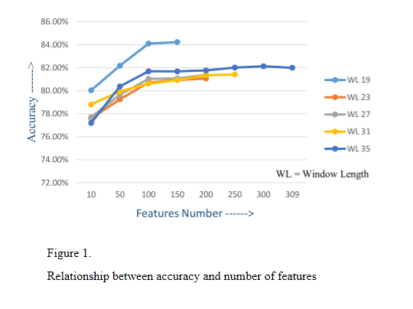

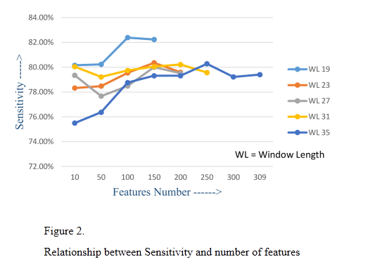

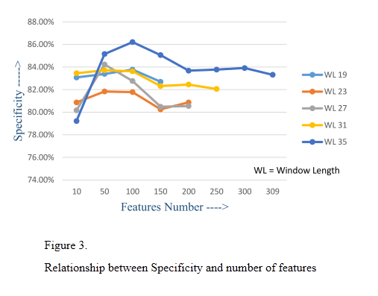

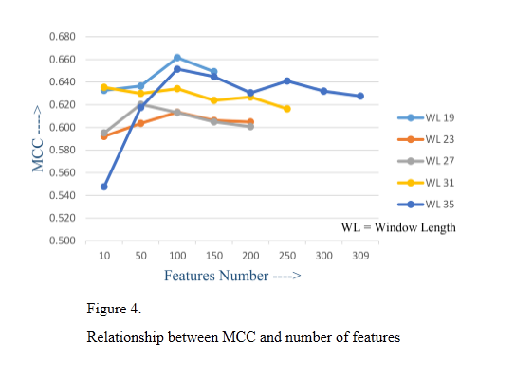

7. ROC curve
ROC curve is graphical display true positive rate (sensitivity) on y-axis and false positive rate (1 – specificity) on x-axis for varying cut-off points of test values. The area under the curve (AUC) is an effective and combined measure of sensitivity and specificity for assessing inherent validity of a classification test. Maximum AUC = 1 and it means classification test is perfect in differentiating positive with negative class. This implies both sensitivity and specificity are one and both errors–false positive and false negative–are zero. This can happen when the distribution of methylated and non-methylated test values do not overlap. This is extremely unlikely to happen in practice. ROC curve of training model represent in Figure 5 (AUC = 0.8411) , ROC curve of test data on training model represent in Figure 6 (AUC = 0.9000), and ROC curve of independent data on training model represent in Figure 7 (AUC = 0.9299).A result of 0.80 <= AUC <=0.95 represent excellent ability to discriminate between of methylated and non-methylated arginine sites.

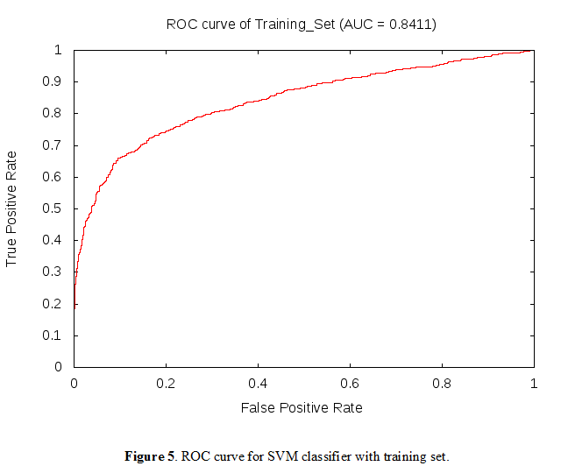

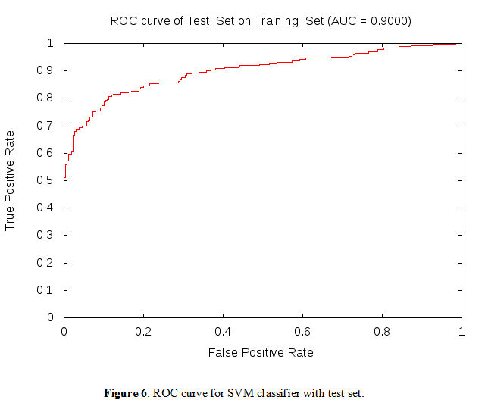

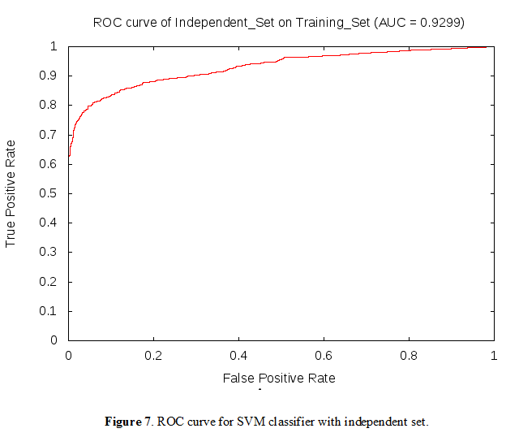

References:
Apweiler, R., et al. (2004), 'UniProt: the Universal Protein knowledgebase', Nucleic Acids Res, 32 (Database issue), D115-9.
Atchley, William R., et al. (2005), 'Solving the protein sequence metric problem', Proceedings of the National Academy of Sciences of the United States of America, 102 (18), 6395-400.
Chang, Chih-Chung and Lin, Chih-Jen (2011), 'LIBSVM: a library for support vector machines', ACM Transactions on Intelligent Systems and Technology (TIST), 2 (3), 27.
Chen, H., et al. (2006), 'MeMo: a web tool for prediction of protein methylation modifications', Nucleic Acids Res, 34 (Web Server issue), W249-53.
Cid, H., et al. (1992), 'Hydrophobicity and structural classes in proteins', Protein Eng, 5 (5), 373-5.
Daily, Kenneth M., Radivojac, Predrag, and Dunker, A. Keith (2005), 'Intrinsic Disorder and Protein modifications: Building an SVM Predictor for Methylation', Symposium on Computational Intelligence in Bioinformatics and Computational Biology, 475-81.
Frank, E., et al. (2004), 'Data mining in bioinformatics using Weka', Bioinformatics, 20 (15), 2479-81.
Huang, Y., et al. (2010), 'CD-HIT Suite: a web server for clustering and comparing biological sequences', Bioinformatics, 26 (5), 680-2.
Kawashima, S., Ogata, H., and Kanehisa, M. (1999), 'AAindex: Amino Acid Index Database', Nucleic Acids Res, 27 (1), 368-9.
Osborne, T. C., et al. (2007), 'Protein arginine methyltransferase 1: positively charged residues in substrate peptides distal to the site of methylation are important for substrate binding and catalysis', Biochemistry, 46 (46), 13370-81.
Peng, K., et al. (2006), 'Length-dependent prediction of protein intrinsic disorder', BMC Bioinformatics, 7, 208.
Qiu, W. R., et al. (2014), 'iMethyl-PseAAC: identification of protein methylation sites via a pseudo amino acid composition approach', Biomed Res Int, 2014, 947416.
Shao, J., et al. (2009), 'Computational identification of protein methylation sites through bi-profile Bayes feature extraction', PLoS One, 4 (3), e4920.
Shi, S. P., et al. (2012), 'PMeS: prediction of methylation sites based on enhanced feature encoding scheme', PLoS One, 7 (6), e38772.
Shien, D. M., et al. (2009), 'Incorporating structural characteristics for identification of protein methylation sites', J Comput Chem, 30 (9), 1532-43.
Vapnik, Valdimir and Cortes, Corinna (1995), 'Support Vector Networks, machine learning 20, 273-297', (Kunwer Acedemic Publisher).
Wen, P. P., et al. (2016), 'Accurate in silico prediction of species-specific methylation sites based on information gain feature optimization', Bioinformatics.
Wilkins, M. R., et al. (1999), 'High-throughput mass spectrometric discovery of protein post-translational modifications', J Mol Biol, 289 (3), 645-57.

