CURRICULUM VITAE

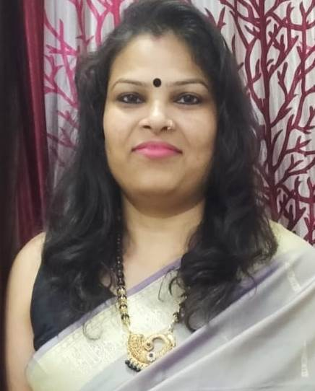
LAXMI
15-16 RK Block
Mohan garden
Uttam Nagar, New Delhi- 110059
Ph: 8800872016
E-mail:Laxmichauhan.89@gmail.com

Career Objective

To attend a position from where I can apply my acquired knowledge and skills while working in a team environment aiming at contributing towards the main objective of the organization and professional growth.

Academic Qualification

Level | Course | Board/University | Year of Passing
GRADUATION | B.A. | D.U. | 2009
SENIOR SECONDARY | Art | CBSE Delhi | 2006
SECONDARY | Regular | CBSE Delhi | 2004

Professional Qualification
- One year Diploma in MULTIMEDIA & WEB DESIGN from F-Tec Computer Institute.
    - Certified CPC - 01944575

Last Organization

AIWS – (Alpha IT Web Solutions)
Designation: Medical Coder-E&M
Time Period: From October 2019 – April 2022

Roles & Responsibilities:

E&M-Outpatient
- AWV
- Immunization
- Televisit
- House Call, TOC,
- Surgery Coding- Integumentary system

Experience 2 Organization
Mercer India Pvt.Ltd
Designation: Process Developer
Time Period: 2011- 2019

Roles & Responsibilities:
Blended US Process (US - Medical billing & Health insurance) - deals with Hospital & Professional claims
- Interact with insurance org. to get the required status update and have the claims resolved.
- To prioritize the pending claims for calling from the aging basket Mentoring.
- Create appeals with medical records.
- Create and update SOP whenever required and edit matrix whenever received any update.
- Complete the work allocated and report to the Group Lead / Team Leader.
- Recording daily activity production parameters for review.
- Coaching new hires

Personal Skills
- Excellent organizer with solid planning and problem-solving skills.
- Quick learner who can rapidly master all aspects of job within time.  Good verbal & written communication skills.

Personal Detail

Husband’s Name : Mr. Naveen Verma
Date of Birth : 20th May 1989
Nationality : Indian
Marital status : Married
Language known : Hindi & English

I hereby declare that all above information is true about my knowledge.

Date: -----------------
Place: ---------------- {LAXMI }

