RESUME
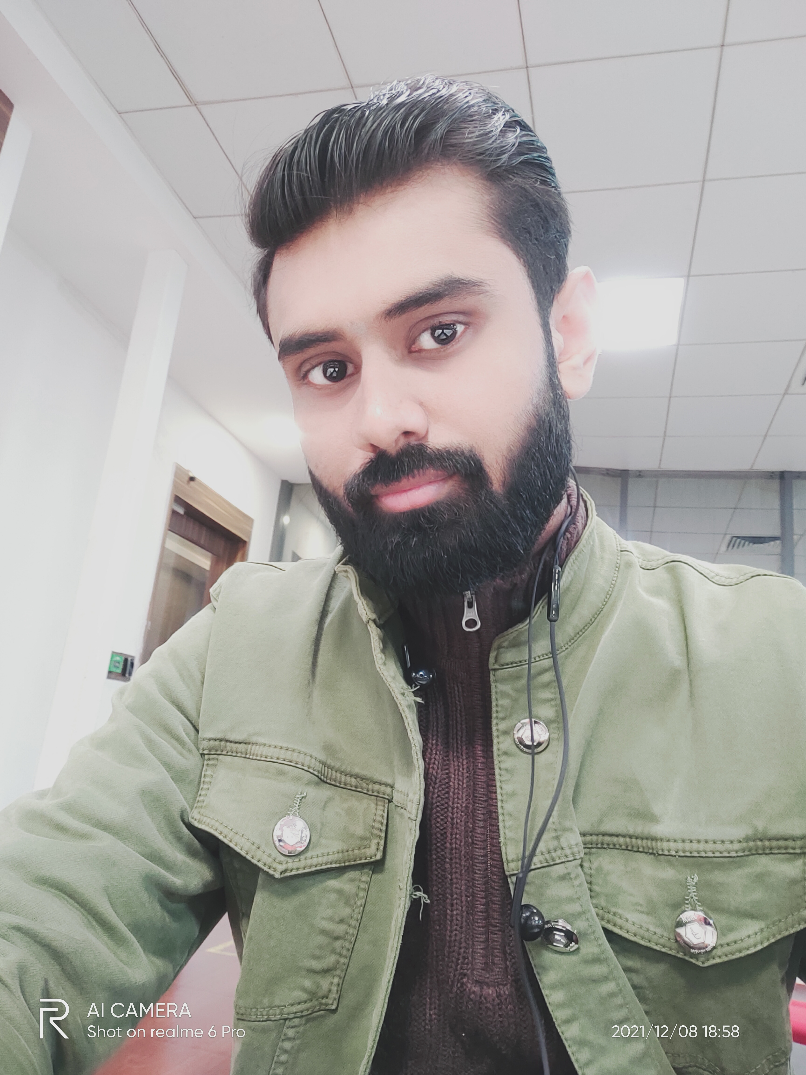

Akash Bhardwaj
Contact No. : 9389184931
Email: - akashbrd7@gmail.com

CAREER OBJECTIVE:
Seeking and excellent opportunity which promotes professional growth while making positive contribution to the organization.

PROFILE:
- Senior Process Expert in US Health Care

ACADMICS:
- PGDBA (Operations)2019 with Grade- A from Symbiosis center for distance learning, Pune
- B.Tech. (Mechanical) Engg 2013 from KNGDMEC,UPTU
- High school from CBSE Board
- Higher secondary from CBSE Board

COMPUTER SKILLS & SOFTWARES

            - Microsoft Office
- SAP,SRM,CRM,Epic,Meditech,Next gen
Centricity & Capario

PROFESSIONAL EXPERIENCE

- Provana Pvt Ltd LLC,Noida
Working currenty since September 2021 as Sr Process Expert for Physician Medical claim
* AR follow up-commercial including BCBS
*CMS1500 claim form dealing
* RCM edits
*Benefits verification-web and call for Abortion services,LARC,BCM,IUD
*Eligibility
*Payment Posting on NEXT GEN tool software and CENTRICITY

- R1 RCM Pvt Ltd, Gurgaon
Worked as Analyst in AR follow up US healthcare for Hospital provider claim from Sep 2019 to Sep 2021
*AR follow up -commerical payers on EPIC and MEDITECH software tool
*UB 04 claim form dealing
*MR upload,Appeals and Reconsideration
*Patient letter and payment posting, write off

- Ienergizer Pvt LTD,Noida
Worked as Senior Operation executive
From Dec 2017 to Nov 2018
*Customer service
*Escalation desk to resolve queries

- TRATEC ENGINEERING Pvt. Ltd. Gurgaon
Company of TII group (Germany) Winner of
DSIR National Award 2001.
Worked here from MAY 2016 to June 2017
as Production Engineer work for Defence missile launcher trailers projects
* Deal with purchase vendors and store,help in production and fabrication for Army projects.

CONTRACTUAL WORK EXPERIENCE:
- CONVERGYS (concentrix) Gurgaon August 2019- September 2019
*Worked as Technical supprort executive for LOREX US & Canada CCTV camera servers
*Taking system on remote and working on live views, formatting,DDNS, Firmware upgrade
with customers on calls.

INDUSTRIAL TRAINING :

Graduate Apprentice Mechanical, Bharat Electronics Limited, Ghaziabad -
- Sep 2014 to Sep 2015 in Sub contract NCS- procurement of various
Mechanical items of Indian Army, Navy & Airforce Radar projects of defence.
(Deal with vendors by phone calls and mails)

Hobbies- Love to make Vlogs,Listen to music,Travelling to explore, increase spritual consciousness,feeding animals.

PERSONAL INFORMATION :

Name : Akash Bhardwaj
Father’s name. : Shri S D Sharma
Date of Birth : 19-06-1992
Language known : Hindi, English
Address : HN 77,Brahampuri,Modinagar, Dist- Ghaziabad, UP-201204

DECLARATION
I hereby declare that the information given above is true to the best of my knowledge

Date:-………….
Akash Bhardwaj
Place …………….

