CURRICULUM VITAE

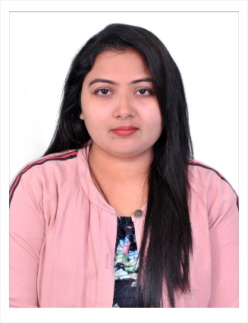
Name: Farhana Anjum
Mobile: 8106368108
Email: syedfarhanasoni@gmail.com
City: Hyderabad
Career Objective

Looking for an entry level position requiring strong analytical, organizational and computer skills in the department.
Experience
( ! ) Company: Hinduja Global Solutions
Experience: 18 months in US Health Care- Accounts Receivable
Period: 29th June 2018 to 24th December 2019
Roles: 12months as Process associate & 6months as Process trainer.
( !! ) Company: COGNIZANT Technology Solutions
Experience: 12 months in US Health Care- Accounts Receivable
Period: 26th December 2019 to 27th November 2020
Role: Senior Process Associate
( !!! ) company : AGS Health
Experience :6 months in US healthcare accounts receivable
Period : 7th January 2021 to still working
Role : Senior process associate
Technical Skills

- Packages : MS Office, MS Excel, Adobe, Tally.
- Operating System : Windows, Linux

Educational Qualifications

COURSE | INSTITUTION | BOARDOF EXAM | YEAROF PASSING | %OF MARKS
B.COM | Vasundhara degree college | Kakatiya university | 2017 | 80%
Intermediate | Balabharti junior college | Board of Intermediate Education, A.P. | 2013 | 86%
S.S.C | Fatima convent High school | Board of Secondary Education, A.P | 2011 | 85%

Strengths

- Can effective Self-motivated.
- Quick learner and good communication skills.
- Ability to drive collaboration in teams, either as leader or team member.
- Sincere & good listener.
- Hardworking Nature.

Personal Profile

Name : Farhana Anjum
Father's Name : MD.Rafeeq
Date of Birth : 31st may, 1996
Gender : Female
Nationality : Indian
Marital Status : Unmarried
Languages Known : English, Hindi, Telugu, Urdu.

DECLARATION:

I hereby declare that the above mentioned particulars are true to the best of my knowledge and belief.
Date: 2nd December 2020.

