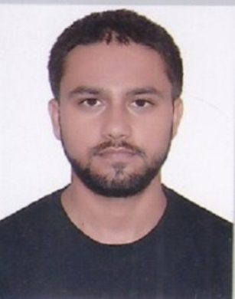
Shoaib Ali
C-3K77 Royal Apartment
Batla House, Jamia Nagar, Okhla New Delhi shoaibchoudhary9119@gmail.com Mobile: +91-8178808565

OBJECTIVE

Seeking for an opportunity to work with an organization that will provide a platform to utilize my skills and enrich my knowledge to help in the process of organizational and self-growth.

ACADEMIC PURSUIT
- Master in Mass Communication from Jamia Millia Islamia New Delhi
- Graduated in Bachelor of Arts with Economics, Psychology and Drawings and Paintings in 2018
- Intermediate [2014] 73% from JV Public School Circular Road Muzaffarnagar
- High School [2012] 72 from JV Public School Circular Road Muzaffarnagar

WORK EXPERIENCE
- Worked as the (AR Accountant Receivable) in MedicSolutions Pvt Ltd for 2.7 years.

FIELD OF INTERESTS
  - Planning and Management
  - Developing new strategies, research and analysis of market-oriented factors
  - To get information about the clients and their interest in choosing the products and services

SKILLS

- Proficient in Communication Skills
- Good knowledge both in Speaking and writing in English, Hindi and Urdu
- Having good knowledge of Web-portals and Software related to the major US based Medical Insurance Companies
- Microsoft Word
- Microsoft Excel
- Computer knowledge
- Internet knowledge
- Content Writing
- Production of Documentaries and short Films
- Professional Photography
- Video and Photo Editing

HOBBIES

- To get know about different Cultures, Societies, Communities and to have a discussion with them
- Tracking and Nature trail in Mountainous region and Rural Areas
- Reading books
- Watching news

PERSONAL CIRCUMSTANTIAL

Date of Birth : 3rd July 1998
Gender : Male
Father’s Name : Mr. Munfait Ali
Mother’s Name : Mrs. Vasila
Marital Status : Unmarried
Languages Known : English, Hindi & Urdu
Nationality : Indian

DECLARATION

I hereby declare that the information given above is correct and in the best of my knowledge.



Place: Shoaib Ali

Date:

