**JAMAL UDDIN KHAN**

Surajpur- Greater Noida

UP

-

201306

(

**India**

)

E

-

mail Id:

-

**Jamal1306192 @gmail.com**

Mob: +91 9654229989

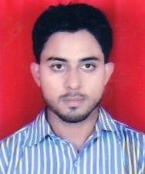

# Career Objective

To build career in a growing organization , where I can get the opportunities to prove my abilities by accepting challenges , fulfilling the organizational goal and climb the career ladder through continuous learning and commitment.

# Qualification

* High school and Intermediate passed from UP Board.
* Graduate from Delhi University in Bachelor of Arts.

**Strength**

* Good communication skills
* Hard working and adaptable to various environments.
* Always aspiring to learn
* Positive attitude
* Ability to work in a team

**Hobbies**

* Traveling
* Listening music
* Playing game

# Personal Details

Father’s Name : Late Mr. Saleem Khan

Date of Birth : 13/06/1992

|  |  |  |
| --- | --- | --- |
| Marital Status | : | married |
| Nationality | : | Indian |
| Language known | : | English, Hindi |
|  |  |  |
| **Declaration** |  |  |

I hereby declare that all the statements made are correct to the best of my knowledge and belief.

# Date: ………………………

**Place: INDIA**

**(JAMAL UDDIN KHAN)**