**Palak Thakur**

**Career Objective**

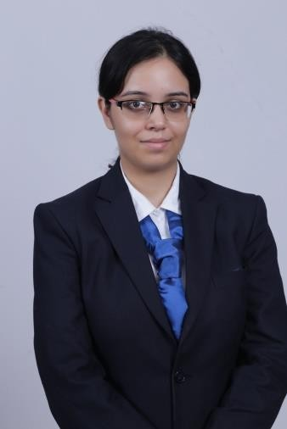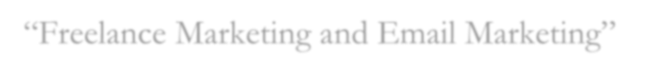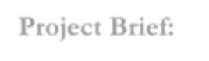

**Permanent Address:**

Aditya Syndicate Colony, Adityapur-2, Jamshedpur-831013

**Mobile:**

+91-8340253635

**E-Mail:**

palak.thakur1995@gmail

.com

**Personal Data: Date of Birth** : 04.05.1995

**Gender** : Female

**Nationality**: Indian

**Marital Status**

:Unmarried

**Languages Known:**

Hindi, English.

**Interests :** Dancing, Singing and Cooking.

To make the best use of my potential and utilize my resources optimally. I believe my career is full of challenges and opportunities so my target is to make the best use of them and groom myself every day to become an effective professional.

**EXPERIENCE: as of now-30 months.**

**Currently working as a Process Associate- Claims in Genpact where my prime work is to do the processing of complex claims of the insurance clients of Genpact and do their payments. (Jan 2021- present).**

**Worked as assistant relationship manager in premium credit card sales in American Express posted in Kolkata (feb 2020- Sep 2020).**

**B2C sales- I was hired for the airport kiosk but due to covid, I had to do wfh in which I was doing cold calling to the prospective targets and tell them about the credit cards and sell them. Basically, the sales model was based on referral system. I was also selling general insurance(health, motor etc) as American Express had tied up ICICI Lombard for selling the same.**

Worked as a Business Trainee (Level 3) at **ICICI Prudential** Jamshedpur. My department is Direct Marketing in the company.(may 2019-dec 2019).

B2C experience- I was hired for direct marketing domain where I was getting leads from my manager everyday. I had to travel to the customer’s residence or office and provide them servicing about their pre-existing products and cross sell them the new products. By doing this, I used to achieve my sales target.

**Academic Qualifications**



**Summer Internship**

|  |  |  |  |
| --- | --- | --- | --- |
| **Degree** | **Board/ University** | **Year** | **Percentage** |
| PGDM in Information  Technology | XISS, Ranchi | 2017-19 | **61.65** |
| B.A Hons(Political Science) | Women’s College,  Ranchi affiliated to  Kolhan University | 2013-17 | **59.63** |
| Intermediate | ISC(arts) | 2013 | **70.25** |
| Matric | ICSE | 2011 | **77.6** |

**Techstern Solutions, Ranchi. (6 Weeks)**

“Freelance Marketing and Email Marketing”

### Project Brief:

#### I did my summer internship with Techstern Solutions, Ranchi. Key Learnings:

**.** My work was basically to do freelance marketing and email marketing on websites like freelance.com, upwork.com and wordpress based on company’s account. It created direct revenue for the company in terms of business.

**.** My key learning was how a handful of 4-5 freelance projects are enough to sustain a company for a complete year thus reflecting the role of digitalization in the modern era..

**Select Projects**

# I did my internship with Techstern Solutions as a Management Trainee for a period of 6 weeks( from 23rd April to 1st June, 2018) with Business Development team. I was working with the Freelance team and was responsible for email marketing and freelance marketing. These projects created direct revenue for the business. It really enhanced my knowledge as a freelancer

and moulded me as an individual.

**Seminars and Workshops Attended**

We had been taken on an industrial tour to Jamshedpur and Ranchi where we had visited various companies like Tata Power, ISWP, Tata Motors, Tata Tinplate, Jindal Power, Indian Institute of Coal Management etc. We learnt a lot about the management that takes place inside the company. We were introduced to our Alumni who were hosting the sessions for us.

Participated in a seminar on “Cyber Security” at ICFAI University, Jharkhand and received a participation certificate.

Attended “Jharkhand Literary Meet” organized by TATA STEEL which was an intellectual and interactive session held by the renowned poets and celebrities of the world.

**Extra Curriculars &Achievements**

Went to Xavier Institute of Polytechnic and Technology for a joint Sports meet between XISS and XIPT.

Participated in Bengali Yuva Mancha and was the speaker there. The topic was “The opportunities and challenges faced by the youth of India today”. Got a participation certificate and a memento.

Participate in a debate competition titled “The common man has no say in curbing corruption.” Was the speaker there and got a participation certificate.

Participated in ULGULAN which was a cultural event held at NUSRL in a group dance performance. Got a participation certificate and great exposure.

I participated in Panache in the ramp walk which was the main event of the show. Panache is the annual fest of our college.

Went for an industrial visit to Delhi and various industries like Maruti Suzuki, Zephyr, Hero Motocorp, Ameriprise, JCB etc and learnt a lot about the actual happenings in the industry. Talking to our alumni in each of the company was really a boost.

#### Palak Thakur