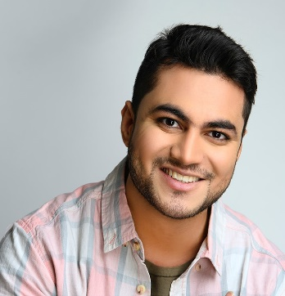**Pushpendra Sharma**

Pushpendra Sharma S/o Ajay Sharma 151-The Savitri, Near Bus stand, BHARATPUR road,

321201, KUMHER (BHARATPUR)

Call and what’s app- 7792077230,

Email – pushpendrasharma375@gmail.com

linkedin - <https://www.linkedin.com/in/pushpendra-sharma-777067a7/>

**Career Objective:**

Want to work with international Organization and should have chance to my growth.

**Educational Qualifications:**

* Completed senior secondary in science (physics, chemistry and math) from Rajasthan board.
* Completed Graduation as BA. From Rajasthan University Jaipur. (Rajasthan).
* Completed MA (philosophy) from maharaja SURAJMAL BRIJ university, BHARATPUR, RAJASTHAN

**ACHIVEMENT.**

* 6 months trading & experience as ERO (Emergency response officer) at 108 Emergency hiplines.
* 6 months trading & experience as Travel desk associate in The Flute boutique and The Sneer boutique hotel, Jaipur.
* State label handball player
* Have knowledge of spirituality and life existence philosophy.
* Worked on commercial modeling projects.
* Involved in office Employee Engagement activity as singing, Dancing, poetry, playing music, drama, Entrainment, sports.

**Professional Qualifications:**

* Diploma and treading in ‘SERVICE INDUSTRY MANAGEMENT’’ (Aviation, hospitality, telecommunication) from AURA NEXUS ACADEMY, JAIPUR.
* Completed a Rajasthan government certified computer course ‘’RSCIT’’ from ‘’VARDHAMAN MAHAVEER OPEN UNIVERSITY’’ KOTA.
* Management in ‘travel & tourism’ from AURA NEXUS, Jaipur
* Certification in ‘sales & marketing and office administration’ from ’ICICI academy’ Jaipur

**WORK EXPERIENCE**

* 1 year experience as AR associate in Pacific global an access healthcare company Noida.
* 1-year experience as senior AR associate in “R SYSTEMS INTERNATIONAL.
* 3-years’ experience in R1RCM Gurgaon as Senior AR senior Analyst. (Currently working)

**STRENGTHS:**

* Positive attitude
* Self confidence

**Declaration: -** I hereby declared that the information furnished above is true to the. Best of my knowledge

**Date:**

**place:**

**PUSHPENDRA SHARMA**