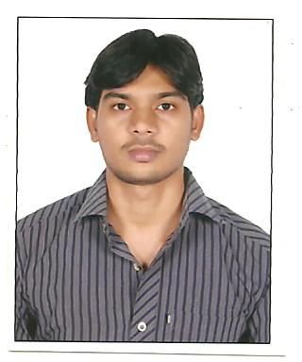 **RESUME**

**MIR ASHRAFALI, CPC**

**Mobile: +91-7207747376**

Email: **ashrafali.mir@gmail.com**

**Immediate joining**

**Objective**

Seeking a position to utilize my skills and abilities in the biotechnology that offers professional growth while being resourceful, innovative and flexible.

**WORK EXPERIENCE:**

* **Certified professional coder (CPC)**
* Working as senior executive verifier from PAST 3.9 Years in **Phycare services ind ptv.ltd**, Auto nagar,guntur dist, mangalagiri (31-05-2016 to 28-03-2020).
* Working as senior medical coder from July 23-07-2020 to 30-09-2020 in Reventics Pvt Ltd.
* At present iam working as junior embryologist in sree krishna fertility center, Eluru(11-01-2021)
* Worked as Assistant Managing Editor in **OMICS Online publishing pvt.ltd**. Mindspace, Madhapur, Hyderabad, AP, INDIA, since 1 and 1/2 year. (1-10-2011-30-03-2012)
* Worked as junior embryologist in **Srushti ivf lab**, Visakhapatnam (03-12-2014 to 03-30-2016)

**Roles and Responsibilities:**

* Worked in E/M outpatient both physician and hospital coding for 3.9 years.
* Well versed with ICD-10 CM, CPT, and HCPCS.

**Education Qualifications**

|  |  |  |  |  |
| --- | --- | --- | --- | --- |
| **Course** | **Institution** | **Year** | **School/**  **University** | **Percentage** |
| B.Ed | H.M.K.S&M.G.S.M College of Education,Kanagala,Guntur Dist. | 2013 | Nagarjuna University | 74% |
| M. Sc., (Biotechnology) | Dr.V.S.KrishnaGovt PG college, Visakhapatnam | 2011 | Andhra university | 7.2 CGPA. |
| B. Sc., (Biotechnology) | Sri Bala Sai Degree college, Machilipatnam | 2009 | Nagarjuna University | 74% |
| Intermediate | Sri Vijaya Junior College, Machilipatnam | 2006 | BIE, Andhra Pradesh | 66% |
| S.S.C., | M.V.P.School, Machilipatnam | 2004 | S.S.C. | 70%. |

**Research Experience**

Worked as a Project Trainer under the project on Isolation of disease causing Aeromonas & Pseudomonas bacteria from fresh water fishes and conducting sensitivity tests with Ginger, Neem and Garlic against synthetic drugs.

**Other Projects**

1. Project on validation of vectors to study the expression pattern of promoters ACS4, ACS5, ACS7 from ARABIDOPSIS THALIANA using GUS as a reporter gene by using molecular biology & tissue Culture techniques.

2. Project on Biofertilizer and Bio-compost.

**Strengths:**

* Dedication and committed towards the assigned works
* Excellent communication skills and inter-personal skills
* I can work either individually or as part of a team
* Open minded and interested in learning new things

**PERSONAL PROFILE**

Name : MIR ASHRAF ALI

Father Name : MIR HASHIM ALI

Date of Birth : 6.april.1989.

Gender : Male

Marital Status : Married

Nationality : Indian

Mother Tongue : Urdu

Languages Known : Telugu, English and Hindi.

Hobbies : Playing cricket, Shuttle and Carroms.

Address : D.no:5/406-A1, Nuruddinpet, Machilipatnam, AP, 521001.

**Declaration**

I here by solemnly declare that all the statements made above are true and correct to the best of my knowledge and belief. I would be obliged if I am endowed with an opportunity to serve your organization.

**Place :   
Date : Mir. Ashraf ali**