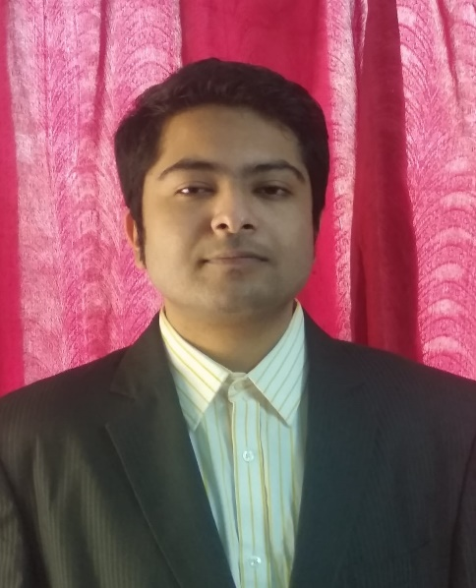

Objective

To seek a challenging career where I can show my technical and functional expertise and work towards the growth of the organization and to explore myself fully, learn new things and realize my potential in this competitive world.

Skill Highlights

|  |  |
| --- | --- |
| * **Good Communication Skill** * **Good Interpersonal skills with an ability to understand problems** * **Quick learner** | * **Ability to grasp new technical things quickly** * **Sound Computer skills** * **Service-focused** * **Adabtility** |

Educational Qualifications

|  |  |  |  |  |
| --- | --- | --- | --- | --- |
| Name of Exam | School/College | Board/  University | Percentage/CGPA | Passing Year |
| 10th | Kendriya Vidyalaya Cossipore | CBSE | 6.0 CGPA | 2016 |
| 12th  (Humanities) | Kendriya Vidyalaya Cossipore | CBSE | 67% | 2018 |
| B.sc Animation, Multimedia & Graphics | NSHM College of Management & Technology | MAKAUT | 7.73 CGPA | 2022 |

Working Knowledge

* BASIC KNOWLEDGE OF MS EXCEL
* MS WORD
* MS POWERPOINT

**Achievements**

* Won 2nd Prize in School Jump Rope Competition
* Won 3rd Prize in Inter-School 100M Race Competition
* Represented School 3 times at Regional Level Tournaments (Cricket).

**Work Experience**

Fresher

Personal Details

**Name: Somanjan Dutta**

**Father’s Name: Sankar Kumar Dutta**

**Date of birth: 28 Sept 2000**

**Nationality: Indian**

**N**

Contacts

**Address:**

48/1 Satchasi Para Road Cossipore, Kolkata 700002

**Phone:**

9038110840

**Email:**

somanjandutta@gmail.com

Languages Known

English

Hindi

Bengali

Hobbies

Cricket

Chess

Carrom

Online Gaming

RESUME