**SWATI SHRESTHA**

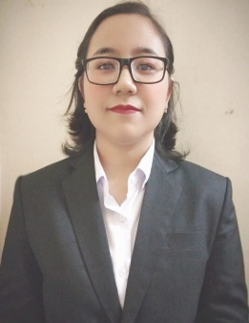

**Address**: BBT Road,Jalkal, Mahestala. Kolkata-700141

**Phone**: +91 8420115027

**Date of Birth**: 18 December 1998

**Email**: swatistudentshrestha1998@gmail.com

**OBJECTIVE**

I would like to nurture my skills and proactively assisting my organization to achieve its goals, so that I eventually get to establish myself as a successful professional.

**ACADEMICS**



* 2016 passed Higher secondary, United Missionary High School
* 2014 Passed Madhyamik , United Missionary High School
* 2020 Passed B.sc, Ihm bhubaneswar

**IT SKILLS and Work experience**

* Conversant with MS office(Word, Excel, Power Point,) & Internet Applications
* Worked in Le meridian resort and spa from 2020 to 2021

**HOBBIES**

* Cooking, music, movies, travelling

**DECLARATION**

I hereby delare that the above mentioned information is true to the best of my knowledge.

Swati Shrestha

Place: Kolkata

Date: