CURRICULUM VITAE

**PAWAN BHANDARI** 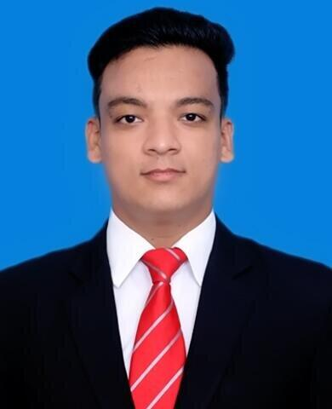

#678/16, Surya Vihar-2

Amarnagar, Faridabad

Haryana 121003

Mobile No. : +91 8802629313

Email: pawanbhandari1996@gmail.com

D.O.B: 02-10-1997

CAREER OBJECTIVE

To be a part of an environment that promotes team efforts and provides opportunity for value based growth as well as career advancement in Corporate operation while making significant contribution to the organization and retain responsible position in the organization.

SUMMARY OF QUALIFICATION

|  |  |  |  |
| --- | --- | --- | --- |
| **INSTITUTE/BOARD** | **QUALIFICATION** | **PASSING YEAR** | **PERCENTAGE** |
| IGNOU/NCHMCT | BSC.H&HA | 2019 | 72% |
| SOL DELHI UNIVERSITY | B.COM PROGRAMME | 2019 | 45% |
| CBSE | 12TH | 2015 | 79.8% |
| CBSE | 10TH | 2013 | 91.2% |

**QUALIFICATION DETAIL IN BRIEF**:

* I completed Bsc.H&HA course from The Lalit Suri Hospitality School in 2019.
* I completed under graduation in B.com programme course from DU through SOL in2019.(45%)
* I completed my 12th from T.N.P.S, Faridabad (CBSE with 79.8% )in 2015.
* I completed my 10th from T.N.P.S, Faridabad (CBSE with 91,2%) in 2013.

EXTRA CURRICULAR ACTIVITIES

* Participated in International Maths Olympiad at school level.
* Played cricket at school level as a team captain.
* Won academic awards in school.
* Participated in clean india campaign in school & College .

SKILLS

* Motivated and eager to learn new things.
* Strong motivational and leadership skills.
* Honest & loyal towards work.
* Ability to work as individual as well as in group.
* Excellent communication skills in written & verbal both.

REFERENCE

1. Abhishek yadav 2. Manish sharma

COMPUTER SCIENCE ENGINEER RESERVATION ASSOCIATE

+91-9205510194 +91-9899688686

Declaration:I do hereby declare that all the information given above is true to the best of my knowledge and belief.

**Date: Signature:**