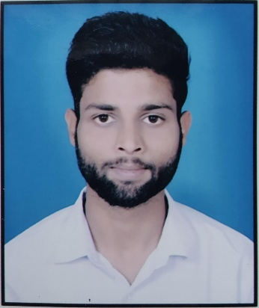

**Ujjwal Goyal**

**Address :** Hukumat Nagar Colony Bilari, Moradabad (U.P.)

**Contact No. :** 8936910051

**E-mail Id. :** ujjwalgoyal9149@gmail.com

# Career objective

I am a fresher so I want to increase my skill and knowledge so that I can do good work in future.

# Academic qualification

|  |  |  |  |  |  |
| --- | --- | --- | --- | --- | --- |
| **S.R. No.** | **DEGREE** | **COLLEGE** | **BOARD** | **PERCENTAGE** | **YEAR** |
| **(1)** | High School | B.H.P. Memorial Inter College, Bilari | UP Board | 79% | 2015 |
| **(2)** | Inter | B.H.P. Memorial Inter College, Bilari | UP Board | 68.4% | 2017 |
| **(3)** | Diploma in Chemical Engineering | Government Polytechnic, Chandausi | BTEUP | 79.43% | 2021 |
| **(4)** | Degree (B.A.) | S.M. College, Chandausi | MJPRU | 54.91% | 2021 |
| **(5)** | Degree  Industrial Economics  (M.A.) | MJPRU Bareilly | MJPRU | Pursuing | ---- |

# Awards/acheivement

|  |  |  |
| --- | --- | --- |
| **S.R. No.** | **CERTIFICATE NAME** | **CERTIFICATE DATE** |
| **(1)** | Basic Computer Skills by IIIT KOTA | 04/09/2021 |

# strengths

1. Positive Mindset
2. Good Leader
3. Team work

# sKills

1. Basic Computer Skills
2. Microsoft Excel
3. Microsoft Word

# personal information

**(1) D.O.B. :** 25/03/2001

**(2) Father's Name :** Satendara Goyal

**(3) Mother's Name :** Anita Goyal

**(4) Nationality :** Indian

**(5) Language :** Hindi, English

**(6) Marital Status :** Single

**(7) Hobby :** Reading, Daily Exercise