**DIPANJAN GOSWAMI**

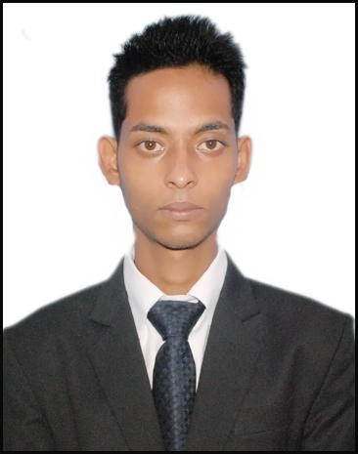

**Address**: 277 B1 Block, New Ashok Nagar, Delhi 110096

**Mobile number**: +91-7982995963

**Email Address**: **jsdipanjan@gmail.com**

**Career Objective**

To succeed in an environment of growth and excellence and earn a job which provides me job Satisfaction and self development and help me achieve personal as well as organization goals

|  |
| --- |
| Education |
| |  |  |  | | --- | --- | --- | | **2013-2015** | **PGDM (Finance and Marketing)**  I.T.S – Institute of Management, Greater Noida, Approved by AICTE, Ministry of HRD, Govt. of India, Equivalent to MBA by AIU. |  | | **2010-2013** | **B.B.A(HONS)**  Durgapur Society Of Management and Science, West Bengal University Of Technology |  | | **2009-2010** | **Senior Secondary Examination - Class XII**  BISSS 3, Bokaro Steel City, CBSE |  | | **2007-2008** | **Higher Secondary Examination - Class X**  B.I.V 3/A, Bokaro Steel City, CBSE |  | |

|  |
| --- |
| Summer Internship/ Industrial Training |
| Company Name : Sharekhan LTD  Project Title :To Study The Risk Profile Of Investors In Delhi NCR  Duration : 15 April 2014 – 15 June 2014  Project Summary : The project deals with the analyzing the investment pattern on the basis of risk profile of investors at Sharekhan Limited and what are the factors that influence the investment pattern. As we all know that every person who wants to grow his /her money in future they must have to invest their money in stock market or anywhere else. This study describes the investment pattern use by different persons while doing investment in stock market |

|  |
| --- |
| Work Experience |
| Worked with Nthrive Global Solutions, Noida As Receivables Analyst (AR) [May 2018-May 2019]  Job Responsibility:   * Follow-up with insurance companies * Denial Management * Resolving Denials On Calls   Worked With Omega Healthcare (Bangalore), As Executive AR [June 2019- Feb 2020]  Job Responsibility:   * Initiate Prior Authorization * Follow up with Insurance Companies for the status of Prior Auth * Resolving Denials   Worked with R1rcm as Senior AR Analyst [Feb 2020 – Feb 2021]   * Working on Medicaid claims * Calling payer to resolve denials * Maintaining AR   Worked with R Systems Pvt. LTD [Feb 2021-Jan 2022]   * Working on Anesthesia claims * Calling payer to resolve denials * Maintaining AR   Working with Wipro LTD.   * Follow up on aging claims * Calling Insurance companies and follow up on pending claims * Denial Management |

|  |
| --- |
| Significant Accomplishment |
| * Won runners up prize in college for cricket tournament in 2013. * Won 1st prize in Bharat kojano quiz competition in 2008 |

|  |
| --- |
| Technical Skills |
| * MS Office, Excel, PowerPoint. * SPSS * Tally 7.2 |

|  |
| --- |
| Strengths |
| * Quick Learner * Can easily adapt to changing environment * Hard working |

|  |
| --- |
| Interest Hobbies |
| * Dancing |

|  |
| --- |
| Extra-Curricular Activities |
| * Worked as an alloy in a marketing seminar on redefine,reimagine , reinvent: a roadmap for new age marketing * Participated in Jharkhand talent award show in 2012 |

|  |
| --- |
| Personal Details |
| Father’s Name :Mr. DebeshGoswami  Date of birth : 15/02/1992  Gender : Male  Marital Status :Single  Nationality :Indian  Languages Known : English, Hindi and Bengali  Permanent Address : Sec-2/B, Q.no- 3-037,Bokaro steel city, Bokaro, Jharkhand-827001 |

**DECLARATION:I hereby declare that the details provided by me in this resume are correct and I have knowingly not omitted/ misrepresented any information.**

Date: Place: Signature: **(Dipanjan Goswami)**